**LAMBLING Clément**

**TP3: MapReduce2**

Here are the commands and results from the terminal:

First, this is the jar command to run each exercise, in an output. So, for the different exercises, I just have to change the part after the .jar file in the command, with a different number of outputs to have them all. SO here I started with the 1st exercise and so I call “district_tree” and display in the output01. For the 2nd exercise, I will call “show_species” and the output02 etc.



Then, to display the result of each exercise I use this command:



So here is the result for the first exercise, it worked well and displays the list of the districts containing trees.

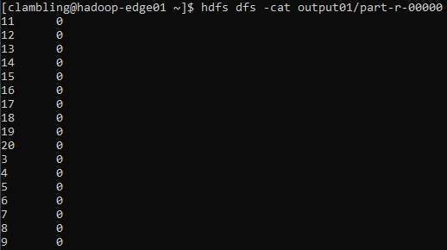

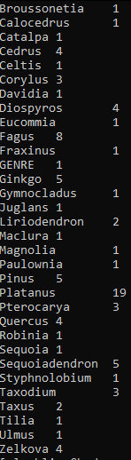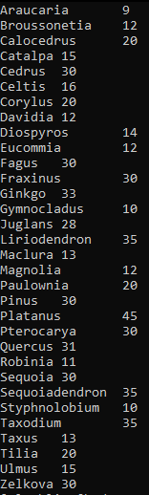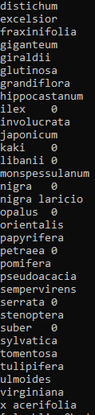

4. This is the result for the 4th exercise

1. This is the result for the 2nd exercise

2. This is the result for the 3rd exercise

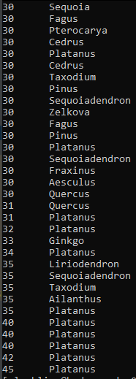



5. This is the result for the 6th exercise

3 This is the result for the 5th exercise

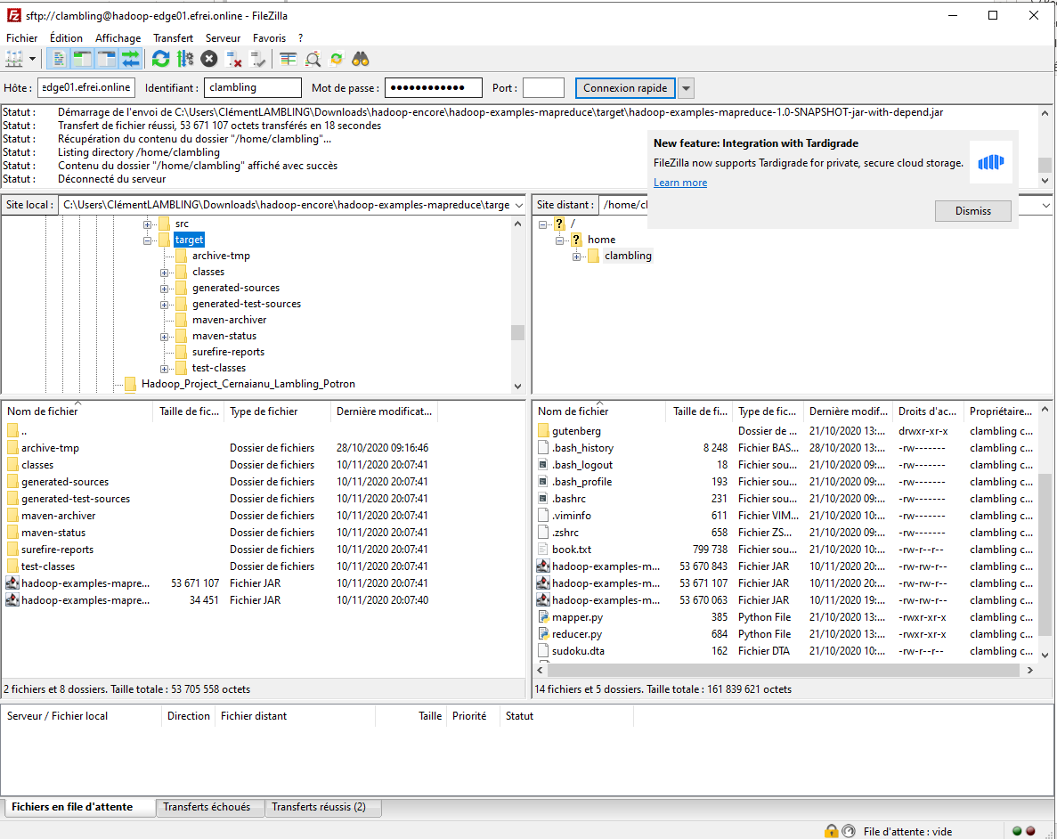

**6**. This is the FilleZilla interface