|  |  |  |  |
| --- | --- | --- | --- |
| A | B | C | R |
| 1 | 1 | 1 | 1 |
| 1 | 1 | 0 | 0 |
| 1 | 0 | 1 | 1 |
| 1 | 0 | 0 | 1 |
| 0 | 1 | 1 | 1 |
| 0 | 1 | 0 | 1 |
| 0 | 0 | 1 | 1 |
| 0 | 0 | 0 | 1 |

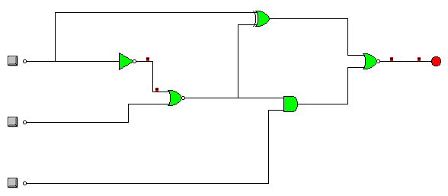

Salida=a·(a+b)+(a+b)+(a+b)·c