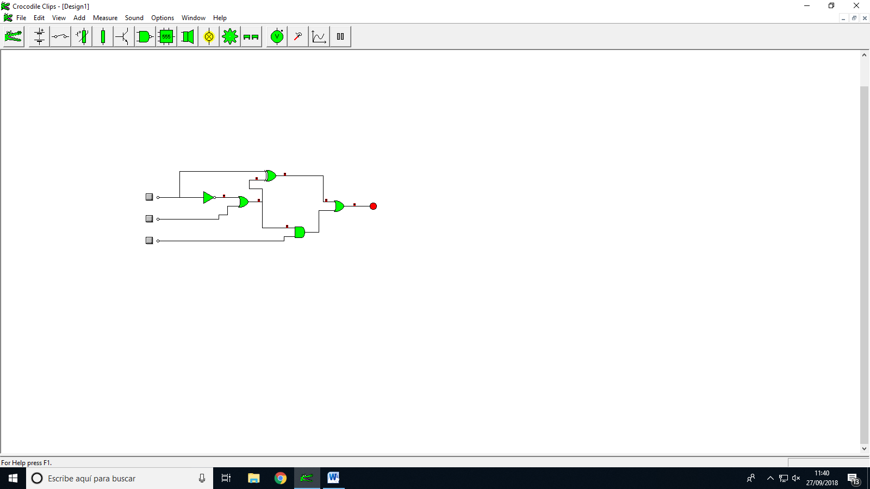

|  |  |  |  |
| --- | --- | --- | --- |
| A | B | C | A+B+C |
| 0 | 0 | 0 | 1 |
| 0 | 0 | 1 | 1 |
| 0 | 1 | 0 | 1 |
| 0 | 1 | 1 | 1 |
| 1 | 0 | 0 | 1 |
| 1 | 0 | 1 | 1 |
| 1 | 1 | 0 | 0 |
| 1 | 1 | 1 | 1 |

***ECUACIÓN:***

­á(á+b)+a(á+b)+(á+b)c