Andrés Pérez y Javier Ayuso 2ºC Bach

TRABAJO 1 : PUERTAS LÓGICAS

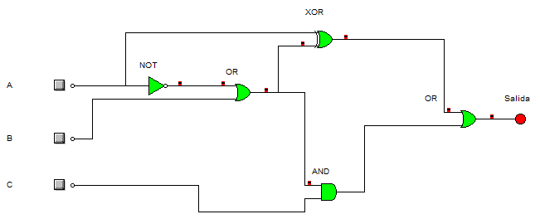

|  |  |  |  |
| --- | --- | --- | --- |
| A | B | C | Salida |
| 0 | 0 | 0 | 1 |
| 0 | 0 | 1 | 1 |
| 0 | 1 | 0 | 1 |
| 0 | 1 | 1 | 1 |
| 1 | 0 | 0 | 1 |
| 1 | 0 | 1 | 1 |
| 1 | 1 | 0 | 0 |
| 1 | 1 | 1 | 1 |

Salida:

a(a+b)+ a(a+b)+(a+b)c