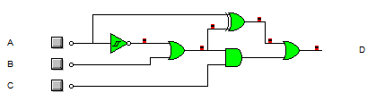

|  |  |  |  |
| --- | --- | --- | --- |
| **A** | **B** | **C** | **D** |
| 0 | 0 | 0 | 1 |
| 0 | 0 | 1 | 1 |
| 0 | 1 | 0 | 1 |
| 0 | 1 | 1 | 1 |
| 1 | 0 | 0 | 0 |
| 1 | 0 | 1 | 0 |
| 1 | 1 | 0 | 0 |
| 1 | 1 | 1 | 1 |

**[A ⊕ (Ā + B)] + [(Ā + B) • C]**