

**Web Development - Project Assignment I**

Undergraduate degree in Games and Multimedia

2º year

Daniel Reis - 2191677

Ricardo Brites - 2202225

Shift - PL3

Leiria, November of 2021

Navigation Scheme

( <https://drive.google.com/file/d/1F7xEdI6zW2ESVoBOFvoD8Wc31c1qlhp3/view?usp=sharing> )

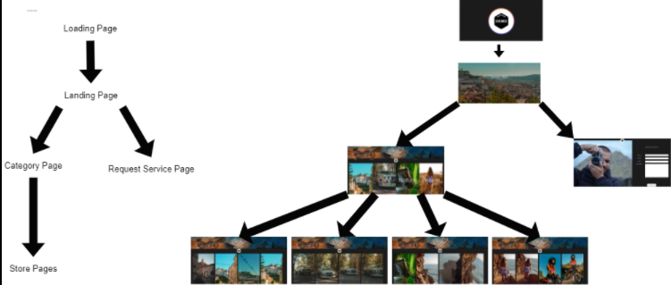

Responsive Design

In this project, we decided to use flexbox, which is already a big help when it comes to width and height adaptability all around… Aside from the flexbox, we used percentages as measurements in pretty much everywhere we were able to, the percentages allowed us to, without extra coding, have a fully responsive website.

We also created some code so the images on our website don’t stretch and create a bad user experience.  
  
 Along the way, since we created the top of the website as an absolute positioned item and the relative positioned items were getting positioned behind that first item, we decided to create an empty <div> with 100% width and the height calculated by javascript both on page load and while the website is running, with the objecting of fixing the positioning of everything in our website to enhance the responsiveness and scalability of our website.

Site Design

The ideology behind the site's main function is to demonstrate the work of an artist, in this case, we use one of the group's elements, Daniel Reis, who is a photographer. In addition to showing the artist's work, it also has the function of delivering a solution to the customer who wants to rent a photographic work, and who may need to contact the artist through the website.

In order for all of this to work in an intuitive way, we decided to approach the website design as follows:

The main page presents the artist's name accompanied by a subtitle “photography” and a background photo taken by the artist, a photo that captivates the customer and makes it clear that this is a photographer's website. This page has only two buttons, one for visiting the artist's gallery and one for renting an artist service;

The gallery page features a banner with the artist's signature and, just below, a search bar with some interesting visual features. The client can search by themes (nature, people, etc…) or by colors (red, blue, etc…). Below are the categories with a cover image. As soon as the customer presses one of these categories, he is redirected to a page where he finds all the published photos belonging to that category.

The service rental page presented with an image of a photographer and filling fields in which the customer has to register his name, the date of the meeting, and the explanation of the work he wants to rent finally has a button that allows the client to send this information to the artist.