

[**Three-Dimensional Vizualization and Animation**](https://fenix.tecnico.ulisboa.pt/disciplinas/AVT351795/2017-2018/1-semestre)

1st Semester 2017/2018

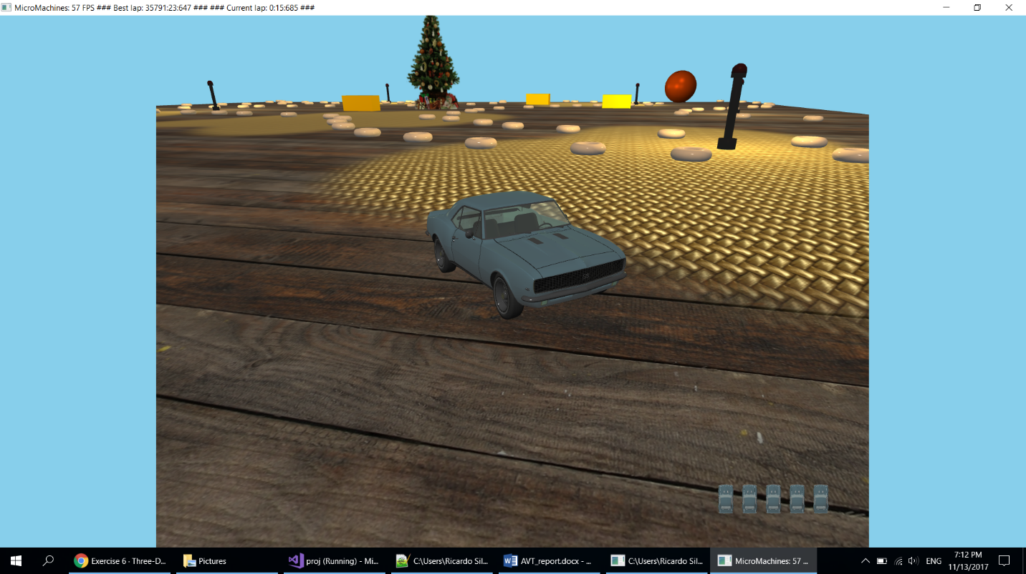

Project Report

Group 13:

78223 João Carvalho

78414 Ricardo Silva

78516 João Loureiro

# Introduction

The first part of the project was to implement the classic micro machines game where we control a car and drive around the track while avoiding obstacles and try to complete the laps as fast as possible. During this stage we implemented the movement of the objects, collisions, lighting and cameras.

The objective of the second part of the project was to implement six different techniques to improve the overall graphics of the application:

1. Stencil Test Based Effects
2. Transparent Objects
3. Fog
4. Particle Systems
5. 2D Lens Flare effect
6. Billboards

# Stencil Test

We used stencil testing to implement the reflection of the rear-view mirror inside the car.

## Method

To accomplish this goal, we used an extra camera located inside the car and oriented towards the road behind the car. First we render the scene as usual, then we render the mirror with the stencil testing active and finally we render the scene using the backwards camera.

## Results

|  |  |
| --- | --- |
|  |  |
| Fig. 1 – View from inside the car | Fig. 2 – View from inside the car |

# Translucid Objects

## Method

## Results

# 2D Lens Flare

## Method

## Results

# Billboards

We used billboards to draw the Christmas tree in the centre of the track and to draw the sun in the sky. We decided to implement true cylindrical billboards to achieve the best quality possible.

## Method

To draw the billboards we apply a texture to a plane that rotates according to the position of the camera.

## Results

|  |  |
| --- | --- |
|  |  |
| Fig. X – Sun Billboard Texture | Fig. X – Christmas Tree Billboard Texture |

# Particles

We used a particle system to implement a snowing effect. Each particle is a cross configuration billboard with a texture applied.

## Method

To implement the snowing effect, we used a particle system where each snowflake is a particle. The particles get spawned at a random position in the sky with a random velocity towards the ground and affected by gravity. When a particle reaches the ground it disappears and a new particle gets spawned in the sky.

## Results

|  |  |
| --- | --- |
|  |  |
|  |  |

# Fog

## Method

## Results

# Conclusion

We completed the project successfully and implemented the six required techniques. During the development of this project we acquired new skills and had the opportunity to learn more about modern OpenGL.