Stage 3 — DDPM-based Indoor Trajectory Refinement
Closing report · Two transitions:
(1) part-trajectory inpainting → full-trajectory refinement
(2) unconditional prior → observation-conditioned residual model
N = 200 evaluation trajectories · training seed = 42 · gaussian_medium training only · paired full-trajectory evaluation

§0 One-sentence principle
Every figure, table, and paragraph in this report is tied to one question: after correcting the task to full-trajectory refinement, does observation-conditioned diffusion give a more useful recovery interface than an unconditional prior?

§1 Task correction and hypothesis
I initially interpreted the Stage 3 task as part-trajectory, missing-segment recovery. In that version, each trajectory had only 20 frames and frames 4–12 were removed, while the start, the end, and both sides of the missing segment remained visible. That matters: linear interpolation can directly connect the boundary points, and many public pedestrian trajectories are close to straight motion or smooth turns. So the linear baseline was not just “simple”; the task itself handed it a very strong interface.
The unconditional DDPM had no missing mask, no endpoint constraint, and no explicit observed-context channel. Its loss against linear therefore became a negative diagnostic. I read it as a task-formulation signal, not as evidence that trajectory priors are useless. I then corrected the formulation to full-trajectory refinement: every frame may be affected by sensor-like error, and the output is a complete refined trajectory.
When the whole trajectory is corrupted by sensor-like errors, the central question becomes whether an observation-conditioned DDPM can provide a more accurate refinement interface than an unconditional trajectory prior.

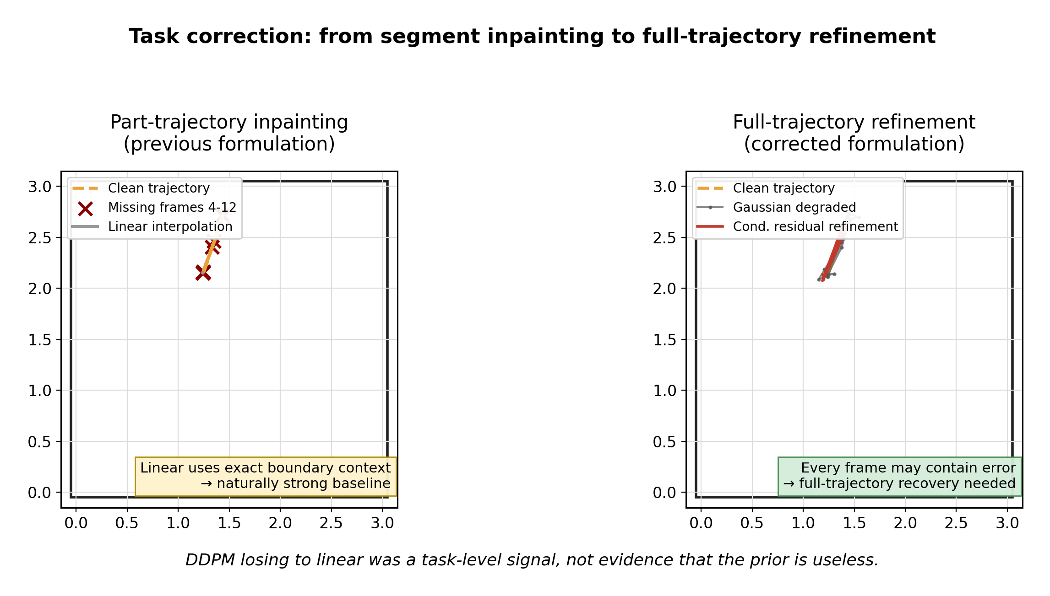
Fig. 01. Task correction using clean trajectory #0 and gaussian_medium degraded input. N=200 for the full report; this visual panel uses idx=0. Source: clean trajectories and cached checkpoint conditional output when available.
Table 1. Why linear was strong in the part-trajectory task.
Aspect | Part-trajectory task | Reason linear wins | Full-trajectory task
Task scope | Frames 4–12 missing (9/20) | Only need local bridge | All 20 frames degraded
Boundary info | Start/end + context preserved | Linear uses exact anchors | No clean anchors available
Trajectory shape | Often straight / smooth turn | Linear approximates well | Diverse with noise
DDPM interface | Unconditional, no mask/context | Cannot use boundaries | Conditioned on full observation
Baseline strength | Linear is near-optimal | Task favors geometry | Linear has no natural advantage
Conclusion | DDPM < linear | Task mismatch signal | Conditioning needed
The previous linear baseline was strong because the task itself exposed boundary context. This negative result motivated task correction rather than rejecting trajectory priors.

§2 Data and simulation environment
I use simulation here as a controlled proxy, not as a replacement for real sensor data. The current stage fixes the recovery-layer input: a synthetic clean trajectory is degraded into a coarse trajectory observation, and the refinement module is judged against the known clean reference. In a future raw-sensor setting, the front-end would change, but the recovery layer can still receive a trajectory-level coarse observation.

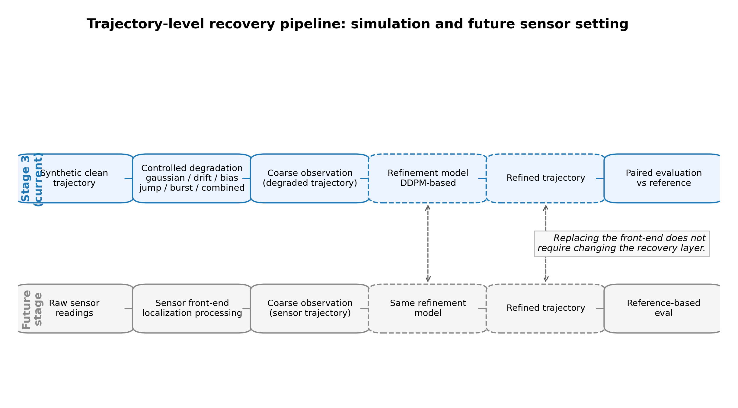
Fig. 02. Pipeline overview. Source: report schematic, not an experimental result. It clarifies why Stage 3 validates the recovery layer before a raw sensor front-end is introduced.
The synthetic indoor data are small on purpose: this is minimum controlled validation. The advantage is that every trajectory has a clean reference, and the degradation type is known. That lets me ask paired full-trajectory questions cleanly, instead of mixing recovery quality with sensor-front-end uncertainty.

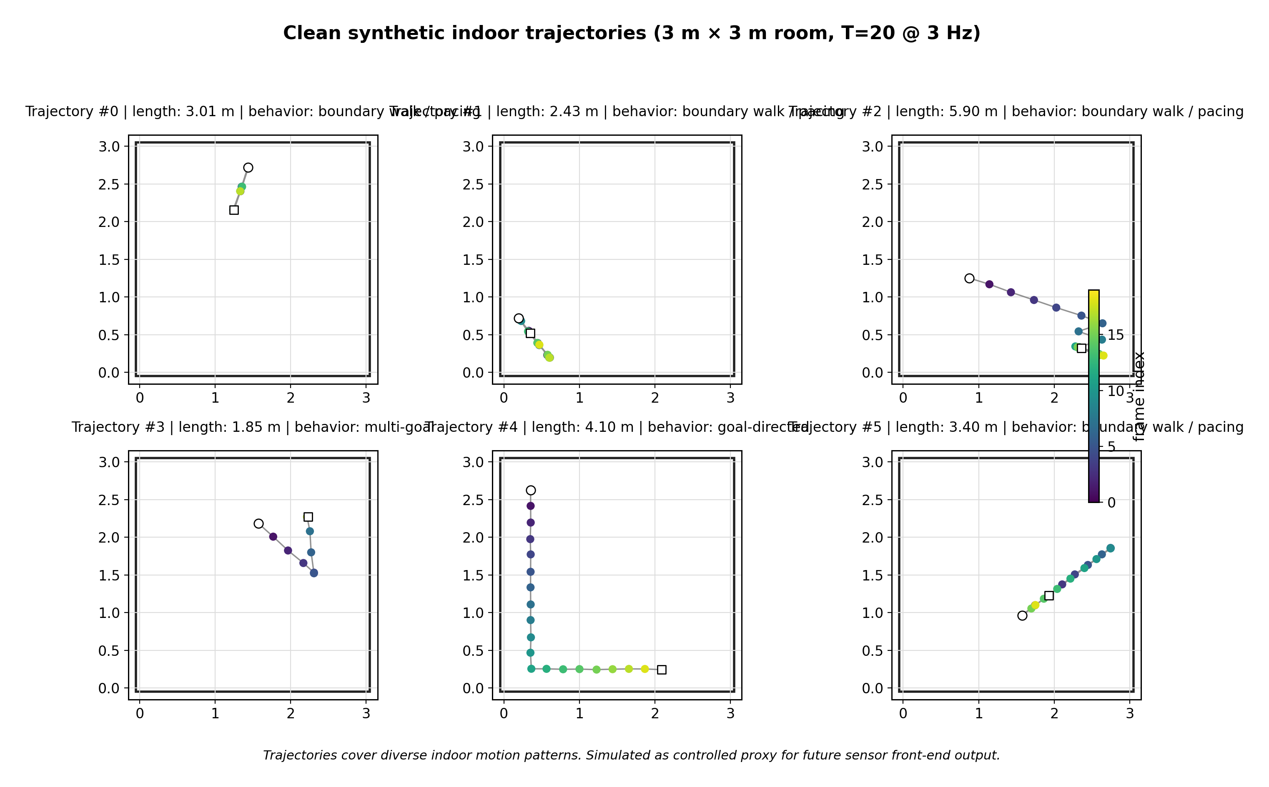
Fig. 03. Clean synthetic indoor trajectories. Source: clean_trajs.npy; N=200 evaluation subset, six fixed examples shown. Frame color indicates temporal order.
Table 2. Synthetic dataset and why controlled simulation is used.
Section | Item / Requirement | Value / ETH-UCY | Synthetic indoor / Future real sensor
Dataset summary | Room size | 3 m × 3 m
Dataset summary | Trajectory length | 20 frames
Dataset summary | Sampling rate | 3 Hz, approximately 6.7 s per trajectory
Dataset summary | Behavior patterns | goal-directed, multi-goal, pacing, near-stationary, boundary-walk
Dataset summary | Training set | 10,000 trajectories
Dataset summary | Validation set | 2,000 trajectories
Dataset summary | Evaluation set | 200 trajectories, fixed
Dataset summary | Relation to ETH/UCY | Independent re-training on indoor synthetic data
Why simulation first | Indoor room scale | weak / unavailable | yes, 3 m × 3 m / yes
Why simulation first | Clean reference available | yes, but not sensor-paired | yes / needs reference system
Why simulation first | Controlled degradation | no | yes / observed naturally
Why simulation first | Recovery-layer validation | limited | yes, current stage / final target
Synthetic data are used here for minimum controlled validation, not as a replacement for real sensor experiments.
The degradation spectrum is meant to mimic different kinds of sensor-front-end errors: frame-wise noise, cumulative drift, sparse jumps, local bursts, global bias, and their partial mixture. The key assumption is explicit: before real sensor data enter, controlled degradation is only a proxy for the trajectory produced by a localization front-end.

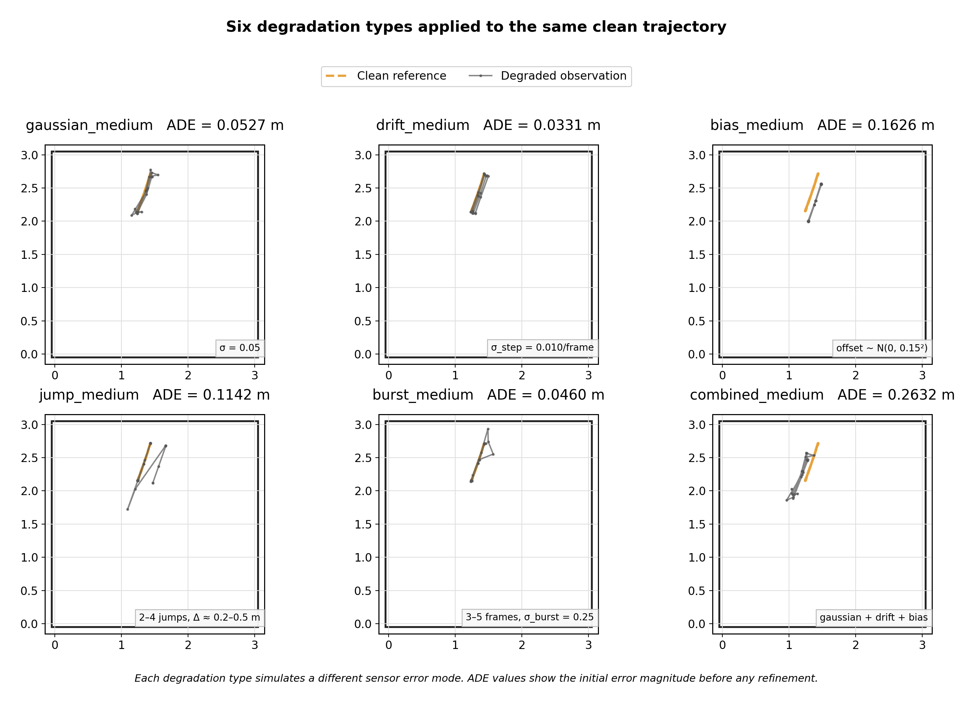
Fig. 04. Six degradation types on trajectory #0. Source: clean_trajs.npy and degraded_*_medium.npy files. N=200 evaluation subset; ADE in each title is computed only for the shown example before refinement.
Table 3. Degradation summary.
Degradation | Sensor error simulated | Parameter | Noisy ADE (m)
gaussian_medium | Frame-wise localization noise | σ = 0.05 | 0.0626
drift_medium | Temporal cumulative drift | σ_step = 0.010/frame | 0.0176
bias_medium | Global coordinate offset | offset ~ N(0, 0.15²) | 0.1890
jump_medium | Sudden localization shifts | 2–4 jumps, Δ = 0.2–0.5 m | 0.2634
burst_medium | Short-burst sensor failure | 3–5 frames, σ = 0.25 | 0.0748
combined_medium | Mixed errors | gaussian + drift + bias | 0.1991
Noisy ADE represents the initial error magnitude before any refinement. Values come from the real result CSV.

§3 Evaluation framework
The evaluation unit is one complete 20-frame trajectory. Each method receives the same degraded observation and is compared against the same clean reference, so the comparison is paired rather than an independent-sample comparison. I report ADE as the primary accuracy metric, while smoothness is a diagnostic: if smoothness improves while ADE worsens, the method is probably over-smoothing rather than recovering.
Table 4. Metric definitions.
Metric | Definition | Note
ADE | Mean Euclidean distance over all 20 frames | Primary accuracy metric
RMSE | Root mean squared frame-wise error | More sensitive to outliers
FDE | Euclidean error at final frame only | Endpoint recovery quality
smoothness | Mean ||p_{t+1}−2p_t+p_{t−1}|| over t=1..18 | Custom diagnostic. Lower = smoother motion. Can conflict with ADE if over-smoothed.
improved_fraction | Percentage of trajectories where method ADE < noisy_input ADE | Custom diagnostic. Shows how often method helps, not just average gain.
delta vs noisy | (method ADE − noisy ADE) / noisy ADE × 100% | Relative change from no-refinement baseline
paired test p-value | Paired statistical test on per-trajectory ADE differences | Tests if improvement is systematic. Small p does not imply large effect.
Custom metrics are defined explicitly here. Smoothness is reported alongside ADE; a lower smoothness score with worse ADE indicates over-smoothing.
Table 5. Evaluation protocol.
Item | Setting
Evaluation unit | One full 20-frame trajectory
Sample size | N = 200, fixed evaluation trajectories
Pairing | Each method sees identical degraded trajectories
Spread definition | ± std across evaluated trajectories, unless CSV states otherwise
DDPM inference seeds | Follow available CSV / provenance; do not assume per-frame averaging unless confirmed
Baselines | noisy_input, kalman_cv, uncond_sdedit_t2
Main method | cond_residual_t20
Statistical test | paired test p-value; Wilcoxon only if confirmed
The key evaluation object is a paired full-trajectory recovery instance: same reference, same degraded observation, different refinement interface.

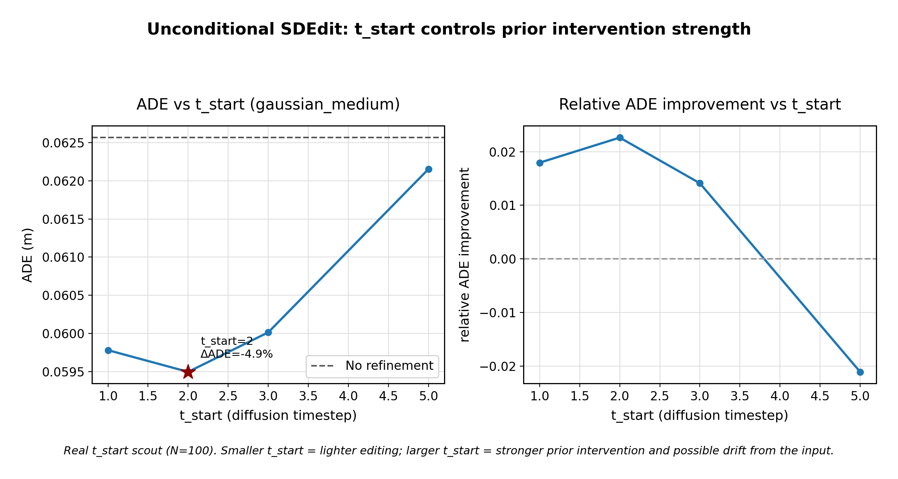
Fig. 06. t_start diagnostic for unconditional SDEdit. Source: sdedit_scout_results.csv where available; if the right-side aggregation is not directly reported, the figure is used only as explanatory visualization. Numeric claims in the report use CSV summary tables.

§4 Indoor DDPM prior
Stage 3 keeps the Stage 2 trajectory-only DDPM formulation, but it does not reuse ETH/UCY weights. The prior is retrained and checked on synthetic indoor trajectories. I use this check only to make sure the model is a plausible indoor-motion prior and can support denoising-style diagnostics. It is not, by itself, evidence that the model recovers sensor errors.

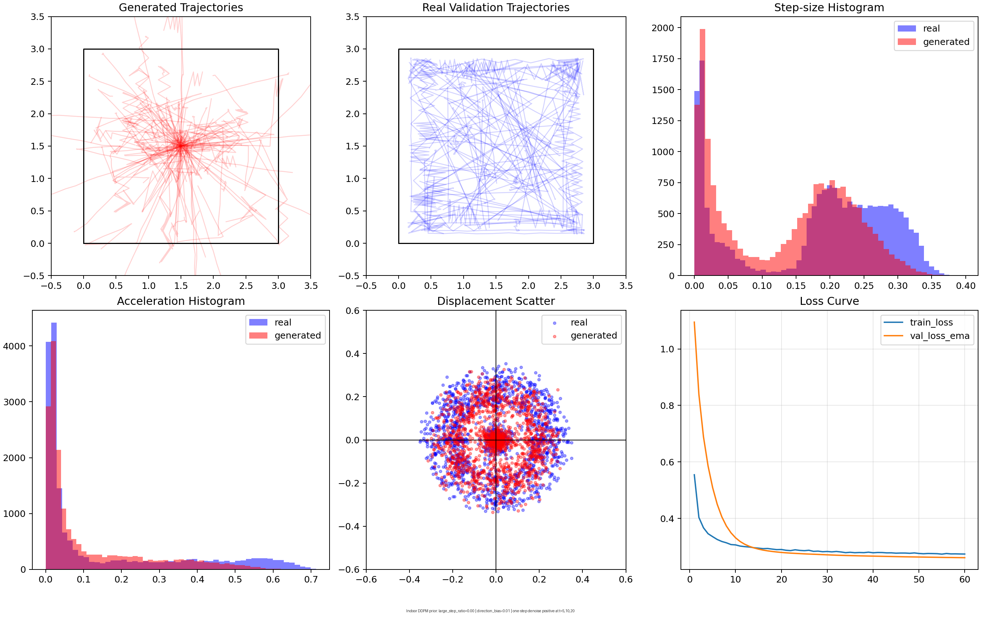
Fig. 05. Indoor DDPM prior sanity check. Source: sampling_check_v2.png when available. This is an internal quality check, not the final recovery evaluation.

§5 Unconditional SDEdit as diagnostic
SDEdit, following Meng et al. (ICLR 2022), starts from a degraded input, adds diffusion noise to a chosen timestep, and then denoises through the learned prior. The knob is t_start: too small means almost no edit; too large means the prior can override the input. That makes SDEdit a useful diagnostic for asking whether the learned indoor prior has recovery value without explicit observation conditioning.
The gaussian result suggests a small but systematic improvement. I read the small p-value as evidence that the effect is not just random noise, not as evidence that the effect is large. Kalman also gives a useful warning: it can make trajectories smoother while making ADE worse, so smoother does not automatically mean more accurate. The diagnostic indicates that the prior contains motion information, but the prior-only interface has a low ceiling.

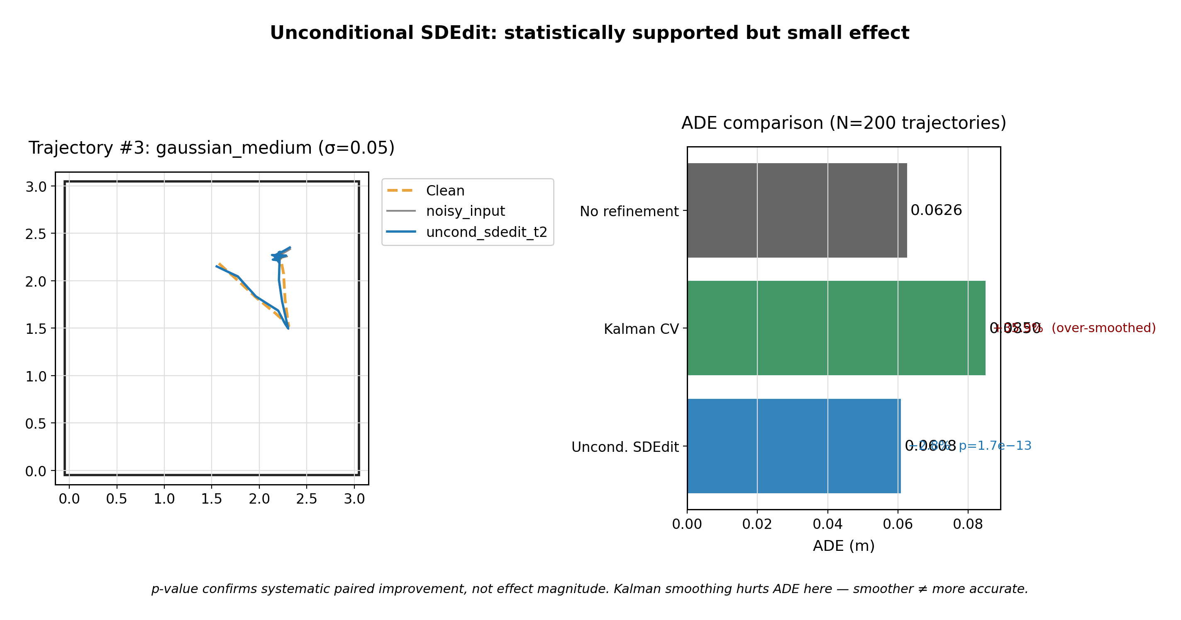
Fig. 07. Unconditional diagnostic under gaussian_medium. Source: gaussian result CSV for bars; trajectory panel uses clean/degraded arrays and cached checkpoint output when available. N=200 for bars, idx=3 for the visual panel.
Table 6. Unconditional SDEdit on gaussian_medium, N=200.
Method | ADE mean ± std | delta vs noisy | improved fraction | paired test p-value | smoothness
No refinement (noisy) | 0.0626 ± 0.0077 | +0.0% | 0.0% | not reported | 0.2319
Kalman CV | 0.0850 ± 0.0281 | +35.9% | 23.5% | 1.0000 | 0.1052
Uncond. SDEdit (t=2) | 0.0608 ± 0.0084 | -2.8% | 76.5% | 1.67e-13 | 0.2240
Spread is across evaluated trajectories unless the CSV states otherwise. The p-value reports systematic paired improvement, not effect magnitude. Kalman hurts ADE here because smoothing can violate short indoor motion dynamics.

§6 Conditional residual DDPM
The conditional residual model is not “just another model.” It is a direct response to the diagnostic above. Instead of asking the DDPM to generate a plausible trajectory from the prior, I give it the full degraded trajectory as the condition and ask it to learn the residual correction: where the observation is off, and by how much. The condition is not the clean target and not a ground-truth anchor; it is the same degraded observation that every method receives.
Under matched gaussian degradation, this interface matters. The conditional model makes a stronger mean ADE correction than unconditional SDEdit on the same evaluation set and same degraded observations. Its improved_fraction is not the whole story: a slightly lower fraction can still coexist with a larger mean gain if the successful corrections are larger. This supports conditioning as the clearest lever in the current framework, but only under the matched gaussian condition.

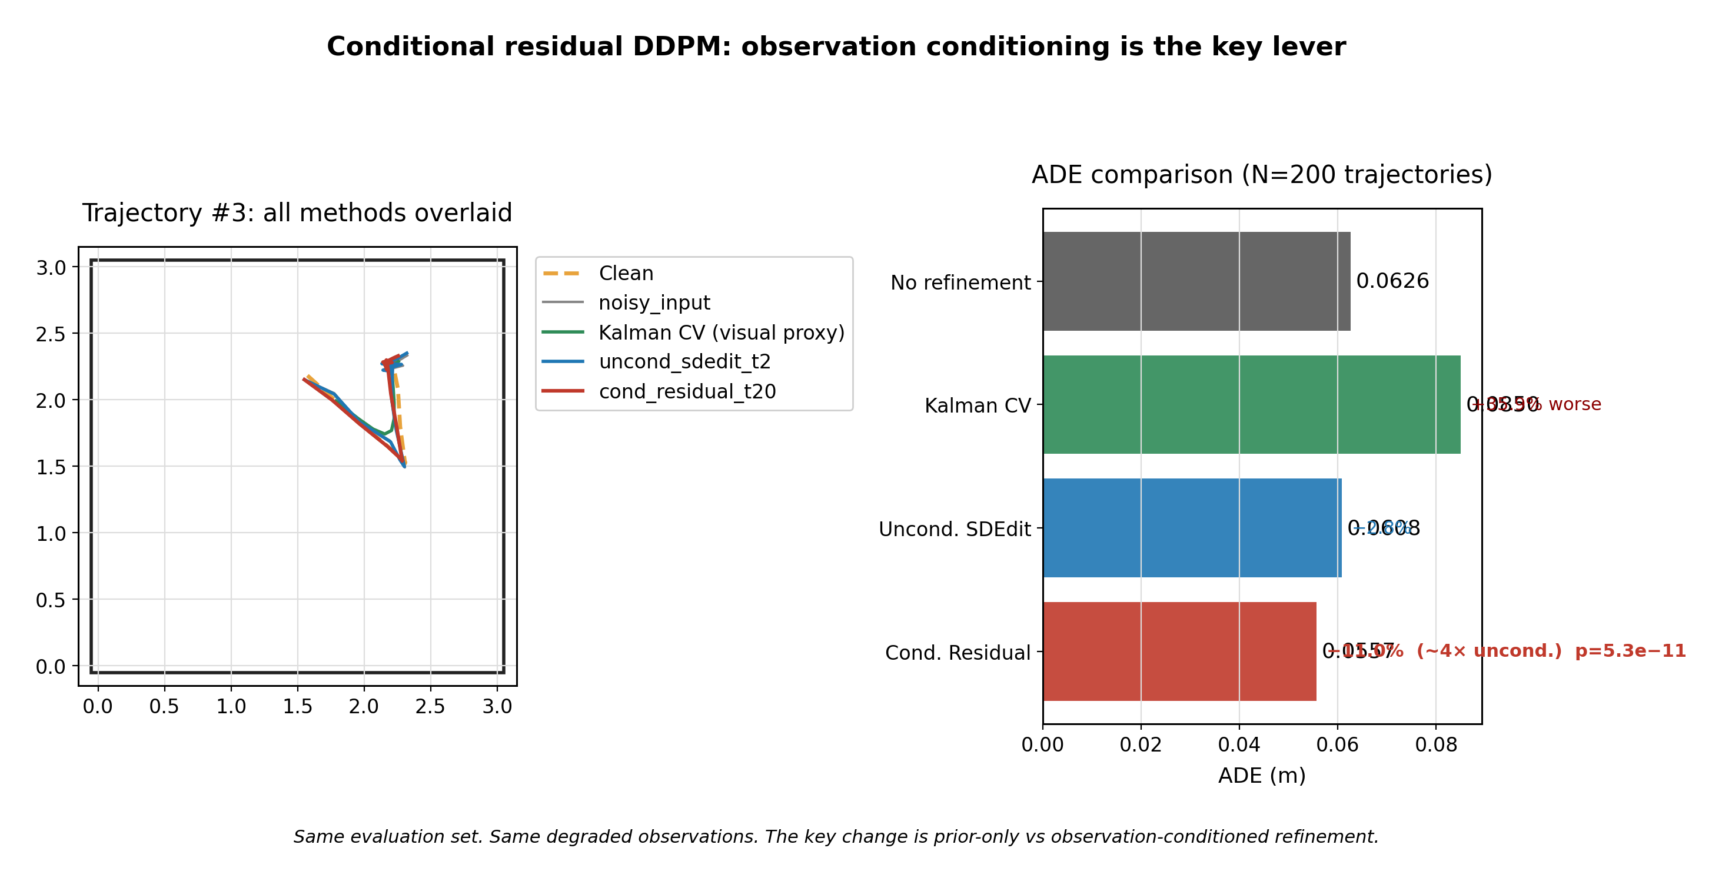
Fig. 08. Conditional comparison under gaussian_medium. Source: gaussian result CSV for bars; trajectory panel uses cached checkpoint outputs when available. Kalman trajectory is a Gaussian-smoothing visualization proxy; Kalman table values remain CSV-based.
Table 7. Unconditional vs conditional, gaussian_medium, N=200.
Method | ADE mean ± std | delta vs noisy | delta vs uncond | improved fraction | paired test p-value
No refinement (noisy) | 0.0626 ± 0.0077 | +0.0% | not reported | 0.0% | not reported
Uncond. SDEdit (t=2) | 0.0608 ± 0.0084 | -2.8% | 0.0000 | 76.5% | 1.67e-13
Cond. Residual (t=20) | 0.0557 ± 0.0162 | -11.0% | -0.0051 | 73.0% | 5.33e-11
The delta vs uncond column isolates the benefit of observation conditioning under the same evaluation set and degraded observations. Improved fraction and mean ADE should be read together.

§7 Generalization
The generalization heatmap is the closing diagnostic. Gaussian improves most clearly because it matches training. Jump shows positive transfer, likely because sparse large offsets have some overlap with extreme local correction behavior. Drift over-corrects: its starting error is already small, but the gaussian-trained model applies a correction scale that can push the trajectory away. Burst is a training mismatch: a few high-noise frames are not the same as uniform gaussian residual noise. Bias is different again, because a constant absolute offset is weakly represented, or nearly invisible, in relative displacement space. Combined errors show that one gaussian-trained conditional model is not degradation-aware enough.
These failures are not the same failure repeated six times. They indicate distinct design gaps: training mismatch, over-correction, representation limit, and insufficient degradation awareness.

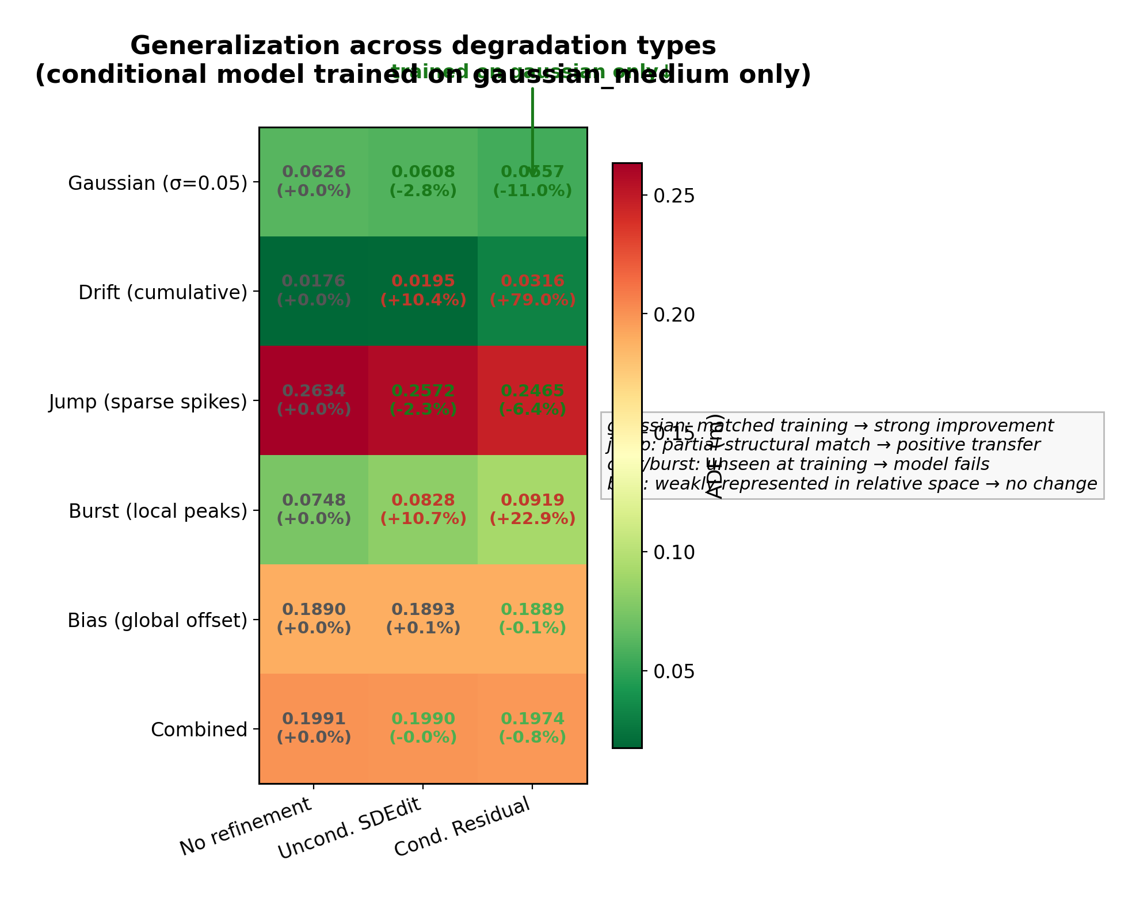
Fig. 09. Generalization heatmap. Source: generalization_summary.csv. N=200; values are ADE means from the CSV. If a method is absent in the CSV, it is not synthesized into the table or heatmap.
Table 8. Full generalization matrix: conditional model trained on gaussian_medium only, N=200.
Degradation | Noisy ADE | Uncond delta | Cond delta | Cond p-value | Interpretation
gaussian_medium | 0.0626 | -0.0018 | -0.0069 | 5.33e-11 | weak / no change
drift_medium | 0.0176 | 0.0018 | 0.0139 | 1.0000 | over-correction
jump_medium | 0.2634 | -0.0062 | -0.0168 | 2.40e-14 | systematic improvement
burst_medium | 0.0748 | 0.0080 | 0.0171 | 1.0000 | training mismatch
bias_medium | 0.1890 | 0.0003 | -0.0001 | 0.4399 | representation limit, relative space
combined_medium | 0.1991 | -0.0001 | -0.0016 | 0.2317 | weak / no change
Cond delta = conditional ADE − noisy ADE. Negative means improvement. The model is trained on gaussian_medium only; failures have distinct structural mechanisms discussed in the text.

§8 Representative cases
The case grid is intentionally visual. The gaussian success case shows a reasonable correction direction under the matched condition. The jump case shows that partial structural transfer is possible. The drift case shows over-correction: the model can push a trajectory that starts with small error into a worse direction. That is not random noise; it is a visible mechanism.

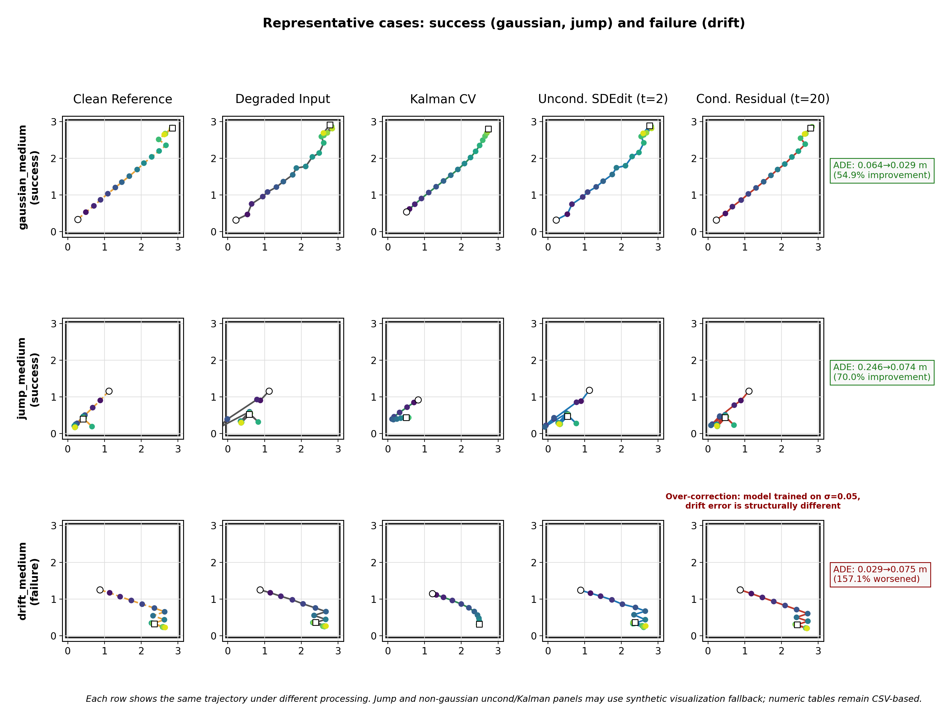
Fig. 10. Representative success and failure cases. Source: clean/degraded arrays, per-trajectory CSV for case selection when available, cached checkpoint outputs for gaussian/drift conditional where available. Some missing method outputs are SYNTHETIC VISUALIZATION ONLY and are not used for numeric tables.

§9 Discussion and closure
The hypothesis is supported with caveats. Under matched gaussian degradation, observation-conditioned DDPM is more accurate than the unconditional prior interface. The gain is real but modest in physical scale, so I would describe it as proof of concept rather than a solved localization system. The unconditional SDEdit result is still valuable: it located the prior-only ceiling and motivated the interface change.
The cross-degradation results are what close Stage 3. Continuing to tune t_start or adding more seeds within the same gaussian-only, relative-residual framework is unlikely to change the structural boundaries. Bias is a representation limitation, burst is a training-distribution mismatch, drift is over-correction, and combined errors require more awareness than the current formulation has. So Stage 3 closes as a controlled recovery-layer study, not as a universal indoor localization result.
Table 9. Claim boundary of the Stage 3 closing report.
Established by this stage | Not established
Part-trajectory task was mismatched, and the failure against linear was a task-level signal | DDPM solves real indoor localization
Synthetic degradation can proxy sensor front-end output under a stated assumption | Raw sensor-to-position pipeline is complete
Paired full-trajectory evaluation framework is functional | Current model handles all sensor error types
Unconditional prior alone is under-constrained | Gaussian-only model generalizes universally
Observation conditioning is the key lever in this framework | Small-scale controlled validation equals final benchmark
Failure modes have distinct structural causes | These failures are fixed in the current framework
This boundary is the reason I treat the report as a closing document for Stage 3 rather than as an opening for more tuning inside the same framework.
Conditioning is the lever. Stage 3 closes at the plateau of the current framework.

References
Meng et al. SDEdit: Guided Image Synthesis and Editing with Stochastic Differential Equations, ICLR 2022.
Tariq et al. Neural Networks for Indoor Human Activity Reconstructions, IEEE Sensors Journal, 2020.
Tariq et al. Neural Networks for Indoor Person Tracking With Infrared Sensors, IEEE Sensors Letters, 2021.

