Stage 3 — DDPM-based Indoor Trajectory Refinement
Closing report. Two transitions: (1) local → global recovery, (2) unconditional → conditional inference.
N = 200 trajectories | DDPM inference seeds = 5 | training seed = 42 | room = 3 m × 3 m | T = 20 frames @ 3 Hz
§0 Core principle
Every figure, table, and discussion paragraph answers the Stage 3 hypothesis: whether DDPM can refine globally degraded indoor trajectories, and under which degradation mechanisms it stops helping.
§1 Hypothesis
§1.1 The hypothesis is that DDPM can act as a controlled refinement prior for globally degraded indoor trajectories, but only when the degradation mechanism is visible in the representation used by the model.
§1.2 The original local-recovery framing was too close to local inpainting and did not match the professor's requirement to simulate indoor sensor-like trajectory outputs. Stage 3 is therefore reframed as global trajectory refinement: every frame may be degraded, and the output is a full refined trajectory.
§1.3 Unconditional SDEdit is not treated as a discarded failed method. It is used as a diagnostic baseline: its weak but statistically supported improvement shows that the DDPM prior learned useful indoor motion structure. The small effect size then motivates the conditional residual formulation, where the degraded trajectory must be visible during denoising.
Before discussing refinement, the report first shows what the simulated indoor trajectories look like.

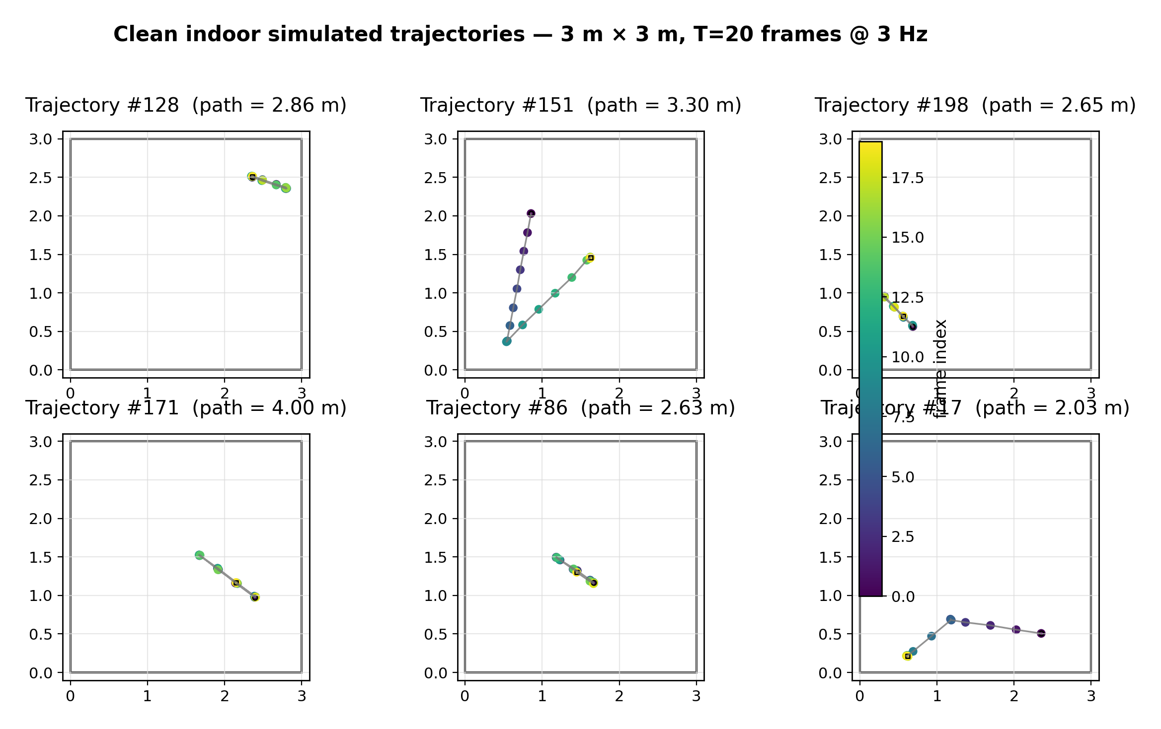
Figure 1. Clean indoor simulated trajectories. N=200 context; six panels selected with seed=42 from clean_trajs.npy.
§2 Method rationale
DDPM is not used as a standalone trajectory generator. Its useful role is tested as a refinement model. Unconditional SDEdit asks the prior to move a degraded trajectory toward the learned motion manifold, while conditional residual DDPM changes the task: given the degraded observation, predict only a local residual correction.
This transition is necessary because trajectory refinement is observation-dependent. A plausible trajectory is not necessarily the correct refinement of the current degraded trajectory. noisy_input tests whether any method helps beyond doing nothing; kalman_cv is a classical smoothing baseline; unconditional SDEdit tests whether the learned prior alone helps; conditional residual DDPM tests whether observation conditioning is the missing lever.

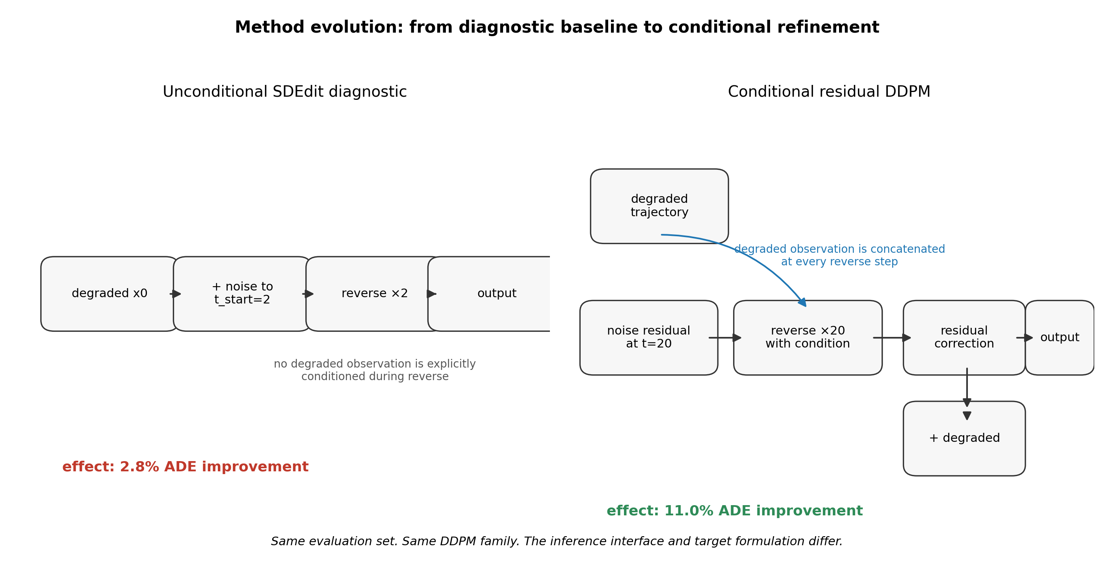
Figure 3. Method evolution from unconditional diagnostic to conditional residual refinement. N=200 effect sizes; DDPM inference seeds=[42,43,44,45,46].
§3 Setup
§3.1 Data. The input file is clean_trajs.npy with shape (2000,20,2); evaluation uses the first 200 trajectories. The room is 3 m × 3 m, T=20 frames, sampled at 3 Hz.
§3.2 Degradation spectrum. The six tested degradations are gaussian_medium, drift_medium, jump_medium, burst_medium, bias_medium, and combined_medium. They simulate global sensor-like outputs rather than a missing local span.

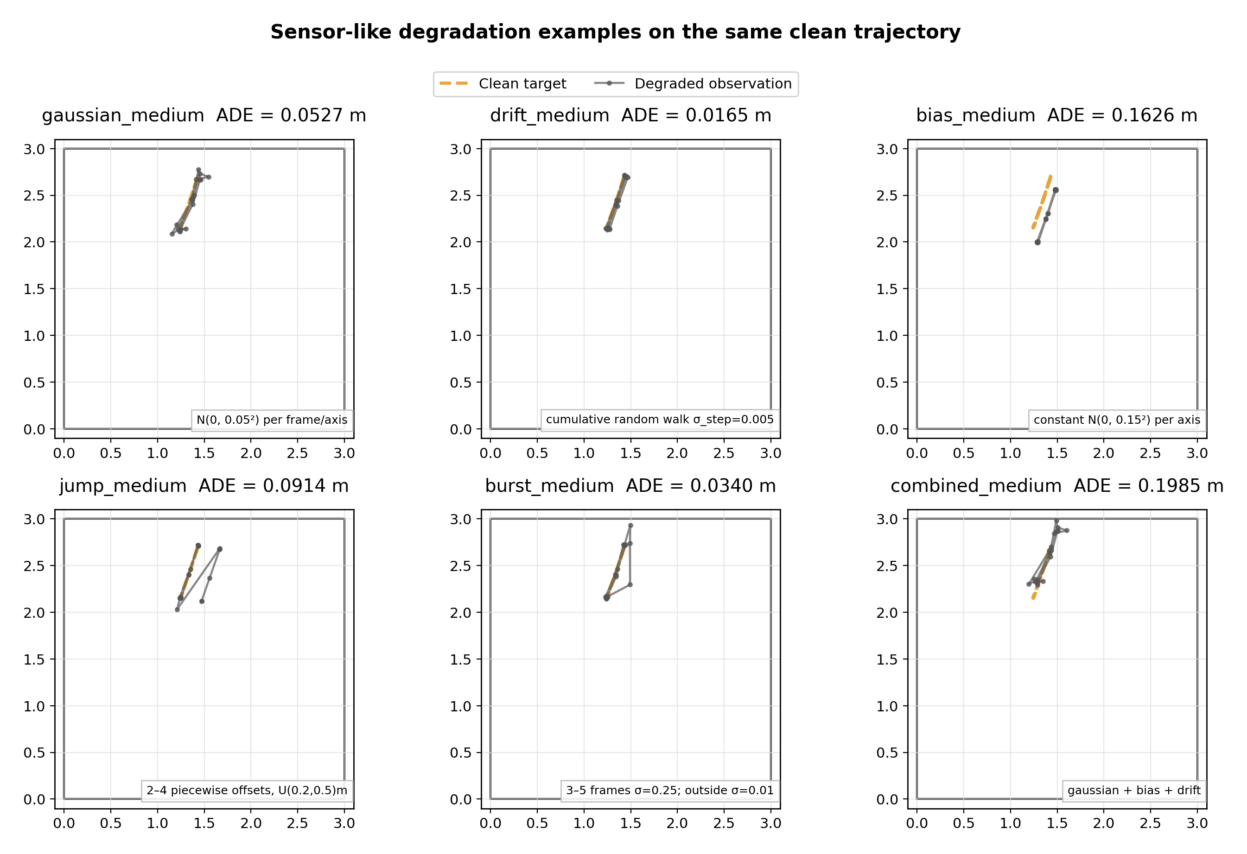
Figure 2. Six deterministic degradation examples on trajectory #0. N=200 context; degradation seeds use 42+idx.
§3.3 Representation. The model works in relative displacement, rel[t] = abs[t+1] − abs[t], normalized with rel_norm_params_v2.npz. This makes local motion corrections tractable, but it also hides constant absolute bias.
§3.4 Evaluation. N=200 trajectories are evaluated. DDPM uses 5 inference seeds, averaged before metric computation; std is across trajectories. Wilcoxon is a one-sided paired test for method ADE < noisy_input ADE.

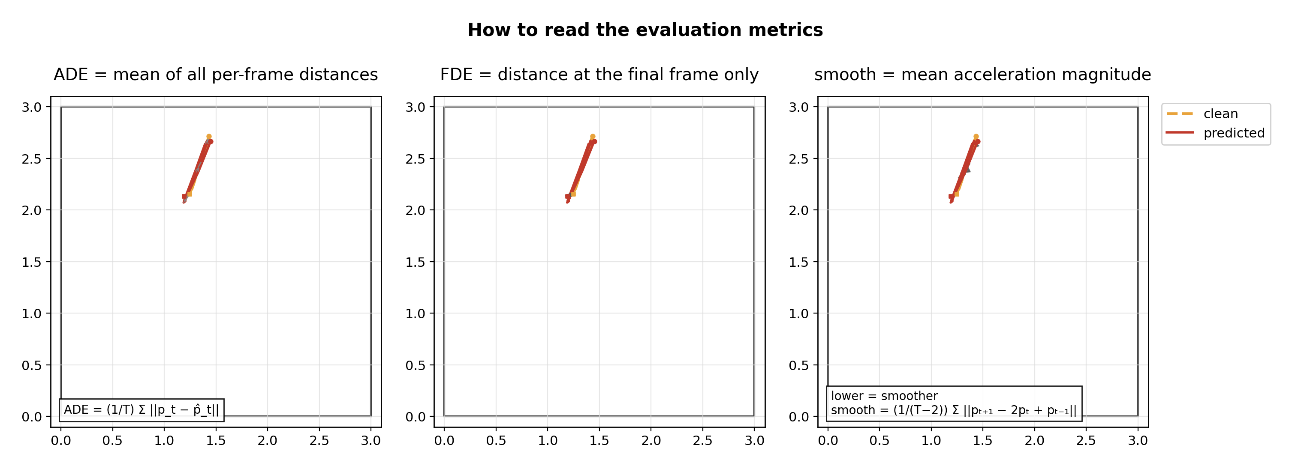
Figure 4. Metric explanation for ADE, FDE, and smooth. Example uses clean idx=0 and cached conditional output.
§3.5 Geometry role. Room geometry is used for visualization and interpretation only; it is not used in training, conditioning, loss, sampling, or rejection.
Table 3. Glossary (terms marked 'my own' are project-specific definitions).
term | definition
ADE | Average Displacement Error. Mean Euclidean distance between predicted and clean positions over all frames of a trajectory.
RMSE | Root Mean Squared Error. Square root of the mean squared Euclidean position error over all frames.
FDE | Final Displacement Error. Euclidean distance between predicted and clean positions at the final frame.
smooth (my own) | Mean magnitude of the second-order finite difference of the trajectory. Lower values indicate smoother local motion, but lower is not always better if the method over-smooths real movement.
improved_fraction (my own) | Fraction of trajectories for which a method has lower ADE than noisy_input.
spread | Standard deviation across the 200 evaluated trajectories. DDPM inference seeds are averaged before metric computation.
residual (in relative normalized space) | The correction term added to degraded relative displacement after normalization. The conditional DDPM predicts this residual rather than the full clean trajectory.
t_start (SDEdit) | The diffusion timestep at which noise is injected before reverse denoising starts. Larger t_start means stronger prior intervention.
oracle t_start (my own) | A diagnostic upper-bound setting where the best t_start is selected after observing evaluation performance. It is not a deployable inference rule unless selected on validation data.
Conditional residual DDPM | A DDPM refinement model that receives degraded relative displacement as a condition and predicts a residual correction through the reverse diffusion process.
EMA decay | Exponential moving average decay used to maintain a smoothed copy of model weights for evaluation.
Definitions used in captions, tables, and metric descriptions.
§4 Results
§4.1 Gaussian-medium main result. Conditional residual DDPM reduces ADE from 0.0626 m to 0.0557 m, an absolute reduction of 6.9 mm and an 11.0% relative improvement (p=5.3e−11). This is millimeter-scale but statistically stable.

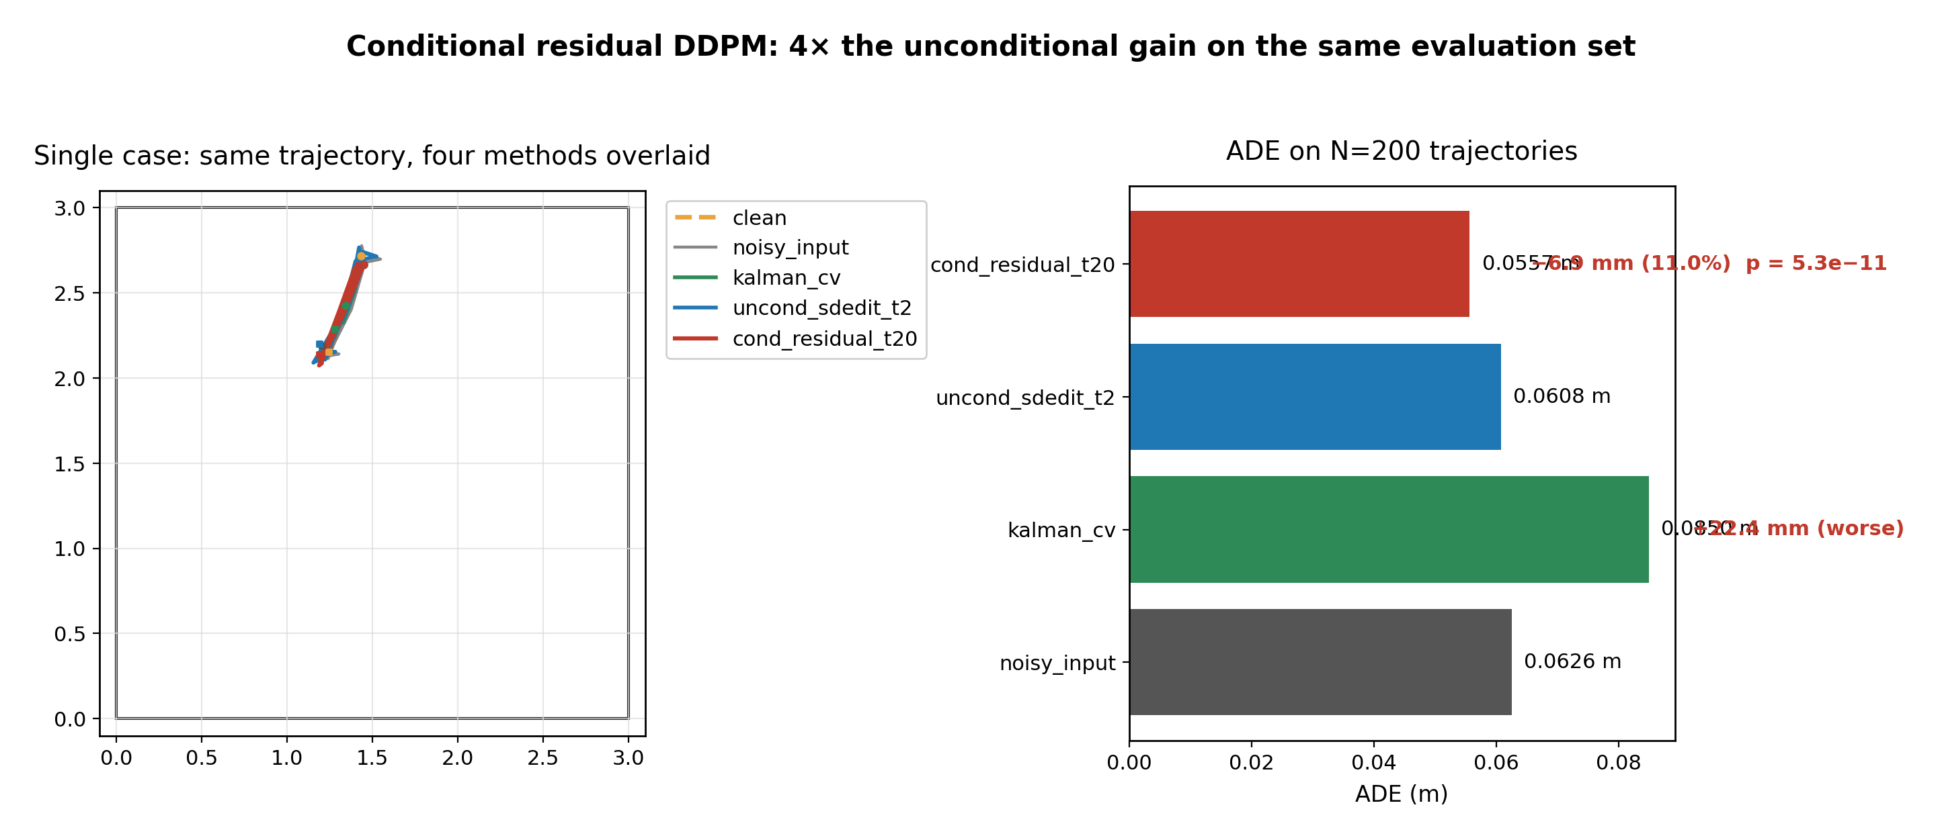
Figure 6. Conditional gaussian success. N=200; bars from summary CSV; trajectory panel uses checkpoint cache and idx=0.
Table 1. Method comparison under gaussian_medium (N = 200, 5 inference seeds for DDPM).
method | ADE_mean | ADE_std | delta_vs_noisy_pct | improved_fraction | wilcoxon_p | smooth_mean
noisy_input | 0.0626 | 0.0077 | 0.0000 | 0.0000 | — | 0.2319
kalman_cv | 0.0850 | 0.0281 | 35.8580 | 0.2350 | 1.0000 | 0.1052
uncond_sdedit_t2 | 0.0608 | 0.0084 | -2.8046 | 0.7650 | 0.0000 | 0.2240
cond_residual_t20 | 0.0557 | 0.0162 | -10.9822 | 0.7300 | 0.0000 | 0.1620
Spread (± std) is across 200 trajectories. Δ vs noisy is relative ADE change. Wilcoxon p is a one-sided paired test for method ADE < noisy_input ADE.
§4.2 Generalization. Gaussian and jump improve; drift and burst worsen; bias is representation-limited; combined shows no significant change. Generalization is therefore partial, not universal.

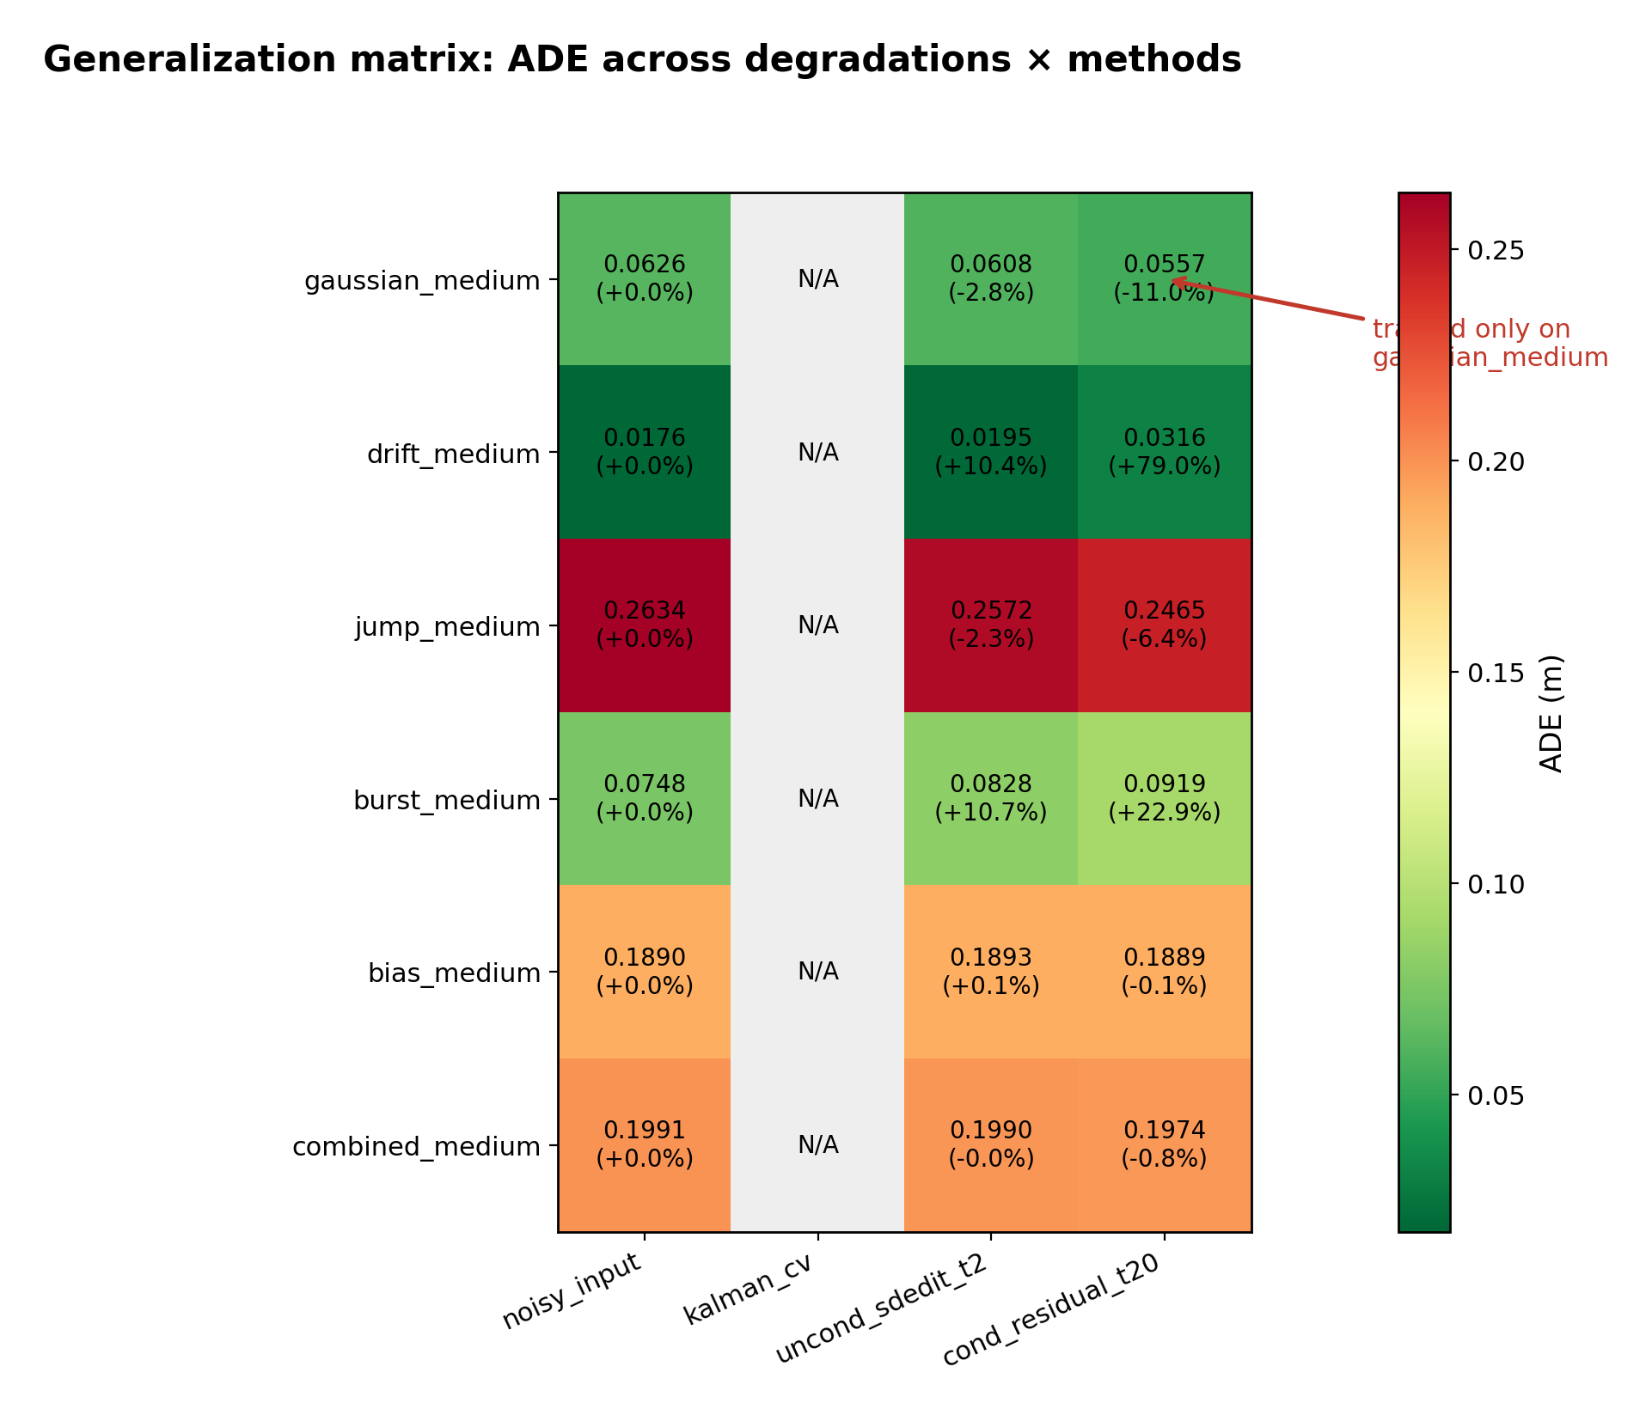
Figure 7. Generalization heatmap. N=200; no official kalman generalization statistics are present, so kalman is marked N/A.
Table 2. Generalization matrix (N = 200, gaussian-only-trained conditional model).
degradation | noisy_input_ADE | kalman_cv_ADE | uncond_sdedit_ADE | cond_residual_ADE | cond_delta_vs_noisy | cond_p_vs_noisy | interpretation
gaussian_medium | 0.0626 | N/A | 0.0608 | 0.0557 | -0.0069 | 0.0000 | sig. improvement
drift_medium | 0.0176 | N/A | 0.0195 | 0.0316 | 0.0139 | 1.0000 | over-correction
jump_medium | 0.2634 | N/A | 0.2572 | 0.2465 | -0.0168 | 0.0000 | sig. improvement
burst_medium | 0.0748 | N/A | 0.0828 | 0.0919 | 0.0171 | 1.0000 | training mismatch
bias_medium | 0.1890 | N/A | 0.1893 | 0.1889 | -0.0001 | 0.4399 | no change (relative-space limit)
combined_medium | 0.1991 | N/A | 0.1990 | 0.1974 | -0.0016 | 0.2317 | no significant change
The conditional residual model was trained on gaussian_medium only. Bias is marked as a representation limit because constant absolute offset is cancelled by relative displacement.
§4.3 Unconditional vs conditional. Unconditional SDEdit improves gaussian ADE by only 2.8%, while conditional residual improves by 11.0%. This fourfold gap shows conditioning is the lever, not simply making the prior smoother.

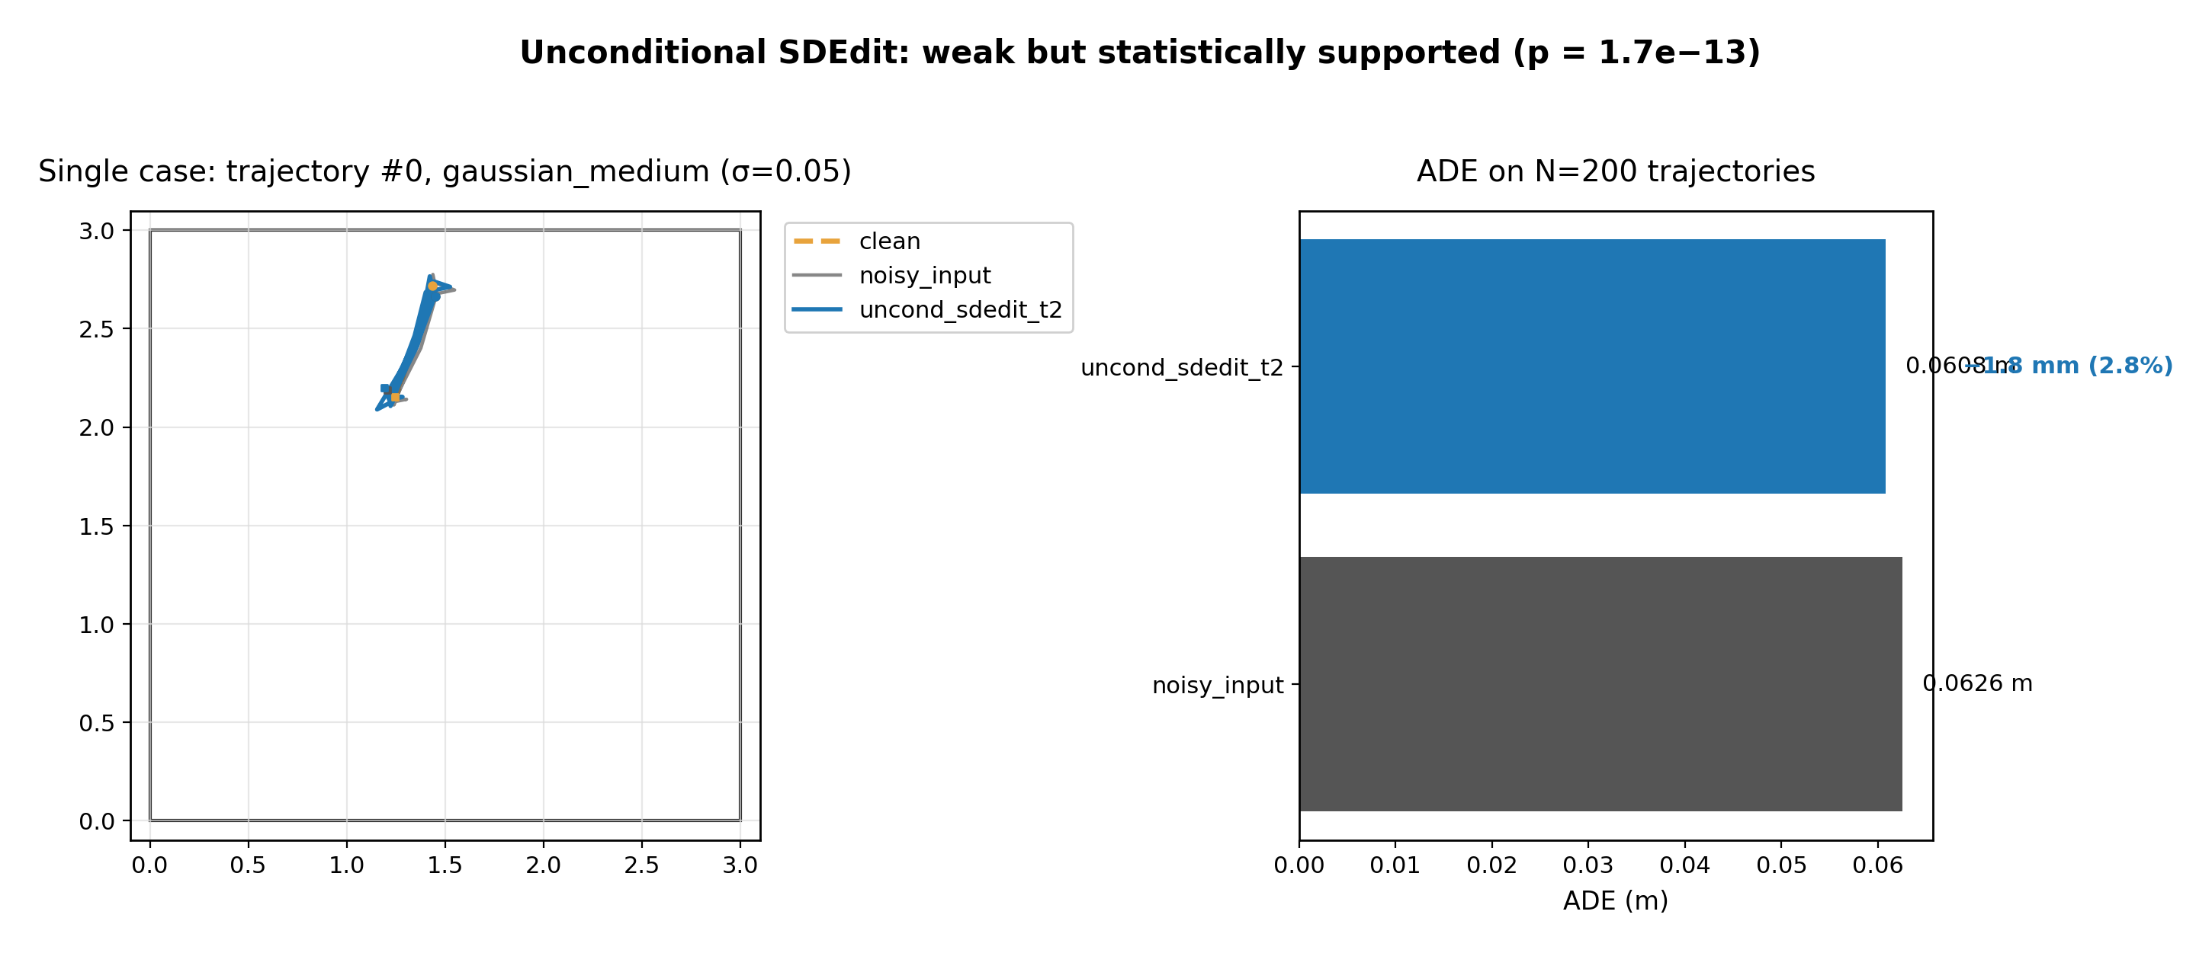
Figure 5. Unconditional diagnostic. N=200; checkpoint-generated SDEdit cache averaged over seeds=[42,43,44,45,46].
§4.4 What pushing further looked like:
- Larger t_start increased prior intervention but often worsened ADE.
- More inference seeds stabilized estimates but did not change failure mechanisms.
- Normalization and data augmentation fixed large-step instability but did not solve observation conditioning.
§5 Discussion
§5.1 The result supports the hypothesis, but with caveats. DDPM is effective as a conditional residual refiner for some relative-observable degradations. It is not a universal restoration model.
§5.2 Failure modes separate into mechanisms. Drift is weak, but the gaussian-trained model over-corrects. Burst is outside the gaussian-only training distribution. Bias is invisible because constant absolute offset cancels in relative displacement.

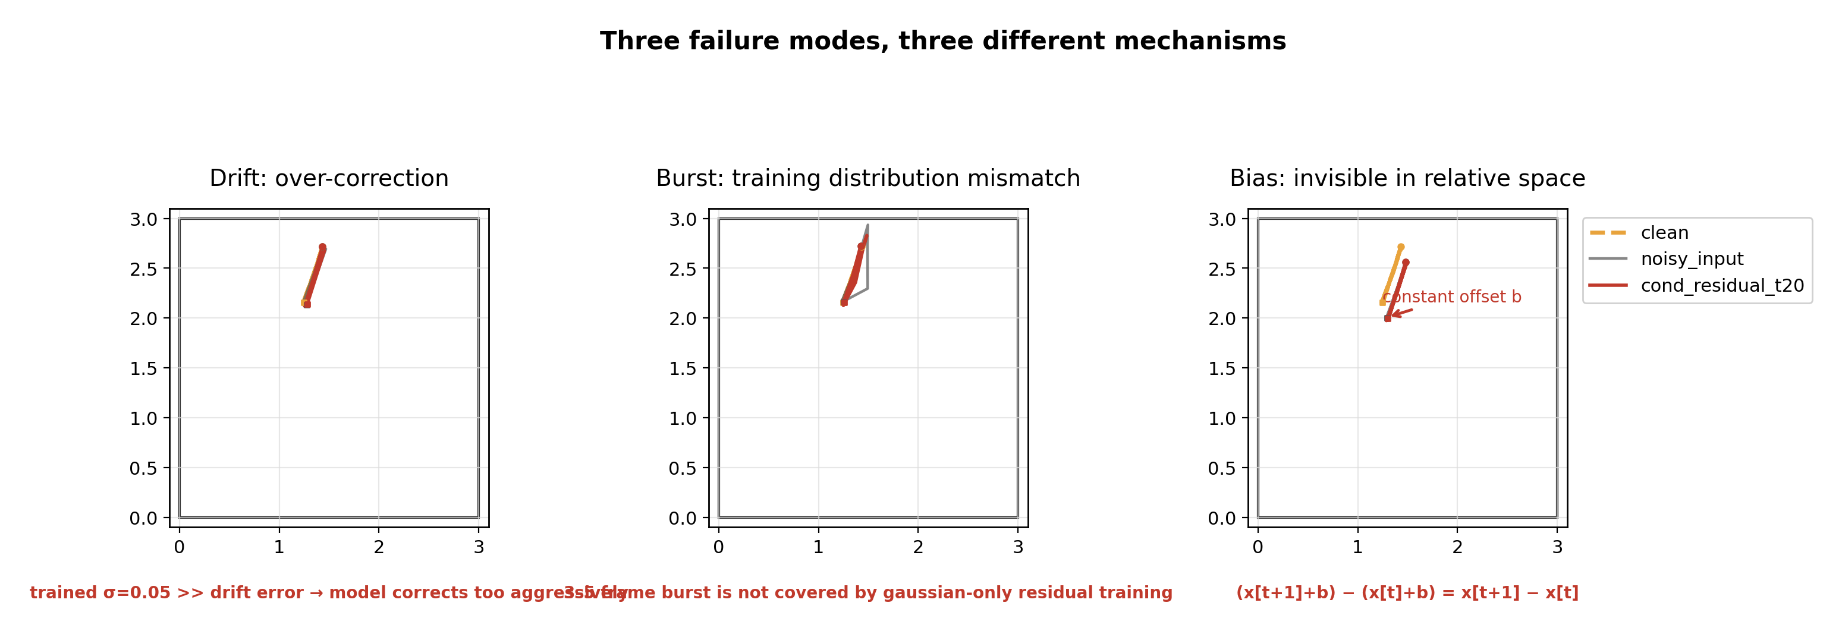
Figure 8. Failure modes. N=200 context; panels use idx=0 and checkpoint-generated conditional cache.
§5.3 The conditioning gap is interface-level. The prior can encode plausible motion, but refinement needs the degraded observation to select the correct correction.
§6 Stage 3 closure
Established:
- global indoor simulated degradation pipeline
- indoor DDPM prior diagnostic
- unconditional SDEdit weak baseline
- conditional residual DDPM positive gaussian result
- partial generalization boundary
- representation limitation for bias
Not established:
- universal DDPM improvement
- bias correction in relative displacement space
- geometry-aware reconstruction
- mixed-degradation robustness
Stage 3 closes here because additional tuning within the same gaussian-only relative-residual framework is unlikely to change the structural limitations. The next stage should start from a new hypothesis rather than adding more components to the current one.
Conditional residual DDPM refines globally degraded indoor trajectories at the millimeter scale; conditioning is the actual lever; remaining limits are structural; Stage 3 is closed at the plateau of the current framework.

