Stage 3: Controlled Evaluation of Conditional DDPM Refinement
for Indoor Sensor-Degraded Trajectories
Stage 3 Experiment Report — May 2026

Contribution Summary
This report makes three contributions:
1. It shows that unconditional DDPM-SDEdit provides only weak refinement (2.8% ADE improvement) under Gaussian-like sensor degradation, identifying the inference interface—not the trajectory prior—as the primary bottleneck.
2. It demonstrates that conditional residual DDPM, where the degraded trajectory is explicitly provided as a condition and the model learns a displacement correction, substantially improves Gaussian refinement (11.0% ADE, p = 5.3×10⁻¹¹) and outperforms unconditional SDEdit (p = 6.7×10⁻⁸).
3. It identifies the boundary of the method: partial generalization to jump-like corruption, failure under burst and weak drift, and structural inability to correct constant absolute bias in relative displacement space.

Stage 2 to Stage 3 Transition
Stage 2 established the trajectory DDPM prior pipeline: relative displacement representation, 1D temporal denoiser architecture, DDPM training and sampling procedures, and a public pedestrian trajectory prior trained on ETH/UCY data. Stage 3 moves from public trajectory prior learning to controlled indoor sensor-degradation refinement. The goal is no longer unconditional generation quality, but whether a DDPM-based prior can improve degraded indoor trajectories under known, controlled corruptions.
The indoor simulated trajectories used in Stage 3 are generated independently of ETH/UCY. The DDPM architecture and training pipeline carry over from Stage 2, but the model is retrained from scratch on indoor data. This separation ensures that Stage 3 results reflect indoor-specific learning rather than transfer from outdoor pedestrian priors.

1. Hypothesis
Primary Hypothesis:
A DDPM trained on indoor simulated trajectories, when conditioned on degraded sensor observations and formulated as residual correction in relative displacement space, can improve trajectory reconstruction accuracy beyond both unprocessed sensor output and unconditional DDPM refinement.
Secondary Hypothesis:
The effectiveness of this refinement is bounded by whether the degradation component is observable in the relative displacement representation. Constant absolute bias, which cancels in the frame-to-frame difference, should be unobservable and therefore uncorrectable by the current model.
Theoretical rationale:
DDPM learns the distribution of clean indoor motion patterns. When a degraded trajectory is provided as a condition, the model only needs to predict the residual correction (clean − degraded in relative displacement space), reducing the search space from all possible trajectories to small corrections near the observation. This coarse-to-fine refinement approach is motivated by the broader literature on conditional diffusion for trajectory recovery and sensor denoising, where observation-conditioned inference consistently outperforms unconditional generation.

2. Method Selection Rationale

2.1 Why DDPM
Trajectory refinement can benefit from a learned motion prior that captures the full distribution of plausible indoor movements (straight walks, turns, pauses, boundary following), rather than relying on hand-crafted assumptions like constant velocity. Recent work on diffusion models for trajectory-related tasks—including sparse trajectory recovery, GPS denoising, and coarse-to-fine trajectory planning—has demonstrated the viability of DDPM in both outdoor and indoor settings.

2.2 Why conditional residual formulation
Unconditional SDEdit was tested first and showed only 2.8% ADE improvement under Gaussian noise (§4.3). The bottleneck was identified as lack of observation constraint: the model could not see the degraded trajectory during inference. By concatenating the degraded trajectory as a condition channel and learning the residual correction, the model task changes from trajectory generation to trajectory correction. This is both easier to learn (smaller search space) and better aligned with the sensor refinement goal.

2.3 Baselines
noisy_input: No-processing baseline representing the degraded sensor trajectory as-is.
kalman_cv: Fixed classical model-based filtering baseline. Constant-velocity RTS Kalman smoother with fixed parameters (process_noise=0.01, obs_noise=0.05). Kalman parameters were not optimized for this dataset; the configuration serves as a fixed canonical reference point.
unconditional SDEdit (t=2): Tests whether an unconditional DDPM prior alone can refine trajectories without seeing the degraded observation. Isolates the contribution of conditioning.

2.4 Known limitations
(a) The model operates in relative displacement space, making constant absolute bias structurally unobservable. (b) The conditional model was trained only on Gaussian noise; generalization is tested but not guaranteed. (c) Trajectories are simulated, not from real sensors (see §8 for justification). (d) Room geometry constraints are not enforced. (e) Single model training seed (seed=42); multi-seed robustness not evaluated.
Room geometry constraints are not enforced at any pipeline stage: training (no), conditioning (no), loss (no), sampling (no), evaluation (no). Trajectories that exit the 3m × 3m room are not clipped during evaluation.

3. Experimental Setup

3.1 Data
Clean trajectories: 2,000 simulated indoor trajectories in a 3m × 3m room, 20 frames at 3 Hz (~6.7s per trajectory). Five behavior types: goal-directed (40%), multi-goal (25%), pacing (15%), stationary (10%), boundary-walk (10%). Mean step size 0.178 m/frame, mean speed 0.535 m/s. The 3m × 3m room size and 3 Hz sampling rate are consistent with existing indoor person tracking studies using low-resolution sensor arrays.
Training: 10,000 trajectories expanded to 60,000 via 6-fold geometric augmentation (x/y mirror, xy mirror, 90°/270° rotation around room center). Validation: 2,000 trajectories (no augmentation).

3.2 Degradation types
Six degradation types, all applied per-frame to simulate sensor-level corruption:
gaussian_medium: N(0, 0.05²) per frame per axis. Simulates ~5cm sensor jitter.
bias_medium: Constant offset ~ N(0, 0.15²) per axis per trajectory. Simulates calibration error.
drift_medium: Cumulative random walk, σ_step=0.005 per axis per frame. Simulates coordinate drift.
jump_medium: 2–4 piecewise constant offsets, magnitude U(0.2, 0.5)m. Simulates multipath jumps.
burst_medium: 3–5 frame burst at N(0, 0.25²), remainder N(0, 0.01²). Simulates intermittent interference.
combined_medium: gaussian + bias + drift superimposed. Most realistic composite error.

3.3 Model
ConditionalTemporalDenoiser1D: 1D temporal convolutional denoiser, hidden_dim=128, timesteps=100. Input: 4 channels (2 noisy state + 2 degraded condition). Output: 2 channels (predicted noise). EMA decay=0.999.

3.4 Training protocol
Target: residual_norm = clean_rel_norm − degraded_rel_norm. Forward diffusion adds noise to this residual; model predicts the noise conditioned on degraded_rel_norm. Degradation: gaussian_medium only, regenerated each epoch (seed = 100000×epoch + index). Validation: fixed gaussian_medium (seed = 42 + index). Hyperparameters: 60 epochs, batch 256, Adam lr=1e-3, no scheduler. Best checkpoint by EMA val_loss. Training seed=42 (single run).

3.5 Evaluation protocol
N=200 trajectories. DDPM methods: 5 inference seeds [42–46], per-frame average before metric computation. Metrics per trajectory: ADE (mean L2 error across 20 frames), RMSE, smooth (mean acceleration magnitude). Statistical test: paired Wilcoxon signed-rank (one-sided, method < noisy_input). Improved fraction: proportion of 200 trajectories where method ADE < noisy ADE.
All ±std values are across 200 trajectories, not across seeds. Seed averaging precedes metric computation. Single training seed (42); five inference seeds.

4. Results

4.1 Gaussian-medium: deep comparison
Table 1: Method comparison under gaussian_medium (N=200, 5 inference seeds)
Method | ADE mean | ADE std | RMSE | Smooth | Impr % | Imp. frac | pvs noisy
noisy_input | 0.0626 | 0.0077 | 0.0698 | 0.2319 | — | — | —
kalman_cv | 0.0850 | 0.0281 | 0.1000 | 0.1052 | -35.9% | 23.5% | 1.0
uncond_sdedit_t2 | 0.0608 | 0.0084 | 0.0680 | 0.2240 | +2.8% | 76.5% | 1.7e-13
cond_resid_t20 | 0.0557 | 0.0162 | 0.0623 | 0.1620 | +11.0% | 73.0% | 5.3e-11
Spread is across 200 trajectories. Improvement % and improved fraction relative to noisy_input. p: one-sided Wilcoxon.

The conditional residual DDPM (t=20) achieves ADE 0.0557m, an absolute improvement of 6.9 mm (11.0%) over noisy_input (p = 5.3×10⁻¹¹), and 5.1 mm (8.4%) over unconditional SDEdit (p = 6.7×10⁻⁸). Although statistically robust, the absolute gain is 6.9 mm; this should be interpreted as a measurable refinement effect, not an order-of-magnitude breakthrough.
Under the fixed canonical Kalman configuration, Kalman smoothing worsens ADE (0.0850 vs 0.0626). This may reflect a mismatch between the constant-velocity assumption and short indoor trajectories with frequent turns and stops, but Kalman parameters were not optimized in this study.
The conditional model exhibits larger trajectory-level spread (ADE std=0.0162 vs 0.0084 for unconditional SDEdit). This is consistent with conditional sampling producing larger per-trajectory corrections: when corrections are bigger in magnitude, their distribution across trajectories is also wider. The improved fraction (73.0%) confirms that the larger spread reflects larger gains rather than instability.

4.2 Generalization across degradation types
Table 2: Full generalization matrix (N=200, gaussian-only trained conditional model)
Degrad. | Method | ADE | std | Smooth | ΔADE | Imp% | p val | Result
gaussian_medium | noisy_input | 0.0626 | 0.0077 | 0.2319 | — | — | — | —
gaussian_medium | uncond_sdedit_t2 | 0.0608 | 0.0084 | 0.2240 | -0.0018 | 76.5 | 1.7e-13 | sig. impr.
gaussian_medium | cond_residual_t20 | 0.0557 | 0.0162 | 0.1620 | -0.0069 | 73.0 | 5.3e-11 | sig. impr.
drift_medium | noisy_input | 0.0176 | 0.0069 | 0.1347 | — | — | — | —
drift_medium | uncond_sdedit_t2 | 0.0195 | 0.0081 | 0.1330 | +0.0018 | 35.0 | 1.0000 | worsened
drift_medium | cond_residual_t20 | 0.0316 | 0.0132 | 0.1259 | +0.0139 | 10.0 | 1.0000 | over-corr.
jump_medium | noisy_input | 0.2634 | 0.0890 | 0.2360 | — | — | — | —
jump_medium | uncond_sdedit_t2 | 0.2572 | 0.0855 | 0.2299 | -0.0062 | 74.0 | 4.4e-15 | small impr.
jump_medium | cond_residual_t20 | 0.2465 | 0.0824 | 0.1907 | -0.0168 | 74.5 | 2.4e-14 | sig. impr.
burst_medium | noisy_input | 0.0748 | 0.0204 | 0.3156 | — | — | — | —
burst_medium | uncond_sdedit_t2 | 0.0828 | 0.0243 | 0.3071 | +0.0080 | 25.0 | 1.0000 | worsened
burst_medium | cond_residual_t20 | 0.0919 | 0.0320 | 0.2487 | +0.0171 | 26.0 | 1.0000 | worsened
bias_medium | noisy_input | 0.1890 | 0.0957 | 0.1334 | — | — | — | —
bias_medium | uncond_sdedit_t2 | 0.1893 | 0.0958 | 0.1320 | +0.0003 | 47.0 | 0.8170 | no change
bias_medium | cond_residual_t20 | 0.1889 | 0.0931 | 0.1258 | -0.0001 | 49.0 | 0.4399 | no change
combined_medium | noisy_input | 0.1991 | 0.0867 | 0.2321 | — | — | — | —
combined_medium | uncond_sdedit_t2 | 0.1990 | 0.0865 | 0.2242 | -0.0001 | 51.5 | 0.4694 | no change
combined_medium | cond_residual_t20 | 0.1974 | 0.0901 | 0.1620 | -0.0016 | 52.5 | 0.2317 | no change
ΔADE = method ADE − noisy ADE (negative = improvement). Imp% = improved fraction. p: one-sided Wilcoxon. sig. impr. = statistically significant improvement; over-corr. = over-correction; no change = negligible.

The model generalizes to jump (ΔADE = −0.0168m, p = 2.4×10⁻¹⁴) but fails on drift (over-correction of already-small error) and burst (training mismatch). Bias and combined show negligible change, consistent with the secondary hypothesis.

4.3 Unconditional vs conditional: the role of conditioning
Under gaussian_medium, unconditional SDEdit-t2 improved ADE by 2.8% (1.8 mm); conditional residual-t20 by 11.0% (6.9 mm)—a 4× increase in effect size. Both use identical DDPM architecture (TemporalDenoiser1D, hidden_dim=128, T=100). The only difference is whether the degraded trajectory is provided as input. This suggests that the inference interface, rather than the trajectory prior alone, is the main factor limiting unconditional SDEdit performance.

5. Representative Figures
Figure 1: Gaussian-medium trajectory examples (success case)
4 columns: clean (blue) / degraded (gray) / uncond_sdedit_t2 (orange) / cond_residual_t20 (red). 2–3 trajectories near median ADE. Each panel: per-trajectory ADE. N=200, seed-averaged. In our pipeline, the degraded trajectory itself serves as the coarse reconstruction; no separate coarse-prediction stage is used. The four displayed columns therefore correspond to: target (clean), input (degraded/coarse), unconditional refinement, and final conditional output.
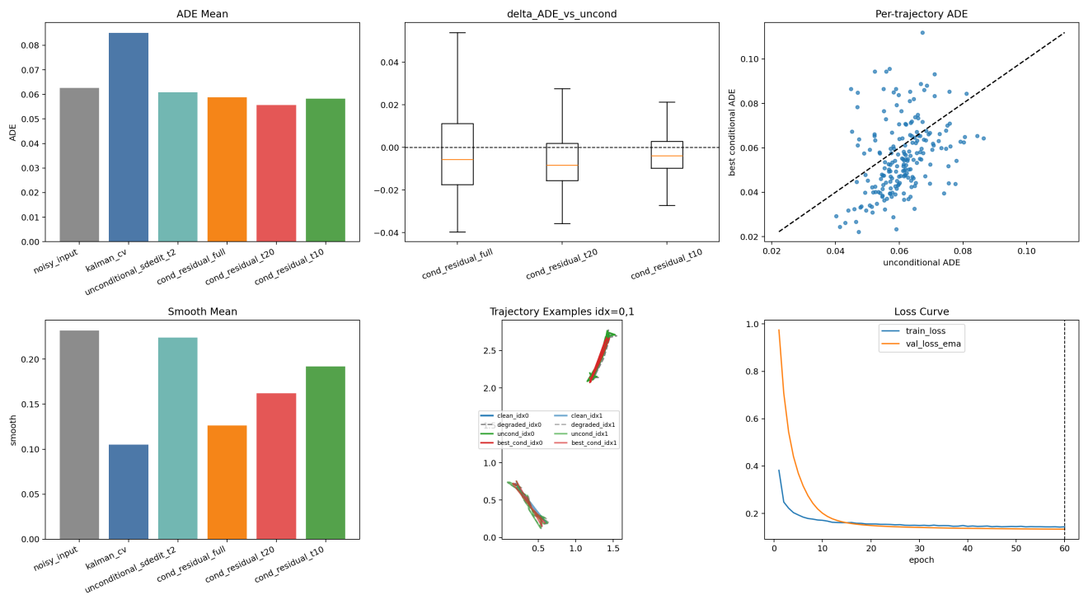

Figure 2: Burst-medium failure case
3 columns: clean / degraded / cond_residual_t20. Smooth decreases but ADE increases: Gaussian-trained model applies uniform correction to both burst and clean frames.
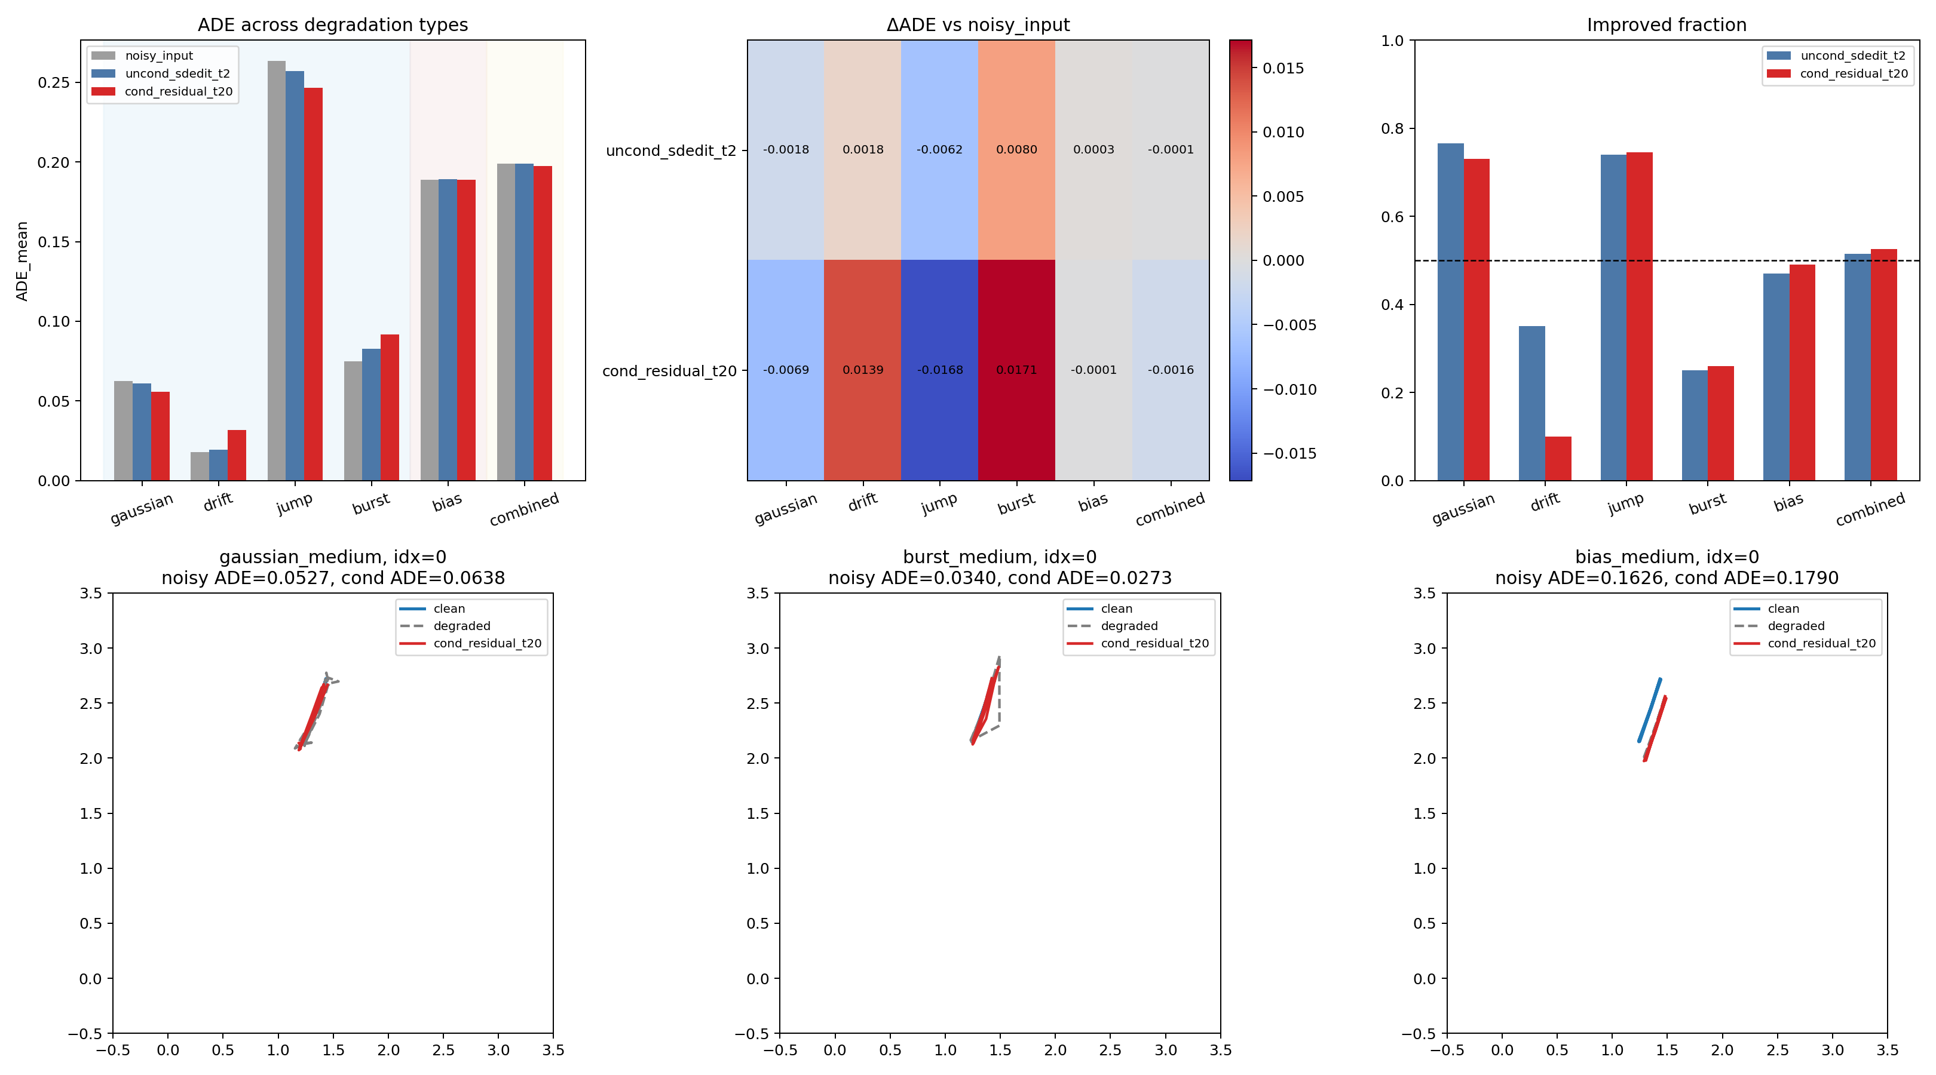

Figure 3: Bias-medium representation limitation
3 columns: clean / degraded / cond_residual_t20. Absolute offset fully preserved. Bias cancels in relative displacement.


Figure 4: ADE grouped bar chart (6 degradations × 3 methods)
Dashed separator between relative-observable (left 4) and relative-unobservable (right 2).
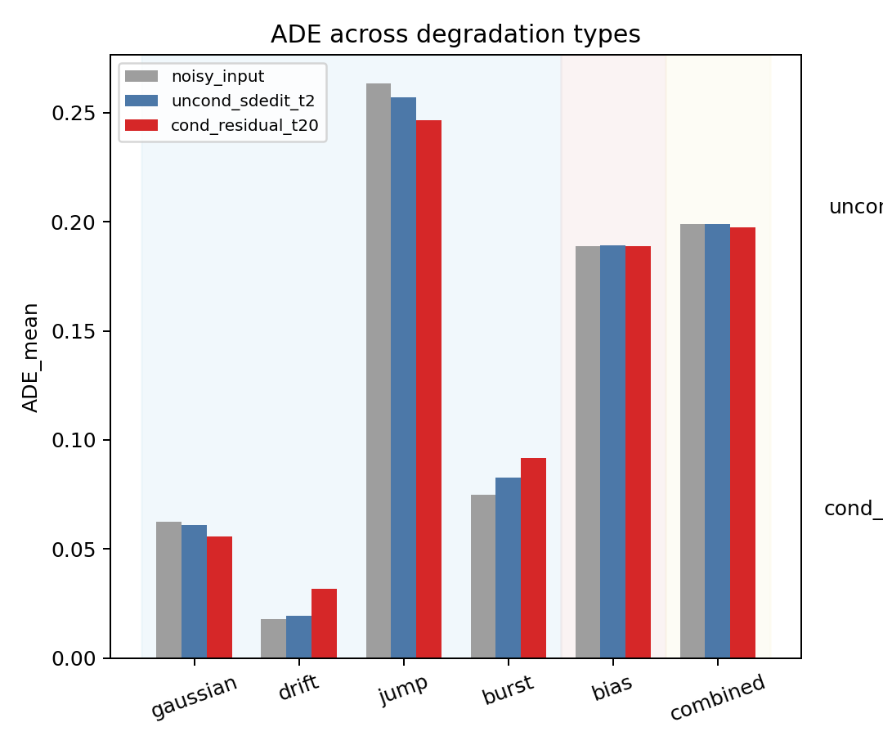

Figure 5: ΔADE heatmap
Rows: uncond / cond. Columns: 6 degradations. Green=improvement, red=worsening. Numeric annotations.
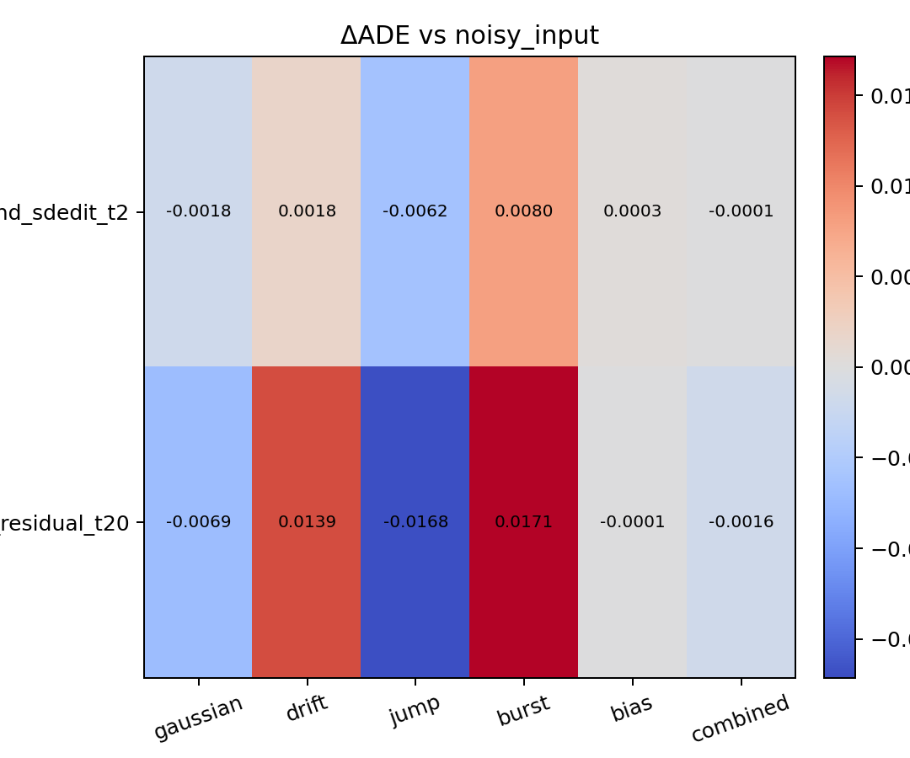

6. Discussion

6.1 Hypothesis evaluation
Primary hypothesis: PARTIALLY SUPPORTED
Conditional residual DDPM significantly improves reconstruction under Gaussian noise (ADE: 0.0626 → 0.0557, +6.9 mm, 11.0%, p = 5.3×10⁻¹¹) and generalizes to jump-like corruption (ADE: 0.2634 → 0.2465, 6.4%, p = 2.4×10⁻¹⁴). It does not improve drift (over-correction) or burst (training mismatch).
Secondary hypothesis: FULLY SUPPORTED
Constant bias produces negligible change (ΔADE = −0.0001m, p = 0.44). Since (x[t+1]+b)−(x[t]+b) = x[t+1]−x[t], bias is mathematically invisible in relative displacement space. The start point from the degraded trajectory preserves the offset. This confirms the predicted representation-level limitation.

6.2 Analysis of negative results
Drift: Ceiling effect and over-correction
Noisy_input ADE under drift is already very low (0.0176m) because drift accumulates slowly over 20 frames at σ_step=0.005. The model, trained to expect ~5cm Gaussian noise, applies corrections of similar magnitude to a near-clean signal, worsening ADE to 0.0316m. This is a ceiling effect combined with training mismatch.
Burst: Training mismatch
Burst concentrates high noise (σ=0.25) in 3–5 frames with low noise elsewhere. The Gaussian-only trained model treats the trajectory uniformly, smoothing both burst and clean frames. Smooth decreases but ADE increases because clean frames are unnecessarily modified.
Bias: Representation limitation
Constant bias cancels in relative displacement and cannot be observed by the model. The degraded start point preserves the offset in absolute coordinates. This requires either absolute residual modeling or a start-point correction head—a representation change, not a DDPM change.

6.3 Conditioning as the key lever
The 4× gap between unconditional (2.8%, 1.8 mm) and conditional (11.0%, 6.9 mm) under identical architecture demonstrates that the inference interface—not the prior—is the main performance lever. Providing the degraded observation as a condition transforms the task from open-ended generation to targeted correction, consistent with findings in the conditional diffusion literature.

6.4 Scale of improvement
The absolute improvement under gaussian_medium is 6.9 mm in a 3m room (sensor-equivalent error: ~6.3 cm → ~5.6 cm). While statistically robust, this is a modest refinement. The result establishes a measurable, reproducible correction mechanism, but does not claim transformative accuracy gains. Larger improvements may require mixed-degradation training, higher noise levels, or absolute-coordinate modeling.

7. Next Hypothesis
Based on the failure analysis in §6.2, the next steps address training data (method fix) and representation (interface fix).
Next Hypothesis 1 — Mixed relative-degradation training (§6.2 drift/burst):
If drift and burst failures are caused by degradation-specific training rather than model capacity, then training on a mixture of Gaussian, drift, jump, and burst should improve all four relative-observable degradation types. Bias and combined are excluded because their failure is representational.
Next Hypothesis 2 — Absolute start-point correction (§6.2 bias):
If bias failure is caused by the relative displacement representation, then an auxiliary head predicting clean_start − degraded_start should enable bias correction without changing the core DDPM. This is independent of Hypothesis 1.
Both hypotheses are derived from §6.2 and can be tested independently. They modify method and interface respectively, not the hypothesis itself.

8. Why Simulated Data
Real sensor experiments are not used at this stage because the objective is to isolate the refinement mechanism under known, controlled degradation. Simulated data provides exact clean targets, known corruption types and magnitudes, and enables paired per-trajectory statistical evaluation. Once the refinement mechanism is validated on simulated data, the next stage will apply it to real sensor outputs where ground truth is available from a reference tracking system.

9. Threats to Validity
1. Simulated trajectories rather than real sensor observations may not capture all characteristics of actual indoor movement and sensor noise.
2. Single model training seed (seed=42); results may vary with different random initializations.
3. Fixed Kalman parameters not optimized for the dataset; an optimized Kalman may perform differently.
4. Gaussian-only training for the conditional model; mixed-degradation training may change the generalization profile.
5. No geometry constraints (room boundaries) enforced during DDPM sampling.
6. Evaluation on N=200 trajectory subset; larger evaluation sets may reveal different statistical patterns.
7. Trajectories are 20 frames at 3 Hz (~6.7s); longer trajectories or different sampling rates may produce different results.

