Stage 3: Controlled Evaluation of Conditional DDPM Refinement
for Indoor Sensor-Degraded Trajectories
Stage 3 Experiment Report — May 2026

1. Objective and Hypotheses
Objective: Evaluate whether a DDPM trained on indoor simulated trajectories can refine sensor-degraded trajectories under controlled corruption conditions.
H1 (primary): Conditional residual DDPM, where the degraded trajectory is provided as a condition and the model learns a displacement correction, improves trajectory reconstruction beyond both noisy input and unconditional SDEdit.
H2 (secondary): The effectiveness is bounded by whether corruption is observable in relative displacement; constant absolute bias should remain uncorrectable.
This work shows (i) unconditional DDPM-SDEdit yields only weak refinement (2.8% ADE under Gaussian noise); (ii) conditional residual DDPM substantially improves Gaussian refinement (11.0%, p = 5.3×10⁻¹¹) and significantly outperforms unconditional SDEdit; (iii) the method generalizes partially to jump corruption but fails on burst and drift, and is structurally unable to correct constant bias.

2. Method
Stage 2 established the trajectory DDPM pipeline (relative displacement representation, 1D temporal denoiser, training/sampling procedures) on public ETH/UCY data. Stage 3 retrains a separate model from scratch on indoor simulated trajectories, focused on degradation refinement rather than open-ended generation.
DDPM choice: a learned probabilistic prior captures the multi-modal distribution of indoor motion (walks, turns, pauses) that hand-crafted filters cannot. Conditional residual choice: unconditional SDEdit gave only 2.8% improvement; concatenating the degraded trajectory as a condition channel and learning the residual correction shrinks the search space and aligns the task with sensor refinement.
Baselines: noisy_input (raw degraded), kalman_cv (constant-velocity RTS, fixed parameters, not optimized), and unconditional SDEdit (t=2).

3. Experimental Protocol
Data: 2,000 indoor simulated trajectories in a 3m × 3m room, 20 frames at 3 Hz. Five behavior types (goal-directed, multi-goal, pacing, stationary, boundary-walk). Training set 10,000 expanded to 60,000 via 6-fold geometric augmentation.
Degradations (six types, per-frame):
- gaussian_medium: N(0, 0.05²)
- bias_medium: constant N(0, 0.15²) per axis
- drift_medium: cumulative random walk σ_step=0.005
- jump_medium: 2–4 piecewise offsets, U(0.2, 0.5)m
- burst_medium: 3–5 frame burst, σ=0.25 (vs 0.01 elsewhere)
- combined_medium: gaussian + bias + drift
Model: 1D conditional temporal denoiser, hidden_dim=128, T=100, input channels = 4 (noisy state + degraded condition). Trained 60 epochs on Gaussian degradation only, with EMA. (Training details: Appendix A.)
Evaluation: N=200 trajectories. DDPM methods average over 5 inference seeds before computing per-trajectory ADE, RMSE, smooth (acceleration magnitude). Statistical test: paired Wilcoxon signed-rank (one-sided). Standard deviations are across 200 trajectories. Geometry constraints are not used during training, inference, or evaluation.

4. Results

4.1 Gaussian-medium deep comparison
Table 1. Gaussian-medium reconstruction metrics.
Method | ADE mean | ADE std | RMSE | Smooth | Impr % | Imp. frac | pvs noisy
noisy_input | 0.0626 | 0.0077 | 0.0698 | 0.2319 | — | — | —
kalman_cv | 0.0850 | 0.0281 | 0.1000 | 0.1052 | -35.9% | 23.5% | 1.0
uncond_sdedit_t2 | 0.0608 | 0.0084 | 0.0680 | 0.2240 | +2.8% | 76.5% | 1.7e-13
cond_resid_t20 | 0.0557 | 0.0162 | 0.0623 | 0.1620 | +11.0% | 73.0% | 5.3e-11
Conditional residual DDPM achieves 0.0557m ADE, an absolute gain of 6.9 mm (11.0% relative) over noisy_input (p = 5.3×10⁻¹¹), and outperforms unconditional SDEdit by 5.1 mm (p = 6.7×10⁻⁸). The conditional model has larger trajectory-level spread (std=0.0162 vs 0.0084), reflecting larger per-trajectory corrections rather than instability (improved fraction 73.0%). Kalman worsens ADE in this protocol due to mismatch between the constant-velocity assumption and short indoor trajectories.

4.2 Generalization summary
Degradation | noisy ADE | cond ADE | ΔADE | p | Outcome
gaussian | 0.0626 | 0.0557 | -0.0069 | 5.3e-11 | sig. improvement
drift | 0.0176 | 0.0316 | +0.0139 | 1.0 | over-correction
jump | 0.2634 | 0.2465 | -0.0168 | 2.4e-14 | sig. improvement
burst | 0.0748 | 0.0919 | +0.0171 | 1.0 | worsened
bias | 0.1890 | 0.1889 | -0.0001 | 0.44 | no change
combined | 0.1991 | 0.1974 | -0.0016 | 0.23 | no change
The model generalizes to jump but fails on drift and burst. Drift and burst failures are training-related; bias and combined failures are representational. Full per-method statistics are in Appendix B.

4.3 Conditioning effect
The 4× gap between unconditional (2.8%, 1.8 mm) and conditional (11.0%, 6.9 mm) under identical architecture indicates the inference interface, not the prior, is the primary performance lever.

5. Figures

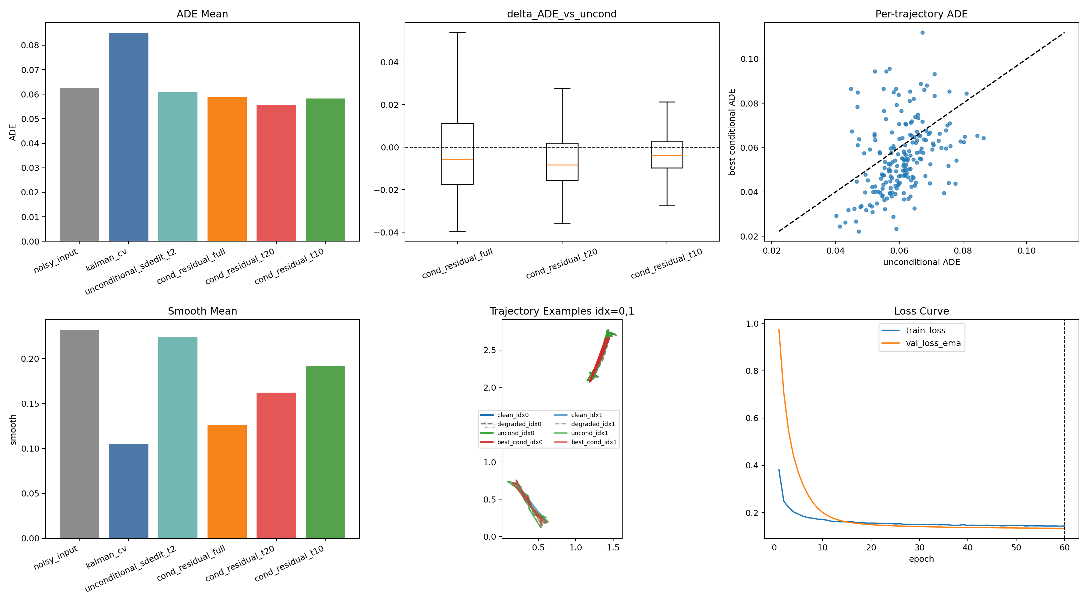
Figure 1. Gaussian-medium refinement examples (clean / degraded / uncond / cond).

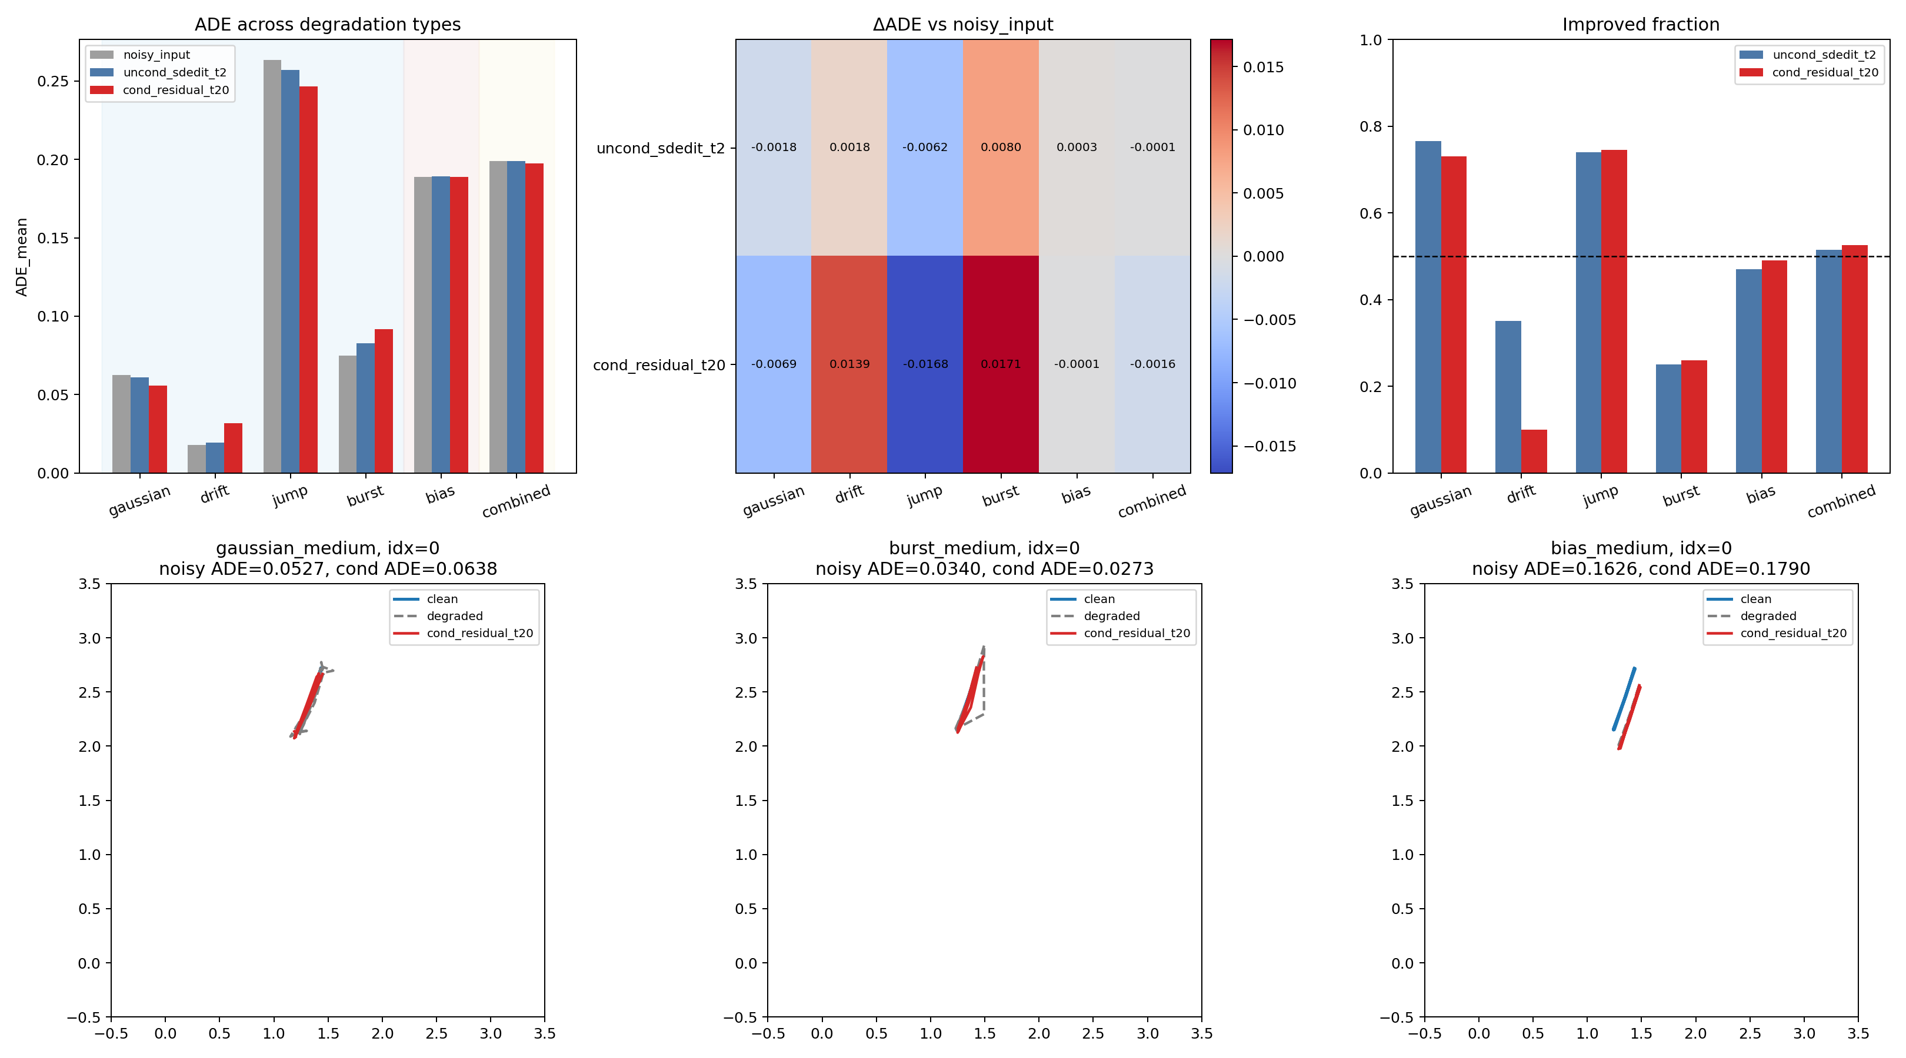
Figure 2. Generalization diagnostic: per-degradation ADE, ΔADE heatmap, and example trajectories (burst showing smoothing without accuracy gain; bias showing preserved offset).

6. Discussion
What worked. Conditional residual DDPM significantly improves Gaussian (p = 5.3×10⁻¹¹) and jump (p = 2.4×10⁻¹⁴) refinement. H1 is supported for relative-observable corruption.
What failed. Drift over-corrects because noisy ADE is already small (0.0176m); the model trained on 5cm Gaussian noise applies similar-magnitude corrections to a near-clean signal. Burst fails because Gaussian-only training does not recognize local strong interference and uniformly smooths both burst and clean frames. Bias fails because constant offset cancels in relative displacement (visible only in absolute coordinates) — the model literally cannot see it.
What it means. H2 is fully supported: the bound on DDPM refinement is representational, not capacity-related. The 4× gap between unconditional and conditional shows the inference interface dominates over prior quality.

7. Limitations and Next Step

7.1 Limitations
- Simulated data, not real sensor measurements
- Single training seed (42)
- Kalman parameters not optimized
- Gaussian-only training for the conditional model
- Evaluation on N=200 trajectory subset

7.2 Next hypotheses
H3 (method fix): Mixed relative-degradation training (gaussian + drift + jump + burst) should improve drift and burst while preserving Gaussian and jump gains.
H4 (interface fix): An auxiliary head predicting absolute start-point correction (clean_start − degraded_start) should enable bias correction without changing the core DDPM.

Appendix A: Training details
- Adam, lr=1e-3, no scheduler
- 60 epochs, batch 256
- EMA decay 0.999
- Degradation seed: 100000 × epoch + index
- Validation seed: 42 + index
- Best checkpoint by EMA val_loss

Appendix B: Full Method × Degradation Matrix
Degradation | Method | ADE | std | Smooth | ΔADE | Imp% | p val | Result
gaussian_medium | noisy_input | 0.0626 | 0.0077 | 0.2319 | — | — | — | —
gaussian_medium | uncond_sdedit_t2 | 0.0608 | 0.0084 | 0.2240 | -0.0018 | 76.5% | 1.7e-13 | sig. impr.
gaussian_medium | cond_residual_t20 | 0.0557 | 0.0162 | 0.1620 | -0.0069 | 73.0% | 5.3e-11 | sig. impr.
drift_medium | noisy_input | 0.0176 | 0.0069 | 0.1347 | — | — | — | —
drift_medium | uncond_sdedit_t2 | 0.0195 | 0.0081 | 0.1330 | +0.0018 | 35.0% | 1.0000 | worsened
drift_medium | cond_residual_t20 | 0.0316 | 0.0132 | 0.1259 | +0.0139 | 10.0% | 1.0000 | over-corr.
jump_medium | noisy_input | 0.2634 | 0.0890 | 0.2360 | — | — | — | —
jump_medium | uncond_sdedit_t2 | 0.2572 | 0.0855 | 0.2299 | -0.0062 | 74.0% | 4.4e-15 | small impr.
jump_medium | cond_residual_t20 | 0.2465 | 0.0824 | 0.1907 | -0.0168 | 74.5% | 2.4e-14 | sig. impr.
burst_medium | noisy_input | 0.0748 | 0.0204 | 0.3156 | — | — | — | —
burst_medium | uncond_sdedit_t2 | 0.0828 | 0.0243 | 0.3071 | +0.0080 | 25.0% | 1.0000 | worsened
burst_medium | cond_residual_t20 | 0.0919 | 0.0320 | 0.2487 | +0.0171 | 26.0% | 1.0000 | worsened
bias_medium | noisy_input | 0.1890 | 0.0957 | 0.1334 | — | — | — | —
bias_medium | uncond_sdedit_t2 | 0.1893 | 0.0958 | 0.1320 | +0.0003 | 47.0% | 0.8170 | no change
bias_medium | cond_residual_t20 | 0.1889 | 0.0931 | 0.1258 | -0.0001 | 49.0% | 0.4399 | no change
combined_medium | noisy_input | 0.1991 | 0.0867 | 0.2321 | — | — | — | —
combined_medium | uncond_sdedit_t2 | 0.1990 | 0.0865 | 0.2242 | -0.0001 | 51.5% | 0.4694 | no change
combined_medium | cond_residual_t20 | 0.1974 | 0.0901 | 0.1620 | -0.0016 | 52.5% | 0.2317 | no change

