ER-Diagram Explanation
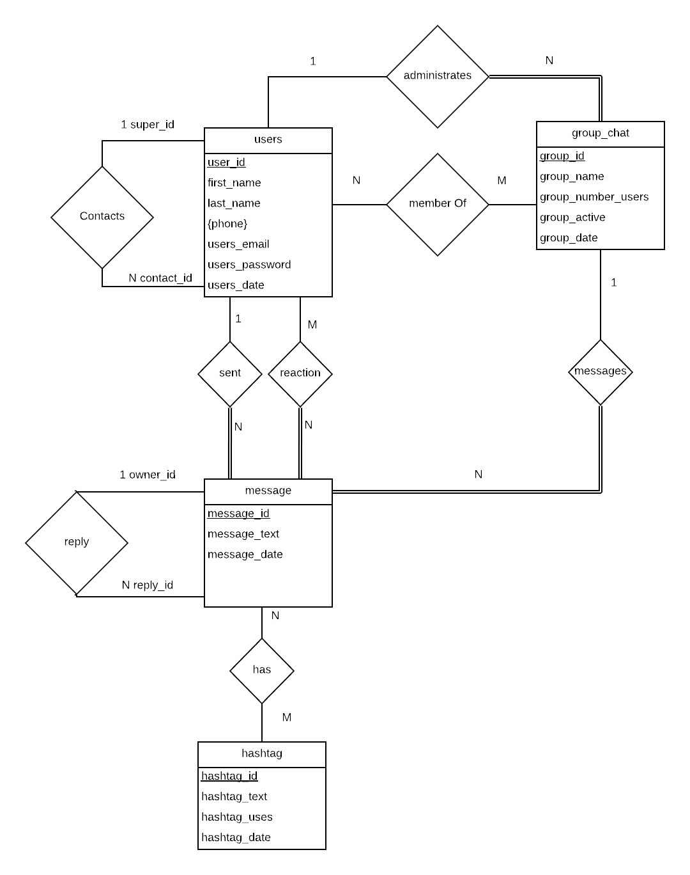

users: users entity contains all information about a user. Users first and last name, phone number, email address, password and the date the account was created.
contacts: contacts relation has one user that has many users in his/her list, represented by super and contact.
administrates: administrates is a relation one to many, since one user can be admin of many groups.
member_of: member_of is a relation many to many, since many users can be in many groups.
sent: sent is a relation one to many, one user can send many messages.
reaction: reaction is a relation one to many, since one user reacts to many messages with a like or dislike.
group_chat: group_chat entity stores groups name, number of users in group, number of active users and date of creation.
messages: messages is a relation one to many with group_chat. A group_chat will contain many messages.
message: message entity contains the text field and date it was posted.
reply: reply relation contains a owner for the message that will have many replys.
has: has relation is many to many since many messages can contain many hashtags and vice versa.
hashtag: hashtag entity stores the hashtag from a message, number of times used, and date first used

