Vitae


Ricardo Yair Garcia-Muñoz received his M.S. degree in Computer Systems from the Technological Institute of Nogales, Sonora, Mexico, in 2025. His current research interests include chaos theory and cryptographic algorithms.



Dr. Manuel Omar Meranza-Castillón is a professor at National Technological Institute of Mexico (TecNM) / Technological Institute of Nogales (ITN) since 2003. He earned his Ph.D. in Electronics and Telecommunications from the Scientific Research and Advanced Studies Center of Ensenada (CICESE), B.C., Mexico in 2020, where he completed his dissertation titled “Chaotic Encryption in Embedded Systems and Cryptographic Security Evaluation.” He also holds a Master’s Degree in Electronics and Telecommunications, from the same institution in 2002, and a Bachelor’s Degree in Electronics Engineering from the Technological Institute of Nogales (ITN) in 1998. His research focuses on chaotic and nonlinear systems, cryptography, embedded systems, cryptographic security, and complex systems.

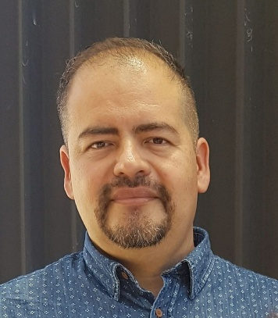
Dr. Samuel González-López is a full professor of the Research Department of the Technological Institute of Nogales. He obtained his PhD in Computer Science at the National Institute of Astrophysics, Optics and Electronics INAOE. His works are focused on improving undergraduate students’ writing with the project Linguistic Analysis of Research Project Drafts of Undergraduate Students. He also conducts research under the project of ‘Dysfunctional consumer behavior”.

