

**UNIVERSIDAD DE LAS FUERZAS ARMADAS ESPE**

**COMPUTER SCIENCE DEPARTMENT**

**INFORMATION TECHNOLOGY ENGINEERING**

**WEB APPLICATIONS DEVELOPMENT**

**LEARNING ACTIVITY N.3**

**TOPIC: Frontend Development, Backend and API Consumption**

**Web Development Client – Server**

**TEAM 4:**

**Gods Of the Web**

**MEMBERS:**

- Ricardo Jaramillo

- Dylan Jiménez

- Raúl Meneses

- José Mejía

**TEACHER:**

PhD. Edison Lascado Mgs.

**QUITO – ECUADOR**

**2022**

**Frontend, Backend and Consumer APIS Development**

**Team 4 Gods of the Web repository link:** <https://github.com/RicardoJ990/ESPE202205-WEB-TI-5450>

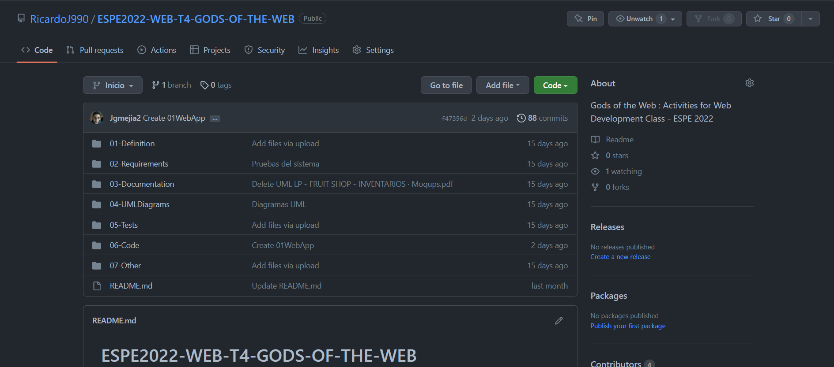

Gráfico 1

**Video link:** <https://uespe-my.sharepoint.com/:v:/g/personal/nrjaramillo2_espe_edu_ec/ESIBMh9v-O1Jvg9HGEsB-0oB7T92DTJJ0ii8_XmmV3fSWQ?e=hGe7oi>

**Client Web**

* **Screenshot**

*Login*

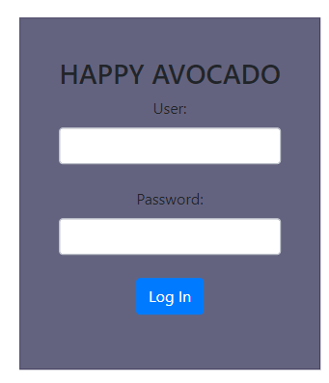

Gráfico 2

* **Moqups**

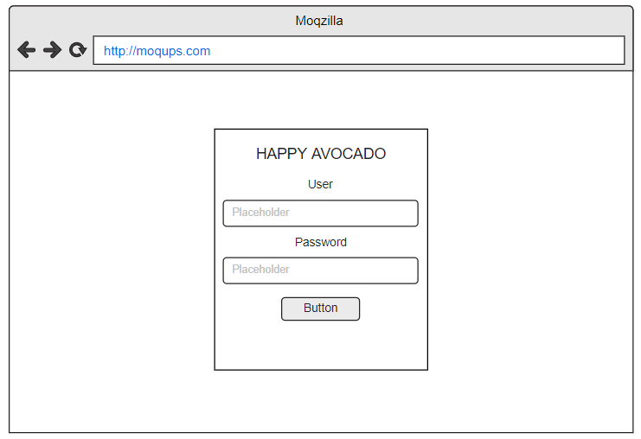

Gráfico 3

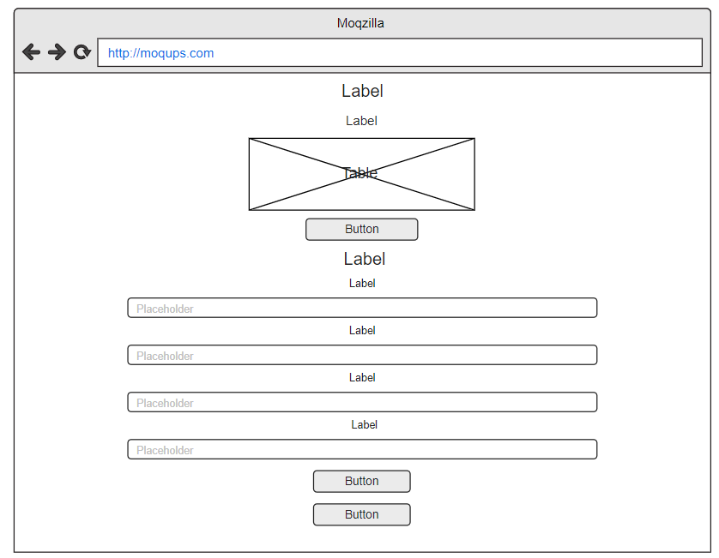

Gráfico 4

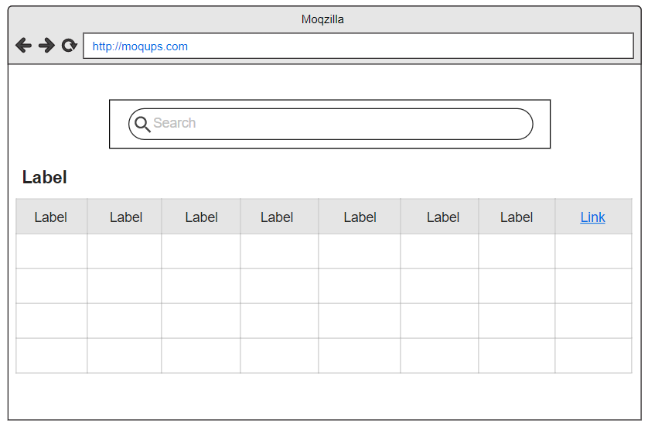

Gráfico 5

**Architecture consumption API**

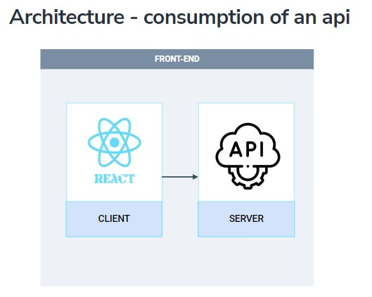

Gráfico 6

**Public consumption API**

The user will be able to enter a search element where a table will be displayed with the elements necessary to identify the scientific article, as well as its access URL.

* **Screenshots**

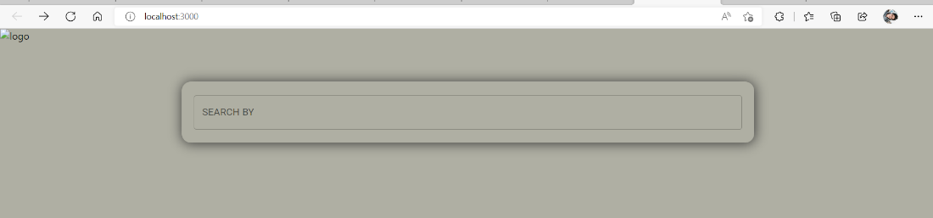

Gráfico 7

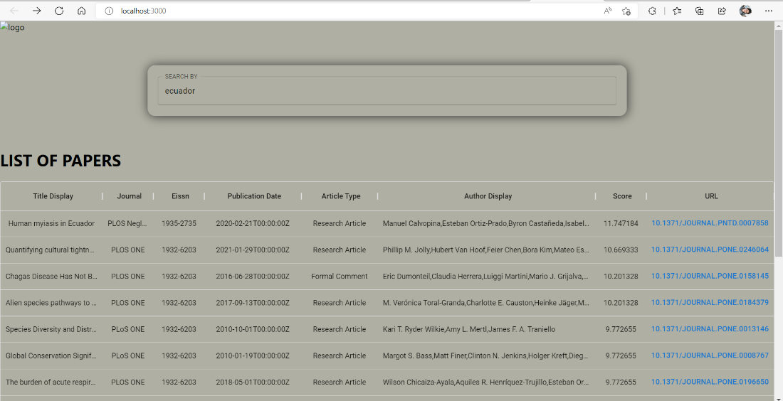

Gráfico 8

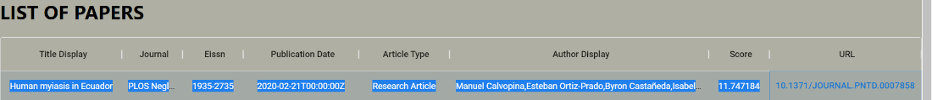

Gráfico 9

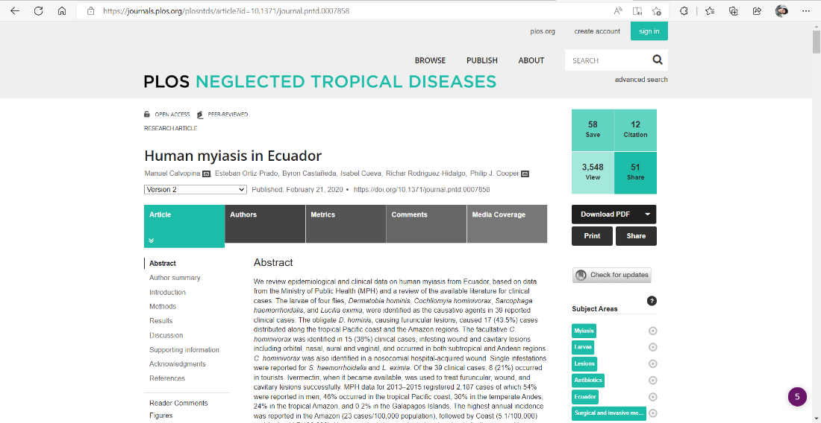

Gráfico 10

**Consuption of a URI from activity 2**

In this section, a get method of different application modules is consumed, both locally and remotely on a machine hosted on AWS

**Screenshots:**

**GET (localhost):**

**Order:**

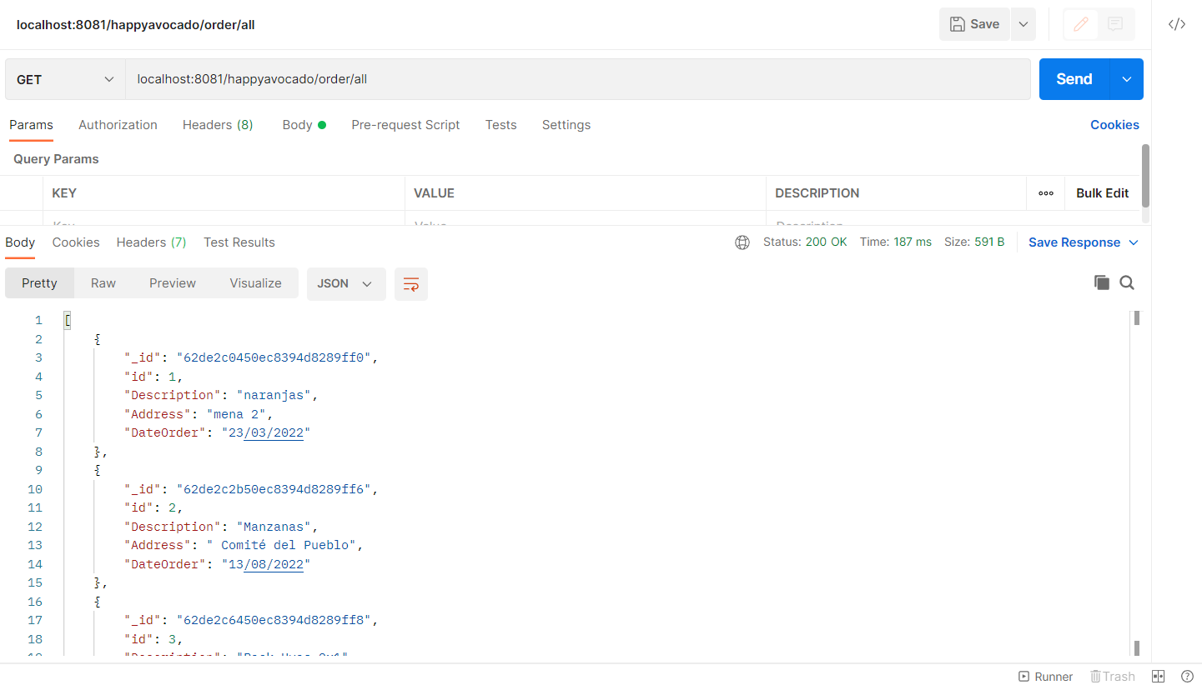

Gráfico 11

**Provider:**

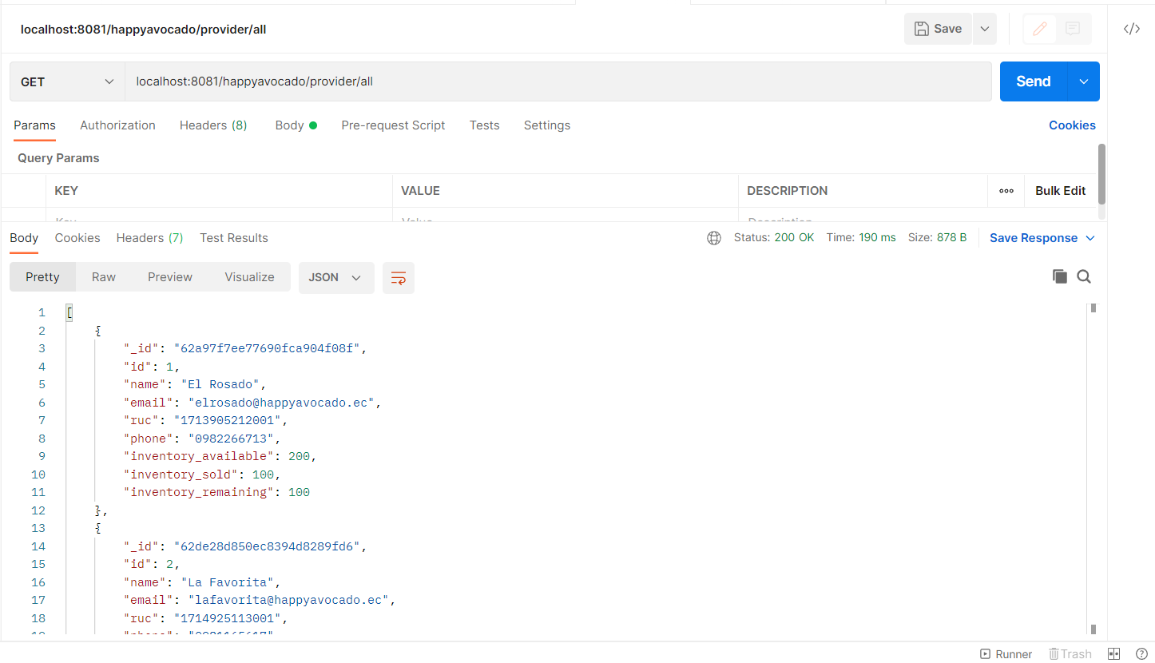

Gráfico 12

**Product:**

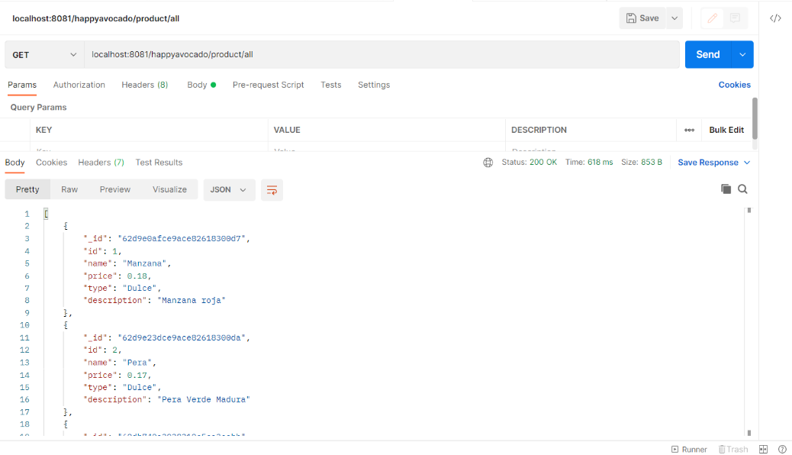

Gráfico 13

**GET (AWS):**

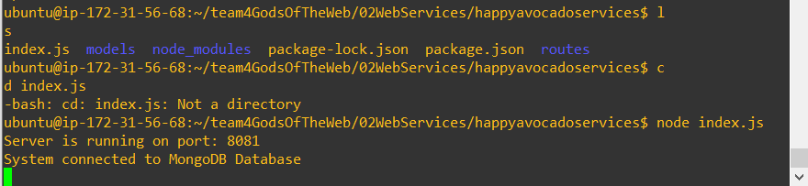

Gráfico 14

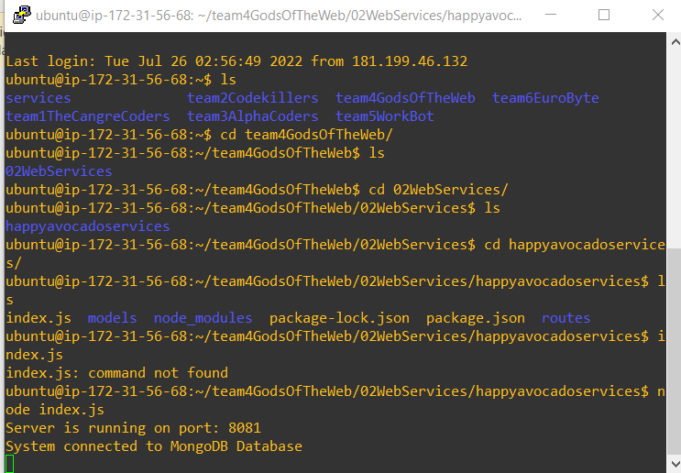

Gráfico 15

**Product:**

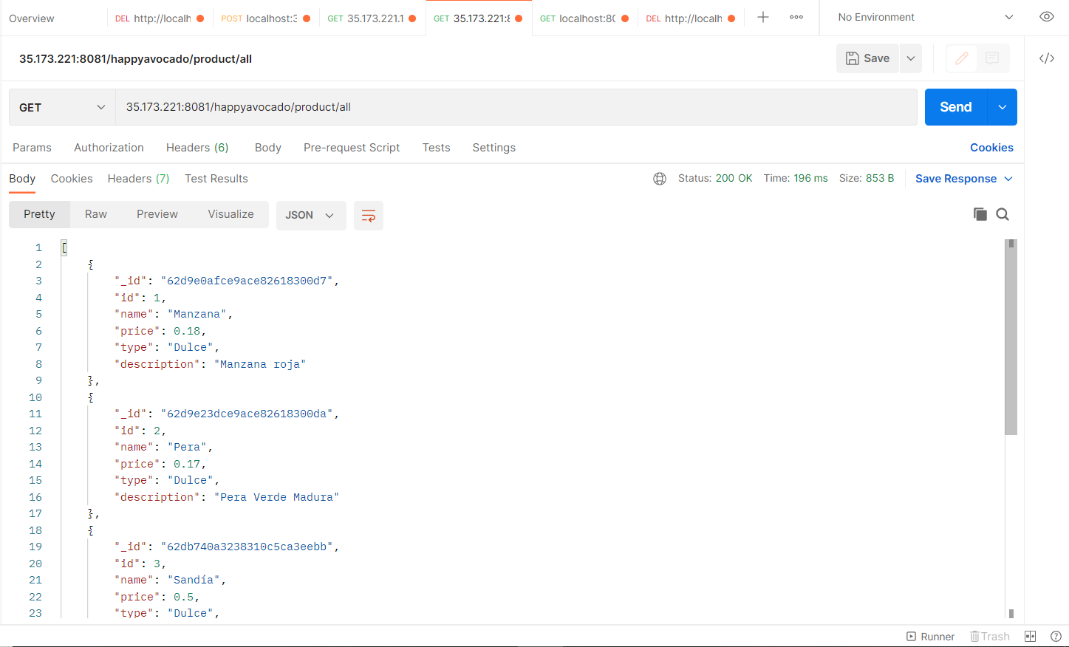

Gráfico 16

**Order:**

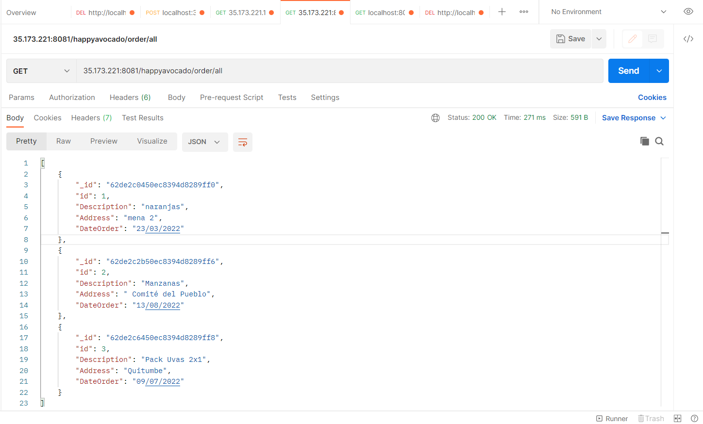

Gráfico 17

**Provider:**

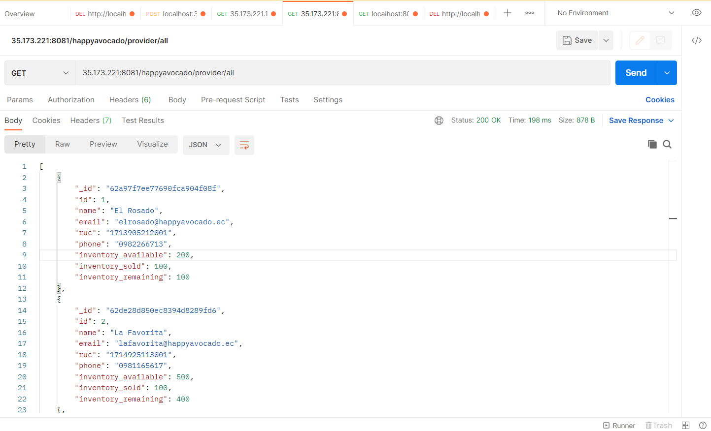

Gráfico 18

**User interfaces**

* **Application login**

In the case of login development, the react library was used.

**Development in a local host:**

In the case of the local headquarters, information was consumed from a URI of type Get, which will have records of each of the members of team 4, and the operation will be verified by means of the login developed.

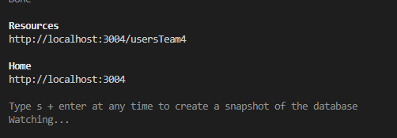

Gráfico 19

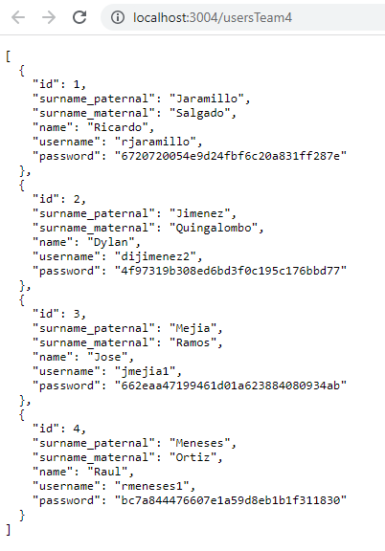

Gráfico 20

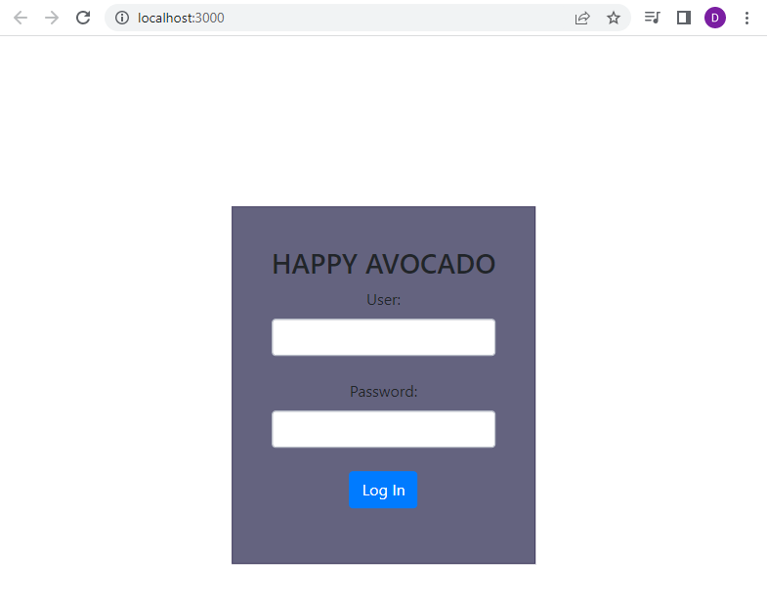

Gráfico 21

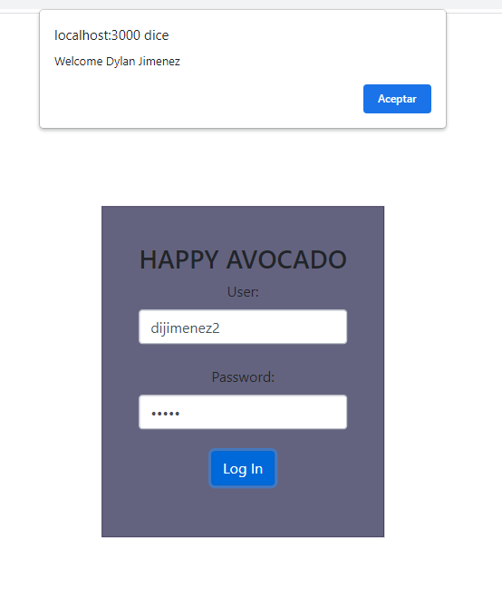

Gráfico 22

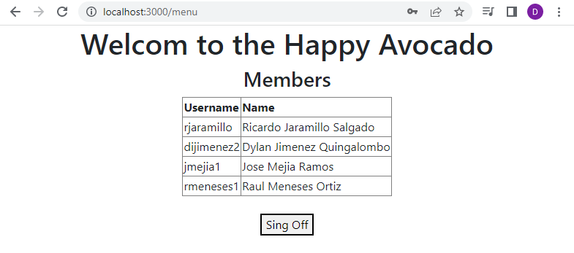

Gráfico 23

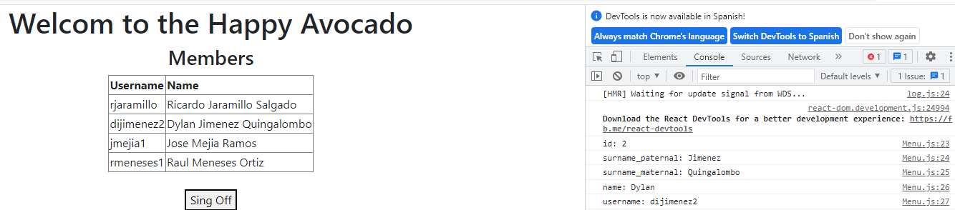

Gráfico 24

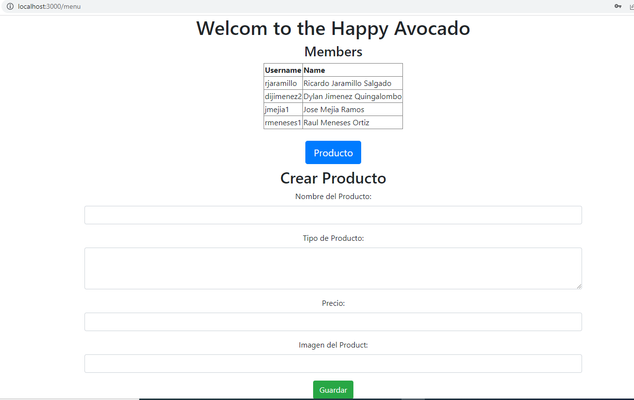

Gráfico 25

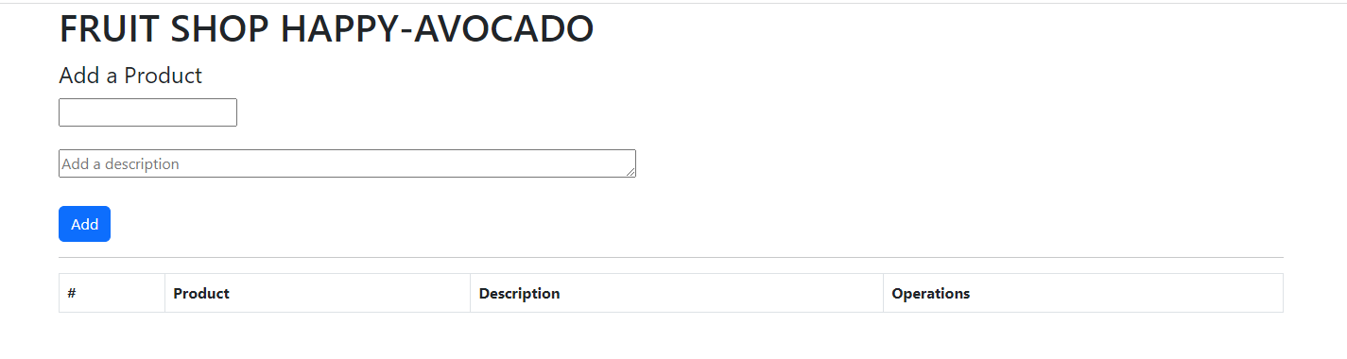

Gráfico 26

**Use Cases**

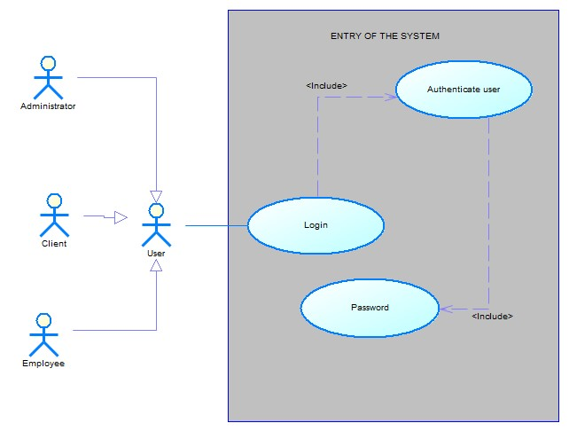

Gráfico 27

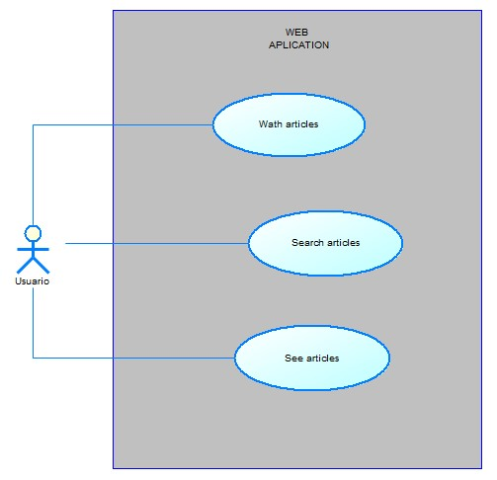

Gráfico 28

**Architecture**

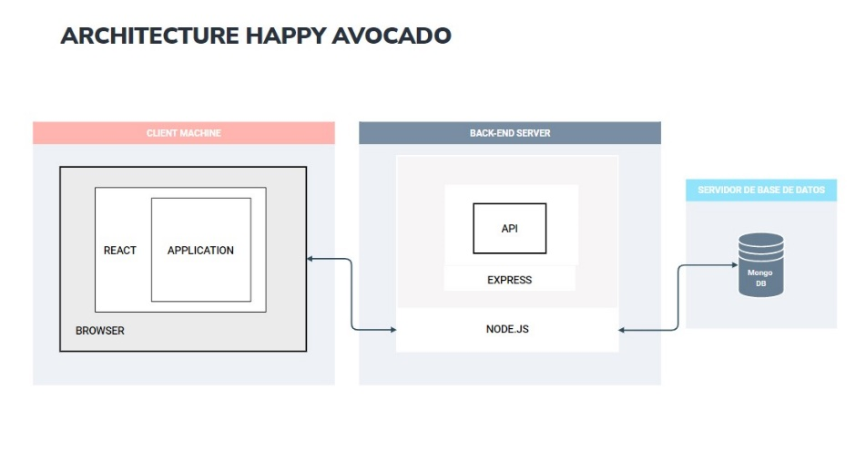

Gráfico 29