

**UNIVERSIDAD DE LAS FUERZAS ARMADAS ESPE**

**COMPUTER SCIENCE DEPARTMENT**

**INFORMATION TECHNOLOGY ENGINEERING**

**WEB APPLICATIONS DEVELOPMENT**

**LEARNING ACTIVITY N.4**

**TOPIC: BE + FE + DB (Final Activity)**

**TEAM 4:**

**Gods Of the Web**

**MEMBERS:**

- Ricardo Jaramillo

- Dylan Jiménez

- Raúl Meneses

- José Mejía

**TEACHER:**

PhD. Edison Lascado Mgs.

**QUITO – ECUADOR**

**2022**

**Frontend + Backend + DataBase**

**Team 4 Gods of the Web repository link:** <https://github.com/RicardoJ990/ESPE202205-WEB-TI-5450>

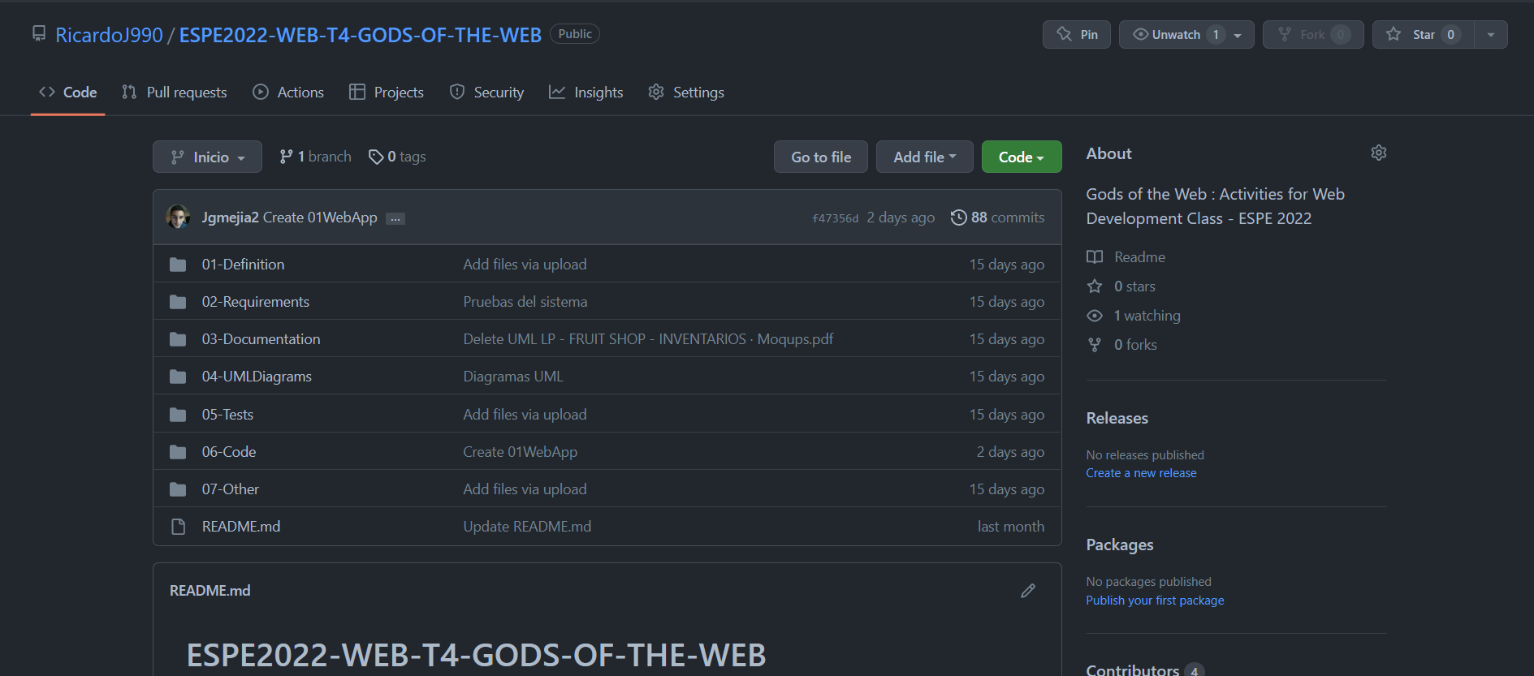

Gráfico 1

**Video link:**

### Architecture:

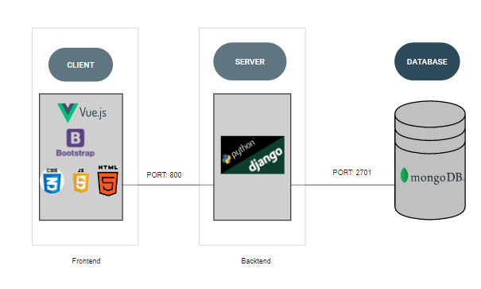

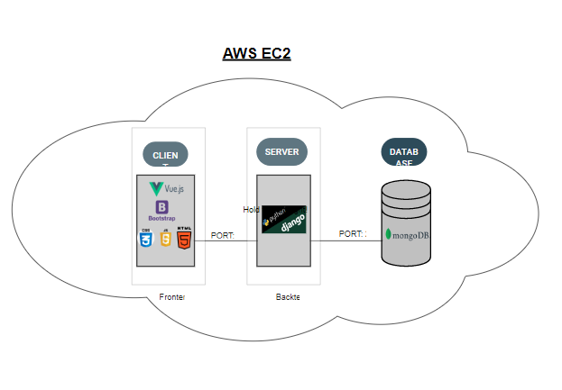

### URIS - Back-End Team 4 (DJANGO)

|  |  |
| --- | --- |
| Método | GET |
| URI | http://3.86.206.55:8000/employee |
| Parámetros | **none** |
| Formato | JSON |
| Devuelve |  |

**GET**

**DELETE**

|  |  |
| --- | --- |
| Método | DELETE |
| URI | http:// 3.86.206.55:8000/employee/id |
| Parámetros | **idBook**: id del empleado |
| Formato | JSON |
| Devuelve |  |

**POST**

|  |  |
| --- | --- |
| Método | POST |
| URI | http:// 3.86.206.55:8000/employee |
| Parámetros | {  "EmployeeName": "maria",  "Department": "Ciencias administrativas",  "DateOfJoining": "2021-12-12",  "PhotoFileName": "anonymous_2PWkMa2.PNG"  } |
| Formato | JSON |
| Devuelve |  |

|  |  |
| --- | --- |
| Método | PUT |
| URI | http://3.86.206.55:8000/employee |
| Parámetros | {  "EmployeeId": 13,  "EmployeeName": "maria",  "Department": "Ciencias sociales",  "DateOfJoining": "2021-12-12",  "PhotoFileName": "anonymous_2PWkMa2.PNG"  } |
| Formato | JSON |
| Devuelve |  |

**PUT**

Design (sketches) of the web pages:

