**THE MINISTRY OF EDUCATION AND SCIENCE OF UKRAINE**

**State University of Intelligent Technologies and Communications**

**Department of Software Engineering**

**Laboratory work №1**

**Variant №8**

**Made by Kadian Richard**

# Task

1. Problem 1: draw the following objects, fill them in different ways: (x=50, y=70, a=750, b=140, h=250, w=150):

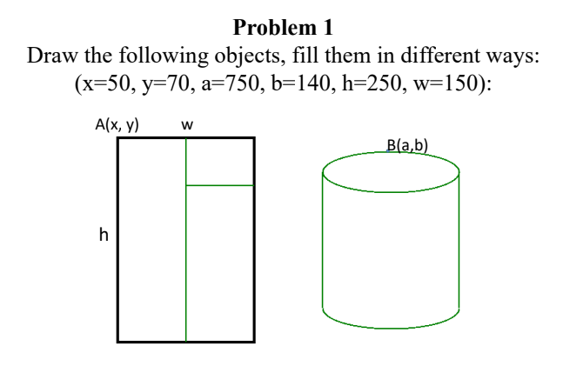

1. Problem 2: draw your name with graphic primitives.

# Code

using System;

using System.Drawing;

using System.Windows.Forms;

namespace Lab_1 {

public partial class Form1 : Form {

public Form1() {

InitializeComponent();

}

private void Form1_Load(object sender, EventArgs e) {

}

private void button1_Click(object sender, EventArgs e) {

Graphics g = CreateGraphics();

g.Clear(BackColor);

Pen blackPen = new Pen(Color.Black, 3);

Pen greenPen = new Pen(Color.Green, 2);

SolidBrush redBrush = new SolidBrush(Color.Red);

SolidBrush greenBrush = new SolidBrush(Color.Green);

SolidBrush blueBrush = new SolidBrush(Color.Blue);

Rectangle lgRect = new Rectangle(50, 70, 150, 250);

Rectangle mdRect = new Rectangle(125, 120, 75, 200);

Rectangle smRect = new Rectangle(125, 70, 75, 50);

g.DrawRectangle(blackPen, lgRect);

g.FillRectangle(blueBrush, lgRect);

g.DrawRectangle(greenPen, smRect);

g.FillRectangle(redBrush, smRect);

g.DrawRectangle(greenPen, mdRect);

g.FillRectangle(greenBrush, mdRect);

Rectangle ovalRect = new Rectangle(275, 95, 150, 50);

Rectangle ovalRect2 = new Rectangle(275, 270, 150, 50);

Rectangle rect = new Rectangle(275, 120, 150, 175);

g.DrawEllipse(greenPen, ovalRect2);

g.FillEllipse(greenBrush, ovalRect2);

g.DrawRectangle(greenPen, rect);

g.FillRectangle(greenBrush, rect);

g.DrawEllipse(greenPen, ovalRect);

g.FillEllipse(redBrush, ovalRect);

g.DrawLine(blackPen, 50, 350, 50, 400);

Rectangle rRect = new Rectangle(50, 350, 30, 30);

g.DrawArc(blackPen, rRect, 200, 320);

g.DrawLine(blackPen, 100, 350, 100, 400);

g.DrawLine(blackPen, 100, 400, 125, 350);

g.DrawLine(blackPen, 125, 350, 125, 400);

g.DrawLine(blackPen, 150, 350, 150, 375);

g.DrawLine(blackPen, 150, 375, 170, 375);

g.DrawLine(blackPen, 170, 350, 170, 400);

g.DrawLine(blackPen, 195, 400, 210, 350);

g.DrawLine(blackPen, 210, 350, 225, 400);

g.DrawLine(blackPen, 203, 375, 217, 375);

g.DrawLine(blackPen, 250, 350, 250, 400);

Rectangle RRect = new Rectangle(250, 350, 30, 30);

g.DrawArc(blackPen, RRect, 200, 320);

g.DrawLine(blackPen, 300, 390, 315, 350);

g.DrawLine(blackPen, 315, 350, 330, 390);

g.DrawLine(blackPen, 290, 390, 340, 390);

g.DrawLine(blackPen, 290, 390, 300, 400);

g.DrawLine(blackPen, 340, 390, 330, 400);

}

}

}

# Screenshots

