**THE MINISTRY OF EDUCATION AND SCIENCE OF UKRAINE**

**State University of Intelligent Technologies and Communications**

**Department of Software Engineering**

**Laboratory work №4**

**Variant №8**

**Made by Kadian Richard**

# Task

Creating an information system of insurance accounting (organization, plant, insurance company) using an object-oriented approach:

# Code

Interface ITurnover

namespace Lab_5 {

internal interface ITurnover {

int Turnover();

}

}

Class Organization

using System.Collections.Generic;

namespace Lab_5 {

internal class Organization {

protected string name;

protected int yearlyIncome;

protected int turnover;

protected int workers;

private List<Factory> clients = new List<Factory>();

public string Name { get => name; set => name = value; }

public int YearlyIncome { get => yearlyIncome; set => yearlyIncome = value; }

public int Workers { get => workers; set => workers = value; }

public int Turnover { get => turnover; set => turnover = value; }

public List<Factory> Clients { get => clients; }

public void addClient(Factory factory) {

clients.Add(factory);

}

}

}

Class Factory

using System;

namespace Lab_5 {

internal class Factory : Organization, ITurnover {

public event EventHandler AddFactory;

int ITurnover.Turnover() {

Turnover = (int)(YearlyIncome + Clients.Count * 0.3 + Workers * 500);

if (AddFactory != null)

AddFactory(this, null);

return Turnover;

}

}

}

Class Insurance

using System;

namespace Lab_5 {

internal class Insurance : Organization, ITurnover {

private static bool f = false;

public static bool F { get => f; set => f = value; }

int ITurnover.Turnover() {

if (Clients.Count > 0)

Turnover = (int)(YearlyIncome + Clients.Count * 40000 + Workers * 1000);

else

Turnover = 0;

return Turnover;

}

public void DoEvent(object sender, EventArgs e) {

Turnover = (int)(YearlyIncome + Clients.Count * 40000 + Workers * 10000);

}

}

}

Class Form1

using System;

using System.Windows.Forms;

namespace Lab_5 {

public partial class Form1 : Form {

public Form1() {

InitializeComponent();

}

private Insurance insurance;

private void Form1_Load(object sender, EventArgs e) {

insurance = new Insurance();

Insurance.F = false;

}

public void ViewEvent(object sender, EventArgs e) {

textBox14.Text = Convert.ToString(insurance.Turnover);

}

private void button1_Click(object sender, EventArgs e) {

}

private void button2_Click(object sender, EventArgs e) {

}

private void button3_Click(object sender, EventArgs e) {

}

private void groupBox2_Enter(object sender, EventArgs e) {

}

private void button4_Click(object sender, EventArgs e) {

if (!Insurance.F) {

Insurance.F = true;

insurance.Name = Convert.ToString(textBox11.Text);

insurance.YearlyIncome = Convert.ToInt32(textBox12.Text);

insurance.Workers = Convert.ToInt32(textBox13.Text);

ITurnover IT = (ITurnover)insurance;

insurance.Turnover = IT.Turnover();

textBox14.Text = Convert.ToString(insurance.Turnover);

} else

MessageBox.Show("Only one insurance company is allowed to exist");

}

private void button5_Click(object sender, EventArgs e) {

if (Insurance.F) {

Factory factory = new Factory();

factory.AddFactory += new EventHandler(insurance.DoEvent);

factory.AddFactory += new EventHandler(ViewEvent);

factory.Name = Convert.ToString(textBox15.Text);

factory.YearlyIncome = Convert.ToInt32(textBox16.Text);

factory.Workers = Convert.ToInt32(textBox17.Text);

ITurnover IT = (ITurnover)factory;

factory.Turnover = IT.Turnover();

insurance.Clients.Add(factory);

textBox18.Text += factory.Name + ". Income: " + factory.Turnover + ". Workers: " +

factory.Workers + "\n";

} else

MessageBox.Show("There is no insurance company!");

}

}

}

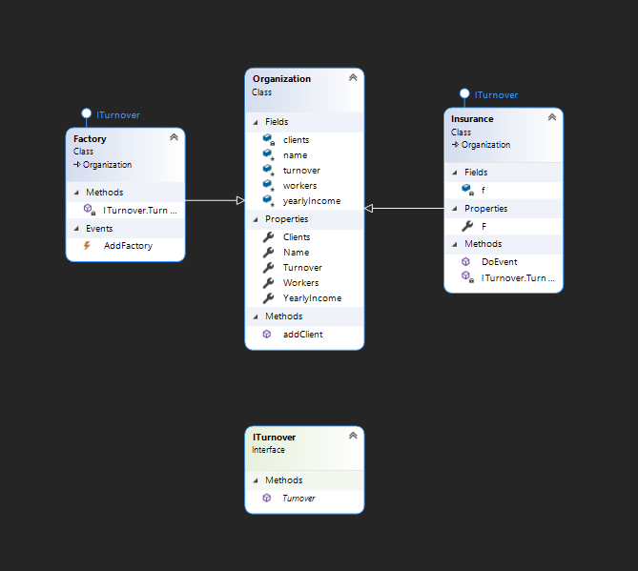

# Screenshots

