**THE MINISTRY OF EDUCATION AND SCIENCE OF UKRAINE**

**State University of Intelligent Technologies and Communications**

**Department of Software Engineering**

**Laboratory work №6**

**Variant №8**

**Made by Kadian Richard**

# Task

1. Develop a window application class that is a subclass of Form. The dimensions of the window, the coordinates of the point of the display in which the upper left corner of the window should be located, its color and title are specified in the individual version (Table 1).

Ensure that the window responds to mouse events. The concretization of the event and the reaction are given in the individual variant.

Create a C # project to test the developed window application.



1. Develop a window application with the ability to display two-dimensional geometric shapes - regular n-angles inscribed in a circle with radius R. The display of the shape should be a reaction to the event MouseEvent. The center of the circle in which the right n-gon is inscribed coincides with the point of origin, and one of the vertices of the polygon has coordinates (xm + R, ym) where xm, ym are the coordinates of the mouse event; R is the radius of the circumscribed circle.

The application should display any number of shapes that do not disappear when resizing the window.

The values ​​of R (radius of the circumscribed circle), n (number of sides of the polygon), its appearance (filled with color or not), the color of the polygon display and the specification of the mouse event are specified in the individual version (Table 2).

Create a C # project to test the developed window application.



# Code

1. Solution for task 1

HandlerClass Class

using System.Windows.Forms;

namespace Lab_1 {

internal class HandlerClass {

public static void Form1_MouseClick(object sender, MouseEventArgs e) {

if (e.Button == MouseButtons.Right)

(sender as Form).Top += 50;

}

public static void CtrlDownHandler(object sender, KeyEventArgs e) {

if (e.Control)

(sender as Form).Top += 50;

}

}

}

Form1 Class

using System;

using System.Drawing;

using System.Windows.Forms;

namespace Lab_1 {

public partial class Form1 : Form {

public Form1() {

InitializeComponent();

Text = "Hey graphical world!";

Width = 300;

Height = 400;

BackColor = Color.Cyan;

MouseClick += HandlerClass.Form1_MouseClick;

KeyDown += HandlerClass.CtrlDownHandler;

}

private void Form1_Load(object sender, EventArgs e) {

Left = 40;

Top = 100;

}

}

}

1. Solution for task 2

Form1 Class

using System.Drawing;

using System.Windows.Forms;

namespace Lab_2 {

public partial class Form1 : Form {

private Graphics g;

public Form1() {

InitializeComponent();

}

private void Form1_MouseDown(object sender, MouseEventArgs e) {

g = CreateGraphics();

if (e.Button == MouseButtons.Left) {

Pen p = new Pen(Brushes.Purple, 3);

SolidBrush sb = new SolidBrush(Color.LightGray);

Point[] pointArr = {

new Point(e.X, e.Y - 40),

new Point(e.X - 34, e.Y + 20),

new Point(e.X + 34, e.Y + 20),

};

g.DrawPolygon(p, pointArr);

g.FillPolygon(sb, pointArr);

p.Dispose();

}

}

}

}

# Screenshots

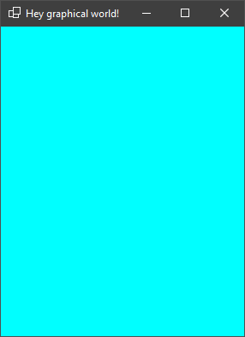

Img. 1. Screenshot of the form for Task 1

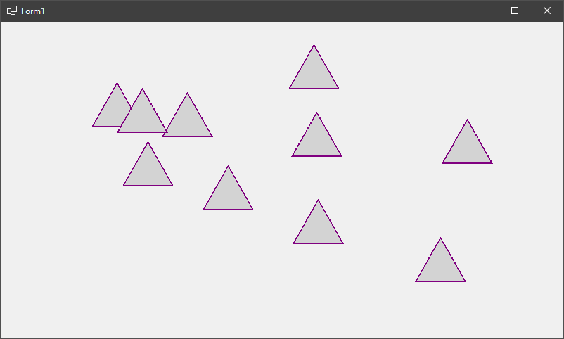

Img. 1. Screenshot of the form for Task 2