Welcome to Word

4 Tips for a simpler way to work.

# You’re an expert with Tell Me

The **Tell Me** box finds the right command when you need it, so you can save time and focus on your work.

Try it:

1. Double click this word: **Adventure**
2. Type reflection in the **Tell Me** box,   
   and point to **Text Effects**.
3. Point to **Reflection**, and choose one of the **Reflection Variations**.  
   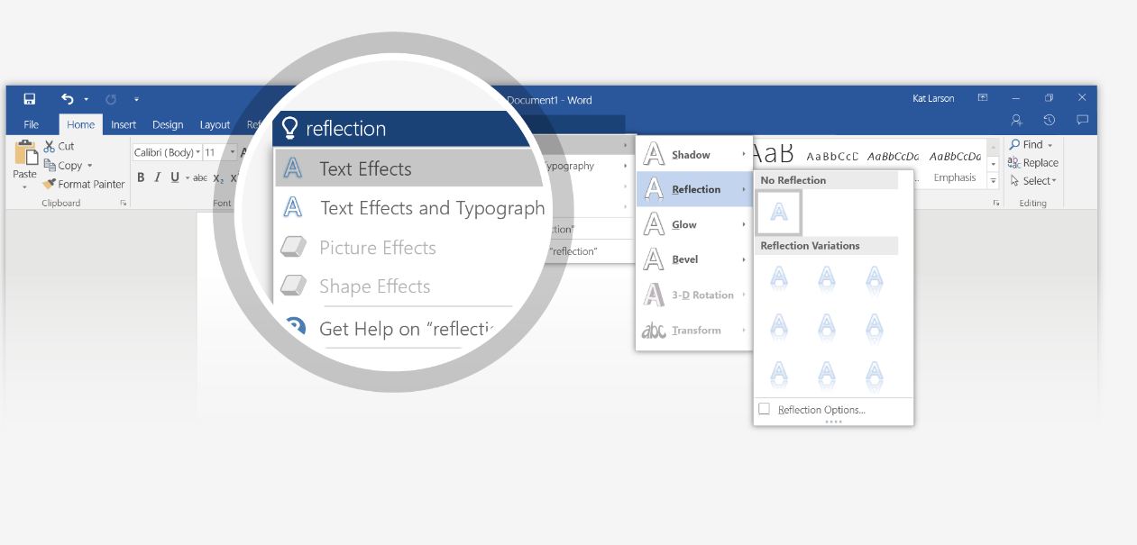

# Explore without leaving your doc

**Smart Lookup** brings research directly in to Word.

Try it:

1. Right click the word office in the following phrase: **office furniture**
2. Choose **Smart Lookup**.  
   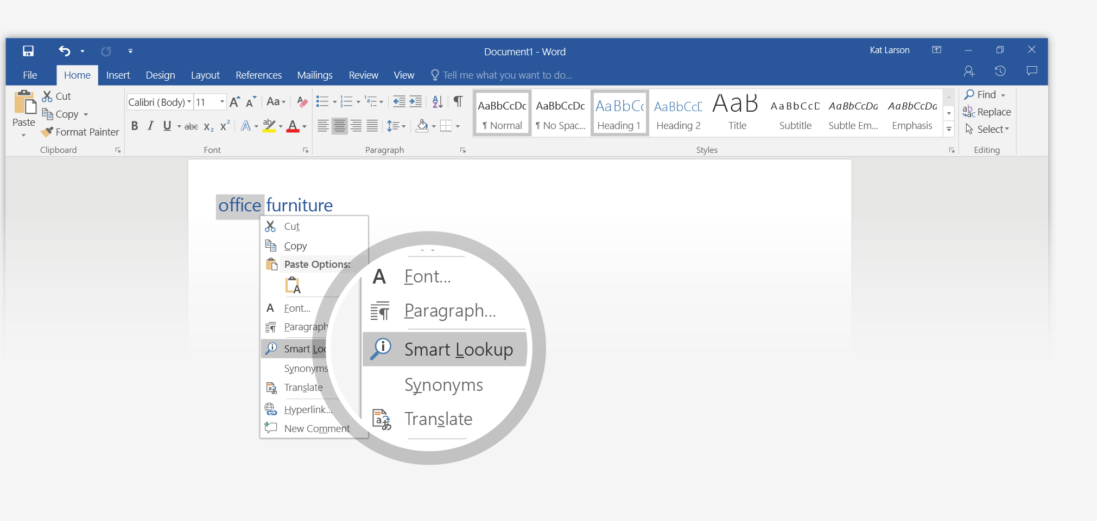
3. Contextual results from online sources like Bing and Oxford Dictionaries are relevant for this use of the word office.  
   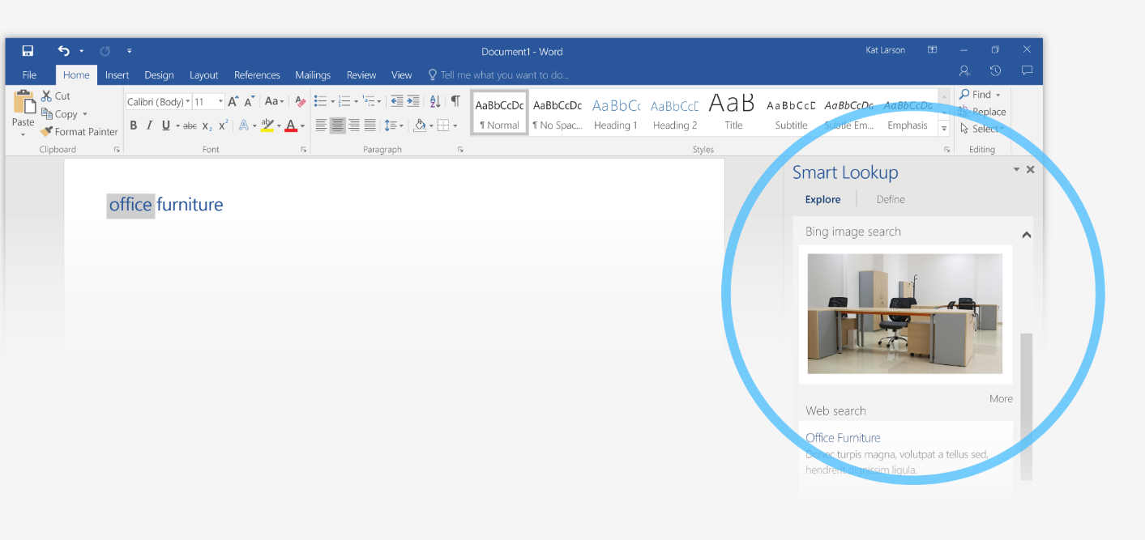
4. Notice that you get different results when you change the context. Try **Smart Lookup** again by right-clicking office in this phrase: **Microsoft Office apps**  
   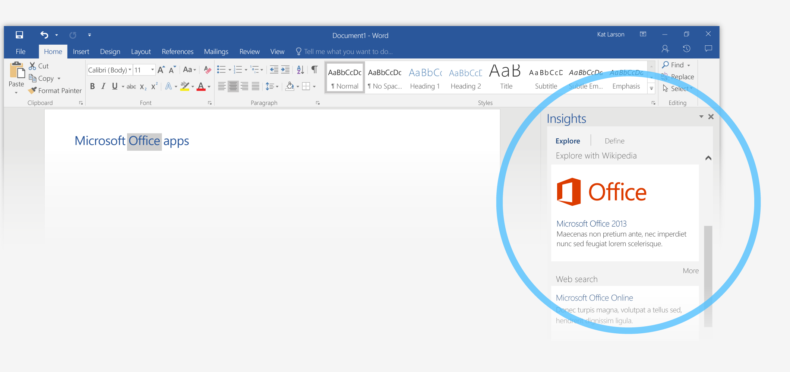

# Look professional, your way

In this document, styles like **Heading 1** and **Title** have been applied to text (**Home** tab, **Styles** gallery). That lets you quickly overhaul the look of the whole document.

Try it:

1. On the **Design** tab, point to the different **Style Sets** and watch the formatting change automatically.  
   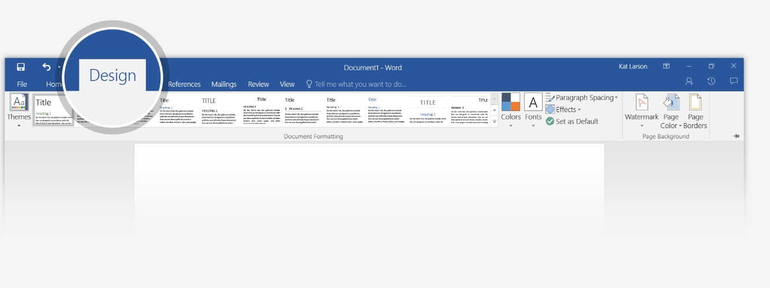
2. Go to **Themes** and watch how colors and font change with the various choices.
3. When you get the design you want all your docs to start with, choose **Set as Default**.  
   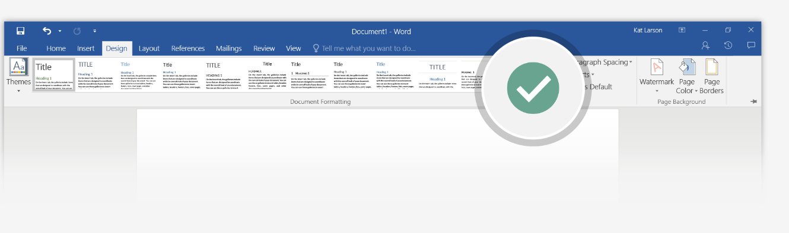

# Work together in real time

With your doc stored in the cloud, you and your colleagues can open it at the same time and see each other making changes.

How it works:

1. Go to **File** > **Save As**, and choose a **OneDrive** or **SharePoint** location.  
   If you’ve never done this before, click **Add a Place**, and then add your **OneDrive** or **SharePoint** service by signing in.  
   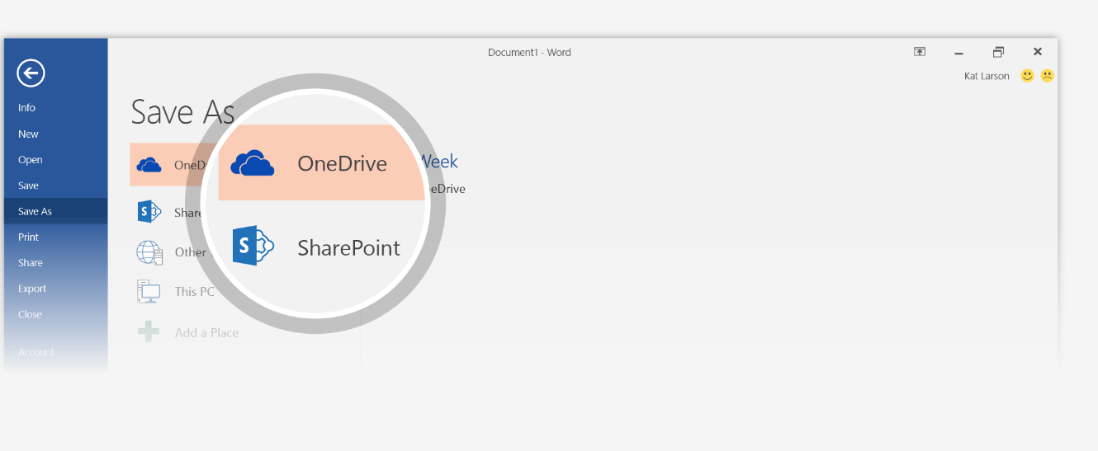
2. Back in the document, click **Share** in the upper right, and **invite people** so they **can edit** with you. They’ll get email with a link to your doc.  
   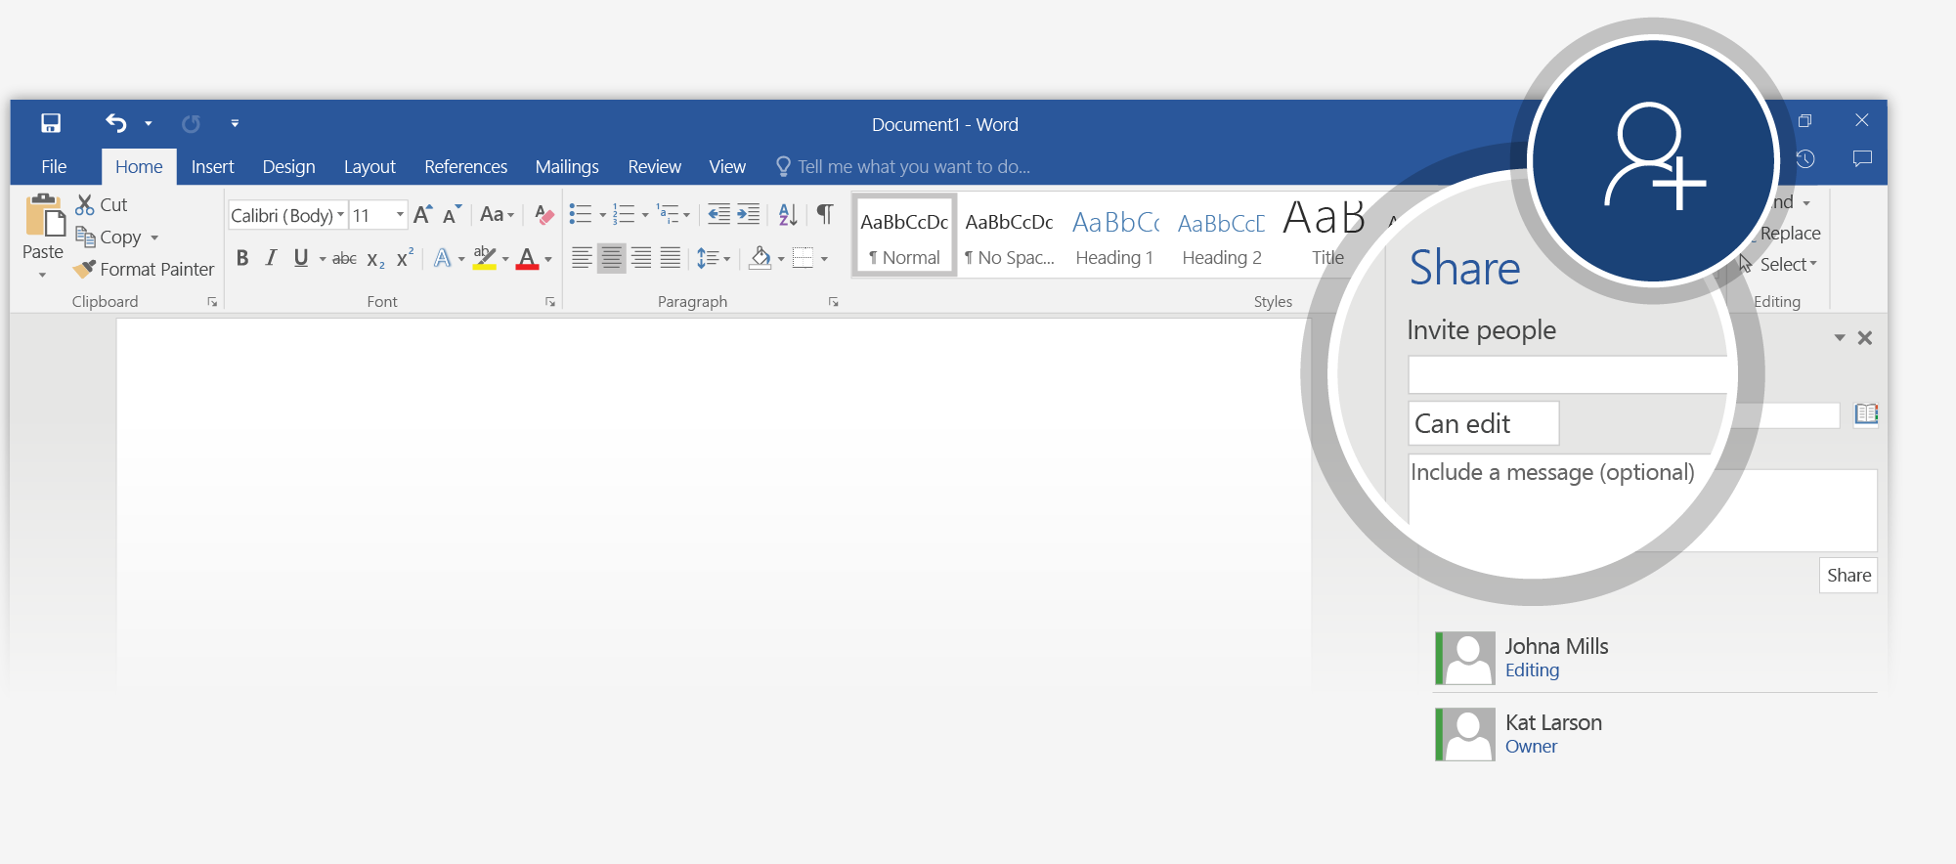

When they follow the link, your doc opens for them in their version of Word, or in their web browser (Word Online).  
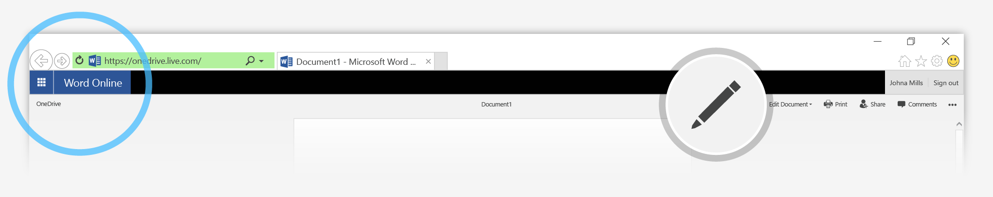

If they’re using Word Online or Word 2016 and have agreed to automatically share changes, you’ll see each other working in the same document.  
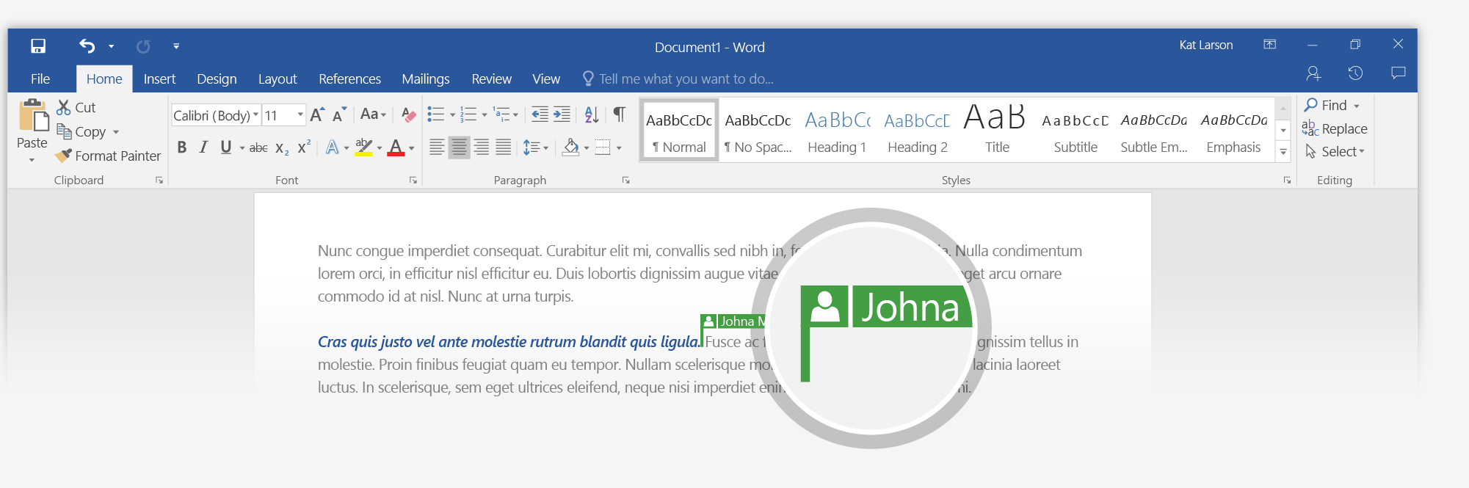

**Note:** The first time you do this in Word 2016, say **Yes** to automatic sharing.  
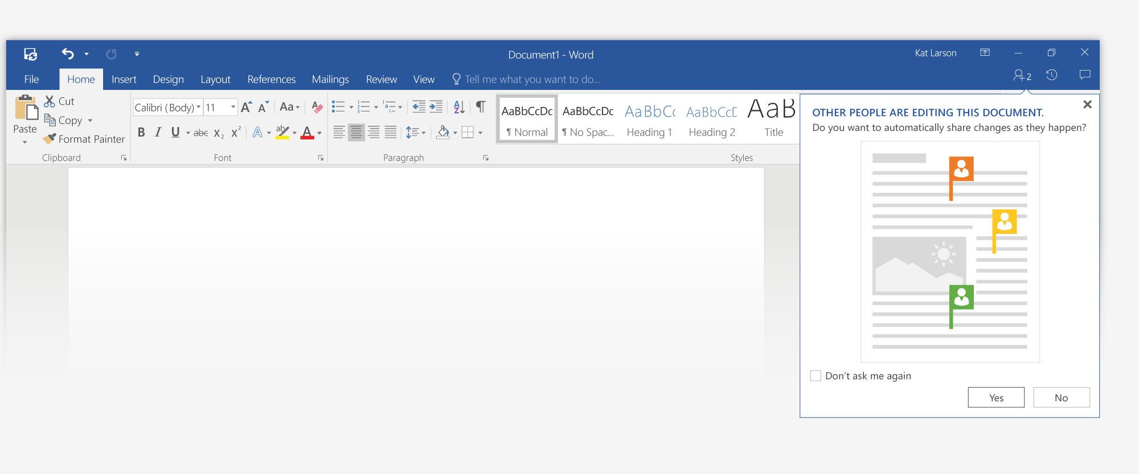

|  |  |
| --- | --- |
| **Tip:** If you’d rather send your own email, **Get a sharing link** instead and then **create an edit link** you can send. | Get a sharing link option |

# More questions about Word?

|  |  |  |  |
| --- | --- | --- | --- |
| Click the **Tell Me** | Tell Me button | | button and type what you want to know. |
|  |  | | Tell Me field |
| Visit the Word team blog. | | [Arrow pointing right with a link to free Word training](http://go.microsoft.com/fwlink/?LinkId=617174) | |
| Go to free Word training. | | [Arrow pointing right with a link to the Word team blog](http://go.microsoft.com/fwlink/?LinkId=623325) | |