1. Introduction
Wima is an API designed to support image transmission over Wirelles Sensor Networks (WSN), it provides a colection of classes to facilitate the implementation and experimentation of visual systems over WSN. This work is an practical extension of a image transmission in image transmission research, the design is based on the main techniches found on the literature.

The API has the fundamental characteristic the ease of adaptation and extension for use in IoT applications, allowing the experimentation of various identified scenarios. Due WSN technical constraints compression, change detection and optmized transmission algorithms are explored on the literature to overcome the WSN technology limitations.

These techniques can have various variants and be used individually or in combination. Thus, there is a wide variety of possible scenarios in the experimentation of solutions for a WSN. These characteristics are important because it was detected in the literature that the techniques are used with various implementation variations and in various arrangements. Therefore, to model the transmission of an image in a WSN.
2. WIMA

The following components were designed:

- Image components : Represents the image data information to be transmitted over the network, it is named tImage and defined in . To take advantage of the simulator environment, a database of images is defined by tImage, the component represents a group of ready-to-use images to automate the simulation.
- Image Slicing : Normally an image represents a large block of data to be handled, in a WSN environment the computational power is limited to solve heavy mathematical algoruthms, then researchs slice the image into small fragments to solve such problems.
Additionally a network has a maximum size of data that can be transmitted at once. If the size of the transmitted data block is greater than a frame of the network, the fragmentation into smaller parts is required.
To solve both computational constraints and network frame package is defined the slicer component to encapsulates the slicing process, it is specified in the xxx .
- Application Protocol: There are not specialized protocols to transmit large amount of data for WSN, the design of optimized protocols between transmitter and receiver is a mandatory component in API, its coordinate the transmission of data between the sender and receiver parts, AppProtocol is presented.

- Network: An entity to interface the transport layer, in which the data will actually be transmitted, Wima implements TransferUDP component in networking process.
- Image compression: Compression is the main technique to reduce amount of data to be transferred in a constrained wireless network, Compression represents the image while tCompressedData represents the compressed data when it exists.

- Change Detection : Change detection techniques detect the parts changed in a sequence of messages, in this way only the changed areas needs to be transmitted, ChangeDetection is a component to implement the change detection algorithm. Similarly the compression component, change detection is an optional implementation.
2.1 Components relationship

Considering two elements of the network, one to send (client) and another to receive (server), the possible relationships between the API components, their attributes and methods, on the client and server parts are described in the Figure

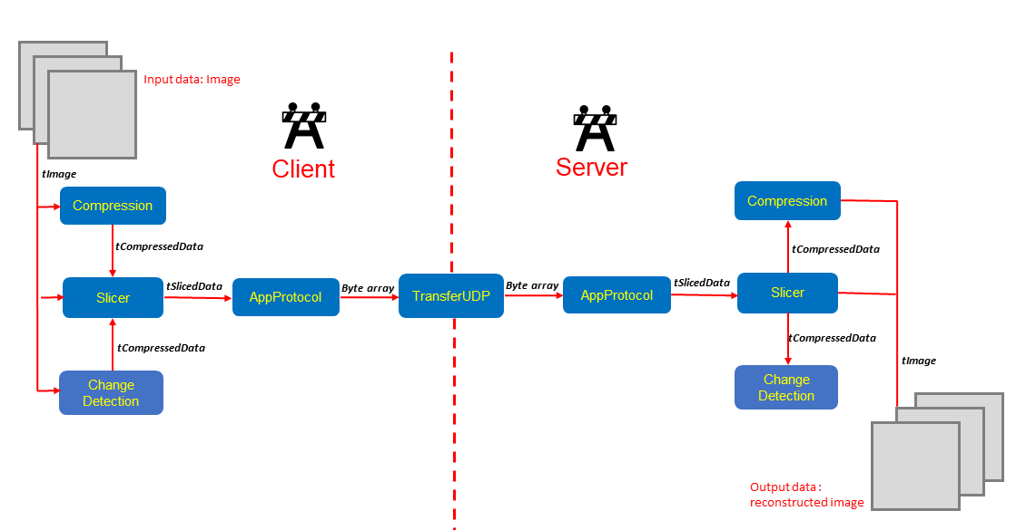

3. API UML Classes

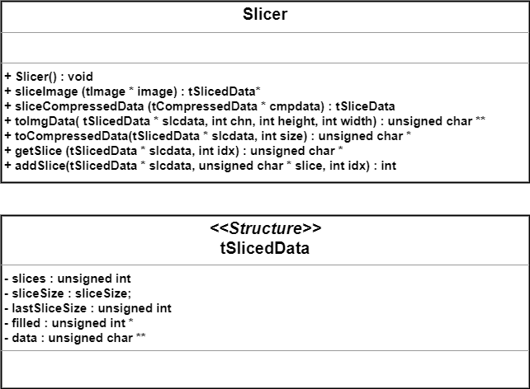

Fig 2. Slicer UML classes

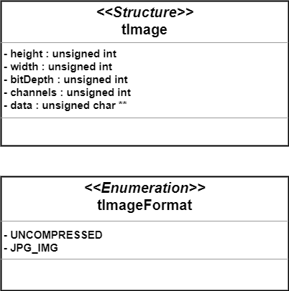

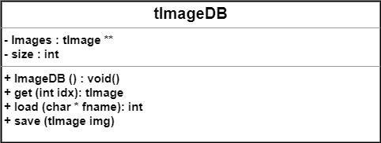

Fig 3. Image and tImageDB UML classes

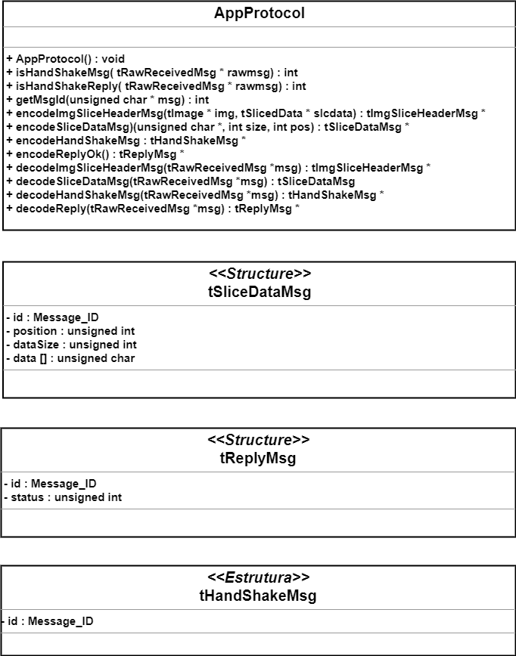

Fig 4. AppProtocol UML classes part 1

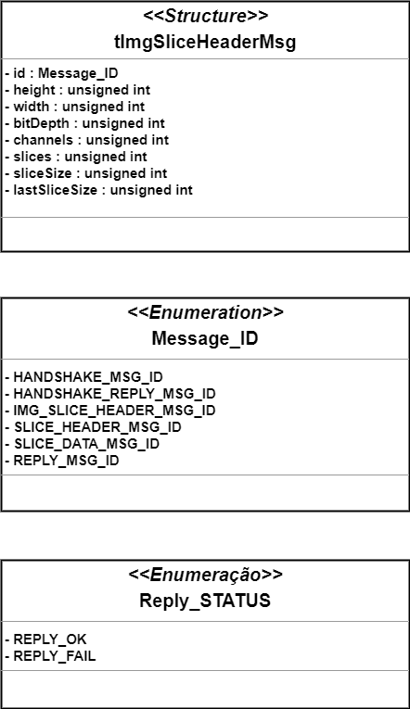

Fig 5. AppProtocol UML classes part 2

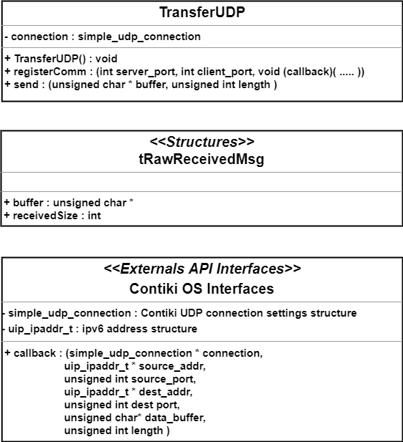

Fig 6. TransferUDP UML classes part 2

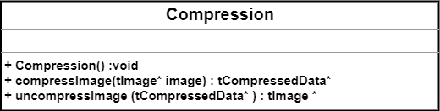

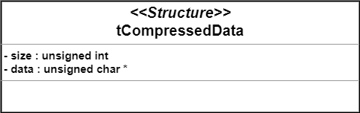

Fig 7. Compression UML classes part 2

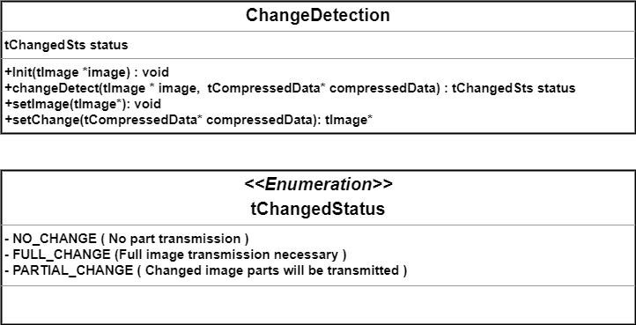

Fig 7. ChangeDetection UML classes part 2

