Vaccination strategies for

Influenza Spreading Models

Ricardo Rei, Raquel Casteleiro, João Ribeiro





# **Introduction:**

Influenza is an infectious disease that according to the World Health Organization affects 5-10% of the adults and 20-30% of children’s world wide. Influenza viruses are spread mainly by droplets made when people sneeze, cough or talk. It is believed that a single droplet can infect someone 6 meter away from the source.

In order to study the spread of this disease we used the high-resolution human contact network (referencia). This work aims to understand how a disease might spread across a school population, so that we can understand how to fight it. Each individual was given a proximity sensor that registered its close proximity interactions (CPR – close proximity record) every 20 seconds. These devices have a radius of 3 meters and had a coverage of 94% of the total school’s population interactions.

“Schools are particularly vulnerable to infectious disease spread because of the high frequency of close proximity interactions” (ref)

In our previous project we studied the topology of this network in order to better understand it. We conclude that the network revealed small-world properties with homogenous contact structure in which short interactions dictate. We also conclude that, when trying to contain or start an epidemic, the students should be the focus, since they proved, throughout our analysis, to be the most popular, most influent and in general the most connected group.

In this project, we explored the spreading of influenza in the network using a SIR model, the effect of different vaccination strategies and the cost associated with those tactics. In order to obtain some more information from influenza in Portugal we also talked with Susana Saldanha, Business Planning & Analytics Manager and Sylvia Lin, General Manager Vaccines both from Sanofi which is one of the major pharmaceuticals selling Influenza vaccines.

During our work, we developed some code in Python[3], package that can be found in our github: https://github.com/RicardoRei/Complex-Networks-17-18

## **SIR model**

An SIR model is and epidemiological model that computes the theoretical number of people infected with a contagious illness in a closed population over time. The name of the model derives from the 3 possible illness states a individual might be in a given time-step. The states are:

* S – a individual in this state is healthy and susceptible to the disease.
* I – a individual in this state is already infected with the disease and can transmit it to others.
* R – a individual in this state is already recovered and can no longer be infected.

In our model we assume that each time-step corresponds to a normal school day.

The probability of an individual change from S state to I state during a school day, or in other words, the probability of transmission per time-step from an infectious individual to a susceptible individual is:

$$1-{\left(1- β\right)}^{w}$$

where $w$ is the number of CPR(20 s) between 2 individuals and $β$ is the probability of transmission per CPR. The intuition is the following:

1. $\left(1- β\right)$ is the probability of **not** transmitting the disease
2. This means that the probability of **not** transmitting the disease in $w$ contacts is ${\left(1- β\right)}^{w}$.
3. The complementary of the probability of **not** transmitting the disease in $w$ contacts is transmitting the disease in $w$ contacts which is equal to $1-{\left(1- β\right)}^{w}$

The value of $β$ we used for our simulations was 0.003, this value has been chosen because it approximates the time-dependent attack rate observed in a outbreak of influenza aboard a commercial airliner (ref) as explained in (ref). We also have studied the effects of this parameter in the spread of the disease in order to get the critical $β$ where the disease changes from endemic to epidemic.

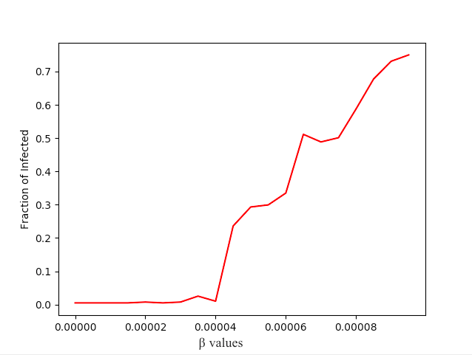

Figure – Fraction of infected population with different $β$ values.

Figure 1 shows that $β ≈0.00004$ is where the Influenza changes from endemic to epidemic. This value is frighteningly small, and finding it wasn’t easy since we weren’t expecting a $β$ so small... but like professor Francisco said: “maybe for this disease the critical $β$ is almost zero” and therefore we decided to test very small values for $β$.

The probability of an individual change from I state to R state during a school day, or in other words, the probability of recovery per time-step from an infectious individual is given by a cumulative distribution function (fig 1) with a mean value of 6. This function assures that an individual recovers between the third day and the ninth day. We chose this interval because Susana Saldanha and Sylvia Lin from Sanofi said that the average time of recovery in a normal influenza case is 1 week.

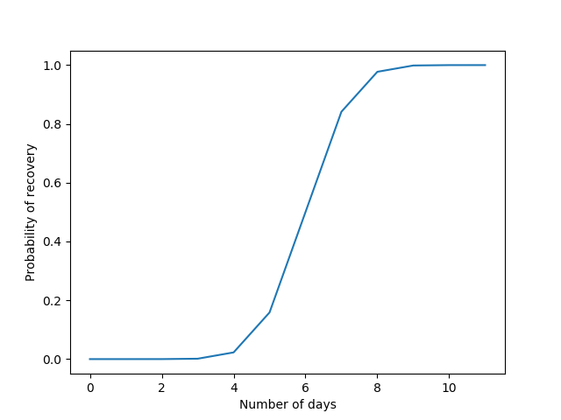

Figure – Cumulative Distribution Function with a mean value of 6

Note that in the study (ref) that we based our work they used a SEIR model which assumes an intermediate state between Susceptible and Infected called Exposed. They also divide each day into 2 half’s (12h) and transmissions only occur on the first half. They also modeled the probability of recovery with a δ parameter equal to 0.05, meaning that an infected individual recovers with a probability of $1- {0.95}^{t}$ per time-step.

Our model is much simpler but the results are pretty much the same. Figure 3 shows the results presented in their study over multiple runs of their model. Figure 4 shows our results with our model over 6 runs.

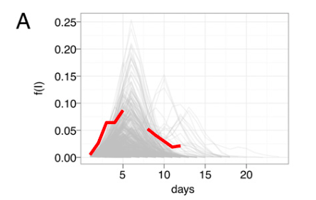

Figure – Frequency of infections over 1000 of SEIR model presented in (ref)

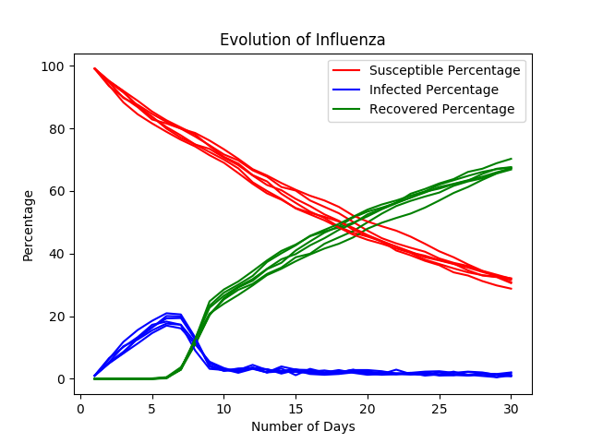

Figure – Percentage of infections over 30 days with SIR model.

Although this figures are a lot different in the way they present the results it’s easy to see that the percentage/frequency of infections in the school population has a peek of 20/0.2 at the sixth day and it fades between the sixth and tenth day.

## **Vaccination:**

Disease control is probably the most important application of these models. There is 3 main ways to halt an epidemic:

1. Aiming at $β$– Transmission-Reducing strategies, in the case of Influenza are not easy to implement and since the $β$ in which the disease starts to be epidemic is so small these strategies have little effect
2. Aiming at $<k>$– Contact-Reducing Interventions, might be useful in Influenza and maybe we could simulate the effects of sending the Infected individuals home for a period of 6 days. But this is not easy to do in a real life situation since due to personal interests people tend to go to school seek unless a complication happens, and separate Infected from Susceptible with a Quarantine methods is not feasible.
3. Aiming at the number of Susceptible individuals – Vaccination Strategies reduce the spreading rate , enhancing the likelihood of the pathogen dies out. In the case of Influenza this is what we believed to be the most efficient and feasible method.

The efficiency of vaccination tactics was tested. We assume that the vaccination occurs before the introduction of the disease and that the vaccine efficacy is 100%. Individuals that are vaccinated start in the Recovery state.

The three vaccination tactics that we implemented were:

* Random – in this strategy a percentage of randomly chosen individuals are vaccinated.
* Vaccination of hubs – in this strategy we use the topology of the network in order to know who are the individuals with more contacts and we vaccinate a certain percentage of this individuals.
* Vaccination of the BFF – in this strategy we randomly choose a certain percentage of individuals and then we ask these individuals who is the person with whom they spend most of the time and vaccinate that person. This tactic is an approximation of the last one that doesn’t require topology knowledge.

|  |  |  |
| --- | --- | --- |
|  | Column Heading | Column Heading |
| Row Heading | Text | 123.45 |
| Row Heading | Text | 123.45 |
|  |  |  |