A Multilevel Signal Detection Theory Approach to Unconscious Processing Research with {uSDT}

Ricardo Rey-Sáez¹, Alicia Franco-Martínez¹, Miguel A. Vadillo², and Francisco Garre-Frutos¹
¹Department of Basic Psychology, Autonomous University of Madrid
²Department of Basic Psychology I, Universidad Nacional de Educación a Distancia

Author Note
Ricardo Rey-Sáez  https://orcid.org/0000-0001-6739-2035
Alicia Franco-Martínez https://orcid.org/0000-0002-9710-1240
Miguel A. Vadillo https://orcid.org/0000-0001-8421-816X
Francisco Garre-Frutos https://orcid.org/0000-0001-9810-186X
This study was not preregistered. All data, models, and scripts required to reproduce the results of this work are publicly available on both Zenodo [ZENODO-URL, ZENODO-REF] and GitHub [GITHUB-URL, GITHUB-REF]. Portions of the results reported in this article were previously presented at the 2025 28th Annual Meeting of the ASSC (Heraklion, Greece), and at the Second Joint Meeting of the Spanish Society for Experimental Psychology (SEPEX) and the Belgian Association for Psychological Science (BAPS) (September 2026; Valencia, Spain). This work was supported by the Spanish Ministry of Science and Innovation grant PID2023-150830NB-I00. During the preparation of this work, the authors used Claude Opus 5.5 (Anthropic) and ChatGPT Sol 6.0 (OpenAI) for copyediting and as programming assistants. After using these tools/services, the authors reviewed and edited the content as needed and take full responsibility for the content of the publication.
Author roles were classified using the Contributor Role Taxonomy (CRediT; https://credit.niso.org/) as follows: Ricardo Rey-Sáez: conceptualization (equal), data curation (lead), formal analysis (lead), investigation (equal), methodology (equal), project administration (lead), software (lead), validation (lead), visualization (supporting), writing – original draft, and writing – review & editing (equal). Alicia Franco-Martínez: conceptualization (equal), investigation (supporting), methodology (supporting), software (supporting), and writing – review & editing (equal). Miguel A. Vadillo: conceptualization (equal), funding acquisition (lead), resources (lead), supervision (equal), and writing – review & editing (equal). Francisco Garre-Frutos: conceptualization (equal), investigation (equal), methodology (equal), software (supporting), visualization (lead), and writing – review & editing (equal)
Correspondence concerning this article should be addressed to Francisco Garre-Frutos, Department of Basic Psychology, Autonomous University of Madrid, Madrid, Spain, Email: francisco.garre@uam.es

Abstract
To test for unconscious processing, researchers typically compare measures of a stimulus’s influence on behavior with measures of awareness of that stimulus. Three common hypotheses are often tested: whether influence is significant while awareness is not (group-level dissociation), whether both measures are independent across participants (correlation), or whether influence persists when awareness is extrapolated to be zero (regression intercept). These hypotheses are typically tested separately, and the conventional analyses suffer from three methodological limitations: First, both measures often differ in scale and number of trials, complicating meaningful comparisons of their relative sensitivities. Second, analyses based on participant-level sensitivities ignore measurement error, which attenuates correlations and inflates regression intercepts, leading to misleading evidence for unconscious processing. Third, the correlation hypothesis requires evidence of null association, but conventional significance tests provide limited evidence for the absence of an effect. To address these problems, we introduce a multilevel signal detection theory (SDT) model that jointly analyzes trial-level responses from both measures and allows all three hypotheses to be tested directly while accounting for measurement error. The model supports both frequentist and Bayesian estimation, allowing researchers to do non-superiority tests and quantify evidence for null hypotheses using Bayes factors. We illustrate this approach through reanalyses of three published studies on unconscious processing. The {uSDT} R package provides an accessible way to fit the joint multilevel SDT model and evaluate all three hypotheses more rigorously.

Impact Statement
Claims that the mind can process information without conscious awareness have broad implications for theories of perception, learning, and decision making. However, commonly used statistical analyses can distort evidence, making unconscious processing appear stronger than it is. Measures for these analyses often differ in scale and number of trials, making their sensitivities difficult to compare. Moreover, analyses based on individual sensitivities often ignore measurement error, which can distort conclusions about unconscious processing. We introduce a statistical framework that addresses these problems and allows researchers to evaluate three common hypotheses about unconscious processing within a single model. We also provide free, open-source software to make this approach accessible to applied researchers.
Keywords: Unconscious processing, Signal detection theory, Multilevel modeling, Measurement error, Awareness
Word Count: 11559

A Multilevel Signal Detection Theory Approach to Unconscious Processing Research with {uSDT}
Understanding cognition requires acknowledging that some cognitive processes operate outside conscious awareness (Hassin, 2013; Kihlstrom, 1987; Merikle et al., 2001). Yet, demonstrating that a process is truly unconscious remains one of experimental psychology’s greatest challenges (Holender, 1986; Newell & Shanks, 2014; Shanks et al., 2021; Stockart et al., 2025). The difficulty is not simply to show that a stimulus or a regularity influences behavior, but to demonstrate that it does so in the absence of awareness.
Most research on unconscious processing can be broadly categorised into two types of paradigms. In experiments on unconscious stimulus processing, researchers are often interested in testing whether individual stimuli (or a critical feature of it) can influence behavior without conscious awareness of those stimuli. To this end, they often employ procedures that limit the conscious availability of the relevant information, such as masking or brief stimulus presentations, and examine whether this information can nevertheless influence performance (Kim & Blake, 2005; Kouider & Dehaene, 2007). In experiments of implicit learning, by contrast, researchers are typically interested in investigating whether learned regularities or stimulus contingencies acquired across many trials can influence behavior without conscious awareness of those regularities (Frensch & Rünger, 2003; Perruchet & Pacton, 2006; Shanks, 2010). Thus, although these paradigms differ in the nature of the relevant information and how it is presented, both types of paradigms typically combine a measure of the influence of this information on behavior (hereon called “influence task,” but also known as indirect or implicit; Reingold & Merikle, 1988; Shanks & St. John, 1994) with a measure of awareness of such information (hereon called “awareness task”, but also known as direct or explicit).
Yet, the procedures used to obtain these two measures, however, can differ considerably across paradigms. In unconscious stimulus processing experiments, the relevant information is often presented on individual trials, allowing both its behavioral influence and awareness to be assessed at the trial level. Awareness can be measured on individual trials through subjective reports of stimulus perception, or in a separate task, often using objective measures that assess whether participants can detect or discriminate the relevant information above chance (Sandberg et al., 2010). In contrast, in implicit learning experiments, the relevant regularities are acquired across multiple trials, and assessing awareness during learning may itself promote explicit knowledge of these regularities (e.g., Smyth & Shanks, 2008). Consequently, awareness is often assessed separately, after the measurement of its influence, through recognition, generation, or other tests of explicit knowledge (Shanks & Johnstone, 1999; Shanks & St. John, 1994; Vadillo et al., 2016). Despite these procedural differences, the logic underlying inferences about unconscious processing remains remarkably similar across paradigms, facing many of the same methodological challenges (Schmidt & Vorberg, 2006; Shanks et al., 2021).

Three Hypotheses of Unconscious Processing
Much of the evidence for unconscious processing has been organized around three key hypotheses (Shanks et al., 2021). The first, and perhaps the most common, is the group-level dissociation hypothesis, traditionally formulated as a simple dissociation: the relevant information influences behavior despite the absence of detectable awareness. Conventionally, this hypothesis has been tested by conducting two separate tests at the group level, showing a statistically significant influence on behavior alongside a nonsignificant effect on awareness (Cheesman & Merikle, 1984). In a seminal study, for instance, Dehaene et al. (1998) found that masked number primes influenced responses to congruent targets by speeding them an average of 24 ms, although participants could not discriminate the primes significantly better than chance, concluding that semantic priming can operate in the absence of awareness. Beyond this specific example, this kind of evidence has been used to claim unconscious processing in disparate literatures, such as reward-driven motivation (Pessiglione et al., 2007) or face perception (Finkbeiner & Palermo, 2009; Wójcik et al., 2019), as well as in lie detection (ten Brinke et al., 2014), response inhibition (van Gaal et al., 2010), fear conditioning (Öhman & Soares, 1998), relational memory (Reber et al., 2012), and visual statistical learning as measured by processes such as distractor suppression (Wang & Theeuwes, 2018) or contextual cuing (Chun & Jiang, 1998; Jiang et al., 2013), among others (Anderson et al., 2021).
The second is the correlation (or regression slope) hypothesis, which predicts that individual differences in the influence-task effect should not correlate with awareness across participants. Researchers test this hypothesis by computing, for each participant, a measure of influence (e.g., a difference score) and an awareness score, and then correlating these scores across participants. A nonsignificant correlation is often taken as evidence that the measure of influence is driven by a process operating independently of awareness. For example, Salvador et al. (2018) found that the effect of briefly flashed cues on memory suppression was unrelated to participants’ ability to discriminate against those cues, even though discrimination was above chance at the group level, suggesting that memory suppression can be triggered by unconscious cues. Similar null correlations have been taken as evidence of unconscious processing in literatures such as response inhibition (Chiu & Aron, 2014), syntactic priming (Berkovitch & Dehaene, 2019), affective priming (Wentura et al., 2025), contextual cuing (Colagiuri & Livesey, 2016; Geyer et al., 2010), statistical, sequence, and language learning (Batterink et al., 2015; Paciorek & Williams, 2015; Sanchez et al., 2010), and evaluative and classical conditioning (Dickinson & Brown, 2007; Jensen et al., 2015).
The third is the intercept hypothesis, which posits that the influence-task effect should be different from zero when awareness is assumed to be absent. To test this hypothesis, researchers use the same participant-level scores as in the correlation hypothesis, but regress the influence-task effect on awareness (Greenwald et al., 1995). The intercept of this regression is the expected influence-task effect for a hypothetical participant with no awareness, so a significant intercept is typically interpreted as evidence that the effect persists in the absence of awareness. Berkovitch and Dehaene (2019), for instance, concluded from a significant intercept that syntactic priming remained significant in participants with null sensitivity to the primes. A significant intercept has also been reported as evidence of unconscious processing in literatures such as Pavlovian conditioning (Greenwald & De Houwer, 2017; Raes & De Raedt, 2011), semantic priming (Bruno et al., 2020; Daltrozzo et al., 2011; Draine & Greenwald, 1998), relational memory (Nickel et al., 2015), attention and motion prediction (Goldstein et al., 2020; Z. Lin & Murray, 2013), and motivation and cognitive control (Pas et al., 2014; Reuss et al., 2015; Wokke et al., 2011).
Taken at face value, these findings suggest that a wide range of cognitive processes can operate outside conscious awareness. However, as several authors have pointed out, the methods traditionally used to test these hypotheses can systematically bias the evidence in favor of unconscious processing, casting doubt on the validity of such conclusions (Franco-Martínez et al., 2025; Klauer et al., 1998; Malejka et al., 2021; Meyen et al., 2022, 2024; Miller, 2000; Newell & Shanks, 2014; Reingold & Merikle, 1988; Rothkirch et al., 2022; Schmidt & Vorberg, 2006; Shanks, 2017; Shanks et al., 2021; Shanks & St. John, 1994; Vadillo et al., 2016, 2020, 2022, 2025).
In the following sections, we first examine the methodological challenges of the conventional analyses to test the three hypotheses. Next, we introduce a multilevel SDT model that addresses all these challenges within a single statistical framework. Then, we present two simulation studies to review the performance of the multilevel SDT model. Finally, we reanalyze three published studies on unconscious conditioning, contextual cuing, and masked affective priming using the open-source R package {uSDT} (Rey-Sáez, Garre-Frutos, et al., 2026), which we developed to make these analyses straightforward for applied researchers and which is publicly available on CRAN.

Challenges to Infer Unconscious Processing

Challenges for the Group-Level Dissociation Hypothesis
When researchers attempt to establish a simple dissociation, that is, a significant effect in the influence task alongside with a nonsignificant effect in the awareness task, two methodological challenges arise. First, inferring a null effect based on a nonsignificant result commits the well-known fallacy of accepting the null hypothesis (Dienes, 2014; Nickerson, 2000). As Carl Sagan (1977, p. 7) noted, “absence of evidence is not evidence of absence”. Thus, establishing a simple dissociation requires evidence that awareness is genuinely absent, not simply failing to detect that it is present.
Relatedly, the second challenge concerns statistical power. The probability of detecting a true effect depends, among other factors, on sample size, the number of trials, and the amount of measurement error. In practice, experiments on unconscious processing often collect substantially more trials in the influence task than in the awareness task. Although in some studies awareness tasks may collect hundreds of trials (e.g., Greenwald et al., 1995; Greenwald & De Houwer, 2017), in most cases awareness is measured with only a few dozen (Vadillo et al., 2016) or even a single trial (Jiang et al., 2015; Wang & Theeuwes, 2018). Figure 1 illustrates how the number of trials can, by design, favor detecting a true effect in the influence task compared to the awareness task (e.g., lower statistical power), even when assuming that the true effect is the same in both tasks.

Figure 1
Probability of Detecting a Significant Effect as a Function of the Number of Trials
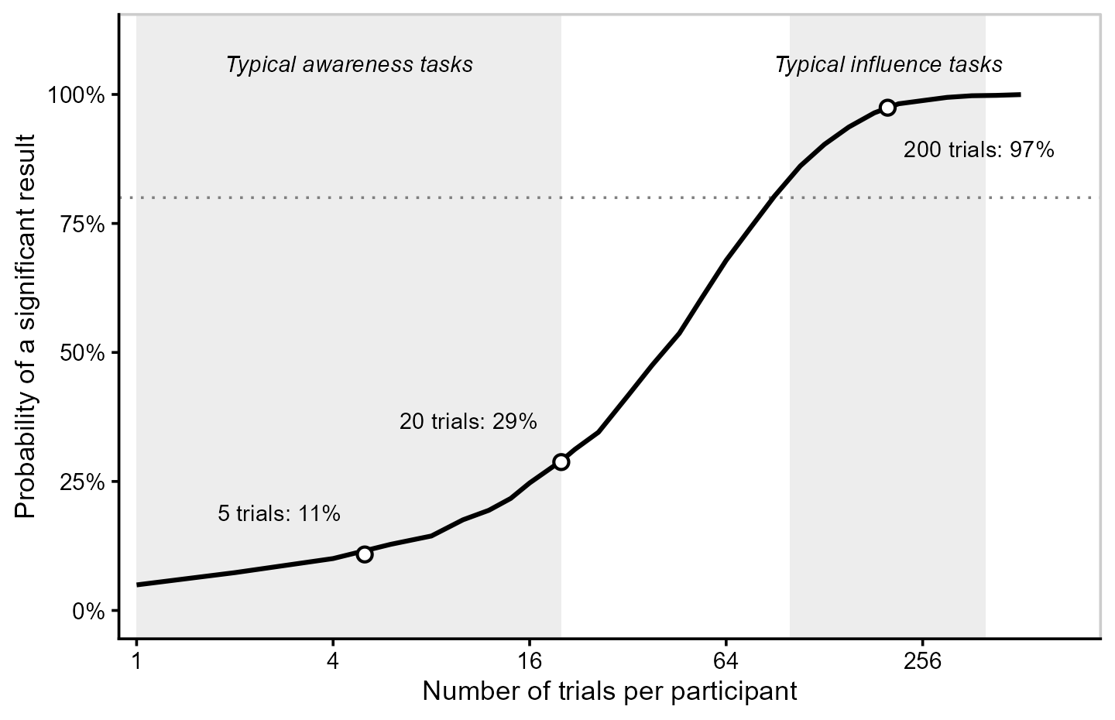
Note. Power of a one-sample t test ($α$ = .05) for 30 participants with the same true mean sensitivity in both tasks ($d^{'}$ = 0.15, between-participant SD = 0.10). Shaded bands mark typical numbers of trials in each task; the dotted line marks 80% power.

Moreover, both influence and awareness measures often suffer from substantial measurement error, particularly when estimated from a limited number of trials (Hernández-Gutiérrez et al., 2025; Vadillo et al., 2022). This error reduces the precision of the estimated effects and, consequently, the statistical power to detect them. Combined with the differences in the number of trials, this may leave awareness tasks with considerably less statistical power than influence tasks.
This imbalance increases the probability of finding a significant influence effect alongside a nonsignificant awareness effect, even when participants have some conscious sensitivity to the relevant information. Indeed, meta-analyses of hundreds of participants across studies have found above-chance awareness in paradigms where individual studies frequently failed to detect it (Vadillo et al., 2016, 2020). In other words, the traditional approach may produce apparent simple dissociations merely because awareness is often measured less precisely almost by design.
Regardless of these methodological challenges, what is perhaps less obvious is that this simple dissociation is often misinterpreted as evidence that the influence task is more sensitive to the relevant information than can be consciously reported in the awareness task (Meyen et al., 2022, 2024). However, as Gelman and Stern (2006, p. 328) famously noted, “the difference between ‘significant’ and ‘not significant’ is not itself statistically significant”. Establishing that the influence task is more sensitive requires directly comparing the sensitivities of both tasks. This alternative criterion, known as a sensitivity dissociation, has long been advocated as a way to move beyond the traditional requirement of demonstrating null awareness (Reingold & Merikle, 1988; Schmidt & Vorberg, 2006).
However, greater sensitivity in the influence task does not, by itself, establish unconscious processing. This interpretation relies on the assumption that the awareness task is at least as sensitive to consciously available information as the influence task. If this assumption holds, any additional sensitivity in the influence task cannot be explained by conscious information alone. To make this assumption more plausible, Reingold and Merikle (1988) recommended that the two tasks be as similar as possible, differing mainly in whether participants are explicitly asked to discriminate the relevant information.
Unfortunately, testing a sensitivity dissociation is not straightforward because influence and awareness effects are rarely measured in terms that allow to compare them in a common sensitivity metric (Meyen et al., 2022; Reingold & Merikle, 1988; Schmidt & Vorberg, 2006). Although one task may already be expressed in terms of signal detection theory (SDT; Green & Swets, 1966) sensitivity ($d^{'}$), the other (or both) may instead be expressed as accuracy or response times (RTs) difference. The problem is that these measures differ not only in their scales but also in what they quantify. Sensitivity, as measured in typical awareness tasks, captures how well participants can use information available for explicit reporting to discriminate between experimental conditions. Applying the same logic, a measure of sensitivity in RTs should discriminate between experimental conditions, so if we observed a RT from a single trial without knowing which condition produced it, how accurately could we identify that condition?
Consider two participants who achieve the same accuracy in an awareness task. Participant 1 tends to respond “present” when the stimulus is actually present and “absent” when it is absent. Participant 2, however, responds “present” much more often, even when no stimulus was shown. If present trials are more frequent than absent trials, both participants can achieve the same accuracy, even though Participant 1 is better at distinguishing between the two conditions. In other words, Participant 1’s responses tell us more about whether the stimulus was actually present, and thus their awareness sensitivity is higher than that for Participant 2. This is precisely what sensitivity $d^{'}$ captures by taking both hits and false alarms into account.
The same might be applied to RTs. Now, imagine two participants who show the same mean RT difference of 50 ms between experimental conditions (Figure 2). For Participant 1, RTs are clearly different between conditions (due to small SD = 25 ms; Panel A), so knowing how long they took to respond would easily allow us to identify the condition. For Participant 2, however, RTs are much more similar across conditions (due to larger SD = 125 ms; Panel B), making it difficult to identify the condition from a single response. This difference is reflected in their sensitivities. Under the equal-variance SDT model, $d^{'}$ can be expressed as the difference between conditions in units of the participant’s own RT variability. Thus, for Participant 1, a 50-ms difference corresponds to 2.00 SDs (50/25 = 2.00; Panel C), whereas for Participant 2 the same 50-ms difference corresponds to only 0.40 SD (50/125 = 0.40; Panel D).
In other words, Participant 1’s RTs contain more information about which condition was presented, and thus their influence-task sensitivity is higher than that of Participant 2. Moreover, even a measure with small sensitivity can produce a highly significant mean RT difference at the group level when enough trials are collected (Meyen et al., 2022). Thus, comparing mean RT differences or accuracies is not equivalent to comparing sensitivities. To establish that the influence task is more sensitive than the awareness task, both must be evaluated using a common sensitivity metric.

Figure 2
Same RT Mean Difference, Different Sensitivities
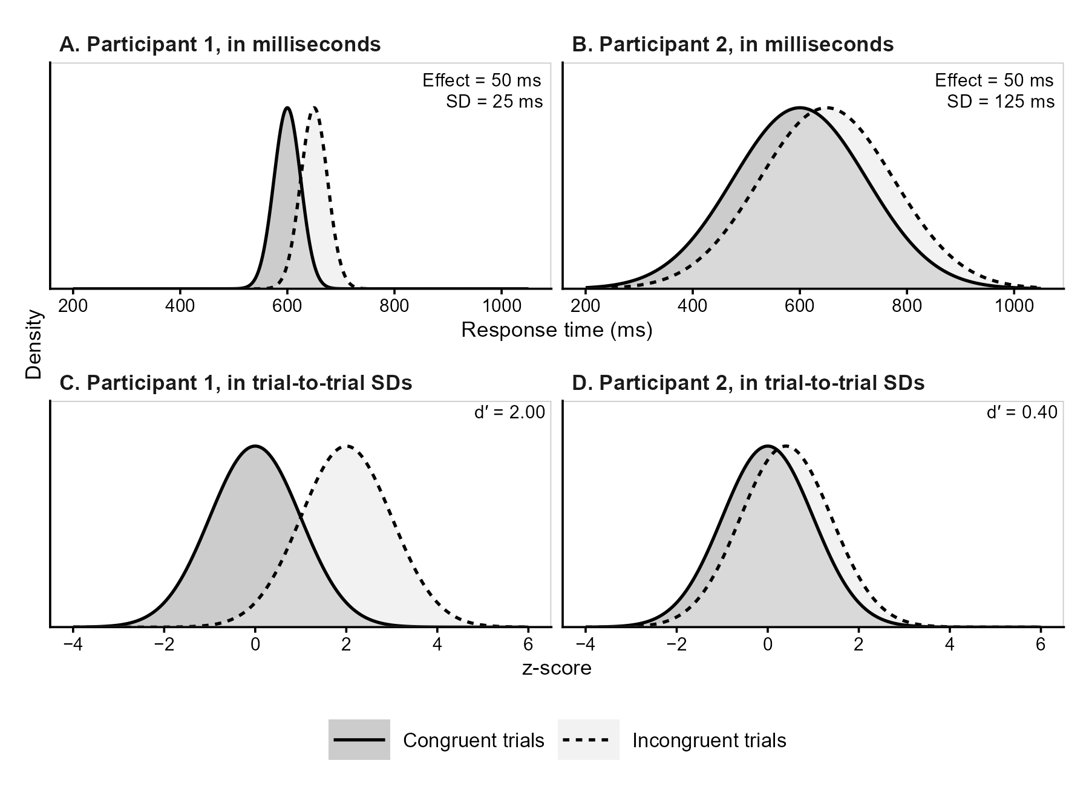
Note. RT distributions of two hypothetical participants with identical mean priming effects (50 ms) but different within-condition variability (SD = 25 vs. 125 ms). The top row shows RTs in milliseconds. In the bottom row, RTs from both conditions are standardized as $z=(RT-μ_{C})/σ$, where $μ_{C}$ is the mean congruent RT and $σ$ is the common within-condition SD. The resulting distributions have means of 0 (congruent) and $(μ_{I}-μ_{C})/σ=d^{'}$ (incongruent), where $μ_{I}$ is the mean incongruent RT.

Challenges for the Correlation and Intercept Hypotheses
The correlation and intercept hypotheses are also affected by measurement error, but with an important difference. Whereas measurement error primarily reduces the precision of group-level estimates (affecting significance but not biasing the mean value), it can also systematically bias estimates of the relationships between tasks (i.e., correlation and regression parameters). This problem arises from the two-step approach commonly used to test these hypotheses. First, researchers compute a single score for each participant and task, such as a mean RT difference or a $d^{'}$. Second, these scores are used in correlation or regression analyses, treating them as if they were measured without error. However, as discussed above, participant-level scores estimated from a finite number of trials inevitably contain measurement error, which can be substantial in experimental tasks (Enkavi et al., 2019; Hedge et al., 2018; Yaron et al., 2024).
The magnitude of this problem has already been illustrated empirically. In the two experiments of Salvador et al. (2018), the split-half reliability of the memory suppression effect was only .26 and $-$.04, respectively, compared with .59 and .72 for the awareness measure (Malejka et al., 2021). In contextual cuing, with the median number of awareness trials used in the literature, the expected reliabilities of two-alternative forced-choice and old/new recognition tests are only .12 and .16, respectively (Vadillo et al., 2022). Similarly, Hernández-Gutiérrez et al. (2025) found that the reliability of the priming effect was below .10 in four of the five masked syntactic priming experiments of Berkovitch and Dehaene (2019), whereas the reliability of the awareness measure ranged from .03 to .48. Concerningly, much of the observed between-participant variability in many of these experiments seems to reflect measurement error rather than true individual differences.
Ignoring this error has two important consequences. First, it attenuates the estimated correlation between influence and awareness (Spearman, 1904), making the two measures empirically appear more independent than they actually are. Second, measurement error in awareness can inflate the regression intercept, making the influence effect empirically appear positive even when the true effect at zero awareness is null (Klauer et al., 1998; Miller, 2000). This is, in fact, just a consequence of regression to the mean: participants whose awareness is underestimated by chance may appear unaware, while their influence scores tend to remain closer to the group mean, which is typically above zero (Shanks, 2017; Shanks et al., 2021). Vadillo et al. (2022) illustrated both consequences using a model in which contextual cuing and recognition depended on a single latent variable and were therefore perfectly correlated at the latent level. Given the trial-by-trial variability in the observed data, the model predicted correlations of only .15 to .30 between the observed scores, alongside positive regression intercepts. Thus, conventional analyses may suggest unconscious processing even when both tasks depend entirely on the same underlying process.
To illustrate these problems, consider a population in which awareness-task sensitivity is higher than influence-task sensitivity ($μ_{I}-μ_{A}=-0.15$), the two are strongly correlated ($ρ=.78$), and the regression intercept is zero (Figure 3A). Thus, none of the three parameters supports an inference of unconscious processing. Figure 3D shows the true sensitivities of 40 participants sampled from this population, as if each had completed an infinite number of trials.

Figure 3
Effects of Measurement Error on Correlations and Regression Intercepts
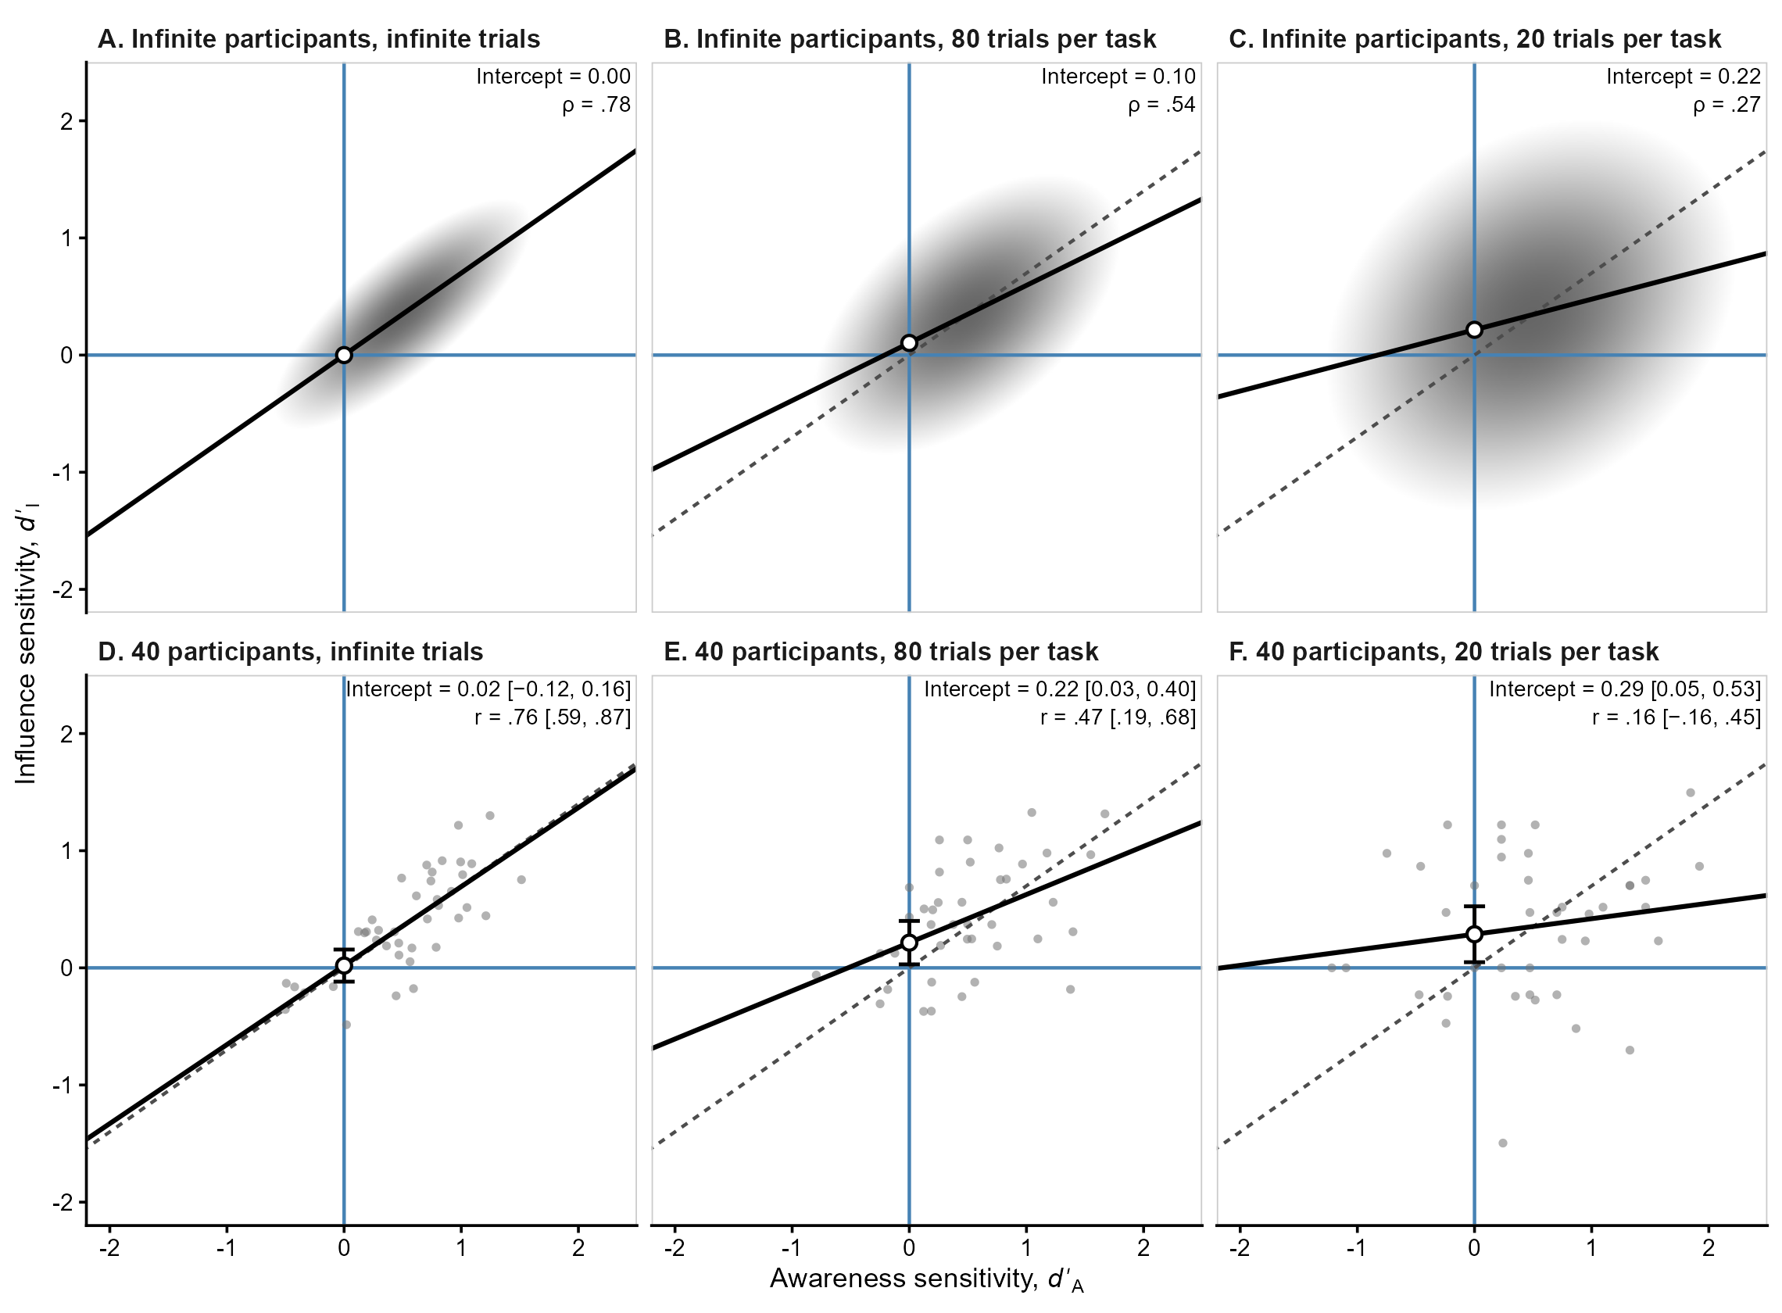
Note. Simulated population with correlated true sensitivities and a zero regression intercept. Top row: population distributions, with darker contours indicating greater density and shaded regions encompassing 95% of the population. Bottom row: the same 40 participants, with sensitivities measured without error (left) or estimated from 80 (middle) and 20 (right) trials per task, yielding reliabilities of approximately .70 and .35, respectively. Solid lines show regressions of influence on awareness sensitivity; dashed lines show the true population regression. Open circles indicate intercepts (error bars: 95% CIs). Upper-right values show intercepts and correlations, with 95% CIs for sample estimates.

However, when sensitivities are estimated from a finite number of trials using the conventional two-step approach, measurement error distorts both correlations and regression intercepts. With 80 trials per task (reliability $≈$ .70, a value sometimes considered acceptable in the psychometric literature; Nunnally, 1978), the population correlation decreases to .54 and the intercept increases to .10 (Figure 3B). With only 20 trials (reliability $≈$ .35), the correlation drops to .27 and the intercept increases to .22 (Figure 3C). Crucially, for the same 40 participants, the intercept becomes significantly positive with both 80 trials (0.22, 95% CI [0.03, 0.40]; Figure 3E) and 20 trials (0.29, 95% CI [0.05, 0.53]; Figure 3F), incorrectly suggesting that influence persists in the absence of awareness. Note that these biases cannot be simply fixed by collecting large sample sizes, as they would persist even with an infinite number of participants, because they arise from measurement error rather than participant-sampling variability.
Finally, as illustrated above, the correlation hypothesis faces the same inferential challenge discussed earlier for simple dissociations. A nonsignificant correlation does not establish the genuine absence of a relationship between influence and awareness. Instead, researchers need methods that both address the impact of measurement error and can distinguish evidence for a null or negligible correlation from inconclusive results, such as Bayesian hypothesis testing (Dienes, 2014; Wagenmakers, 2007) or equivalence testing (Lakens, 2017).

Addressing All Challenges in a Single Approach
Several solutions have been proposed within both frequentist (e.g., Fuller, 1987; Hunter & Schmidt, 2015; Klauer et al., 1998; Lublinsky et al., 2026; Meyen et al., 2022; Spearman, 1904) and Bayesian (e.g., Dienes, 2014; Goldstein et al., 2022; Malejka et al., 2021; Matzke et al., 2017; Rouder & Haaf, 2019) frameworks, but they typically address these limitations in isolation. Applied researchers are therefore left with a patchwork of techniques that differ in their assumptions and often lack accessible software implementations.
In this article, we propose a single-step approach to address these challenges, based on a multilevel extension of SDT (DeCarlo, 2010). The {uSDT} package integrates the necessary procedures into a single function call, allowing researchers to test the unconscious processing hypotheses while addressing the common challenges: First, researchers’ measures of influence and awareness can be expressed on a common sensitivity scale ($d^{'}$), using the approach of Meyen et al. (2022) when necessary. Second, by jointly modeling trial-level responses, the model accounts for measurement error and different numbers of trials across tasks, allowing researchers to estimate the differences and relationships between their true sensitivities. Third, the {uSDT} package supports both Bayesian hypothesis testing and frequentist equivalence testing, allowing researchers to evaluate evidence for null or negligible effects rather than relying on nonsignificant results.

Comparing the Sensitivity of Influence and Awareness Tasks
As discussed in the Introduction, the group-level dissociation hypothesis concerns whether the influence task is more sensitive to the relevant information than the awareness task. A meaningful comparison therefore requires two things: expressing sensitivity in both tasks on a common scale and collecting enough information from each task to achieve adequate statistical power to detect a difference between them.
We already explained why comparing the sensitivities of influence and awareness tasks requires both measures to be expressed on a common SDT scale ($d^{'}$). When tasks involve binary discrimination responses—such as identifying whether a stimulus was present or absent—, sensitivity can be estimated directly from the trial-level responses using SDT. However, when performance is measured using response times (RTs), an additional step is necessary because differences in mean RTs do not directly quantify sensitivity.
To overcome this challenge, we use the approach proposed by Meyen et al. (2022), which allows us to convert RTs into a measure of sensitivity similar to that of the awareness task. Specifically, each participant’s median RT is used as a threshold to classify trials according to their experimental condition. For example, in a priming task where congruent trials are expected to produce faster responses, RTs below the median (i.e., fast responses) are classified as “congruent” and those above it (i.e., slow responses) as “incongruent”. Comparing these classifications with the actual experimental conditions quantifies the kind of classifications that participants are asked to perform in typical awareness tasks, and provides the binary responses needed for any conventional SDT analysis. Under the appropriate assumptions, this procedure allows influence and awareness sensitivities to be estimated on the same scale. Our multilevel model then jointly analyzes these trial-level classifications, estimating the sensitivities and their relationships.

Accounting for Measurement Error to Estimate True Sensitivities
Even when both tasks are expressed on the same sensitivity scale, individual sensitivity estimates remain subject to measurement error. An observed difference between two participants may reflect a genuine difference in sensitivity, random variation across trials, or both. The key advantage of multilevel modeling is that it analyzes individual trial responses while estimating how sensitivities vary across participants, allowing these two sources of variability to be distinguished (Haines et al., 2025; Rouder & Haaf, 2019).
To understand this distinction, consider that each participant has an underlying sensitivity in both the influence ($I$) and awareness ($A$) tasks, denoted by $d_{iI}^{'}$ and $d_{iA}^{'}$, respectively, for participant $i$. As illustrated in Figure 3, these true sensitivities represent the values that would be obtained from an infinite number of trials, eliminating trial noise. Across participants, these sensitivities may differ in their average values, their variability, and the extent to which they are related. We can characterize these differences using five population parameters: two mean sensitivities ($μ_{I}$ and $μ_{A}$), two between-participant standard deviations ($σ_{I}$ and $σ_{A}$), and their correlation ($ρ$). Assuming a bivariate normal distribution, as is common in hierarchical models (DeCarlo, 2010; Raudenbush & Bryk, 2002; Rouder & Haaf, 2019), these parameters can be expressed as follows:
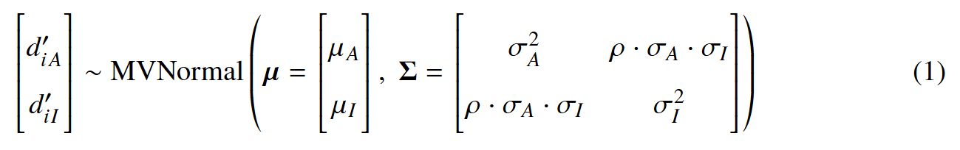
These five parameters contain all the information needed to evaluate our three hypotheses. The group-level dissociation hypothesis concerns the difference in mean sensitivity between tasks ($μ_{I}-μ_{A}$), the correlation hypothesis concerns the association between true sensitivities ($ρ$), and the intercept hypothesis concerns the expected influence sensitivity when awareness sensitivity is zero. Under the assumed bivariate normal distribution, this last quantity corresponds to the regression intercept ($β_{0}$) of true influence sensitivity on true awareness sensitivity:
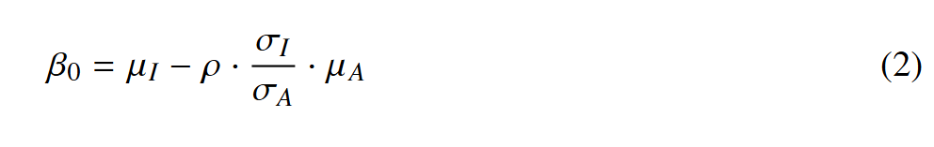
By estimating these population parameters directly from trial-level responses, the multilevel SDT model allows researchers to evaluate all three hypotheses while accounting for measurement error. It also accommodates differing numbers of trials across tasks and participants, and allows researchers to quantify the reliability of their measures. In the next section, we introduce the multilevel SDT model used to estimate these parameters directly from trial-level responses.

A Multilevel Signal Detection Theory Model
Multilevel models (also known as hierarchical or mixed-effects models, Raudenbush & Bryk, 2002) are already familiar in experimental psychology, in part due to accessible tutorials and practical guidelines written for experimental psychologists (Baayen et al., 2008; Barr et al., 2013; Hoffman & Rovine, 2007; Meteyard & Davies, 2020; Singmann & Kellen, 2020). Their main advantage is that they naturally accommodate the hierarchical structure of experimental data: trial responses (level 1) nested within participants (level 2). Within this framework, trial-to-trial variability within participants (i.e., measurement error) is modeled separately from variability in participant-specific parameters (i.e., true individual differences). In this sense, multilevel models can be conceptualized as psychometric models in experimental psychology, and have been used to estimate correlations corrected for measurement error across tasks (Rouder et al., 2023; Rouder & Haaf, 2019), as well as test–retest reliability (Haines et al., 2025; Rouder & Haaf, 2019). Building on this foundation, we introduce a multilevel SDT model that jointly analyzes trial-level responses from the awareness and influence tasks. We begin by assuming that both tasks are expressed on a common sensitivity scale, either directly or by applying the transformation proposed by Meyen et al. (2022) to the influence measure.

Model Formulation
Let $y_{ijl}$ denote the observed response of participant $i$ in task $j$ on trial $l$, coded as 1 for one response category and 0 for the other. For example, participants may classify trials as congruent (1) or incongruent (0) in a typical priming experiment, or displays as repeated (1) or new (0) in the case of contextual cuing of visual attention, as we illustrate below. We assume that each response follows a Bernoulli distribution:
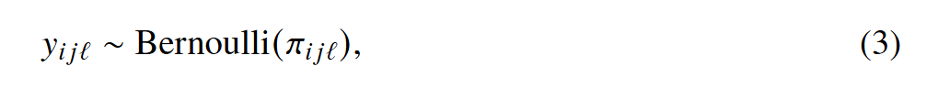
where $π_{ijl}$ is the probability of a response coded as 1 on that trial. This probability is modeled using a probit regression:
where $Φ^{-1}$ is the inverse standard normal cumulative distribution function (i.e., the “probit” link function), $x_{ijl}$ represents the experimental condition (coded as 0.5 for signal trials and $-0.5$ for noise trials), and $d_{ij}^{'}$ and $c_{ij}$ are the participant- and task-specific sensitivity and response criterion, respectively. We further assume that these participant- and task-specific parameters jointly follow a multivariate normal distribution:
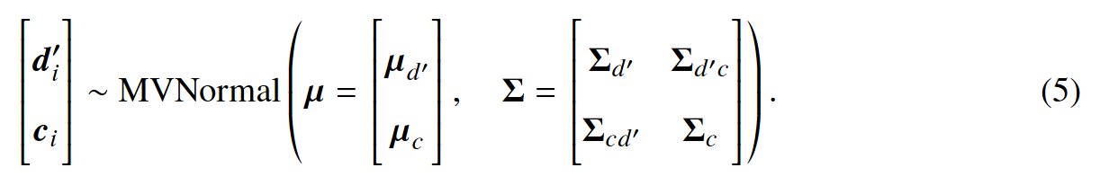
Here, $d_{i}^{'}=(d_{iA}^{'},d_{iI}^{'})^{⊤}$ contains participant $i$’s sensitivities in the awareness ($A$) and influence ($I$) tasks, while $c_{i}=(c_{iA},c_{iI})^{⊤}$ contains the corresponding response criteria. The vectors $μ_{d^{'}}$ and $μ_{c}$ contain the population means of these parameters, known as fixed effects in multilevel terminology. Individual participants can deviate from these means, and these deviations are the random effects. The matrix $Σ$ describes how much these random effects vary across participants and how they covary. Its upper-left block, $Σ_{d^{'}}$, contains the variances of true sensitivities and their covariance across tasks, while $Σ_{c}$ describes the corresponding variances and covariance of response criteria. Finally, the off-diagonal blocks, $Σ_{d^{'}c}=Σ_{cd^{'}}^{⊤}$, describe how sensitivities and response criteria covary, both within and across tasks.
Notice that $μ_{d^{'}}$ and $Σ_{d^{'}}$ are exactly the mean vector and covariance matrix of true sensitivities introduced in Equation 1. This means that the five population parameters defining our three hypotheses are estimated directly by the multilevel SDT model itself. Because these parameters are estimated jointly from trial-level responses, the model accounts for measurement error without requiring separate estimates of individual sensitivities or their reliability. All three hypotheses can therefore be tested using the model’s parameters, avoiding the distortions introduced by the conventional two-step approach.

Participant-Specific Sensitivities
As shown in Equation 4, the participant-specific sensitivities, $d_{ij}^{'}$, are themselves parameters of the multilevel model. As discussed earlier, these parameters can be understood as true sensitivities, in the sense that they represent the values that would be recovered from infinite trials, assuming the model is correctly specified. However, this does not mean that the model can recover these values perfectly from a finite number of trials.
Consider a participant whose observed sensitivity is unusually high after completing only a few trials, so this estimate is highly uncertain. Multilevel models address this uncertainty by estimating individual sensitivities using both the participant’s responses and the information shared with the rest of the group, represented by the multivariate normal distribution in Equation 5. The resulting estimates represent a compromise between these two sources of information: the less reliable a participant’s observed sensitivity, the more their estimated sensitivity is pulled toward the group mean. Figure 4 shows the estimates of the multilevel model for the two samples discussed in the section “Challenges for the Correlation and Intercept Hypotheses”, in which each participant completed 80 (Panel A) or 20 (Panel B) trials per task.

Figure 4
Participant-Specific Sensitivities Estimated by the Multilevel Model
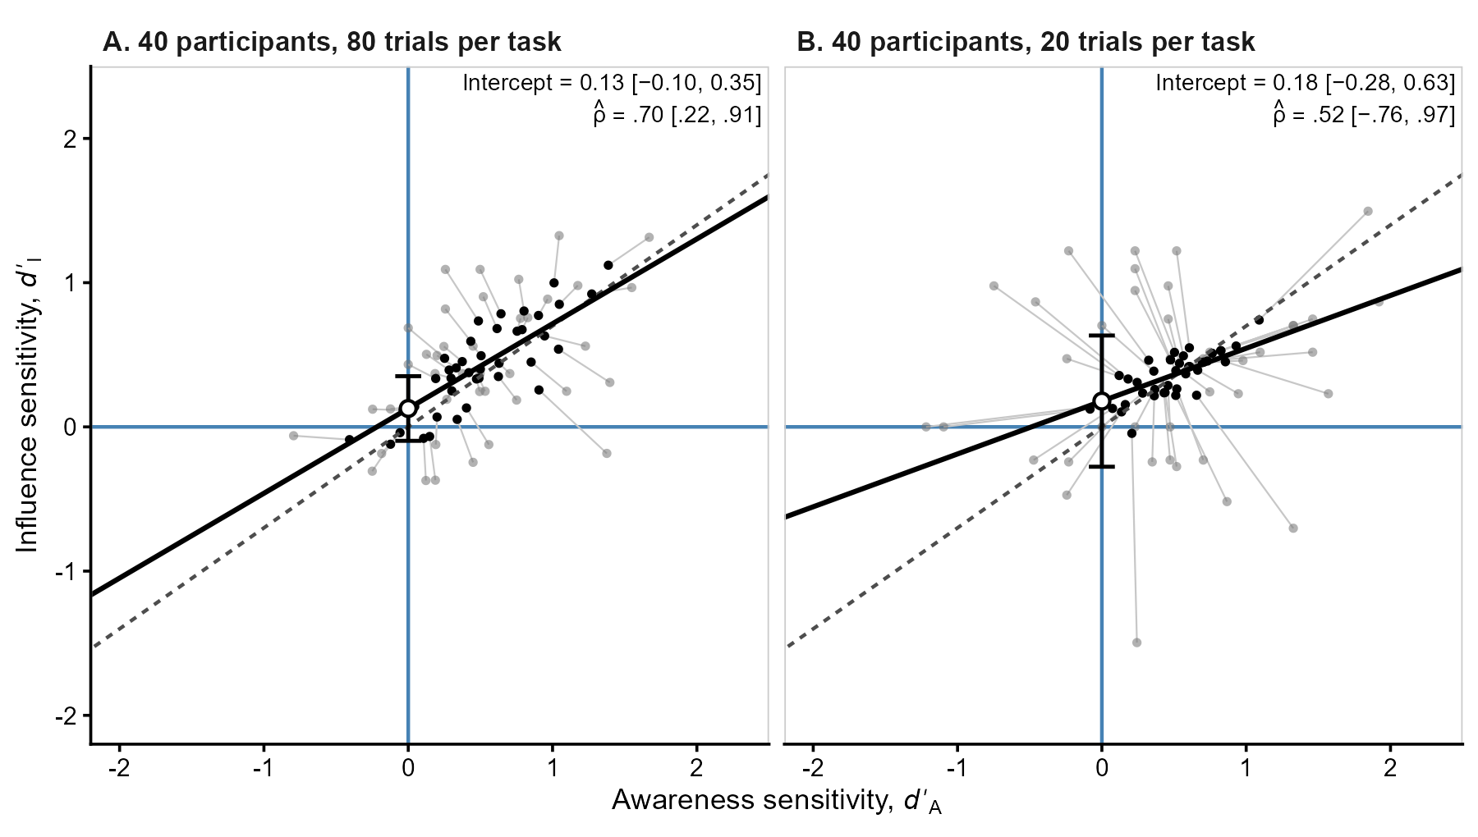
Note. The samples of 40 participants with 80 (Panel A) and 20 (Panel B) trials per task from the section Challenges for the Correlation and Intercept Hypotheses, reanalyzed using the multilevel SDT model. Gray points show observed sensitivities from the two-step approach; black points show multilevel estimates, with segments connecting each participant’s scores. Solid lines show the model-implied regressions of influence on awareness sensitivity; dashed lines show the true population regression. Open circles indicate estimated intercepts (95% CIs). Upper-right values report the estimated intercept and correlation between true sensitivities ($\hat{ρ}$), both with 95% CIs.

This mechanism, known as partial pooling or shrinkage (James & Stein, 1961), is particularly useful from a psychometric perspective because random measurement error does not systematically affect the group mean. In fact, this same principle is captured by a century-old psychometric equation for estimating true scores: Kelley’s regression formula (Kelley, 1927, p. 178),
where ${\hat{d}}_{ij}^{'}$ is the observed sensitivity of participant $i$ in task $j$, $R_{j}$ is the reliability of that task, and $μ_{j}$ is its population mean sensitivity ($μ_{I}$ or $μ_{A}$ in Equation 1). When reliability is perfect ($R_{j}=1$), the estimate equals the observed sensitivity. When reliability is zero ($R_{j}=0$), the observed score provides no information about individual differences, and the best estimate is the group mean. When reliability falls between 0 and 1, Kelley’s formula produces precisely the partial pooling described above. Multilevel models build on this same idea, but extend it to multiple variables that may be correlated with one another (Raudenbush & Bryk, 2002).
As model-based sensitivities are estimates of true participants’ sensitivities, it may be tempting to use them in subsequent analyses, such as correlations or regressions. However, accurately estimating each participant’s true sensitivity is not the same as accurately estimating how sensitivities vary and relate to one another across participants. To improve these predictions, partial pooling exploits the classical bias–variance tradeoff (Yarkoni & Westfall, 2017), introducing some bias toward the population mean in exchange for reduced estimation variance (Efron & Morris, 1975; James & Stein, 1961). A perhaps surprising consequence is that, if we calculated the sample variance of these individual estimates, we would generally obtain a smaller value than the corresponding variance in Equation 5 estimated by the multilevel model (Louis, 1984; Skrondal & Rabe-Hesketh, 2004). The same applies to covariances, which will generally differ from those estimated in $Σ_{d^{'}}$. Although both sets of quantities may appear to describe the same individual differences, the former describe the variability of individual predictions, whereas the latter describe the variability of true sensitivities in the population. Correlations and regression coefficients calculated from these predictions can therefore yield biased estimates of population relationships (Devlieger et al., 2016; Skrondal & Laake, 2001).
For population-level inference, we should instead use the parameters estimated directly by the multilevel model. The correlation between true sensitivities can be obtained from $Σ_{d^{'}}$, while the regression intercept can be calculated from the population parameters, as shown in Equation 2. Other individual-difference questions can often be addressed by extending the model to include additional covariates or outcomes, allowing the relationships of interest to be estimated while accounting for measurement error.
However, accounting for measurement error does not eliminate uncertainty when few trials are available. Even when both tasks are expressed on a common sensitivity scale, differences in the number of trials can still affect statistical power. As illustrated in Figure 5, collecting too few trials in one of the tasks can make genuine differences in sensitivity between tasks difficult to detect (and the multilevel SDT model cannot fix this, as we say in Spain: “Where there’s no sprout, there’s no spud.”). Thus, a meaningful sensitivity comparison requires not only comparable measures, but also sufficient information from both tasks. To address this limitation, the {uSDT} package also allows researchers to evaluate statistical power when planning their experiments.

Figure 5
Power to Detect Sensitivity Differences as a Function of Awareness-Task Number of Trials
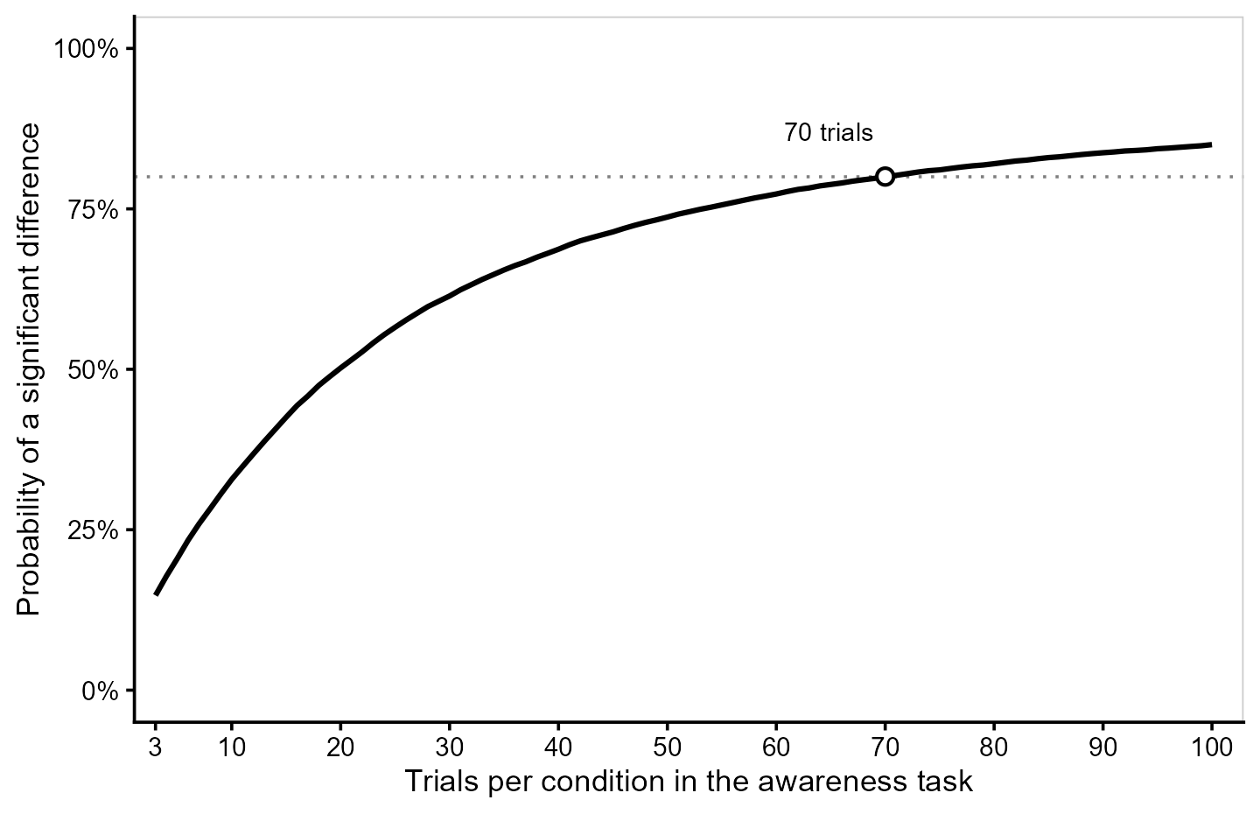
Note. Power of the difference between mean sensitivities in the multilevel SDT model ($α$ = .05), computed with the usdt_power() function of {uSDT} for a sample of 40 participants. True mean sensitivities were 0.30 (awareness) and 0.15 (influence), with between-participant SDs of 0.15 and a population correlation of zero between tasks. Trials per condition ranged from 3 to 100 (awareness) and were fixed at 150 (influence). The open circle marks the minimum number of awareness-task trials required to reach 80% power (dotted line)

Bayesian Extension
The multilevel SDT model described above can also be estimated within a Bayesian framework (Gelman et al., 2013; Kruschke, 2015; McElreath, 2020; for hierarchical Bayesian SDT models, see Rouder & Lu, 2005; Lee & Wagenmakers, 2013). This extension is relatively straightforward and is already implemented in the {uSDT} package: the model structure remains unchanged, but prior distributions are assigned to its parameters. Combining these priors with the observed trial-level likelihood yields posterior distributions for all model parameters, including the five population parameters defining our three hypotheses. These posterior distributions can be used to compute credible intervals and, with appropriate prior specifications, Bayes factors to quantify evidence for or against the null hypotheses (Dienes, 2014; Wagenmakers, 2007).
One important consideration is that specifying priors on the five population parameters in Equation 1 also implicitly defines a prior on the regression intercept in Equation 2, since the intercept is a function of these parameters. This induced prior may not reflect the researcher’s prior expectations when testing the intercept hypothesis using Bayes factors. When previous empirical evidence informs the priors on these population parameters, researchers can inspect the resulting prior on the intercept through prior predictive checking (Gelman et al., 2020) to assess its plausibility. Alternatively, the model can be parameterized as a latent regression (with the argument latent = "regression" in the hsdt() function), allowing a prior to be specified directly on its intercept. In this parameterization, the intercept replaces the influence-task mean sensitivity ($μ_{I}$), while the remaining four population parameters keep their own priors. The influence-task mean is no longer sampled directly, but is derived at each posterior draw by solving Equation 2 for $μ_{I}$. As a result, both the intercept and the correlation between sensitivities ($ρ$) have priors chosen by the researcher, whereas the prior on the group-level difference ($μ_{I}-μ_{A}$) is induced by the others.
The Bayesian framework also allows us to consider a more flexible version of the model that relaxes the equal-variance assumption of SDT (with the argument unequal_variances = TRUE in the hsdt() function). The model presented in Equation 4 assumes that the underlying signal and noise distributions have the same variance. Following Lages (2024), this assumption can be relaxed by examining how hit and false-alarm rates vary across participants. Assuming that sensitivity and response criterion are independent at the population level (i.e., $Σ_{dc}=0$), differences in this variability can be used to estimate the relative variances of the signal and noise distributions.

Model Assumptions
The multilevel SDT model makes several assumptions about how responses are generated and how sensitivities vary across participants. At the trial level, it assumes normally distributed evidence with equal variances across stimulus conditions, although our Bayesian extension relaxes the equal-variance assumption. It also requires that performance in both tasks can be expressed on a common sensitivity scale. For tasks based on RTs, this involves converting continuous responses into binary outcomes, and the choice of conversion may affect the results. At the participant level, sensitivities and response criteria are assumed to follow a single multivariate normal distribution.
This last assumption deserves particular attention. A single normal distribution represents individual differences as continuous variation within one population. However, some theories propose that aware and unaware participants constitute qualitatively distinct populations (Goldstein et al., 2022; Lublinsky et al., 2026). Such an alternative could be accommodated within our framework using a mixture SDT model (Lee & Wagenmakers, 2013), but would require additional assumptions about how these populations are defined. For example, should the unaware population include only participants with exactly zero awareness-task sensitivity, or also those with sensitivity below a specified threshold? Furthermore, assigning participants to these populations would be uncertain when sensitivity is measured imperfectly. Although mixture models can account for this uncertainty without requiring definitive classifications, they cannot determine what constitutes unawareness.
But suppose that aware and unaware participants do constitute distinct populations. We would still be interested in the relationship between awareness and influence, particularly their correlation and regression intercept. Can our multilevel SDT model accurately recover these parameters when the true population consists of distinct aware and unaware subpopulations, despite assuming a single multivariate normal distribution? Simulation Study 2, presented in the next section, was designed specifically to address this question.

Simulation Studies
We conducted two simulation studies to evaluate the multilevel SDT model before applying it to empirical data. Simulation Study 1 was a validation study in which data were generated from our model to assess parameter recovery and the validity of inferences on all three hypotheses across a broad range of conditions. Simulation Study 2 was a robustness study examining whether inferences on the correlation and intercept remained valid when true sensitivities were generated from the population models of Klauer et al. (1998) and Goldstein et al. (2022). Both approaches were developed to estimate the relationship between awareness and influence measures while accounting for measurement error, and both assume two subpopulations of participants: those with no awareness ($d_{iA}^{'}=0$) and those with positive awareness-task sensitivity. Although they formalize these subpopulations differently, neither population model follows the bivariate normal distribution assumed by our model. Here, we summarize the simulation designs and main results, with full methodological details provided in the Supplemental Material.

Method

Design
In Simulation Study 1, true sensitivities were drawn from the bivariate normal distribution in Equation 1, and trial responses were generated from Equation 4. We manipulated five factors: sample size ($N$), trials per condition ($K$), reliability ($R$), correlation between true sensitivities ($ρ$), and regression intercept ($β_{0}$). To manipulate reliability for a given number of trials, we derived the variances of true sensitivities from the target reliability ($R$) and the sampling variance of $d^{'}$ with $K$ trials per condition (Gourevitch & Galanter, 1967; see the Supplemental Material).
In Simulation Study 2, true sensitivities were generated from the population models of Klauer et al. (1998) and Goldstein et al. (2022). We manipulated six factors: generating model, $N$, $K$, proportion of unaware participants ($π_{0}$), correlation ($ρ$), and intercept ($β_{0}$). Unlike in Study 1, reliability was not manipulated but depended on $K$ and, for the awareness task, $π_{0}$. Influence-task reliabilities were .22, .46, and .58 for $K$ = 10, 30, and 50, respectively, comparable to $R$ = .2, .5, and .6 in Study 1. Awareness-task reliability was higher (.48 to .93) due to greater variability in true sensitivities (Table S9 of the Supplemental Material). Crossing all factor levels (Table 1) yielded 1,260 and 648 conditions in Studies 1 and 2, respectively, with 1,000 simulated datasets per condition.

Table 1
Design of the Simulation Studies
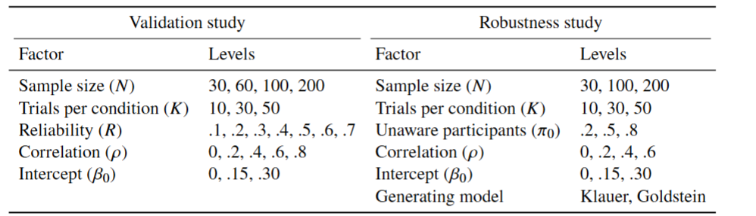
Note. In Study 1, $μ_{A}=0.2$, and true-sensitivity SDs were derived from $R$ and $K$. In Study 2, $σ_{I}=0.3$, and $ρ$ and $β_{0}$ refer to regressions on awareness-task $d^{'}$ (Klauer) or chance-centered accuracy (Goldstein). In both studies, awareness-task criteria varied (SD = 0.3), and the influence-task criterion was fixed at 0.

Procedure
Both studies were conducted in R version 4.5.0 (R Core Team, 2024), using {SimDesign} (Chalmers & Adkins, 2020) to manage the simulation workflow. Each dataset was analyzed with the frequentist multilevel SDT model implemented in {uSDT} (Rey-Sáez, Garre-Frutos, et al., 2026), fitted by maximum likelihood using {lme4} (Bates et al., 2015). We used 95% Wald CIs (computed on the log scale for SDs) and the three hypothesis tests implemented in {uSDT}. Fits with singular random-effects covariance matrices (e.g., an SD estimated at zero or a correlation at $±1$) were classified as untestable for H2 and H3 because SEs for the correlation and intercept were unavailable.

Analysis
For each parameter, we computed bias (mean estimate minus true value) and empirical coverage of the 95% CIs. For each hypothesis, we computed the rejection rate at the .05 level, representing Type I error when the null hypothesis was true and statistical power otherwise. The intercept was evaluated only in testable fits, as its estimate becomes unstable when $σ_{A}$ approaches zero (Equation 2). All other parameters were evaluated in every fit, and the proportion of untestable fits was reported separately. To summarize parameter recovery across conditions, we computed Lin’s (1989) concordance correlation coefficient (CCC) between the mean estimates and true values, which measures agreement with the identity line. Following Bradley’s (1978) liberal criterion, acceptable coverage and Type I error rates were [.925, .975] and [.025, .075], respectively. Results for individual conditions and ANOVA metamodels examining the effects of the simulation factors (Skrondal, 2000) are reported in the Supplemental Material.

Results

Simulation Study 1: Validation
All but 106 of the 1,260,000 fits converged (0.008% returned estimation errors). Figure 6 shows the recovery of the population parameters. The influence-task mean sensitivity, group-level dissociation (H1), and SDs were recovered almost perfectly (CCC $≥$ .995), and the awareness-task mean sensitivity, fixed at 0.2, showed biases below .015 in every condition (Table S2 in the Supplemental Material). Recovery was also strong for the correlation (H2; CCC = .955) and intercept (H3; CCC = .952), although their estimates were less accurate, particularly under low reliability.

Figure 6
Recovery of the Population Parameters in Simulation Study 1
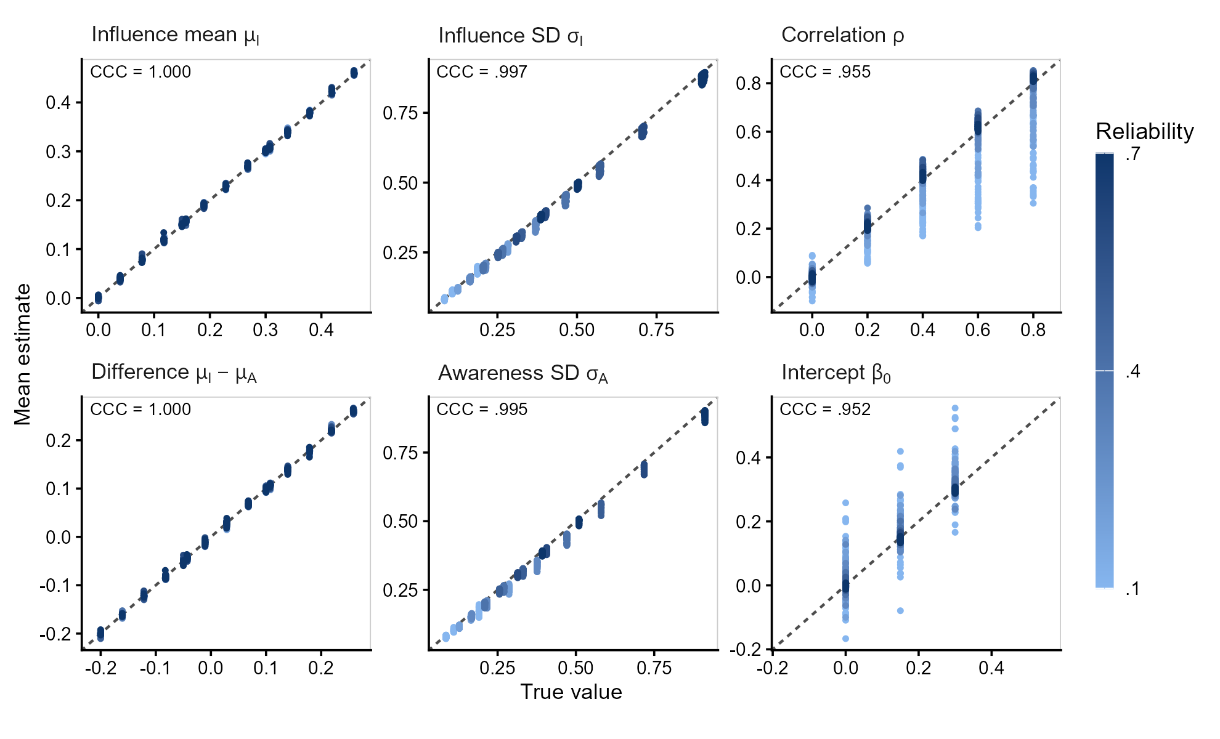
Note. Each point represents a simulation condition, averaged over 1,000 replications. Colors indicate reliability values. Dashed lines indicate perfect recovery. CCC = concordance correlation coefficient. The awareness-task mean (fixed at 0.2) is omitted, and the intercept was computed over testable fits.

As shown in Table 2, the group-level dissociation was recovered almost perfectly at every level of reliability, whereas recovery of the correlation and intercept was poor at $R=.1$ (CCC = .72 and .79, respectively), but improved substantially at $R=.3$ (CCC $≥$ .98). Low reliability also increased the frequency of boundary estimates (SDs of zero or correlations of $±1$), leaving fits untestable for H2 and H3 (Table 3). At $R=.1$, 71% of fits were untestable, ranging from 56% at $N=200$ to 83% at $N=30$, compared with less than 9% at $R≥.5$. Moreover, at extremely low reliability, correlations were biased toward zero when their true values were high (bias = $-$.31 at $R=.1$ and $ρ=.8$), whereas with $R≥.3$ they were slightly overestimated on average (by at most .09 in any condition). The intercept, in turn, was overestimated when the correlation was strong and reliability extremely low (bias = .11 at $R=.1$ and $ρ=.8$ when $β_{0}=0$, and .05 at $R=.2$), because the attenuated slope inflates it.

Table 2
Recovery of the Parameters of the Three Hypotheses by Reliability in Simulation Study 1
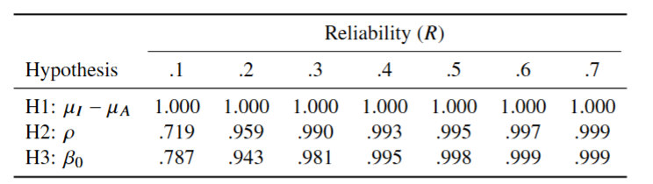
Note. Lin’s concordance correlation coefficient (CCC) between true values and mean estimates across 1,000 replications, computed over 180 conditions per reliability level. The intercept was computed over testable fits. See Figure S2 for scatterplots.

Coverage and rejection rates are summarized in Table 3. Inferences on H1 were valid at every level of reliability: the coverage of $μ_{I}-μ_{A}$ ranged from .917 to .970 and met Bradley’s criterion in 99% of conditions. For H2 and H3, results differed between low ($R≤.3$) and moderate to high reliability ($R≥.4$). With $R≤.3$, 48% of fits were untestable on average (up to 86%), leaving only a selected subset for inference. In this subset, CIs for H2 were conservative in most conditions, but with $ρ=.8$ their coverage fell below .925 in 68% of the conditions, down to .85. Type I error for H2 was below .025 in 75% of null conditions. Type I error for H3 met Bradley’s criterion in only 46% of null conditions: it was conservative in 49% and exceeded .075 in 9 (maximum = .11), all with $R≤.2$ and $ρ=.8$, where the intercept was overestimated. With $R≥.4$, only 8% of fits were untestable, Type I error for H2 never exceeded .067, and Type I error for H3 met Bradley’s criterion in 98% of null conditions (maximum = .073).

Table 3
Inference on the Three Hypotheses by Reliability in Simulation Study 1
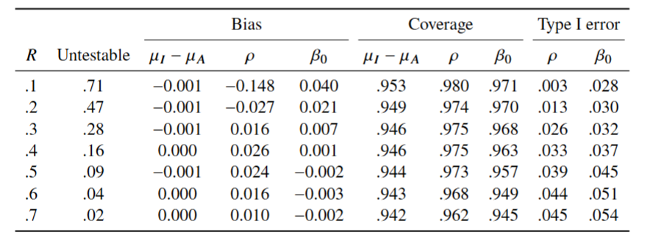
Note. Values are averaged across simulation factors (Type I error only when the tested parameter is zero). Untestable fits are boundary estimates for which H2 and H3 cannot be tested. Correlation bias includes boundary estimates, whereas intercept bias, coverage, and Type I error rates are computed over testable fits.

The power of H1 increased with effect size, sample size, and number of trials, as expected for a test of a group-level mean (Figure S6 in the Supplemental Material). We therefore focus on H2 and H3, whose power depended more directly on reliability (Figure 7). Untestable fits were counted as non-rejections, reflecting the power researchers can expect in practice. Considering only testable fits yielded higher power when boundary estimates were frequent (up to .36 higher; Figure S8), but these constituted a selected subset of fits. With $R≤.3$, power for H2 never reached .80, even with $N=200$ (maximum = .61), and H3 reached .80 only for $β_{0}=.30$, $R=.3$, and $N=200$. With $N=200$ and $R≥.5$, power was at least .82 for correlations of .4 or larger and .98 for $β_{0}=.30$. Small correlations were difficult to detect: power for $ρ=.2$ never exceeded .50. Power for $β_{0}=.15$ leveled off at .79 to .82 with $N=200$ and $R≥.5$, because $β_{0}$ was fixed while $σ_{I}$ increased with $R$, so the same intercept was a smaller effect relative to individual differences.

Figure 7
Power by Reliability, Sample Size, and Effect Size in Simulation Study 1
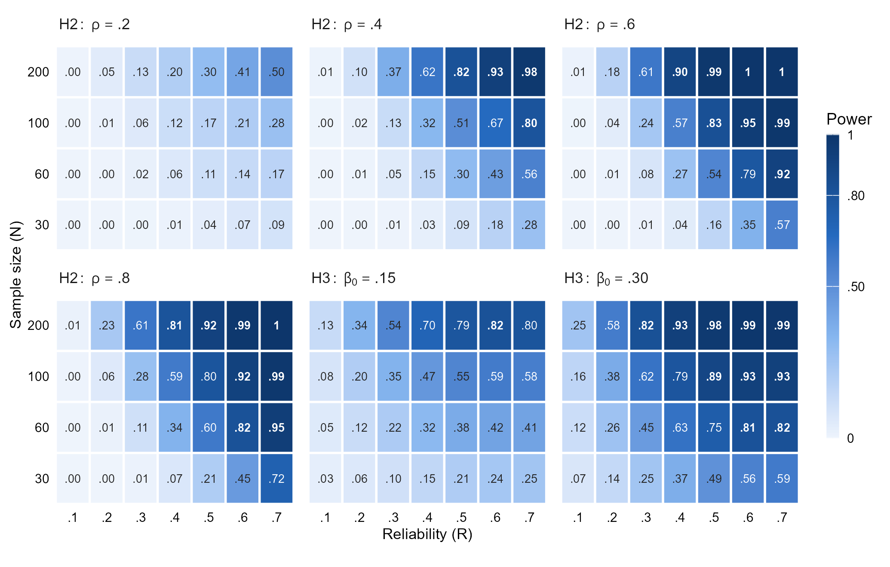
Note. Proportion of the 1,000 replications per condition in which H2 or H3 was rejected ($α=.05$). Each H2 panel shows one nonzero true correlation, averaged over the three true intercepts, and each H3 panel one nonzero true intercept, averaged over the five true correlations; all cells are also averaged over $K$. Untestable fits were counted as non-rejections. Values of .80 or higher are in bold. Because $σ_{I}$ increased with $R$ at a fixed $K$, the same $β_{0}$ is a smaller effect at higher reliability.

Overall, the multilevel SDT model showed good parameter recovery and generally well-calibrated inferences across the simulated conditions. As expected, low reliability made the estimation of the correlation and intercept more difficult, leading to boundary estimates and reduced statistical power.

Simulation Study 2: Robustness
Only 31 of the 648,000 fits returned estimation errors. Boundary fits were less frequent than in Study 1, because the awareness measure was more reliable, occurring in 8% and 6% of fits under the models of Klauer et al. (1998) and Goldstein et al. (2022), respectively, mostly with $K=10$, when the influence measure was least reliable, and small samples. Under both generating models, the correlation and intercept were recovered accurately (all CCCs $≥$ .991). Coverage was close to .95 for the intercept and conservative for the correlation with few trials, approaching .95 as the number of trials, and thus the reliability of the influence task, increased (from .981 and .976 with $K=10$ to .951 and .956 with $K=50$). Type I error rates remained close to the nominal level, never exceeding .080 (Table 4).

Table 4
Inference on the Correlation and the Intercept by Trials in Simulation Study 2
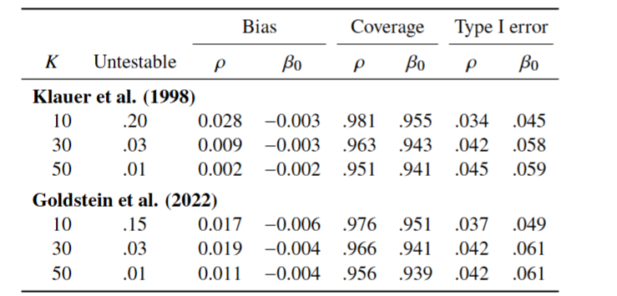
Note. Values are averaged across conditions (Type I error over null conditions only). $K$ = trials per condition. True values follow Equation 2; under Klauer et al. (1998), the true $β_{0}$ equals the manipulated intercept. Boundary fits are untestable for H2 and H3. Correlation bias includes these fits; intercept bias, coverage, and Type I error exclude them.
Under the model of Klauer et al. (1998), the multilevel SDT model accurately recovered both the population correlation and intercept, despite the violation of its assumed bivariate normal distribution, and even though up to 80% of participants had a true awareness-task sensitivity of exactly zero. Both parameters were also accurately recovered under Goldstein et al. (2022), although a complication arises in interpreting the intercept. Goldstein et al. define the regression of influence-task sensitivity on awareness accuracy, rather than $d^{'}$. This means that the regression is estimating an intercept related to that of Goldstein, but not exactly the same. When awareness and the influence effect are related, our intercept is slightly larger than the one manipulated in their model, even when the latter is zero. In our simulations, the difference was at most 0.045, and when the manipulated intercept was zero, H3 was rejected in up to 15% of the replications, with rejection rates above .075 in 13% of these conditions. The difference comes from participants with almost perfect accuracy, which the model of Goldstein et al. allows. If the accuracy of aware participants did not exceed .75 (i.e., a $d^{'}$ of 1.35), the intercept defined by Goldstein et al. and the intercept estimated by our model would differ by at most 0.004. The Supplemental Material reports these results in detail and explains where the difference comes from (Tables S10–S14 and Figures S9–S11).
The multilevel SDT model thus provided generally robust inferences under both generating models, even when the intercept defined by Goldstein et al. (2022) did not exactly correspond to the one estimated by our model. This makes it a promising approach even when the population consists of distinct subpopulations of aware and unaware participants.

Empirical Illustrations
We now illustrate how the multilevel SDT model can be applied to empirical data and compare its conclusions with those obtained using conventional analyses. We fit the models with the {uSDT} R package (Rey-Sáez, Garre-Frutos, et al., 2026), using both frequentist and Bayesian estimation in the first two examples, and only Bayesian estimation in the last one, whose original analyses were based on Bayes factors. All Bayesian models were fitted using four chains with 2,000 warmup iterations and 25,000 post-warmup draws per chain. Model-specific prior distributions are reported in the Appendix A. All code needed to reproduce the analyses is publicly available at [CODE]. To illustrate how straightforward the implementation is, Appendix B presents the few lines of code used for the contextual-cuing example, including both frequentist and Bayesian estimation. The other two illustrations follow essentially the same workflow, requiring only minor changes to the data and, when needed, the priors.

Masked Conditioning
Greenwald and De Houwer (2017) conducted 20 experiments investigating whether conditioning can occur without conscious awareness, including 14 experiments with masked conditioned stimuli (CSs) and 6 with visible CSs. Across experiments, participants categorized either words as “pleasant” or “unpleasant”, or first names as “male” or “female”. During acquisition, each word or name (unconditioned stimulus, US) was preceded by one of two four-consonant strings (CSs; e.g., “NPLW” or “DHJF”), each consistently paired with one US category (e.g., “NPLW” with pleasant words and “DHJF” with unpleasant words). In the subsequent conditioning test (influence task), CS–US pairings were randomized and conditioning was measured as $d^{'}$ (e.g., a “pleasant” response counted as a hit when preceded by “NPLW” and as a false alarm when preceded by “DHJF”, regardless of whether the word itself was pleasant or unpleasant). In the masked-CS experiments, a subsequent visibility test (awareness task) required participants to identify which of the two consonant strings had appeared on each trial, measuring awareness with $d^{'}$ as well. The data are publicly available at https://osf.io/ydeza.
For our illustration, we use Experiment 1c (S18), the last and largest of their 14 unconscious conditioning experiments. CSs were presented for 75 ms following a forward mask, and a response window (333–467 ms after US onset) encouraged rapid categorization. Of 386 participants, 350 met the authors’ inclusion criteria and completed 192 acquisition trials, 96 conditioning test trials, and 144 visibility test trials. The authors regressed conditioning on visibility, interpreting a positive intercept as evidence of conditioning at zero visibility. To account for measurement error in the visibility measure, they also applied the errors-in-variables correction of Klauer et al. (1998), after which the intercept remained statistically significant. The original regression yielded a positive intercept, 0.10, 99% CI [0.06, 0.14], and a slope close to zero. Together with the finding that no participant showed perfect awareness of the CS–US contingency, the authors interpreted these results as evidence of unconscious conditioning.
We fitted the multilevel SDT model to the trial-level data from Experiment 1c (S18), applying the original authors’ exclusion criteria. We estimated the model using both frequentist and Bayesian methods. Because the authors’ conclusion rests on the regression intercept, the Bayesian model used the latent regression parameterization, with a weakly informative prior placed directly on its intercept, $N(0,1)$, a uniform prior on the correlation, and the default priors of {uSDT} on the remaining parameters (see Appendix A). For comparison, we also applied the errors-in-variables correction of Klauer et al. (1998), implemented in {uSDT}, to the $d^{'}$ scores computed separately for each participant and task. The results are presented in Table 5.

Table 5
Reanalysis of Experiment 1c of Greenwald and De Houwer (2017)
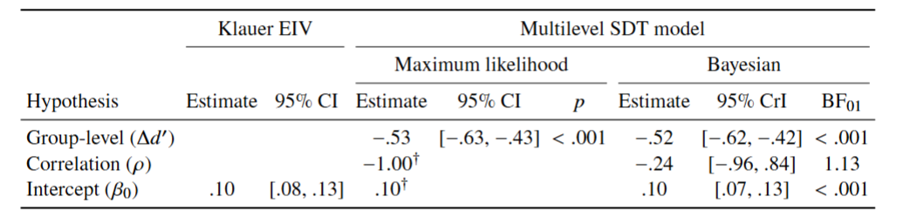
Note. EIV = errors-in-variables regression; $Δd^{'}$ = mean influence minus mean awareness sensitivity; $ρ$ = correlation between true sensitivities; $β_{0}$ = latent regression intercept. Intervals are 95% confidence intervals (EIV and maximum likelihood) or credible intervals (Bayesian). The maximum likelihood fit reached a boundary, preventing interval estimation for $ρ$ and $β_{0}$ ($†$). The Bayesian fit used the latent regression parameterization, with a prior specified directly on $β_{0}$. BF$​_{01}$ > 1 favors the null hypothesis. See Appendix A for model specifications and priors.
The awareness task was substantially more sensitive to the CS than the influence task (mean $d^{'}$ = 0.62 vs. 0.09, corresponding to approximately 62% vs. 52% correct classification of individual trials; ${\text{BF}}_{10}$ = $7.8×{10}^{8}$). The group-level analysis therefore showed the opposite of a dissociation. This difference is illustrated in Figure 8, which shows the population ROC curves for the awareness and influence tasks. Evidence concerning the correlation between true task sensitivities was inconclusive ($ρ$ = $-.24$, 95% CrI $[-.96,.84]$; ${\text{BF}}_{01}$ = $1.13$). In contrast, the latent intercept provided extreme evidence for conditioning at zero visibility ($d^{'}$ = 0.10, 95% CrI [0.07, 0.13]; ${\text{BF}}_{10}$ = $97,738$), consistent with the original analyses and the correction of Klauer et al. (1998).

Figure 8
Population ROC Curves for the Awareness and Influence Tasks
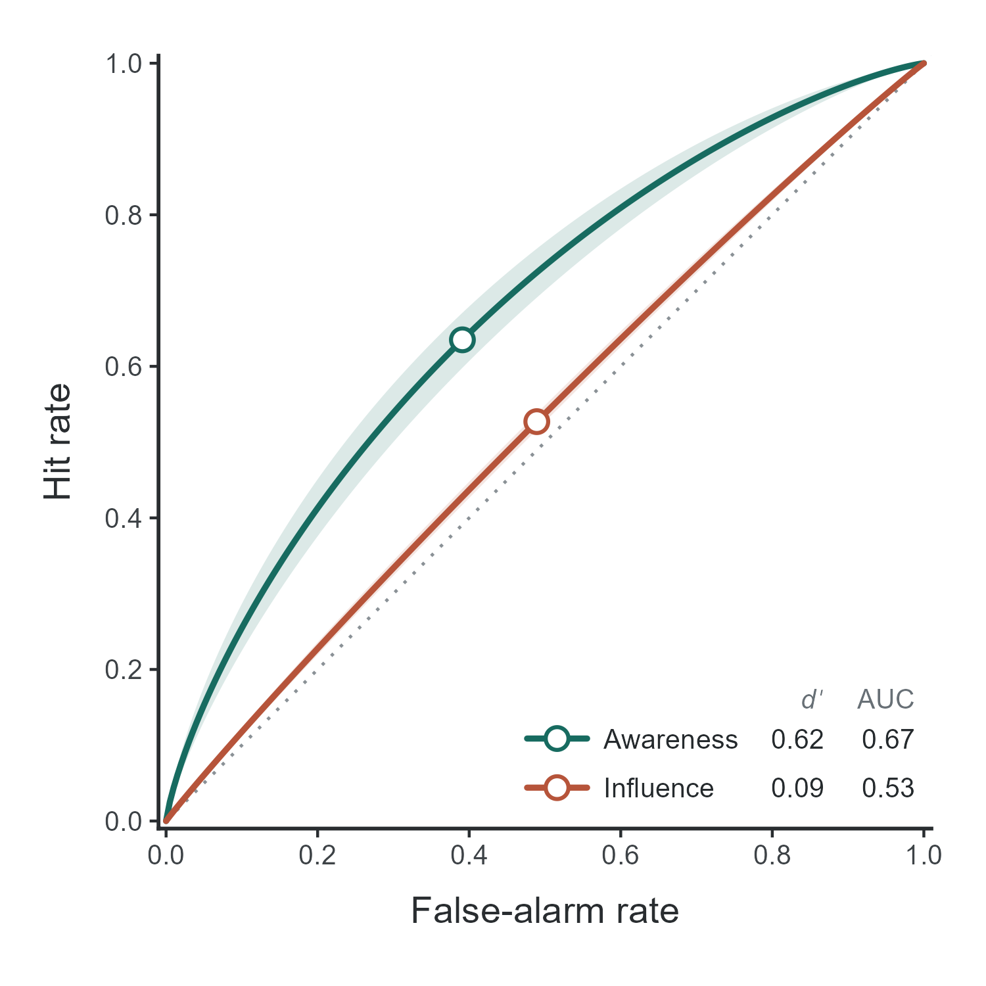
Note. Curves represent population-level sensitivity under equal-variance SDT. Shaded areas indicate 95% Wald confidence bands, and points mark the estimated response criteria. AUC = area under the curve; $d^{'}$ = sensitivity. Figure generated using the {uSDT} R package.

These results must be interpreted in light of the extremely low reliability of the influence measure (reliability = .01, 95% CrI [.00, .05], compared with .94, 95% CrI [.93, .95] for the awareness measure). As ilustrated in Figure 9, although observed influence sensitivities vary considerably across participants (top panel), the multilevel model attributes nearly all this variability to measurement error, shrinking individual estimates toward the group mean (bottom panel). The estimated between-participant variance in true influence-task sensitivity was so close to zero that we could not obtain standard errors for the other hypotheses from the frequentist model. With virtually no true variability in conditioning, its relationship with CS visibility is difficult to evaluate, explaining why the correlation between true sensitivities could not be reliably estimated. Under these circumstances, the regression slope approaches zero ($-0.01$) regardless of the true correlation, and the intercept becomes nearly identical to the mean conditioning effect. Although this produces strong evidence for a positive intercept, interpreting it as evidence of conditioning without conscious awareness would be problematic, because the data cannot establish either the presence or the absence of an association between conditioning and awareness.

Figure 9
Regression Model With Observed and Model-Estimated Sensitivities in Masked Conditioning
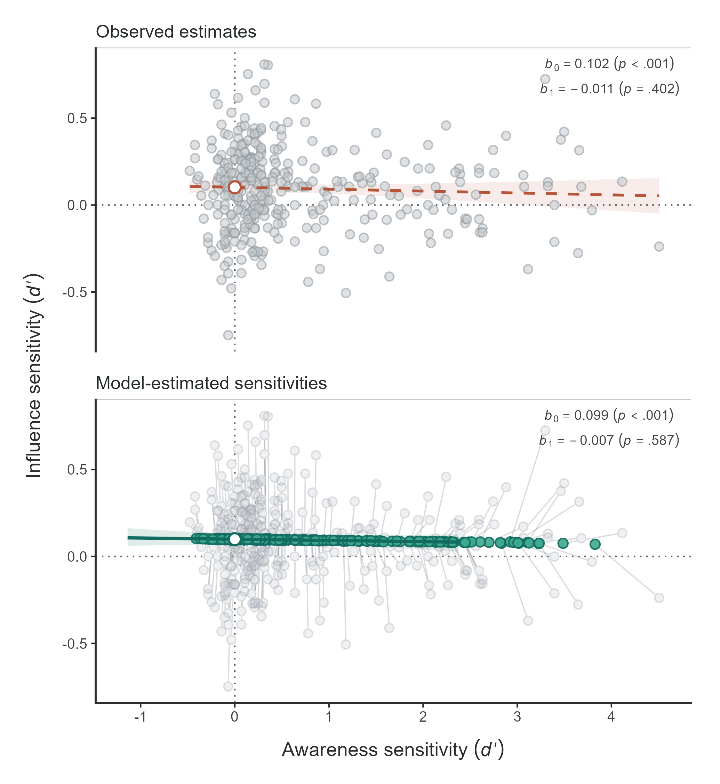
Note. Gray circles show observed participant-level sensitivities, and green points show posterior mean estimates from the multilevel SDT model. Connecting segments illustrate shrinkage. Lines represent the observed regression (top) and the model-implied latent regression (bottom), with 95% confidence and credible bands, respectively. Open circles mark the intercepts. b₀ = intercept; b₁ = slope. P-values in the bottom panel are two-sided posterior p-values. Figure generated using the {uSDT} R package.

Contextual Cuing of Visual Attention
Vadillo et al. (2025) investigated how to improve the reliability of contextual-cuing measures by manipulating several experimental features (set size, color vs. grayscale, and distractor–target similarity) and conducting a multiverse analysis of different preprocessing decisions. In contextual-cuing paradigms, participants search for a target (a rotated T) among distractors (L-shaped), with some displays repeated across blocks (Old) and others presented for the first time (New). Contextual cuing was measured as the difference in RTs between Old and New displays (influence task), with faster responses to Old displays indicating learning. After the search task, participants completed an explicit recognition test (awareness task), identifying Old and New displays using a six-point confidence scale, allowing awareness to be assessed using both $d^{'}$ and rating-based measures. For our illustration, we use Experiment 2 with a Spanish sample ($N$ = 104), which included a relatively large number of trials for contextual-cuing research. Each participant completed 384 visual-search trials across 24 blocks (192 Old and 192 New), followed by 64 recognition trials (32 Old and 32 New), with responses ranging from 1 (“sure New”) to 6 (“sure Old”). The data are publicly available at https://osf.io/jp3gx.
We fitted the multilevel SDT model to the trial-level data, following the original authors’ preprocessing procedures. We excluded incorrect visual-search responses, RTs longer than 10 s, and RTs more than three standard deviations from each participant’s mean (4.0% of trials). Following Meyen et al. (2022), we dichotomized the remaining RTs at each participant’s median, coding faster responses as “Old” responses (and slower as “New” responses). We considered Old displays as signal trials (and New displays as noise trials) to compute a $d^{'}$ as the sensitivity of the influence measure. Recognition ratings were dichotomized into New (1–3) and Old (4–6) responses, with Old displays as signal trials. We fitted both frequentist and Bayesian models, using the latent regression parameterization for the latter, with a $N(0,1)$ prior on the intercept, a uniform prior on the correlation, and the default {uSDT} priors for the remaining parameters (see Appendix A). For comparison, we also applied the conventional two-step approach, testing the three hypotheses using a paired $t$ test, a Pearson correlation, and an ordinary least-squares regression intercept, respectively. Results are presented in Table 6.

Table 6
Reanalysis of Experiment 2 of Vadillo et al. (2025)
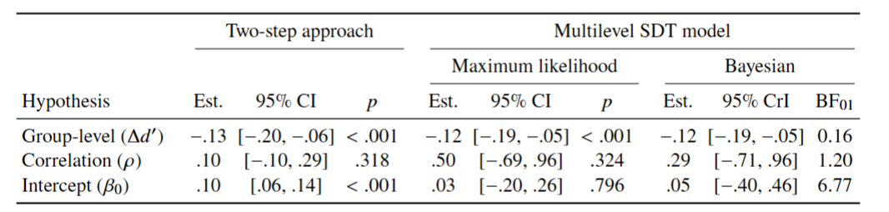
Note. $Δd^{'}$ = mean influence minus mean awareness sensitivity; $ρ$ = correlation between true sensitivities (Pearson $r$ between observed sensitivities in the two-step approach); $β_{0}$ = regression intercept. Intervals are 95% confidence intervals (two-step and maximum likelihood) or credible intervals (Bayesian). The Bayesian fit used the latent regression parameterization, with a prior specified directly on $β_{0}$. BF$​_{01}$ > 1 favors the null hypothesis. See Appendix A for model specifications and priors.

The original analyses found a contextual-cuing effect, with responses 99 ms faster for Old than New displays, $t(103)=10.02$, $p<.001$. However, recognition was also above chance ($d^{'}$ = 0.23, $t(103)=6.95$, $p<.001$). The two-step analyses showed greater sensitivity in the recognition than in the search task, but no significant correlation between observed sensitivities ($r$ = .10, 95% CI $[-.10,.29]$) and a significantly positive regression intercept (0.10, 95% CI [0.06, 0.14]), the two latter typically interpreted as evidence of contextual cuing without awareness.
The multilevel SDT model supported only the first of these conclusions. The awareness task was more sensitive than the influence task (mean $d^{'}$ = 0.23 vs. 0.11, corresponding to approximately 55% vs. 52% correct classification of individual trials; ${\text{BF}}_{10}=6.43$), again showing the opposite of a group-level dissociation. Evidence concerning the correlation between true sensitivities was inconclusive ($ρ=.29$, 95% CrI $[-.71,.96]$; ${\text{BF}}_{01}=1.20$). The latent intercept was close to zero, with moderate evidence against contextual cuing at zero awareness ($d^{'}$ = 0.05, 95% CrI $[-0.40,0.46]$; ${\text{BF}}_{01}=6.77$).
The discrepancy with the two-step approach can be explained by the low reliability of the awareness measure. With 64 recognition trials, its reliability was .12 (95% CrI [.00, .34]), compared with the influence measure’s reliability of .29 (95% CrI [.06, .48]). Much of the observed variability in recognition therefore reflected measurement error, which can attenuate the correlation and inflate the intercept when ignored (Figure 10). As in the previous example, low reliability complicates the interpretation of a positive intercept as evidence of unconscious processing.

Figure 10
Regression Model With Observed and Model-Estimated Sensitivities in Contextual Cuing
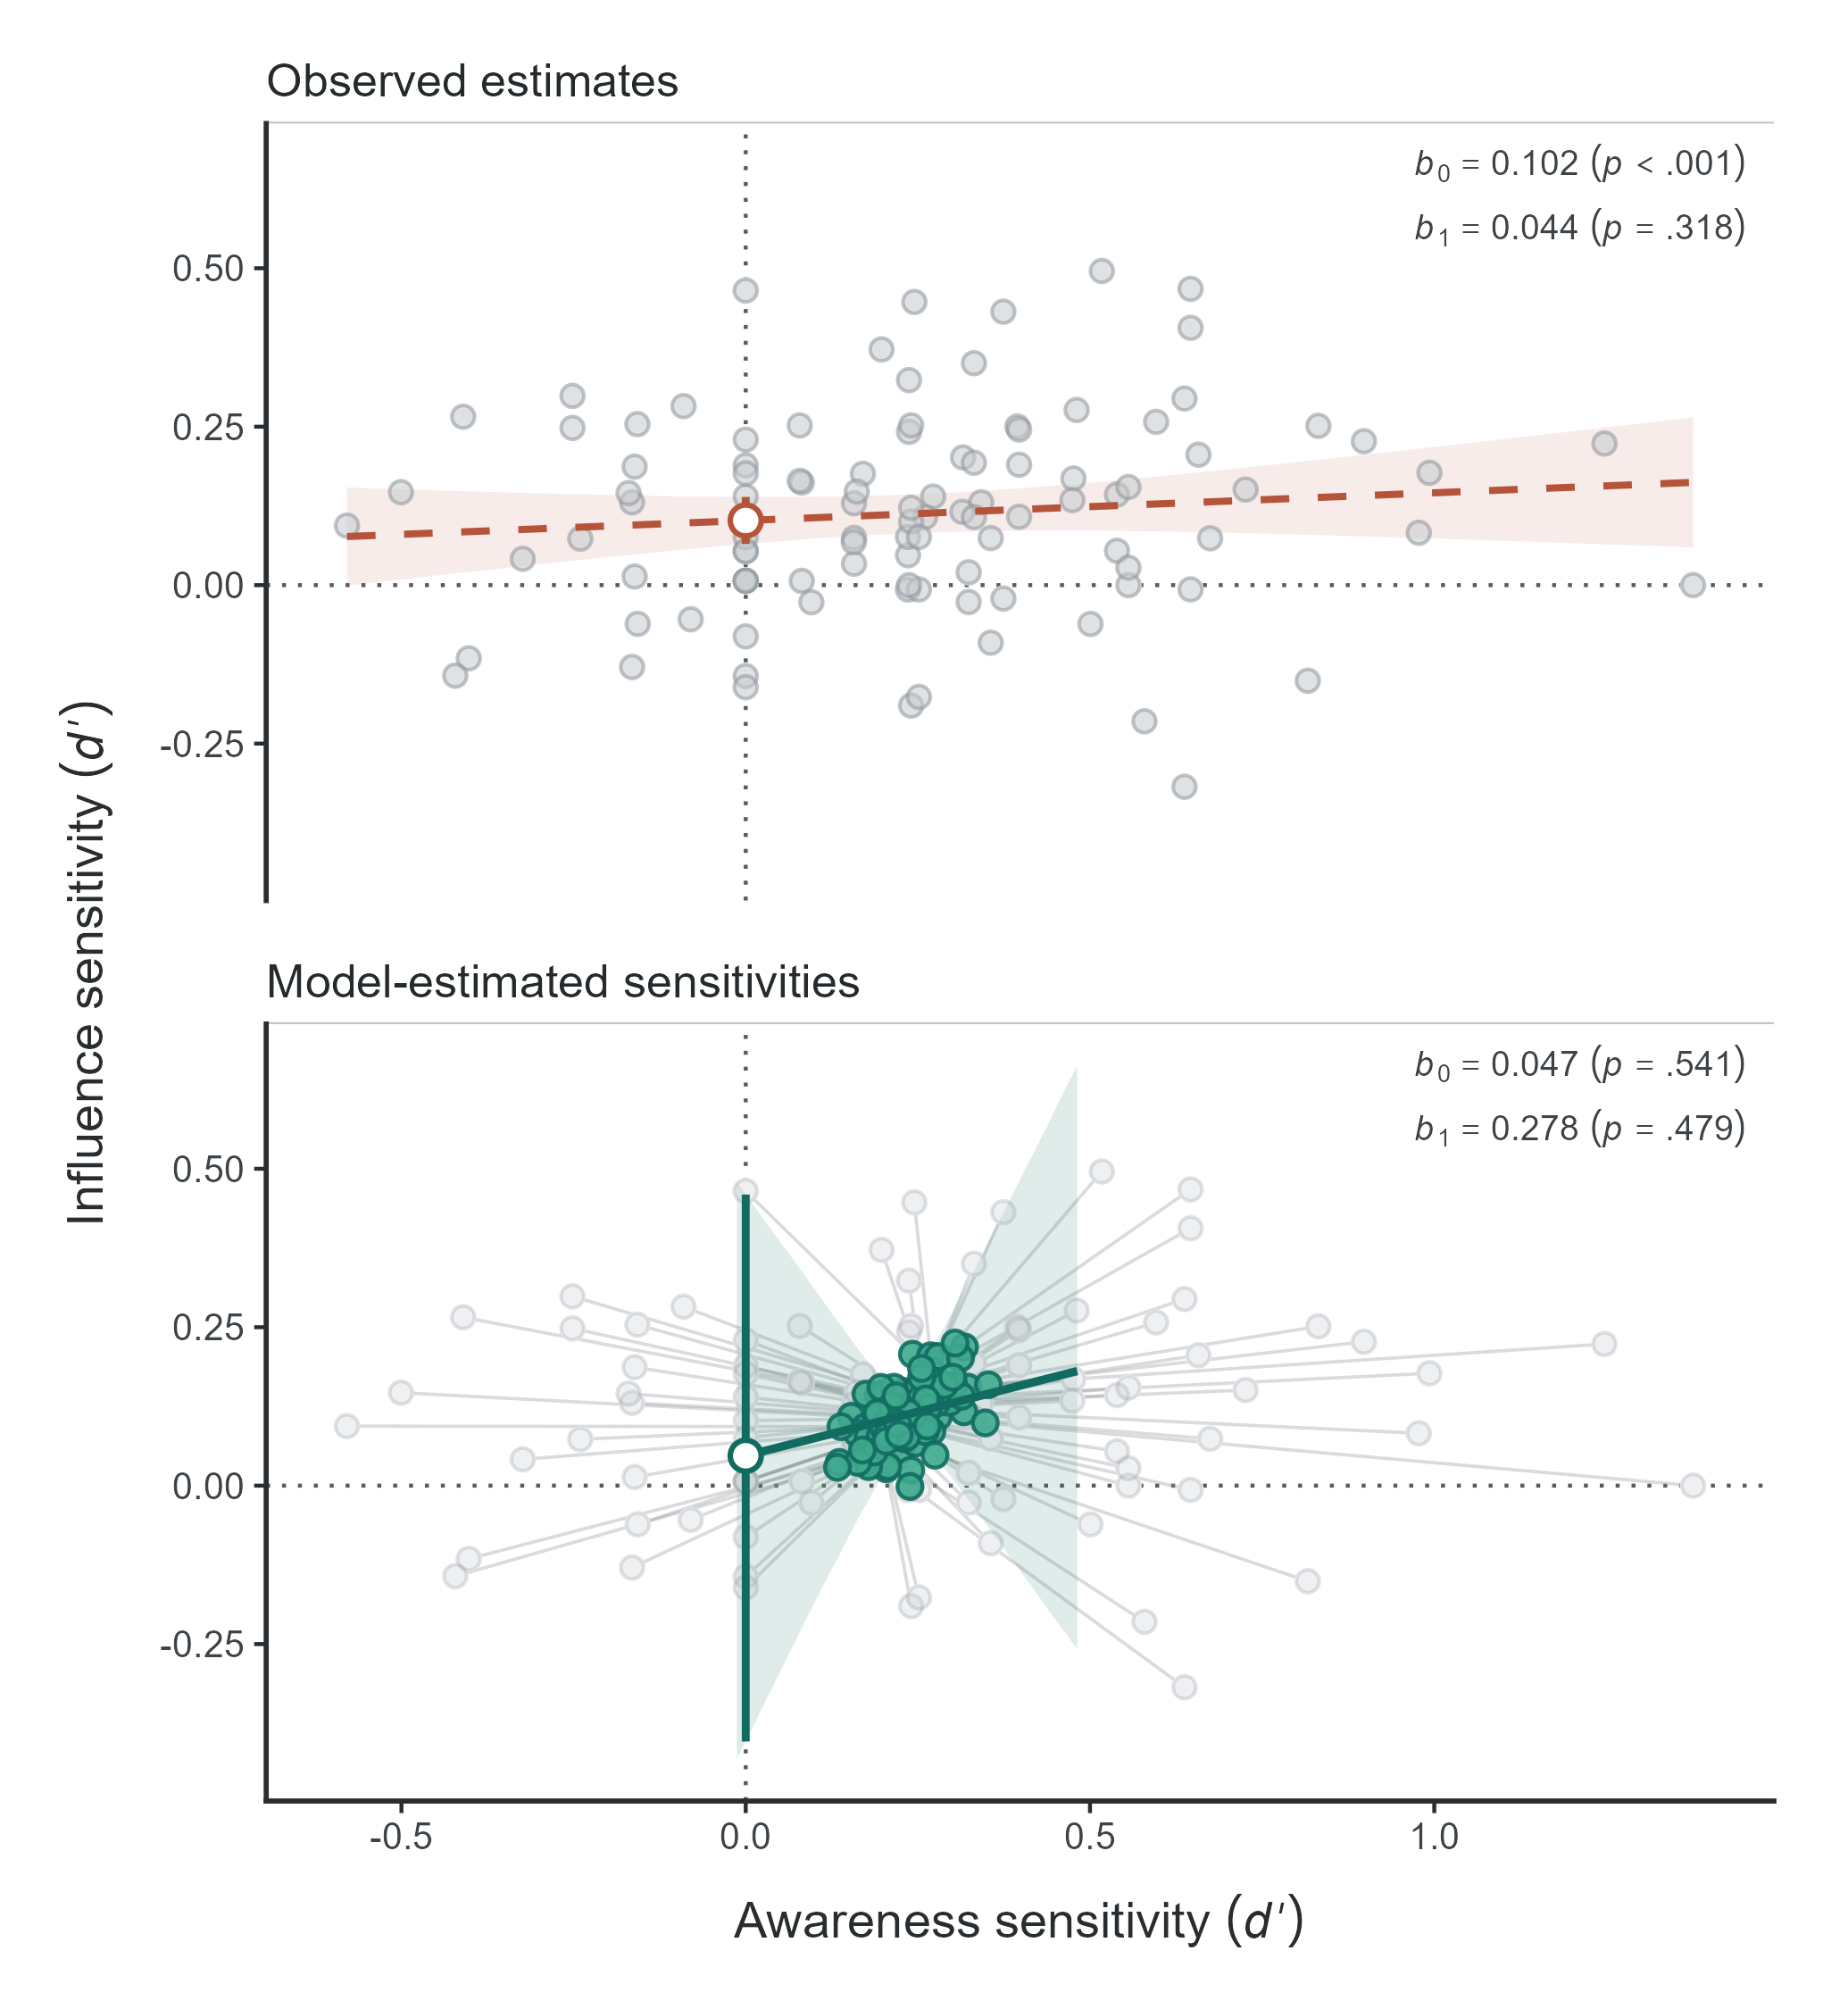
Note. Gray circles show observed participant-level sensitivities, and green points show posterior mean estimates from the multilevel SDT model. Connecting segments illustrate shrinkage. Lines represent the observed regression (top) and the model-implied latent regression (bottom), with 95% confidence and credible bands, respectively. Open circles mark the intercepts. b₀ = intercept; b₁ = slope. P-values in the bottom panel are two-sided posterior p-values. Figure generated using the {uSDT} R package.

Masked Affective Priming
Wentura et al. (2025) investigated whether the processing of emotional facial expressions requires awareness, revisiting the conclusions of Lähteenmäki et al. (2015). For our illustration, we use their preregistered Experiment 2a. In the influence task, a face expressing anger or sadness (the prime) was presented for 40 ms between a forward and a backward mask, followed by a visible target face that participants categorized as “angry” or “sad” as quickly as possible. Affective priming (influence measure) was computed as the RT difference between congruent trials, in which prime and target expressed the same emotion, and incongruent trials. In the subsequent awareness task, participants categorized the emotion of the masked prime. Eighty-six participants completed 360 trials per task, equally balanced between conditions. The data are publicly available at https://osf.io/9t4pk.
The authors tested the group-level dissociation hypothesis separately for each task. Responses were 6 ms faster on congruent than incongruent trials, with strong evidence for a priming effect (${\text{BF}}_{10}=10.57$). In contrast, mean sensitivity in the awareness task was very low, with only anecdotal evidence that it differed from zero (${\text{BF}}_{10}=1.93$). They also found no correlation between the priming effect and awareness sensitivity ($r(84)=-.03$, ${\text{BF}}_{01}=7.20$). The intercept hypothesis was not tested. Based on these findings, the authors concluded that masked affective priming does not require awareness.
We fitted the multilevel SDT model to the trial-level data, following the authors’ preprocessing procedures, which excluded errors and RT outliers (16.1% of trials). Following Meyen et al. (2022), we dichotomized RTs at each participant’s median, treating faster responses as “congruent” responses (and slower as “incongruent” responses). We considered congruent trials as signal (and incongruent trials as noise) to compute a $d^{'}$ as the sensitivity of the influence measure. For the awareness task, sad primes were treated as signal (and angry primes as noise). To mirror the original Bayesian analyses, we fitted only the Bayesian model, using the authors’ priors for the mean task sensitivities and their correlation (see Appendix A). Bayes factors were computed using the Savage–Dickey density ratio for all three hypotheses and each task’s mean sensitivity against zero. Results are presented in Table 7.

Table 7
Reanalysis of Experiment 2a of Wentura et al. (2025)
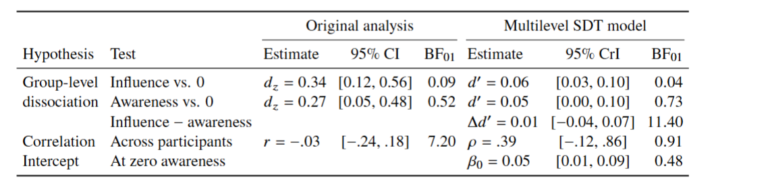
Note. Original results are from Wentura et al. (2025). We calculated 95% CIs from reported effect sizes (N = 86). Original BFs used JASP with a two-sided Cauchy prior (r = sqrt(2)/2). Cohen’s $d_{z}$ is the mean within-participant effect divided by its SD. Multilevel estimates are posterior means with 95% CrIs; BFs use the Savage–Dickey ratio. $d^{'}$ = mean sensitivity; $ρ$ = correlation between true sensitivities; $β_{0}$ = latent regression intercept. BF_01 > 1 favors the null.

The multilevel SDT model did not support the original conclusions. Testing each task separately reproduced the original pattern, with strong evidence that influence sensitivity was above zero (${\text{BF}}_{10}=28.20$) but only anecdotal evidence for awareness sensitivity (${\text{BF}}_{10}=1.37$). However, both measures were practically equally sensitive (mean $d^{'}$ = 0.05 vs. 0.06, corresponding to approximately 51% correct classification of individual trials in both tasks; ${\text{BF}}_{01}=11.40$). The group-level analysis therefore provided strong evidence against a dissociation. Evidence concerning the correlation between true sensitivities was inconclusive ($ρ=.39$, 95% CrI $[-.12,.86]$; ${\text{BF}}_{01}=0.91$). The latent intercept was positive but close to zero, with only anecdotal evidence for affective priming at zero awareness ($d^{'}$ = 0.05, 95% CrI $[0.01,0.09]$; ${\text{BF}}_{10}=2.06$).
Although neither measure was as unreliable as in the previous examples, both still showed limited reliability. The reliability of the awareness task was .53 (95% CrI [.39, .66]), compared with reliability of the influence task of .30 (95% CrI [.06, .50]). The estimated correlation between true sensitivities ($ρ=.39$) was more than twice the observed correlation between participant-level estimates ($r=.17$), although evidence concerning the true correlation remained inconclusive. Evidence against a zero correlation remained inconclusive (${\text{BF}}_{01}=0.91$), but the posterior probability that the true correlation was positive was 93.7%, with a directional Bayes factor of 14.73 favoring a positive correlation over a negative or zero correlation (Figure 11). The original null correlation therefore cannot establish that affective priming is independent of awareness. The results were also sensitive to the choice of priors. With the wider priors used in the authors’ sensitivity analysis ($r=1$ and $r=\sqrt{2}$), evidence for equal sensitivities increased (${\text{BF}}_{01}$ up to $22.44$), while evidence for a positive intercept decreased (${\text{BF}}_{01}$ up to $0.83$). Overall, the reanalysis provides no convincing evidence of unconscious affective priming.

Figure 11
Prior and Posterior Distributions of the Latent Correlation Between True Awareness and Influence Sensitivities
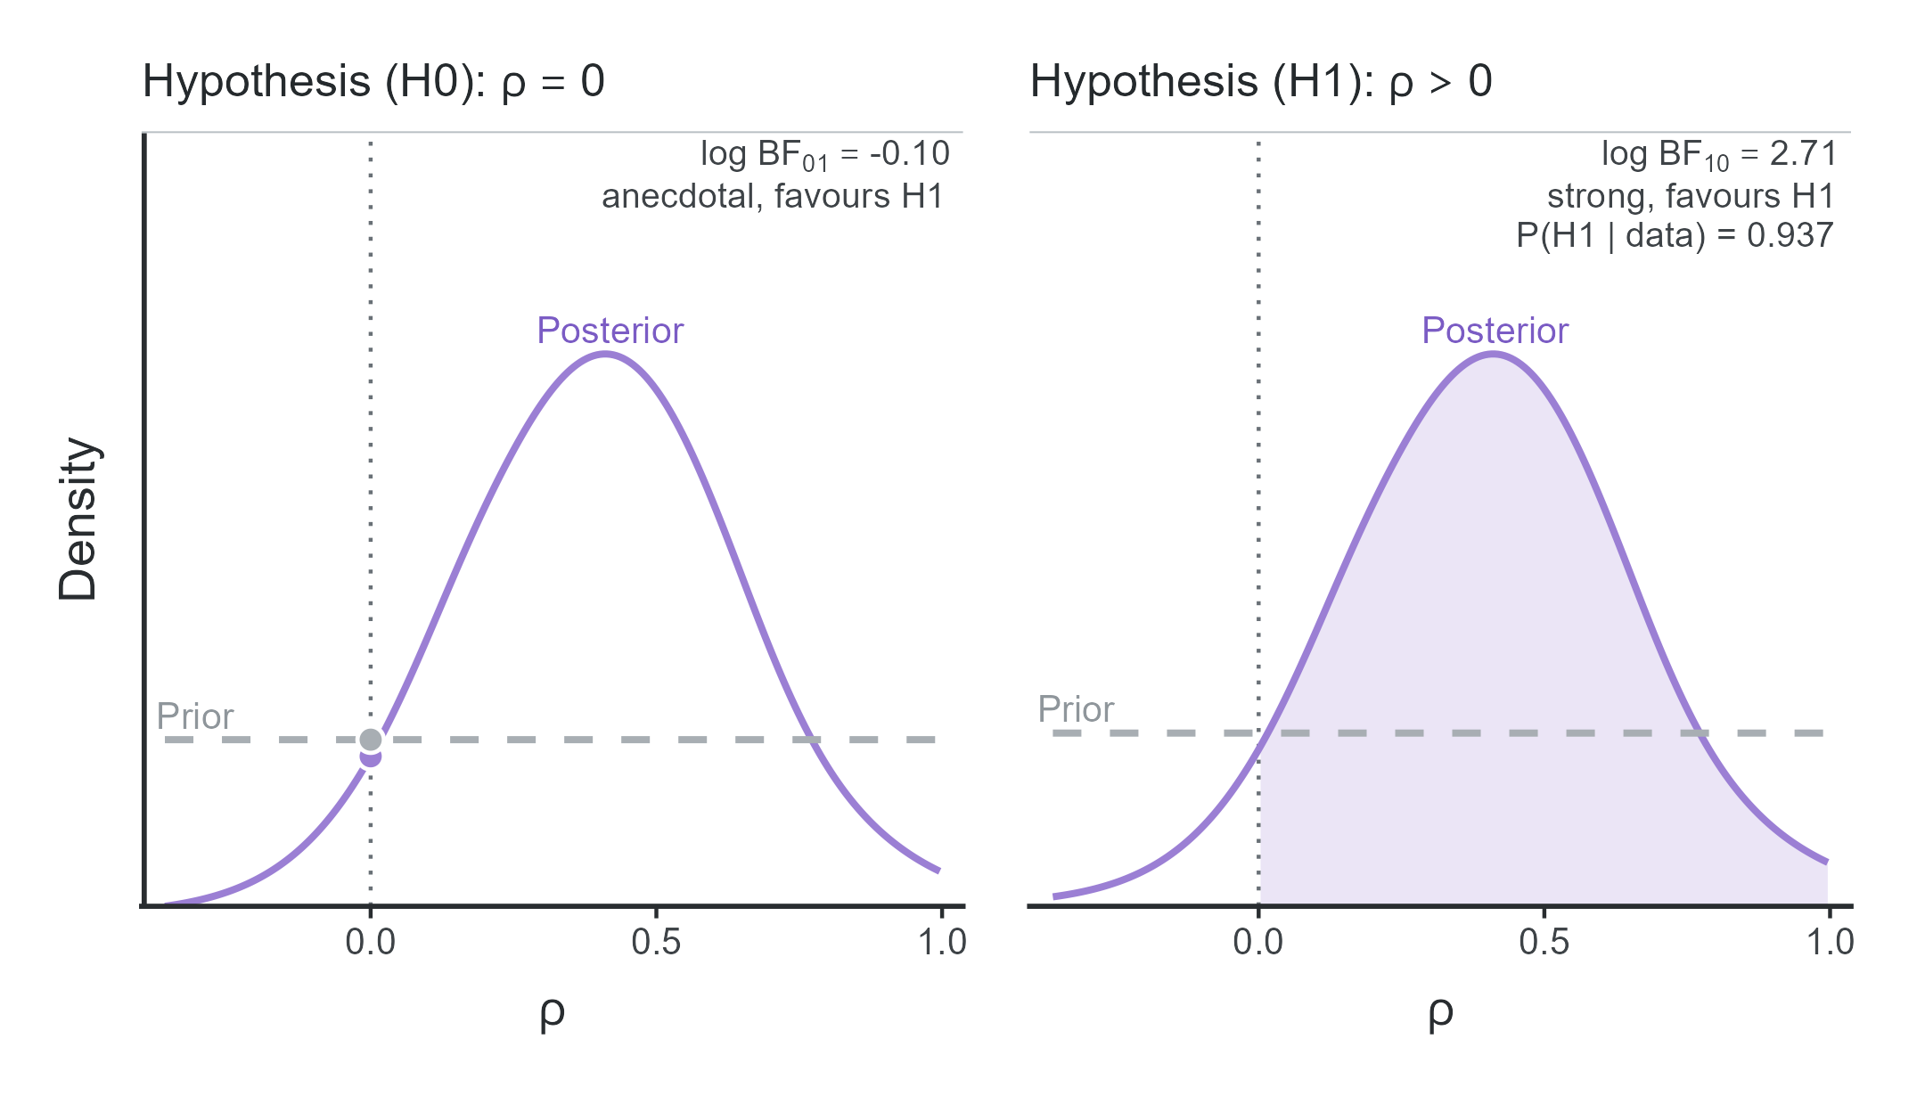
Note. The left panel shows the prior (dashed) and posterior (solid) densities of the latent correlation $ρ$, with the vertical dotted line marking the null value $ρ=0$. The ratio of the prior and posterior densities at this point yields the Savage–Dickey Bayes factor for the point-null hypothesis. The right panel shows the same posterior distribution for the directional hypothesis $ρ>0$; the shaded area represents the posterior probability that the true correlation is positive. The qualitative evidence labels (e.g., anecdotal, moderate, strong) follow the classification adapted from Jeffreys (1961) by Lee and Wagenmakers (2013). Figure generated using the {uSDT} R package.

Discussion
Research on unconscious processing has traditionally relied on three types of evidence: group-level dissociations between influence and awareness measures, their correlation across individuals, and the intercept of their regression. These hypotheses are often tested using separate analyses that overlook methodological challenges: differences in statistical power and measurement scales, measurement error, and the failure to distinguish absence of evidence from evidence of absence. Together, these challenges can artificially inflate the apparent evidence for unconscious processing. Although several methods have been proposed to address each of these challenges, researchers must identify, understand, and implement the appropriate methods for each challenge, which can be highly demanding. In this work, we have introduced a multilevel SDT model that simultaneously addresses these challenges and allows all three hypotheses to be tested in a single step, using just one R function. By jointly analyzing trial-level responses from influence and awareness tasks, the model accounts for uncertainty in individual sensitivities and estimates the population parameters needed to evaluate each hypothesis. To facilitate its use in applied research, we have implemented the models in the R package {uSDT}, available on CRAN (Rey-Sáez, Garre-Frutos, et al., 2026). The package provides both frequentist and Bayesian implementations, allowing researchers to fit these models with minimal effort.

Reliability and Validity
Although multilevel models account for measurement error, they cannot compensate for too low reliability. When one or both tasks are highly unreliable (e.g., reliabilities below .30), the data may simply contain too little information to estimate the relationship between true sensitivities with sufficient precision. This problem cannot be solved by statistical modeling alone, but the multilevel SDT model can at least alert researchers to the substantial uncertainty surrounding these estimates. Nevertheless, researchers should prioritize improving task reliability through experimental design, for example, by increasing the number of trials or optimizing task procedures to obtain more precise measures of individual differences (e.g., Siegelman et al., 2017; Franco-Martínez, Rey-Sáez, et al., 2026; Vadillo et al., 2025; Whitehead et al., 2020).
Reliability alone, however, does not guarantee that our inferences are valid. For instance, even when measurement error is minimized and a proper sensitivity comparison is computed, inferences about unconscious processing still depend on whether the awareness task adequately measures conscious awareness (e.g., Giménez-Fernández et al., 2020; Franco-Martínez, Rey-Sáez, et al., 2026; Franco-Martínez, Ferrer-Mendieta, et al., 2026; Schmidt & Biafora, 2024). Beyond measurement validity, our model does not currently accommodate alternative criteria for inferring unconscious processing, such as the double-dissociation criterion proposed by Schmidt and Vorberg (2006). Nevertheless, note that the proposed framework could be readily extended to test this criterion with an appropriate experimental design, simply by framing H1 to test for an interaction. In other words, while statistical modeling can help to mitigate methodological issues and improve inferences in unconscious processing research, these models cannot, by themselves, ensure the validity of the measures on which those inferences rely.
A further limitation concerns the generalizability of correlations between influence and awareness tasks. These correlations are inherently task-specific and cannot be directly interpreted as correlations between influence and awareness constructs. This has been referred to as “task impurity” (Miyake et al., 2000), that is, no task can be a perfectly pure measure of a latent construct. With only one influence and one awareness task, we cannot aim to determine whether their relationship might generalize across different measures of the same construct. A promising alternative is to collect multiple awareness and influence measures and analyze them using generalized hierarchical factor models (Rey-Sáez, Franco-Martínez, et al., 2026; Rouder & Mehrvarz, 2026; Stevenson, Heathcote, et al., 2024; Stevenson, Innes, et al., 2024; Stevenson et al., 2025). These models adapt exploratory and confirmatory factor analysis to experimental settings, allowing researchers to model awareness and influence as latent factors underlying their respective measures and estimate the correlation between them. Their main advantage is that they do so by modeling trial-level responses within a hierarchical framework, as in our multilevel SDT model, but allowing for task-specific likelihoods (e.g., Bernoulli for binary responses or ex-Gaussian for response times). Moreover, combining multiple tasks can improve the precision of estimates of true correlations between task effects by leveraging the information each task shares with the others (Mehrvarz & Rouder, 2025; Rey-Sáez, Franco-Martínez, et al., 2026). This approach would allow researchers to move beyond task-specific associations and examine whether awareness and influence performance share common underlying processes across different paradigms.

Conclusion
Claims that information can be processed without conscious awareness have important implications for theories of human cognition. Yet such claims have often relied on inconsistent statistical evidence, small samples, few awareness trials, unreliable measures, and tests not suitable for evidence of absence. Extraordinary claims require extraordinary evidence (Sagan, 1979), and we have shown that nonsignificant awareness effects, weak correlations, and significant regression intercepts can have much more ordinary methodological explanations, such as insufficient statistical power, differences in measurement scales, and measurement error. Clearly, the multilevel SDT model (like any statistical model) cannot compensate for insufficient data or invalid measures, but it provides a robust model-based approach to assessing the strength of evidence for and against unconscious processing while accounting for measurement error and differences in scale. We hope this framework, and its accessible implementation in the {uSDT} package, will encourage researchers to revisit established findings and design more informative studies capable of providing the robust evidence that claims of unconscious processing require.

References
Anderson, B. A., Kim, H., Kim, A. J., Liao, M.-R., Mrkonja, L., Clement, A., & Grégoire, L. (2021). The past, present, and future of selection history. Neuroscience & Biobehavioral Reviews, 130, 326–350. https://doi.org/10.1016/j.neubiorev.2021.09.004
Baayen, R. H., Davidson, D. J., & Bates, D. M. (2008). Mixed-effects modeling with crossed random effects for subjects and items. Journal of Memory and Language, 59(4), 390–412. https://doi.org/10.1016/j.jml.2007.12.005
Barr, D. J., Levy, R., Scheepers, C., & Tily, H. J. (2013). Random effects structure for confirmatory hypothesis testing: Keep it maximal. Journal of Memory and Language, 68(3), 255–278. https://doi.org/10.1016/j.jml.2012.11.001
Bates, D., Mächler, M., Bolker, B., & Walker, S. (2015). Fitting linear mixed-effects models using lme4. Journal of Statistical Software, 67(1), 1–48. https://doi.org/10.18637/jss.v067.i01
Batterink, L. J., Reber, P. J., Neville, H. J., & Paller, K. A. (2015). Implicit and explicit contributions to statistical learning. Journal of Memory and Language, 83, 62–78. https://doi.org/10.1016/j.jml.2015.04.004
Berkovitch, L., & Dehaene, S. (2019). Subliminal syntactic priming. Cognitive Psychology, 109, 26–46. https://doi.org/10.1016/j.cogpsych.2018.12.001
Bradley, J. V. (1978). Robustness? British Journal of Mathematical and Statistical Psychology, 31(2), 144–152. https://doi.org/10.1111/j.2044-8317.1978.tb00581.x
Bruno, N. M., Embon, I., Díaz Rivera, M. N., Giménez, L., D’Amelio, T. A., Torres Batán, S., Guarracino, J. F., Iorio, A. A., & Andreu, J. M. (2020). Faster might not be better: Pictures may not elicit a stronger unconscious priming effect than words when modulated by semantic similarity. Consciousness and Cognition, 81, 102932. https://doi.org/10.1016/j.concog.2020.102932
Chalmers, R. P., & Adkins, M. C. (2020). Writing effective and reliable Monte Carlo simulations with the SimDesign package. The Quantitative Methods for Psychology, 16(4), 248–280. https://doi.org/10.20982/tqmp.16.4.p248
Cheesman, J., & Merikle, P. M. (1984). Priming with and without awareness. Perception & Psychophysics, 36(4), 387–395. https://doi.org/10.3758/BF03202793
Chiu, Y.-C., & Aron, A. R. (2014). Unconsciously triggered response inhibition requires an executive setting. Journal of Experimental Psychology: General, 143(1), 56–61. https://doi.org/10.1037/a0031497
Chun, M. M., & Jiang, Y. (1998). Contextual cueing: Implicit learning and memory of visual context guides spatial attention. Cognitive Psychology, 36(1), 28–71. https://doi.org/10.1006/cogp.1998.0681
Colagiuri, B., & Livesey, E. J. (2016). Contextual cuing as a form of nonconscious learning: Theoretical and empirical analysis in large and very large samples. Psychonomic Bulletin & Review, 23(6), 1996–2009. https://doi.org/10.3758/s13423-016-1063-0
Daltrozzo, J., Signoret, C., Tillmann, B., & Perrin, F. (2011). Subliminal semantic priming in speech. PLoS ONE, 6(5), e20273. https://doi.org/10.1371/journal.pone.0020273
DeCarlo, L. T. (2010). On the statistical and theoretical basis of signal detection theory and extensions: Unequal variance, random coefficient, and mixture models. Journal of Mathematical Psychology, 54(3), 304–313. https://doi.org/10.1016/j.jmp.2010.01.001
Dehaene, S., Naccache, L., Le Clec’H, G., Koechlin, E., Mueller, M., Dehaene-Lambertz, G., van de Moortele, P.-F., & Le Bihan, D. (1998). Imaging unconscious semantic priming. Nature, 395(6702), 597–600. https://doi.org/10.1038/26967
Devlieger, I., Mayer, A., & Rosseel, Y. (2016). Hypothesis testing using factor score regression: A comparison of four methods. Educational and Psychological Measurement, 76(5), 741–770. https://doi.org/10.1177/0013164415607618
Dickinson, A., & Brown, K. J. (2007). Flavor-evaluative conditioning is unaffected by contingency knowledge during training with color–flavor compounds. Learning & Behavior, 35(1), 36–42. https://doi.org/10.3758/BF03196072
Dienes, Z. (2014). Using Bayes to get the most out of non-significant results. Frontiers in Psychology, 5, 781. https://doi.org/10.3389/fpsyg.2014.00781
Draine, S. C., & Greenwald, A. G. (1998). Replicable unconscious semantic priming. Journal of Experimental Psychology: General, 127(3), 286–303. https://doi.org/10.1037/0096-3445.127.3.286
Efron, B., & Morris, C. (1975). Data analysis using Stein’s estimator and its generalizations. Journal of the American Statistical Association, 70(350), 311–319. https://doi.org/10.1080/01621459.1975.10479864
Enkavi, A. Z., Eisenberg, I. W., Bissett, P. G., Mazza, G. L., MacKinnon, D. P., Marsch, L. A., & Poldrack, R. A. (2019). Large-scale analysis of test–retest reliabilities of self-regulation measures. Proceedings of the National Academy of Sciences, 116(12), 5472–5477. https://doi.org/10.1073/pnas.1818430116
Finkbeiner, M., & Palermo, R. (2009). The role of spatial attention in nonconscious processing: A comparison of face and nonface stimuli. Psychological Science, 20(1), 42–51. https://doi.org/10.1111/j.1467-9280.2008.02256.x
Franco-Martínez, A., Ferrer-Mendieta, A., Peiró Lanchares, C., Vadillo, M. A., & Garre-Frutos, F. (2026). Choose your own PAS? Quantitative and qualitative validity evidence for the Perceptual Awareness Scale. PsyArXiv. https://doi.org/10.31234/osf.io/n7zuw_v3
Franco-Martínez, A., Rey-Sáez, R., Adrián-Ventura, J., Amerio, P., Baciero, A., Bennis, A., Bergström, F., Cleeremans, A., Contu, L., Dell’Acqua, R., Deng, X., Dolu, F. N., Gambarota, F., Gao, Y., Garre-Frutos, F., Grubert, A., Hernando, A., Hinojosa, J. A., Hoory, A., … Vadillo, M. A. (2026). Replicating the unconscious working memory effect: A multisite registered report. Neuroscience of Consciousness, 2026(1), niaf046. https://doi.org/10.1093/nc/niaf046
Franco-Martínez, A., Vicente-Conesa, F., Shanks, D. R., & Vadillo, M. A. (2025). Measurement and sampling noise undermine inferences about awareness in location probability learning: A modeling approach. Journal of Memory and Language, 143, 104621. https://doi.org/10.1016/j.jml.2025.104621
Franz, V. H., & von Luxburg, U. (2015). No evidence for unconscious lie detection: A significant difference does not imply accurate classification. Psychological Science, 26(10), 1646–1648. https://doi.org/10.1177/0956797615597333
Frensch, P. A., & Rünger, D. (2003). Implicit learning. Current Directions in Psychological Science, 12(1), 13–18. https://doi.org/10.1111/1467-8721.01213
Fuller, W. A. (1987). Measurement error models. Wiley.
Gelman, A., Carlin, J. B., Stern, H. S., Dunson, D. B., Vehtari, A., & Rubin, D. B. (2013). Bayesian data analysis (3rd ed.). Chapman & Hall/CRC. https://doi.org/10.1201/b16018
Gelman, A., & Stern, H. (2006). The difference between “significant” and “not significant” is not itself statistically significant. The American Statistician, 60(4), 328–331. https://doi.org/10.1198/000313006X152649
Gelman, A., Vehtari, A., Simpson, D., Margossian, C. C., Carpenter, B., Yao, Y., Kennedy, L., Gabry, J., Bürkner, P.-C., & Modrák, M. (2020). Bayesian workflow. arXiv. https://doi.org/10.48550/arXiv.2011.01808
Geyer, T., Shi, Z., & Müller, H. J. (2010). Contextual cueing in multiconjunction visual search is dependent on color- and configuration-based intertrial contingencies. Journal of Experimental Psychology: Human Perception and Performance, 36, 515–532. https://doi.org/10.1037/a0017448
Giménez-Fernández, T., Luque, D., Shanks, D. R., & Vadillo, M. A. (2020). Probabilistic cuing of visual search: Neither implicit nor inflexible. Journal of Experimental Psychology: Human Perception and Performance, 46(10), 1222–1234. https://doi.org/10.1037/xhp0000852
Goldstein, A., Rivlin, I., Goldstein, A., Pertzov, Y., & Hassin, R. R. (2020). Predictions from masked motion with and without obstacles. PLOS ONE, 15(11), e0239839. https://doi.org/10.1371/journal.pone.0239839
Goldstein, A., Sklar, A. Y., & Siegelman, N. (2022). Accurately measuring nonconscious processing using a generative Bayesian framework. Psychology of Consciousness: Theory, Research, and Practice, 9(4), 336–355. https://doi.org/10.1037/cns0000316
Gourevitch, V., & Galanter, E. (1967). A significance test for one parameter isosensitivity functions. Psychometrika, 32(1), 25–33. https://doi.org/10.1007/BF02289402
Green, D. M., & Swets, J. A. (1966). Signal detection theory and psychophysics. John Wiley & Sons.
Greenwald, A. G., & De Houwer, J. (2017). Unconscious conditioning: Demonstration of existence and difference from conscious conditioning. Journal of Experimental Psychology: General, 146(12), 1705–1721. https://doi.org/10.1037/xge0000371
Greenwald, A. G., Klinger, M. R., & Schuh, E. S. (1995). Activation by marginally perceptible (“subliminal”) stimuli: Dissociation of unconscious from conscious cognition. Journal of Experimental Psychology: General, 124(1), 22–42. https://doi.org/10.1037/0096-3445.124.1.22
Haines, N., Kvam, P. D., Irving, L., Smith, C. T., Beauchaine, T. P., Pitt, M. A., Ahn, W.-Y., & Turner, B. M. (2025). A tutorial on using generative models to advance psychological science: Lessons from the reliability paradox. Psychological Methods. https://doi.org/10.1037/met0000674
Hassin, R. R. (2013). Yes it can: On the functional abilities of the human unconscious. Perspectives on Psychological Science, 8(2), 195–207. https://doi.org/10.1177/1745691612460684
Hedge, C., Powell, G., & Sumner, P. (2018). The reliability paradox: Why robust cognitive tasks do not produce reliable individual differences. Behavior Research Methods, 50(3), 1166–1186. https://doi.org/10.3758/s13428-017-0935-1
Hernández-Gutiérrez, D., Sorrel, M. A., Shanks, D. R., & Vadillo, M. A. (2025). The conscious side of “subliminal” linguistic priming: A systematic review with meta-analysis and reliability analysis of visibility measures. Journal of Cognition, 8(1), 13. https://doi.org/10.5334/joc.419
Hoffman, L., & Rovine, M. J. (2007). Multilevel models for the experimental psychologist: Foundations and illustrative examples. Behavior Research Methods, 39(1), 101–117. https://doi.org/10.3758/BF03192848
Holender, D. (1986). Semantic activation without conscious identification in dichotic listening, parafoveal vision, and visual masking: A survey and appraisal. Behavioral and Brain Sciences, 9(1), 1–23. https://doi.org/10.1017/S0140525X00021269
Hunter, J. E., & Schmidt, F. L. (2015). Methods of meta‐analysis: Correcting error and bias in research findings (3rd ed.). SAGE Publications, Ltd.
James, W., & Stein, C. (1961). Estimation with quadratic loss. In J. Neyman (Ed.), Proceedings of the fourth Berkeley symposium on mathematical statistics and probability (Vol. 1, pp. 361–379). University of California Press. https://projecteuclid.org/euclid.bsmsp/1200512173
Jeffreys, H. (1961). Theory of probability (3rd ed.). Clarendon Press.
Jensen, K., Kirsch, I., Odmalm, S., Kaptchuk, T. J., & Ingvar, M. (2015). Classical conditioning of analgesic and hyperalgesic pain responses without conscious awareness. Proceedings of the National Academy of Sciences, 112(25), 7863–7867. https://doi.org/10.1073/pnas.1504567112
Jiang, Y. V., Swallow, K. M., Rosenbaum, G. M., & Herzig, C. (2013). Rapid acquisition but slow extinction of an attentional bias in space. Journal of Experimental Psychology: Human Perception and Performance, 39(1), 87–99. https://doi.org/10.1037/a0027611
Jiang, Y. V., Swallow, K. M., Won, B.-Y., Cistera, J. D., & Rosenbaum, G. M. (2015). Task specificity of attention training: The case of probability cuing. Attention, Perception, & Psychophysics, 77(1), 50–66. https://doi.org/10.3758/s13414-014-0747-7
Kelley, T. L. (1927). Interpretation of educational measurements. World Book Company.
Kihlstrom, J. F. (1987). The cognitive unconscious. Science, 237(4821), 1445–1452. https://doi.org/10.1126/science.3629249
Kim, C.-Y., & Blake, R. (2005). Psychophysical magic: Rendering the visible “invisible.” Trends in Cognitive Sciences, 9(8), 381–388. https://doi.org/10.1016/j.tics.2005.06.012
Klauer, K. C., Draine, S. C., & Greenwald, A. G. (1998). An unbiased errors-in-variables approach to detecting unconscious cognition. British Journal of Mathematical and Statistical Psychology, 51(2), 253–267. https://doi.org/10.1111/j.2044-8317.1998.tb00680.x
Kouider, S., & Dehaene, S. (2007). Levels of processing during non-conscious perception: A critical review of visual masking. Philosophical Transactions of the Royal Society B: Biological Sciences, 362(1481), 857–875. https://doi.org/10.1098/rstb.2007.2093
Kruschke, J. K. (2015). Doing Bayesian data analysis: A tutorial with R, JAGS, and Stan (2nd ed.). Academic Press. https://doi.org/10.1016/B978-0-12-405888-0.09999-2
Lages, M. (2024). A hierarchical signal detection model with unequal variance for binary responses. Psychonomic Bulletin & Review, 31(6), 2534–2557. https://doi.org/10.3758/s13423-024-02504-5
Lähteenmäki, M., Hyönä, J., Koivisto, M., & Nummenmaa, L. (2015). Affective processing requires awareness. Journal of Experimental Psychology: General, 144(2), 339–365. https://doi.org/10.1037/xge0000040
Lakens, D. (2017). Equivalence tests: A practical primer for $t$ tests, correlations, and meta-analyses. Social Psychological and Personality Science, 8(4), 355–362. https://doi.org/10.1177/1948550617697177
Lee, M. D., & Wagenmakers, E.-J. (2013). Bayesian cognitive modeling: A practical course. Cambridge University Press. https://doi.org/10.1017/CBO9781139087759
Lin, L. I.-K. (1989). A concordance correlation coefficient to evaluate reproducibility. Biometrics, 45(1), 255–268. https://doi.org/10.2307/2532051
Lin, Z., & Murray, S. O. (2013). Visible propagation from invisible exogenous cueing. Journal of Vision, 13(11), 12. https://doi.org/10.1167/13.11.12
Louis, T. A. (1984). Estimating a population of parameter values using Bayes and empirical Bayes methods. Journal of the American Statistical Association, 79(386), 393–398. https://doi.org/10.1080/01621459.1984.10478062
Lublinsky, S., Yaron, I., Marshall, W., & Mudrik, L. (2026). Increasing power for detecting awareness: A new approach to test group level objective performance. Neuroscience of Consciousness, 2026(1), niag039. https://doi.org/10.1093/nc/niag039
Malejka, S., Vadillo, M. A., Dienes, Z., & Shanks, D. R. (2021). Correlation analysis to investigate unconscious mental processes: A critical appraisal and mini-tutorial. Cognition, 212, 104667. https://doi.org/10.1016/j.cognition.2021.104667
Matzke, D., Ly, A., Selker, R., Weeda, W. D., Scheibehenne, B., Lee, M. D., & Wagenmakers, E.-J. (2017). Bayesian inference for correlations in the presence of measurement error and estimation uncertainty. Collabra: Psychology, 3(1), 25. https://doi.org/10.1525/collabra.78
McElreath, R. (2020). Statistical rethinking: A Bayesian course with examples in R and Stan (2nd ed.). Chapman & Hall/CRC. https://doi.org/10.1201/9780429029608
Mehrvarz, M., & Rouder, J. N. (2025). Estimating correlations in low-reliability settings with constrained hierarchical models. Behavior Research Methods, 57(2), 59. https://doi.org/10.3758/s13428-024-02568-0
Merikle, P. M., Smilek, D., & Eastwood, J. D. (2001). Perception without awareness: Perspectives from cognitive psychology. Cognition, 79(1–2), 115–134. https://doi.org/10.1016/S0010-0277(00)00126-8
Meteyard, L., & Davies, R. A. I. (2020). Best practice guidance for linear mixed-effects models in psychological science. Journal of Memory and Language, 112, 104092. https://doi.org/10.1016/j.jml.2020.104092
Meyen, S., Vadillo, M. A., von Luxburg, U., & Franz, V. H. (2024). No evidence for contextual cueing beyond explicit recognition. Psychonomic Bulletin & Review, 31(3), 907–930. https://doi.org/10.3758/s13423-023-02358-3
Meyen, S., Zerweck, I. A., Amado, C., von Luxburg, U., & Franz, V. H. (2022). Advancing research on unconscious priming: When can scientists claim an indirect task advantage? Journal of Experimental Psychology: General, 151(1), 65–81. https://doi.org/10.1037/xge0001065
Miller, J. (2000). Measurement error in subliminal perception experiments: Simulation analyses of two regression methods. Journal of Experimental Psychology: Human Perception and Performance, 26(4), 1461–1477. https://doi.org/10.1037/0096-1523.26.4.1461
Miyake, A., Friedman, N. P., Emerson, M. J., Witzki, A. H., Howerter, A., & Wager, T. D. (2000). The unity and diversity of executive functions and their contributions to complex “frontal lobe” tasks: A latent variable analysis. Cognitive Psychology, 41(1), 49–100. https://doi.org/10.1006/cogp.1999.0734
Newell, B. R., & Shanks, D. R. (2014). Unconscious influences on decision making: A critical review. Behavioral and Brain Sciences, 37(1), 1–19. https://doi.org/10.1017/S0140525X12003214
Nickel, A. E., Henke, K., & Hannula, D. E. (2015). Relational memory is evident in eye movement behavior despite the use of subliminal testing methods. PLOS ONE, 10(10), e0141677. https://doi.org/10.1371/journal.pone.0141677
Nickerson, R. S. (2000). Null hypothesis significance testing: A review of an old and continuing controversy. Psychological Methods, 5(2), 241–301. https://doi.org/10.1037/1082-989X.5.2.241
Nunnally, J. C. (1978). Psychometric theory (2nd ed.). McGraw-Hill.
Öhman, A., & Soares, J. J. F. (1998). Emotional conditioning to masked stimuli: Expectancies for aversive outcomes following nonrecognized fear-relevant stimuli. Journal of Experimental Psychology: General, 127(1), 69–82. https://doi.org/10.1037/0096-3445.127.1.69
Paciorek, A., & Williams, J. N. (2015). Semantic generalization in implicit language learning. Journal of Experimental Psychology: Learning, Memory, and Cognition, 41(4), 989–1002. https://doi.org/10.1037/xlm0000100
Pas, P., Custers, R., Bijleveld, E., & Vink, M. (2014). Effort responses to suboptimal reward cues are related to striatal dopaminergic functioning. Motivation and Emotion, 38(6), 759–770. https://doi.org/10.1007/s11031-014-9434-1
Perruchet, P., & Pacton, S. (2006). Implicit learning and statistical learning: One phenomenon, two approaches. Trends in Cognitive Sciences, 10(5), 233–238. https://doi.org/10.1016/j.tics.2006.03.006
Pessiglione, M., Schmidt, L., Draganski, B., Kalisch, R., Lau, H., Dolan, R. J., & Frith, C. D. (2007). How the brain translates money into force: A neuroimaging study of subliminal motivation. Science, 316(5826), 904–906. https://doi.org/10.1126/science.1140459
R Core Team. (2024). R: A language and environment for statistical computing. R Foundation for Statistical Computing. https://www.R-project.org/
Raes, A. K., & De Raedt, R. (2011). Interoceptive awareness and unaware fear conditioning: Are subliminal conditioning effects influenced by the manipulation of visceral self-perception? Consciousness and Cognition, 20(4), 1393–1402. https://doi.org/10.1016/j.concog.2011.05.009
Ratcliff, R., & McKoon, G. (2008). The diffusion decision model: Theory and data for two-choice decision tasks. Neural Computation, 20(4), 873–922. https://doi.org/10.1162/neco.2008.12-06-420
Raudenbush, S. W., & Bryk, A. S. (2002). Hierarchical linear models: Applications and data analysis methods (2nd ed.). SAGE Publications, Inc. https://uk.sagepub.com/en-gb/eur/hierarchical-linear-models/book9230
Reber, T. P., Luechinger, R., Boesiger, P., & Henke, K. (2012). Unconscious relational inference recruits the hippocampus. Journal of Neuroscience, 32(18), 6138–6148. https://doi.org/10.1523/JNEUROSCI.5639-11.2012
Reingold, E. M., & Merikle, P. M. (1988). Using direct and indirect measures to study perception without awareness. Perception & Psychophysics, 44(6), 563–575. https://doi.org/10.3758/BF03207490
Reuss, H., Kiesel, A., & Kunde, W. (2015). Adjustments of response speed and accuracy to unconscious cues. Cognition, 134, 57–62. https://doi.org/10.1016/j.cognition.2014.09.005
Rey-Sáez, R., Franco-Martínez, A., Revuelta, J., & Vadillo, M. A. (2026). A unified framework for psychometrics in experimental psychology: The standardized generalized hierarchical factor model. Psychological Methods. https://doi.org/10.1037/met0000846
Rey-Sáez, R., Garre-Frutos, F., Franco-Martínez, A., & Vadillo, M. (2026). uSDT: Hierarchical signal detection theory models for unconscious processing. https://doi.org/10.32614/CRAN.package.uSDT
Rothkirch, M., Shanks, D. R., & Hesselmann, G. (2022). The pervasive problem of post hoc data selection in studies on unconscious processing: A reply to Sklar, Goldstein, and Hassin (2021). Experimental Psychology, 69(1), 1–11. https://doi.org/10.1027/1618-3169/a000541
Rouder, J. N., & Haaf, J. M. (2019). A psychometrics of individual differences in experimental tasks. Psychonomic Bulletin & Review, 26(2), 452–467. https://doi.org/10.3758/s13423-018-1558-y
Rouder, J. N., Kumar, A., & Haaf, J. M. (2023). Why many studies of individual differences with inhibition tasks may not localize correlations. Psychonomic Bulletin & Review. https://doi.org/10.3758/s13423-023-02293-3
Rouder, J. N., & Lu, J. (2005). An introduction to Bayesian hierarchical models with an application in the theory of signal detection. Psychonomic Bulletin & Review, 12(4), 573–604. https://doi.org/10.3758/BF03196750
Rouder, J. N., & Mehrvarz, M. (2026). Random-effects psychophysics for studying individual differences in perception and cognition. Psychonomic Bulletin & Review, 33(5), 144. https://doi.org/10.3758/s13423-026-02890-y
Sagan, C. (1977). The dragons of Eden: Speculations on the evolution of human intelligence. Random House.
Sagan, C. (1979). Broca’s brain: Reflections on the romance of science. Random House.
Salvador, A., Berkovitch, L., Vinckier, F., Cohen, L., Naccache, L., Dehaene, S., & Gaillard, R. (2018). Unconscious memory suppression. Cognition, 180, 191–199. https://doi.org/10.1016/j.cognition.2018.06.023
Sanchez, D. J., Gobel, E. W., & Reber, P. J. (2010). Performing the unexplainable: Implicit task performance reveals individually reliable sequence learning without explicit knowledge. Psychonomic Bulletin & Review, 17(6), 790–796. https://doi.org/10.3758/PBR.17.6.790
Sandberg, K., Timmermans, B., Overgaard, M., & Cleeremans, A. (2010). Measuring consciousness: Is one measure better than the other? Consciousness and Cognition, 19(4), 1069–1078. https://doi.org/10.1016/j.concog.2009.12.013
Schmidt, T., & Biafora, M. (2024). A theory of visibility measures in the dissociation paradigm. Psychonomic Bulletin & Review, 31(1), 65–88. https://doi.org/10.3758/s13423-023-02332-z
Schmidt, T., & Vorberg, D. (2006). Criteria for unconscious cognition: Three types of dissociation. Perception & Psychophysics, 68(3), 489–504. https://doi.org/10.3758/BF03193692
Schmidt, T., Wolkersdorfer, M. P., Lee, X. Y., & Jubran, O. (2026). Unconscious cognition without post hoc selection artifacts: From selective analysis to functional dissociations. Behavior Research Methods, 58(2), 39. https://doi.org/10.3758/s13428-025-02926-6
Shanks, D. R. (2010). Learning: From association to cognition. Annual Review of Psychology, 61, 273–301. https://doi.org/10.1146/annurev.psych.093008.100519
Shanks, D. R. (2017). Regressive research: The pitfalls of post hoc data selection in the study of unconscious mental processes. Psychonomic Bulletin & Review, 24(3), 752–775. https://doi.org/10.3758/s13423-016-1170-y
Shanks, D. R., & Johnstone, T. (1999). Evaluating the relationship between explicit and implicit knowledge in a sequential reaction time task. Journal of Experimental Psychology: Learning, Memory, and Cognition, 25(6), 1435–1451. https://doi.org/10.1037/0278-7393.25.6.1435
Shanks, D. R., Malejka, S., & Vadillo, M. A. (2021). The challenge of inferring unconscious mental processes. Experimental Psychology, 68(3), 113–129. https://doi.org/10.1027/1618-3169/a000517
Shanks, D. R., & St. John, M. F. (1994). Characteristics of dissociable human learning systems. Behavioral and Brain Sciences, 17(3), 367–395. https://doi.org/10.1017/S0140525X00035032
Siegelman, N., Bogaerts, L., & Frost, R. (2017). Measuring individual differences in statistical learning: Current pitfalls and possible solutions. Behavior Research Methods, 49(2), 418–432. https://doi.org/10.3758/s13428-016-0719-z
Singmann, H., & Kellen, D. (2020). An introduction to mixed models for experimental psychology. In D. H. Spieler & E. H. Schumacher (Eds.), New methods in cognitive psychology (pp. 4–31). Routledge. https://doi.org/10.4324/9780429318405-2
Skrondal, A. (2000). Design and analysis of Monte Carlo experiments: Attacking the conventional wisdom. Multivariate Behavioral Research, 35(2), 137–167. https://doi.org/10.1207/S15327906MBR3502_1
Skrondal, A., & Laake, P. (2001). Regression among factor scores. Psychometrika, 66(4), 563–575. https://doi.org/10.1007/BF02296196
Skrondal, A., & Rabe-Hesketh, S. (2004). Generalized latent variable modeling: Multilevel, longitudinal, and structural equation models. Chapman & Hall/CRC. https://doi.org/10.1201/9780203489437
Smyth, A. C., & Shanks, D. R. (2008). Awareness in contextual cuing with extended and concurrent explicit tests. Memory & Cognition, 36(2), 403–415. https://doi.org/10.3758/MC.36.2.403
Spearman, C. (1904). The proof and measurement of association between two things. The American Journal of Psychology, 15(1), 72–101. https://doi.org/10.2307/1412159
Stevenson, N., Heathcote, A., Forstmann, B. U., & Matzke, D. (2024). Efficient Bayesian hierarchical factor analysis for model-based psychological research. PsyArXiv. https://doi.org/10.31234/osf.io/zangj
Stevenson, N., Innes, R. J., Boag, R. J., Miletić, S., Isherwood, S. J. S., Trutti, A. C., Heathcote, A., & Forstmann, B. U. (2024). Joint modelling of latent cognitive mechanisms shared across decision-making domains. Computational Brain & Behavior, 7(1), 1–22. https://doi.org/10.1007/s42113-023-00192-3
Stevenson, N., Innes, R. J., Gronau, Q. F., Miletić, S., Heathcote, A., Forstmann, B. U., & Brown, S. D. (2025). Using group level factor models to resolve high dimensionality in model-based sampling. Psychological Methods, 30(6), 1218–1241. https://doi.org/10.1037/met0000618
Stockart, F., Schreiber, M., Amerio, P., Carmel, D., Cleeremans, A., Deouell, L. Y., Dienes, Z., Elosegi, P., Gayet, S., Goldstein, A., Halchin, A.-M., Hesselmann, G., Kimchi, R., Lamy, D., Loued-Khenissi, L., Meyen, S., Micher, N., Pitts, M., Salomon, R., … Mudrik, L. (2025). Studying unconscious processing: Contention and consensus. Behavioral and Brain Sciences, 1–77. https://doi.org/10.1017/S0140525X25101489
ten Brinke, L., Stimson, D., & Carney, D. R. (2014). Some evidence for unconscious lie detection. Psychological Science, 25(5), 1098–1105. https://doi.org/10.1177/0956797614524421
Vadillo, M. A., Konstantinidis, E., & Shanks, D. R. (2016). Underpowered samples, false negatives, and unconscious learning. Psychonomic Bulletin & Review, 23(1), 87–102. https://doi.org/10.3758/s13423-015-0892-6
Vadillo, M. A., Linssen, D., Orgaz, C., Parsons, S., & Shanks, D. R. (2020). Unconscious or underpowered? Probabilistic cuing of visual attention. Journal of Experimental Psychology: General, 149(1), 160–181. https://doi.org/10.1037/xge0000632
Vadillo, M. A., Malejka, S., Lee, D. Y. H., Dienes, Z., & Shanks, D. R. (2022). Raising awareness about measurement error in research on unconscious mental processes. Psychonomic Bulletin & Review, 29(1), 21–43. https://doi.org/10.3758/s13423-021-01923-y
Vadillo, M. A., Malejka, S., & Shanks, D. R. (2025). Mapping the reliability multiverse of contextual cuing. Journal of Experimental Psychology: Learning, Memory, and Cognition, 51(6), 910–927. https://doi.org/10.1037/xlm0001410
van Gaal, S., Ridderinkhof, K. R., Scholte, H. S., & Lamme, V. A. F. (2010). Unconscious activation of the prefrontal no-go network. Journal of Neuroscience, 30(11), 4143–4150. https://doi.org/10.1523/JNEUROSCI.2992-09.2010
Wagenmakers, E.-J. (2007). A practical solution to the pervasive problems of p values. Psychonomic Bulletin & Review, 14(5), 779–804. https://doi.org/10.3758/BF03194105
Wang, B., & Theeuwes, J. (2018). How to inhibit a distractor location? Statistical learning versus active, top-down suppression. Attention, Perception, & Psychophysics, 80(4), 860–870. https://doi.org/10.3758/s13414-018-1493-z
Wentura, D., Rohr, M., & Kiefer, M. (2025). Does affective processing require awareness? On the use of the Perceptual Awareness Scale in response priming research. Journal of Experimental Psychology: General, 154(1), 128–151. https://doi.org/10.1037/xge0001648
Whitehead, P. S., Brewer, G. A., & Blais, C. (2020). Reliability and convergence of conflict effects: An examination of evidence for domain-general attentional control. Experimental Psychology, 67(5), 303–313. https://doi.org/10.1027/1618-3169/a000497
Wójcik, M. J., Nowicka, M. M., Bola, M., & Nowicka, A. (2019). Unconscious detection of one’s own image. Psychological Science, 30(4), 471–480. https://doi.org/10.1177/0956797618822971
Wokke, M. E., van Gaal, S., Scholte, H. S., Ridderinkhof, K. R., & Lamme, V. A. F. (2011). The flexible nature of unconscious cognition. PLoS ONE, 6(9), e25729. https://doi.org/10.1371/journal.pone.0025729
Yarkoni, T., & Westfall, J. (2017). Choosing prediction over explanation in psychology: Lessons from machine learning. Perspectives on Psychological Science, 12(6), 1100–1122. https://doi.org/10.1177/1745691617693393
Yaron, I., Zeevi, Y., Korisky, U., Marshall, W., & Mudrik, L. (2024). Progressing, not regressing: A possible solution to the problem of regression to the mean in unconscious processing studies. Psychonomic Bulletin & Review, 31(1), 49–64. https://doi.org/10.3758/s13423-023-02326-x

Appendix A

Model Specification and Prior Distributions
All models share the likelihood in Equation 3 and Equation 4. $d_{i}^{'}$ and $c_{i}$ contain the sensitivities and response criteria of participant $i$ in the awareness ($A$) and influence ($I$) tasks. $μ_{d}=(μ_{A},μ_{I})^{⊤}$ and $μ_{c}=(μ_{cA},μ_{cI})^{⊤}$ are their population means; $σ_{d}=(σ_{A},σ_{I})^{⊤}$ and $σ_{c}=(σ_{cA},σ_{cI})^{⊤}$ their between-participant SDs; $R_{d}$ and $R_{c}$ their correlation matrices, with $ρ$ the correlation between true sensitivities; and $S_{d}$ and $S_{c}$ the resulting covariance matrices. $β_{0}$ is the latent regression intercept (Equation 2). When RTs are split at the median, the influence-task criterion is fixed at zero ($c_{iI}=0$). $Student\text{-}t^{+}(ν,0,s)$ is a Student-$t$ distribution with $ν$ degrees of freedom and scale $s$, truncated at zero, and $LKJcorr(1)$ is a uniform prior on correlation matrices.
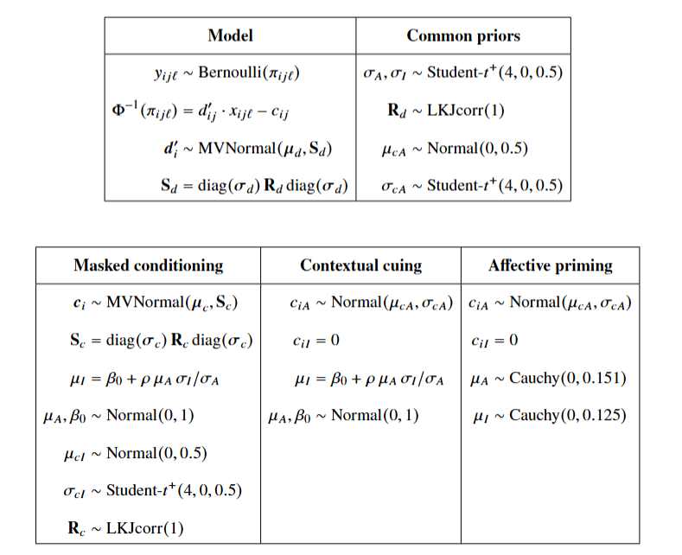

Appendix B

Fitting the Multilevel SDT Model With {uSDT}
The code below fits the models of the contextual-cuing study of Vadillo et al. (2025), whose trial-level data are included in {uSDT}. The package takes the data of each task, one row per trial, and only needs to know which columns identify the participant, the condition, and the response. RTs are split at each participant’s median internally (Meyen et al., 2022).
library(uSDT)
# Trial-level data of both tasks, one row per trial
# Awareness measure # Influence measure
data(vadillo_awareness) data(vadillo_cuing)
#> subj condition judged.old #> subj condition rt
#> 1 2001 old 0 #> 1 2001 new 1305.352
#> 2 2001 old 1 #> 2 2001 old 4027.887
#> 3 2001 new 1 #> 3 2001 old 2484.210
# Both tasks in one object, with Old displays as signal trials
d <- usdt_data_tasks(
awareness = vadillo_awareness,
influence = vadillo_cuing,
subject_col = "subj",
condition_col = "condition",
condition_levels = c(signal = "old", noise = "new"),
response_col = list(awareness = "judged.old", influence = "rt"),
response_levels = list(awareness = c(signal = 1, noise = 0),
influence = c(signal = "faster", noise = "slower")),
dichotomize = list(awareness = FALSE, influence = TRUE))
# Fit the frequentist hierarchical SDT model and check results
fit <- hsdt(d); summary(fit)
# Other utilities
usdt_reliability(fit) # Reliability estimates per task and participant
plot(fit, type = "roc") # Our figure 8 in main text
plot(fit, type = "regression") # Our figures 9 and 10 in main text
# Bayesian model: set prior distributions (if not, default priors used)
priors <- usdt_priors(intercept = "normal(0, 1)", cor_dprime = "lkj(1)")
# Fit the Bayesian hierarchical SDT model and check results
fit_b <- hsdt(d, estimation = "bayesian", priors = priors, latent = "regression")
summary(fit_b)
# Bayes factors and plots for the same hypotheses as the frequentist model
usdt_bf(fit_b)
# Bayes factors and plot type as in Figure 11
usdt_bf(fit_b, hypothesis = c("rho = 0", "rho > 0"))

Despite its popularity, we prefer to avoid the direct/indirect terminology, as it may be confusing for readers unfamiliar with it. Although these terms refer to direct and indirect measures of processing, they could be misinterpreted as referring to “direct measures of awareness” and “indirect measures of influence”, respectively, which would be incorrect.
Actually, there is a fourth hypothesis that is typically tested using an analytical strategy known as post hoc selection (i.e., to test whether the influence is above-chance after selecting only trials or participants with no awareness). We do not consider this approach in the present article, because it has no straightforward solution from the model here presented—unlike the other hypotheses—, and because post hoc selection has been criticized not only methodologically (Rothkirch et al., 2022; Shanks, 2017; Yaron et al., 2024), but also conceptually (Schmidt et al., 2026).
We use the term group-level dissociation hypothesis to refer collectively to simple and sensitivity dissociations, which represent two distinct criteria for establishing a dissociation between influence and awareness (Schmidt & Vorberg, 2006).
For illustrative purposes, the RT distributions in Figure 2 are assumed to be normal with equal variances across conditions. Although empirical RT distributions are typically right-skewed, the same reasoning applies to asymmetric distributions, such as the lognormal.
This artifact applies to any score computed separately for each participant, whether a mean, a difference between means, a proportion of correct responses, a $d^{'}$, or parameters of a cognitive computational model, such as the drift rate of the drift diffusion model (Ratcliff & McKoon, 2008).
Meanwhile, the estimated group-level dissociation, not shown in the figure, was significantly negative with infinite trials ($-0.16$, 95% CI [$-0.26$, $-0.05$]), but became nonsignificant with both 80 trials ($-0.08$, 95% CI [$-0.25$, 0.09]) and 20 trials ($-0.12$, 95% CI [$-0.41$, 0.16]), despite the awareness task being more sensitive in the underlying population.
The median classifier is optimal when RT distributions are normal or lognormal with a common dispersion parameter and different location parameters across conditions, and both conditions have equal numbers of trials (see Meyen et al., 2022, Supplemental Materials B). Note, however, that using the median as the classification threshold implicitly fixes the response criterion to zero in the influence task. This restriction can be relaxed by data-driven approaches that estimate the optimal classification threshold from training data and evaluate its performance on held-out trials (Franz & von Luxburg, 2015).
Consider a simplified example in which true awareness- and influence-task sensitivities have a correlation of $ρ=.50$ and SDs of $σ_{A}=1$ and $σ_{I}=2$, giving a population regression slope of $β=ρ⋅σ_{I}/σ_{A}=1$. Suppose awareness-task sensitivity is measured with perfect reliability, so its true scores can be obtained directly. Influence-task sensitivity, however, has a reliability of .64 and must be estimated. If we predict these sensitivities using univariate shrinkage, as illustrated by Kelley’s formula (Equation 6), the resulting predictions have an SD of 1.6 and a correlation of .40 with awareness-task sensitivity. Regressing these predictions on awareness-task sensitivity gives a slope of 0.64 instead of 1. In our joint multilevel model, shrinkage also uses information from correlated parameters, making its consequences for regression slopes more complex.
Although we focus on Experiment 1c (S18) here, we also prepared the trial-level data and fitted the same models to the other 17 datasets from Series 1 of Greenwald and De Houwer (2017). The code for reproducing these analyses is available in the project’s GitHub repository (URL).

