Talento Altamente Especializado – Inteligencia Artificial 2025 COCYTEN-Nayarit

Lab 1: Python & Tools Installation
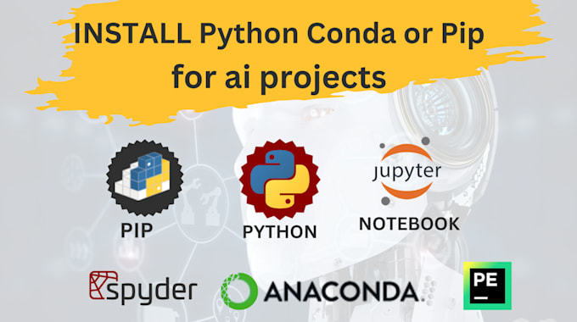

Students: Ricardo Torres López y Cesar Eduardo Inda Ceniceros
Instructor: Dr. Cristian Torres González

Assignment Date: 6/10/2025
Submission Date: 10/10/2025

Introduction
To continue with the course, it is important to have the necessary tools installed and complete the following activities. Tasks marked as (Urgent) must be completed before the second class.

Laboratory Description
Complete Questionnaire: https://forms.gle/WWzMHrpge6kZxcZf8 (Done!!)

Microsoft Documents General. Register the Team in the Table.

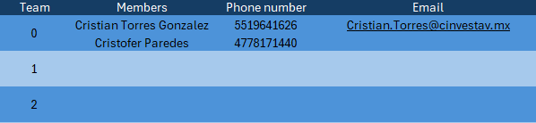
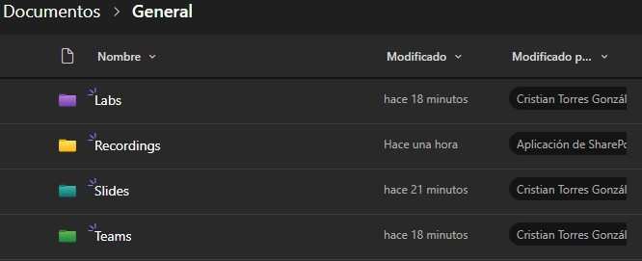

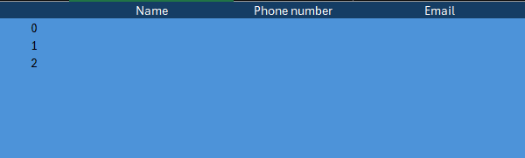

1.- Install Anaconda (Navigator)
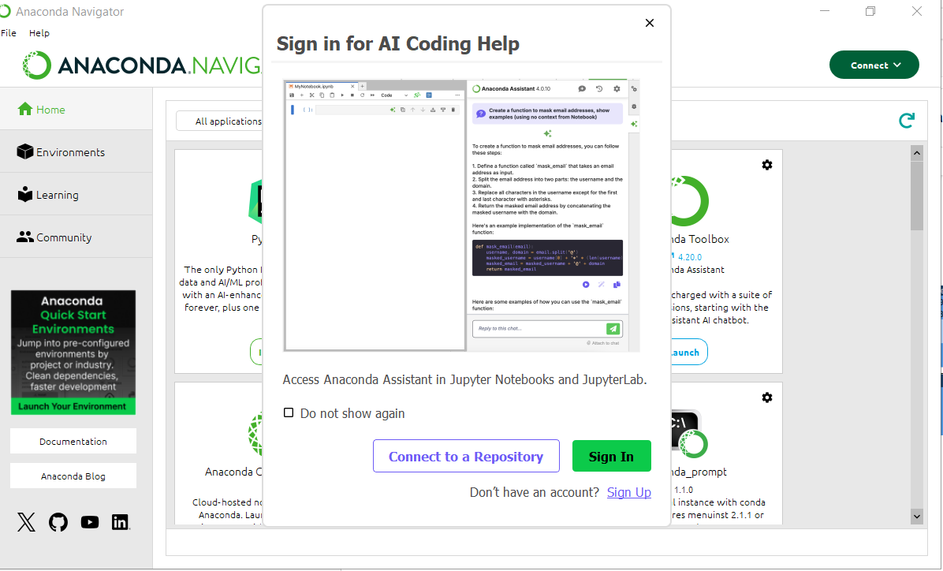

2.- Run “Hello World” program in Anaconda Prompt (Anaconda)
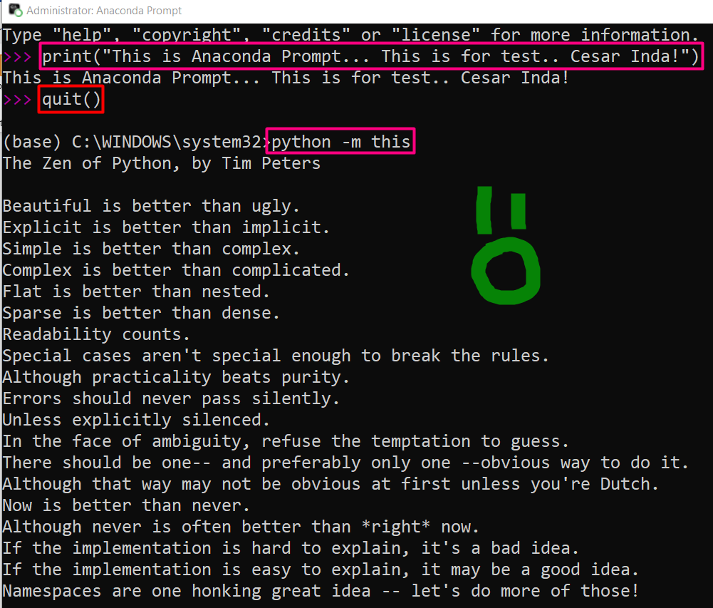

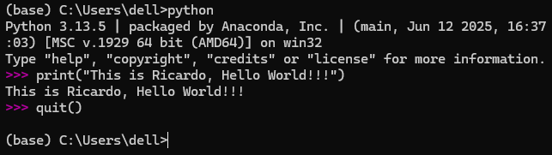

Create a presentation slide that includes:

Cesar Eduardo Inda Ceniceros
- Cybersecurity Engineer and Mechatronic Engineer
- Specialization Embedded Systems
- Interest: Electronic And Semiconductors Security.
- 2 years exp. Embedded Software Security Developer (Automotive)
- 1 year exp. Embedded Software Security Developer (Payment Devices)

Ricardo Torres López
- Chemical Engineer
- Designer in Unit Operations.
- Electronic and semiconductor
- 12 years as Director
- 5 years as a trader (yellow belt).
3.- Write a free-form report explaining step by step the execution of the “Hello World” program in:

  - Anaconda prompt



b) Windows PowerShell
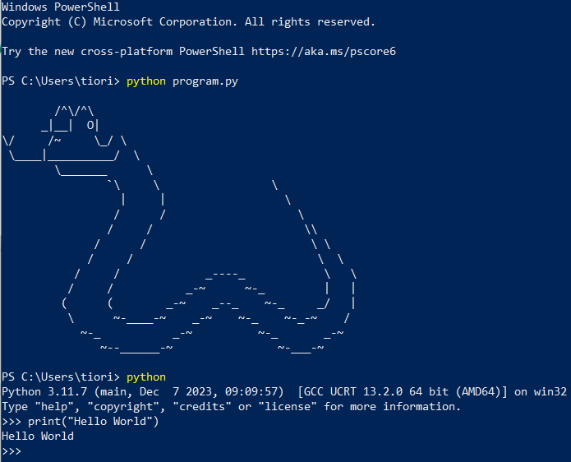

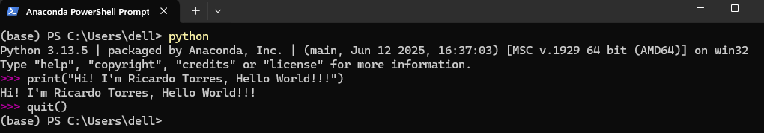

c) Visual StudioCode

- Jupyter Notebook

We runned the program in the “Visual Studio Code” extension. We execute the code and then execute the command in the terminal “Jupyter notebook - -port=8080”.
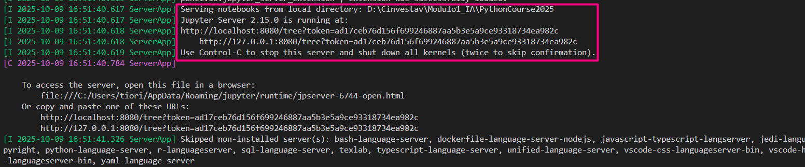

Then we can see the connection to kernel.
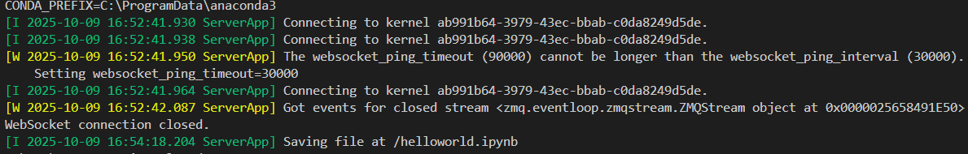

URL that was generated: http://localhost:8080/notebooks/helloworld.ipynb?

Home Anaconda Toolbox

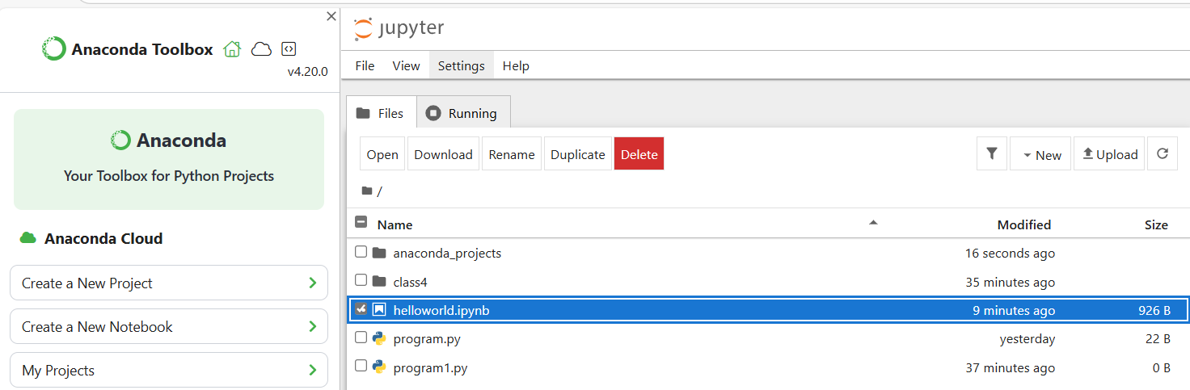

We can observe in the other windows the example of the code.

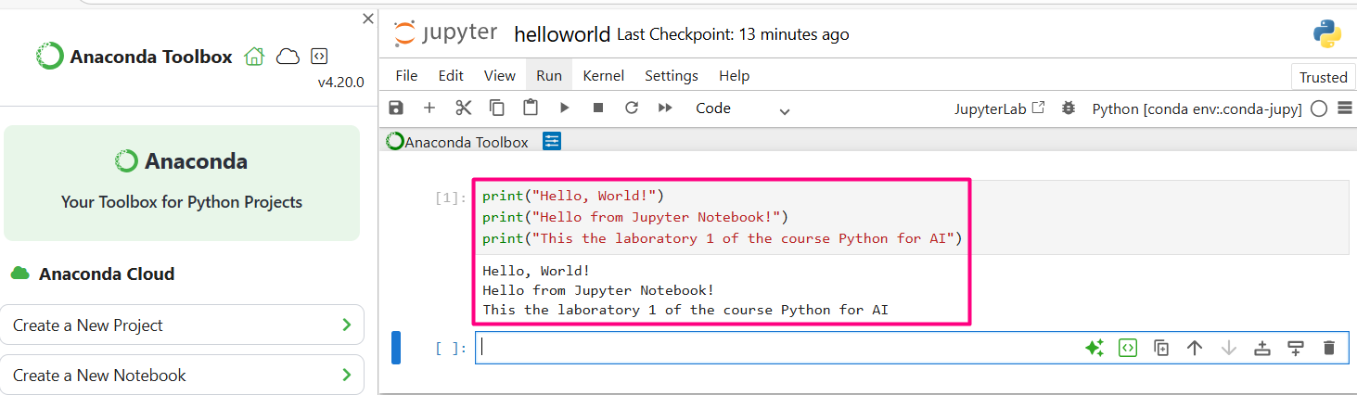

- Google Colab

Before writing code in Google Colab, we need to install it and then open a new notebook to work with these collaborative tools. The open the notebook.
https://colab.google/
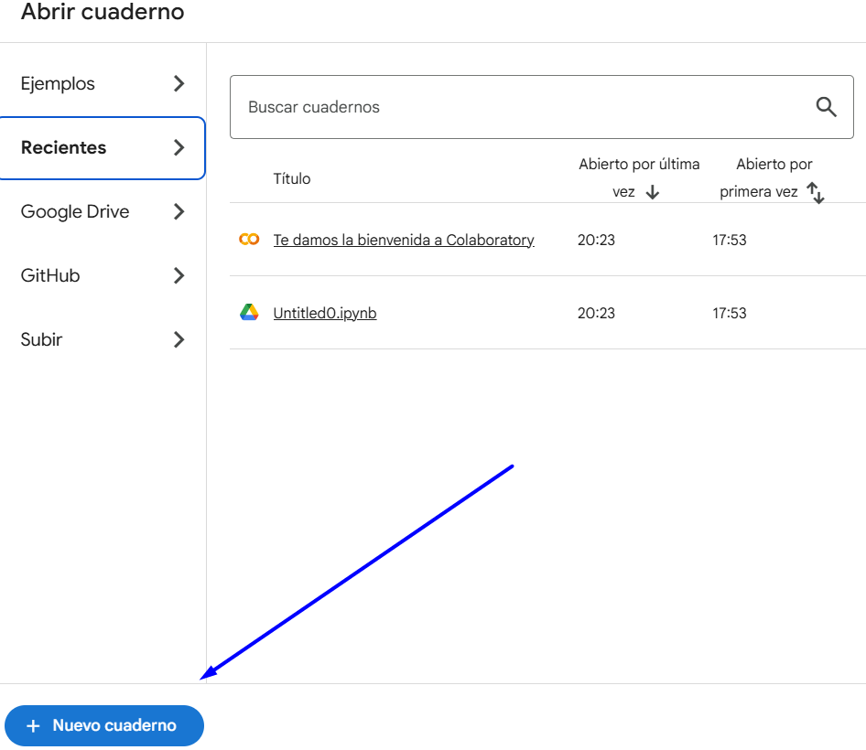

After that, we run a test code using Python libraries with Jupyter Notebook extension (.ipynb)

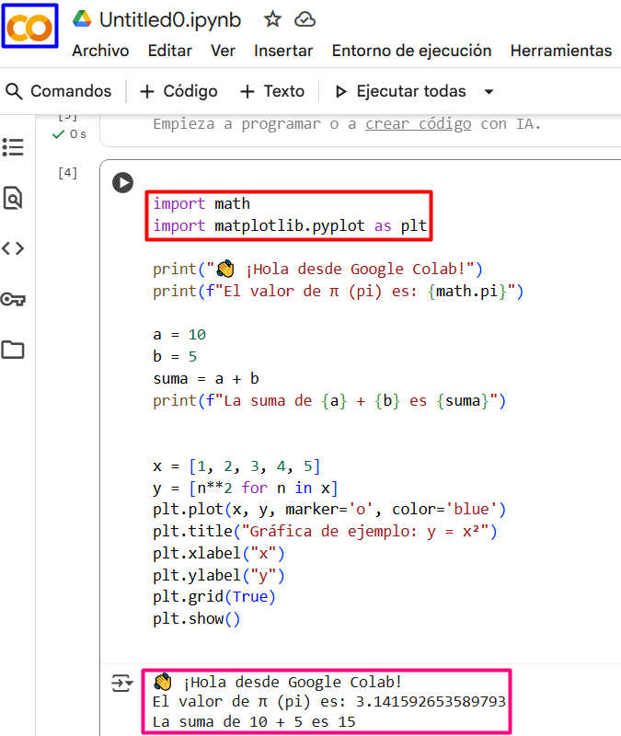

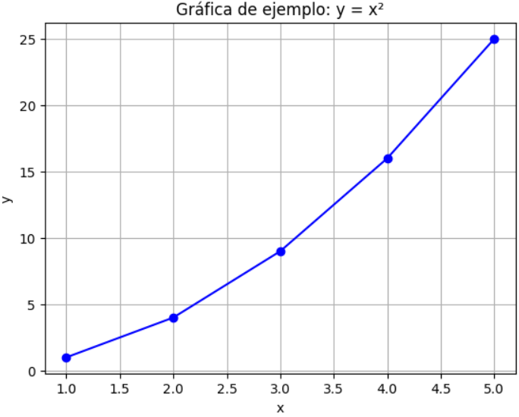

Conclusions / Issues

Cesar Eduardo Inda Ceniceros
This practice was interesting; personally, I had never used Anaconda before, nor had I explored virtual environments in such depth. For me, it was something very valuable, and I also believe that many of these tools provide a new perspective on each of the elements of the certification and the learning modality.

Ricardo Torres Lopez
As a student (beginner), it has been an amazing trip, where I leared to install, actívate, deactivate, deinstall, print, etc. I faced some problems during the process of learnig, nevertheless, it could be solved by my profesors’ instructions and suporting.

Troubleshooting
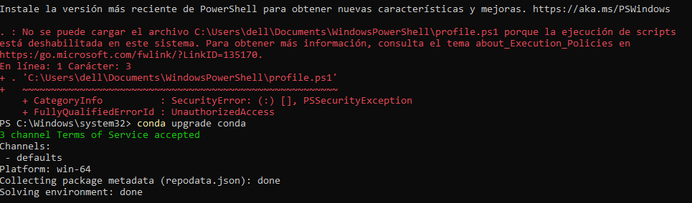

Before solving the problema, we must understand the differences between Anaconda prompt and Anaconda PowerSheel prompt.
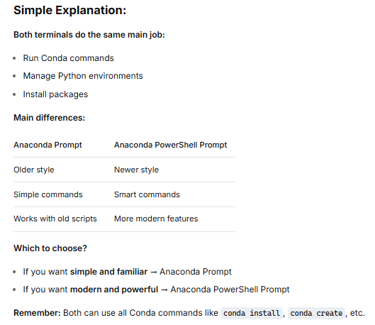
Therefore, the best option will be Anaconda PowerShell prompt to solve the toubleshoot generated for the system. Follow the next steps:
- Activate the prompt as a administrator
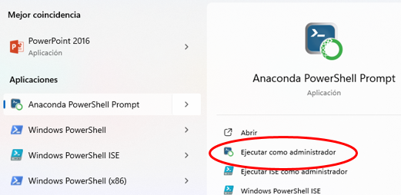

- Type the command
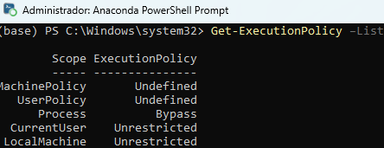

- Then type Set-ExecutionPolicy -ExecutionPolicy Unrestricted -Scope LocalMachine
- Finally, type Set-ExecutionPolicy -ExecutionPolicy Unrestricted -Scope CurrentUser

GitHub Repository
https://github.com/CeicGitHub/Specialization_Artificial_Intelligence_Module1/tree/Lab1_PythonAndTools

