Talento Altamente Especializado – Inteligencia Artificial 2025 COCYTEN-Nayarit

Lab 2: Python Introduction


Students: Ricardo Torres López y Cesar Eduardo Inda Ceniceros
Instructor: Dr. Cristian Torres González

Assignment Date: 14/10/2025
Submission Date: 21/10/2025

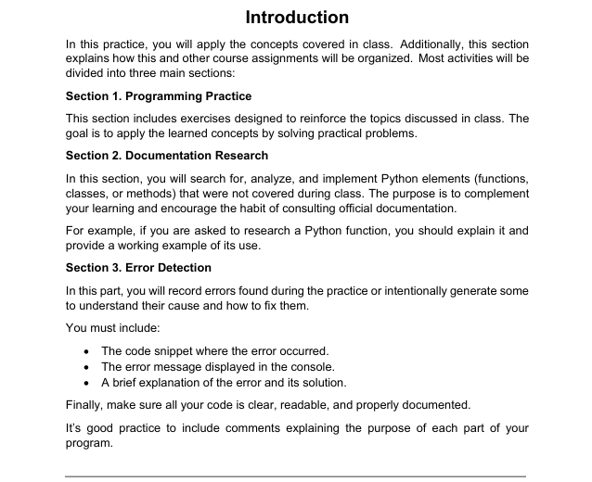
Introduction

Laboratory Description
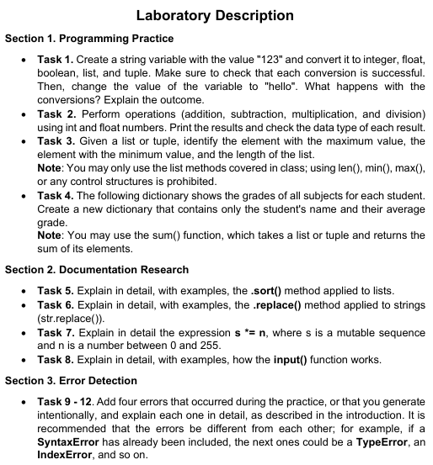

Section 1: Programming Practice

GitHub Repository

https://github.com/RicardoTL75/Modulo1_AI.git

Section 2. Documentation Research
Task_5
.short: https://python-reference.readthedocs.io/en/latest/docs/list/sort.html#id1
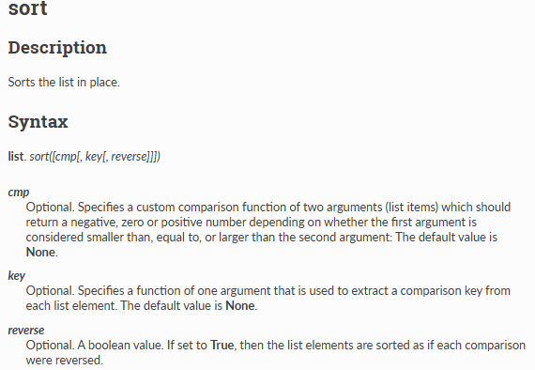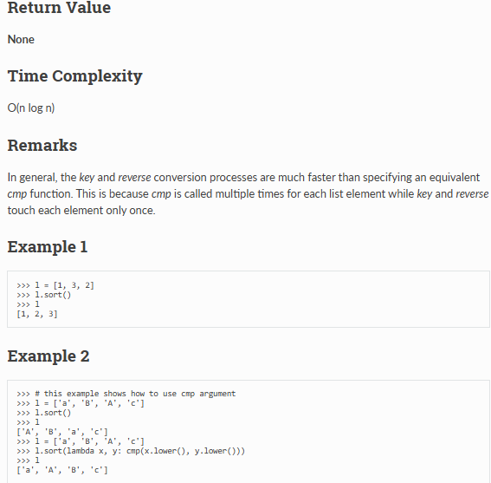

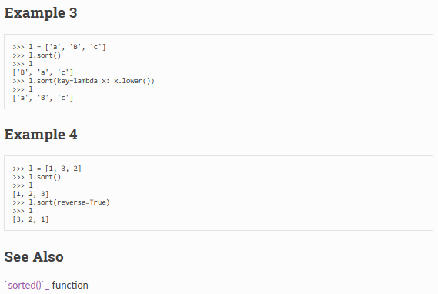

The task_4 will be taken as an example to in order to apply and explain the command (.short or shorted in the present Python version). The dictionary shows the grade, nevertheless, it is not sorted it by grade or by alphabetical order.

To sort the average_grades dictionary by grade (value) from high to low, it can be used:

Or lowest first without “reverse=True”:

Also, the alphabetical order could be applied:
Finally, in order to give an Aesthetics by printing like wáter-fall the name, the followind command will be used?
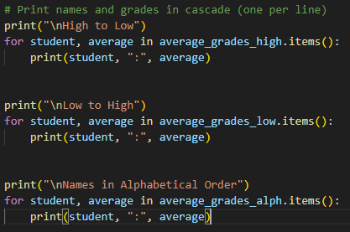

The following image shows the result of sorting the dictionary:
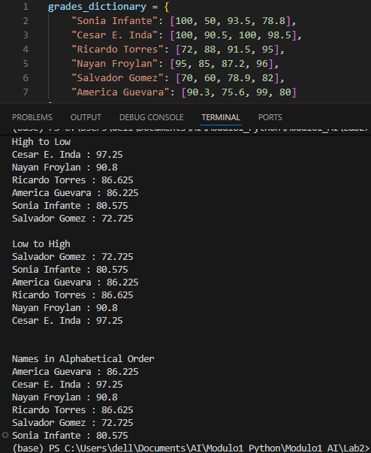

Task_6
.replace https://python-reference.readthedocs.io/en/latest/docs/str/replace.html

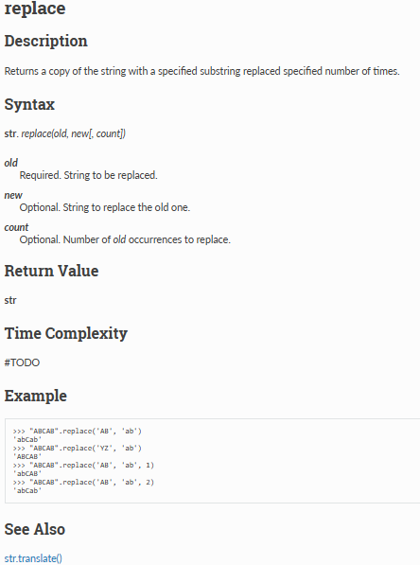

Summary:

What it is
- .replace() is a method of string objects in Python.
- It creates and returns a new string where a given substring is replaced by another.

General form
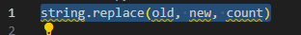
• old: the substring you want to replace.
• new: the substring you want to insert instead.
• count (optional): number of times to replace. If omitted, all occurrences are replaced.

The task 4 will be used as an exmple in order to demostrade the using of .replace
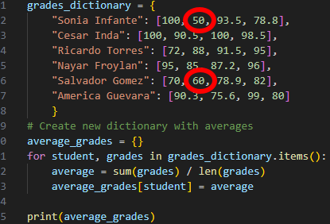

In the grade_dictionary Sonia Infante and Salvador Gomez, both failed the second subject (50, 60 respectively). Both grades will be replaced as following:
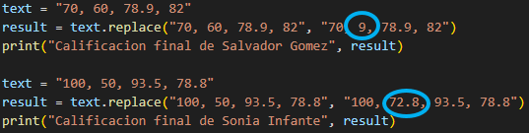

The result will be printed such as the following image:

Task_7

S * = n

This topic will be explained through a summary table in order to visualize it much better:

Summary of s *= n
Aspect | What it means
What is it? | A short way to write s = * n. It repeats a list.
What does it do? | It takes the items in list s and makes n copies of them, all inside the same list.
The main point | It changes the original list s. It does not make a new list.
Example | If s = [1, 2] and n = 3, then s *= 3 makes s = [1, 2, 1, 2, 1, 2].
Special Case | If n is 0, the list becomes empty: s = [].
Why n=0 to 255? | This is a special rule for a type of list called bytearray. For normal lists, n can be any number.

Simple short examples are being presented:
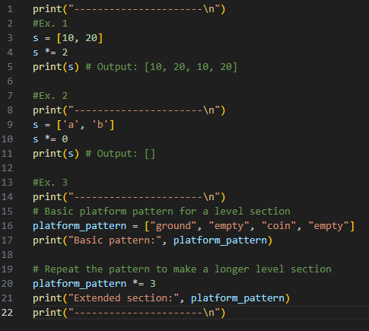

Output:
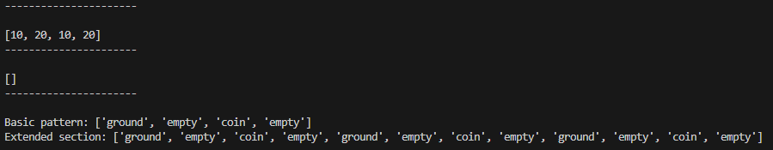

💡 When to Use This:
- When it’s needed multiple copies of the same items
- When it’s wanted to extend an existing list with its own items
- When preparing templates or patterns that repeat
- When wishing to keep working with the same list (not create a new one)

Task_8

Input()

🎯 What is the input() Function?
The input() function is a built-in Python function that reads a line from the keyboard and returns it as a string. It allows the program to interact with the user by waiting for them to type something.

🔧 Basic Syntax
python
variable = input("prompt_message")

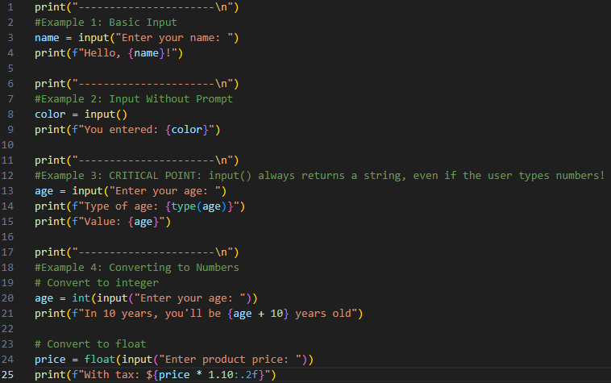

Output:
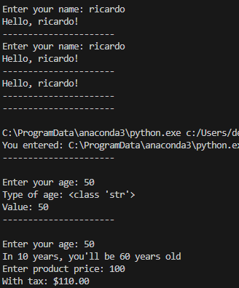

Section 3. Error Detection

Task_9:

📊 Summary Chart – Error Detection (Tasks 9–12)
Error Type | Example Code | Explanation (B1 English)
SyntaxError | print("Hello" | Happens when the code is not written correctly. Python cannot run because a parenthesis is missing.
TypeError | "123" + 5 | Happens when you try to use two different data types together (string + number). You need to change one type before.
IndexError | lst = [10, 20, 30]  print(lst[5]) | Happens when you ask for a list position that does not exist. The list has only 3 items (index 0–2).
NameError | print(result) | Happens when you use a variable that is not defined yet. Python does not know the name.

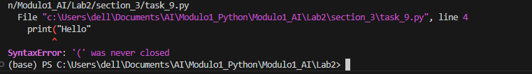

Task_10:

From task_4, intentionally made mistakes in that arithmetic code
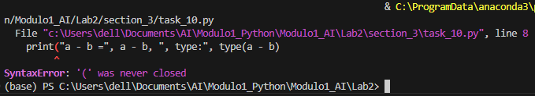

📌 Explanation of errors:
- SyntaxError → The print line is missing a closing ). Python stops immediately.
- TypeError → "Result: " + (a + b) tries to join a string and an int.
- IndexError → The list numbers has only indices 0–2, but we asked for 5.
- NameError → The variable total was never defined.
⚠️ Important: If you run this code directly, Python will stop at the first error (SyntaxError) and won’t continue.

Task_11:

From task_3, intentionally made mistakes in that arithmetic code

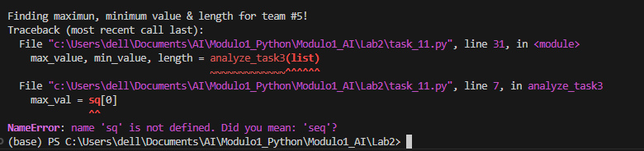

📌 What errors will happen?
- NameError → sq is not defined.
- TypeError → comparing number with "wrong" (string).
- IndexError → trying to access seq[99], which doesn’t exist.
- Logical Error → length becomes -14 instead of 14.

Task_12: At the begining, for task_4, I wanted the output be in column and alphabetical order.
Then, We found out the following code:
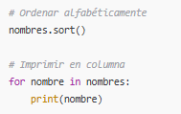

We did it such as it was mentiond before, how ever the result was not what we were spected.
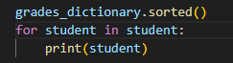

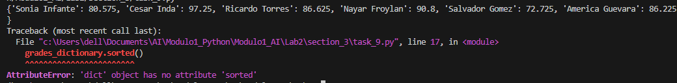

Finally, we found out the right way to do it:
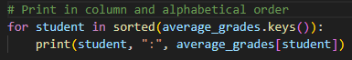

Finally the result was obtained:
