**TELEXn TIPS**

The TELEXn (TXn) is a seven-channel fixed panning mixer. It has two outputs, one at the top of the array of jacks and one at the bottom. Signals are panned between the two outputs based on the position of the jack. As you move out from the center, signals get louder in the nearest output and softer in the furthest. Got it? If not, here is a diagram that shows how it works:

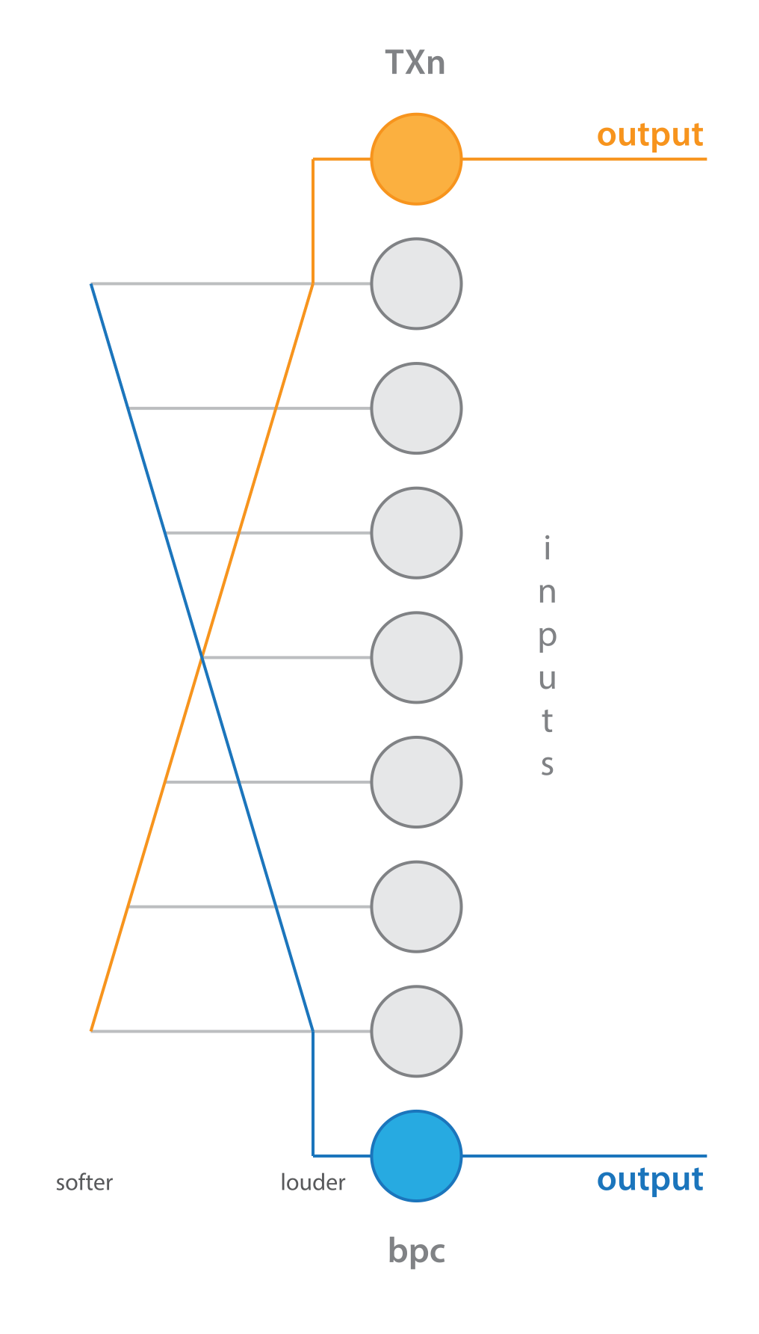

**TELEXn TIPS**

The TELEXn (TXn) is a seven-channel fixed panning mixer. It has two outputs, one at the top of the array of jacks and one at the bottom. Signals are panned between the two outputs based on the position of the jack. As you move out from the center, signals get louder in the nearest output and softer in the furthest. Got it? If not, here is a diagram that shows how it works:



The module uses standard Eurorack power. Make sure to orient your red stripe (-12V) properly. You can see it marked here on the close-up of the PCB:

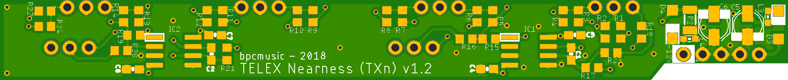

Finally, the TXn has two optional jumpers on the back where you can enable a 6dB pad for each of the channels. Simply use the included jumpers and connect the pins as marked below:



The TXn is based on the wonderful, minimal, open-source mixer *Nearness* designed by Jesper Särnesjö. This thing wouldn’t exist without all of the creativity and smarts he put into the original design. The TXn’s power section was inspired by designs from Mutable Instruments.

This module is also open source. All of the relevant files are available at https://github.com/bpcmusic/txn.

bpcmusic – 20181117; v1.0

The module uses standard Eurorack power. Make sure to orient your red stripe (-12V) properly. You can see it marked here on the close-up of the PCB:



Finally, the TXn has two optional jumpers on the back where you can enable a 6dB pad for each of the channels. Simply use the included jumpers and connect the pins as marked below:



The TXn is based on the wonderful, minimal, open-source mixer *Nearness* designed by Jesper Särnesjö. This thing wouldn’t exist without all of the creativity and smarts he put into the original design. The TXn’s power section was inspired by designs from Mutable Instruments.

This module is also open source. All of the relevant files are available at https://github.com/bpcmusic/txn.

bpcmusic – 20181117; v1.0