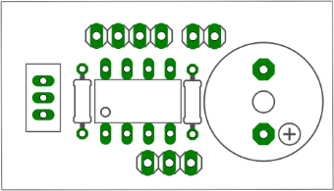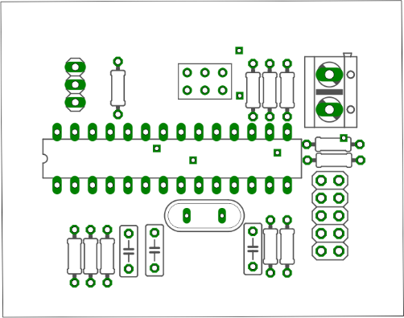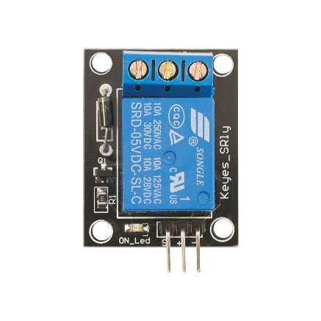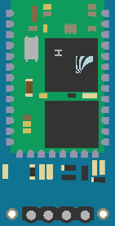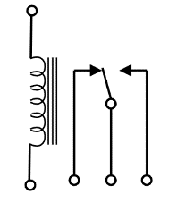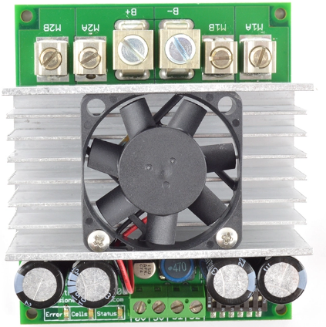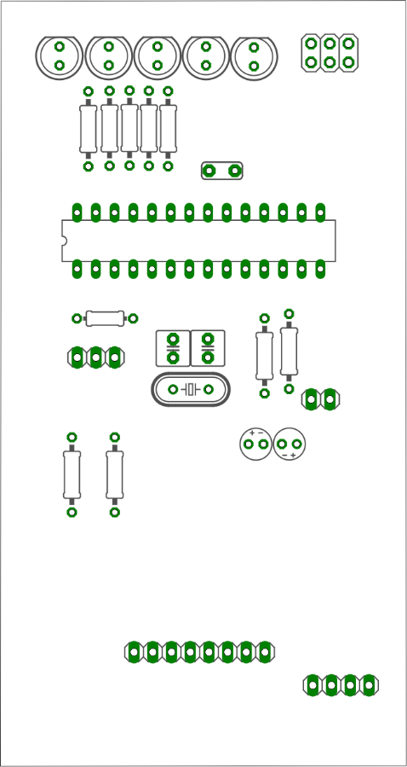**Chair Wiring Diagram**

Bluetooth

Right motor

Left motor

Electric motor brakes

**24VDC**

Switch

sensor 10: right

sensor 9: left

sensor 8: back-down-right

sensor 7: back-down-left

sensor 6: front-down-right

sensor 5: front-down-left

sensor 4: back-right

sensor 3: back-left

sensor 1: front-left

sensor 2: front-right

Sensor Module PCB

Contactor

Sabertooth 2x60

Relay Module

Control PCB