**GHANA TECHNOLOGY UNIVERSITY COLLEGE**



**FACULTY OF COMPUTING AND INFORMATION SYSTEMS**

**PROGRAMME – DIPLOMA IN INFORMATION TECHNOLOGY (LEVEL 100)**

**END-OF- FIRST SEMESTER EXAMINATIONS, DECEMBER 2019**

**IT 121: SYSTEM ANALYSIS AND DESIGN FUNDAMENTALS**

**Duration: 3 Hours**

**INSTRUCTIONS**

**Attempt ALL questions**

**ALL questions should be answered in the ANSWER BOOKLET provided**

**Section A**

1. In system analysis and design, the purpose of the analysis phase is to figure out the ………………………………… and the purpose of design phase is to figure out how to ……………………. it.
2. The three primary roles of the system analyst are …………………………………., ………………………… and ……………………………………..
3. …………………………… are productivity tools for systems analysts that have been created explicitly to improve their routine work through the use of automated support
4. ……………………….. CASE tools perform both upper- and lower-case functions
5. An……………………… can be a person, place, thing or event for which data is collected or maintained.
6. …………………………. it illustrates how data moves through an information system
7. ….……………………. the transfer of information systems development, operations and maintenance to an outside firm to provide for a fee
8. …………………………………. is defined as a Unit System.
9. A ...………………………………..as a stakeholder may have direct or indirect interest in the project. And is usually not part of the project itself but May influence the system and its outcome.
10. ……………………………………… is a systemic approach for tackling real-world problematic situations which is messy and lacks formal problem definition

**Section B**

1. In flowcharts, symbol of rectangle is used to represent
2. operations on data
3. system process
4. manual operations
5. magnetic disc
6. Making of a system that can be used easily by majority users is classified as
7. system friendly
8. user friendly
9. environment friendly
10. management friendly
11. Task of analyzing situation, designing a system and implementing new system all are tasks of
12. system consultants
13. cash terminals
14. system analysts
15. both a and c
16. In flowchart, invert trapezoid is used to represent
17. on-line storage symbol
18. manual operations
19. communication link
20. show annotations
21. System study involves
22. study of an existing system
23. documenting the existing system.
24. identifying current deficiencies and establishing new goals
25. All of the above
26. The primary tool used in structured design is
27. Structure chart
28. Data-flow diagram
29. Program flowchart
30. Module
31. The step-by-step instructions that solve a problem is
32. An algorithm
33. A list
34. A plan
35. A sequential structure
36. Which of the following is a task for system analyst?
37. teaching training courses to new system users
38. regularly updating existing systems software with the new standard releases arriving from the vendor.
39. programming the main modules of the programs being developed.
40. writing job descriptions and work specifications for people to be hired with the new system
41. Which of the following items result in eliminating one or more of the phases of the Systems Development Lifecycle?
42. Using Prototyping tools
43. Purchasing a software application package
44. Using object-oriented technology
45. Using CASE tools
46. Which of the following items is not an appropriate behavior for a good interviewer?
47. Showing good listening skills
48. Marketing - being able to sell the new system to its future users
49. Using a balance of open-ended and closed-ended questions
50. Restating responses of interviewee
51. Which of the following might be an intangible benefit arising from the introduction of a new information system?
52. Employee productivity improvement resulting in twice as many orders processed per day.
53. Less shrinkage (theft) of inventory through the computerized control of the items kept in the storerooms.
54. An increase in the amount of money made on interest bearing investments because of the improvement in handling cash receipts.
55. Customer responsiveness and thus, more satisfied customers
56. ……………….. can be defined as most recent and perhaps the most comprehensive technique for solving computer problems.
57. System analysis
58. System data
59. System record
60. System procedure
61. SDLC stands for
62. Structure Design Life Cycle
63. System Development Life Cycle
64. System Design Life Cycle
65. Structure Development Life Cycle
66. Which of the following is not a factor for the failure of the developments of software systems?
67. The size of the company
68. Inadequate user involvement
69. Failure of systems integration
70. Continuation of a system that should have been cancelled
71. I n which phase is problem analysis is done?
72. Before system test
73. System design phase
74. System analysis phase
75. System implementation phase
76. in which phase of SDLC is file conversion done?
77. System analysis
78. System design
79. System implementation
80. System development
81. ………… is an outline of processes that helps in developing successful information systems.
82. Case tool
83. Phased conversion
84. Success factors
85. System Development Life Cycle
86. A common reason for changing an information system is
87. New requirements
88. New technology
89. Problems in the existing system
90. All of the above
91. Which is of the following is not a characteristic of a system?
92. Operates for some purpose
93. Has homogeneous components
94. Operates within a boundary
95. Has interacting components
96. In what phase is requirement analysis done?
97. System analysis
98. System design
99. System implementation
100. System development

**Section C**

**Case Study – ATM Cash Provision**

An ATM (Automated Teller Machine) cash provision is defined as a problem situation which requires a solution.

**Scenario:**

The bank employs a team of ATM engineers, bank managers, bank officers, customers and ATM manufacturer to support the operation of the services.

The currencies of different denominations must be restocked when the threshold is reached. Printing of bank statements must be generated upon request. The bank officer must be responsible for restocking cash, replacing receipt paper rolls and changing ink cartilages.

All the ATM users must be authenticated for validity and security.

1. Identify all the Unit Systems in the scenario**. (10 MARKS)**
2. Identify the stakeholders and state their responsibilities. **(4 MARKS)**

**SECTION D**

The diagram below is an Entity-Relationship diagram for a school. Use the diagram to provide answers to the following questions. (**16 MARKS)**

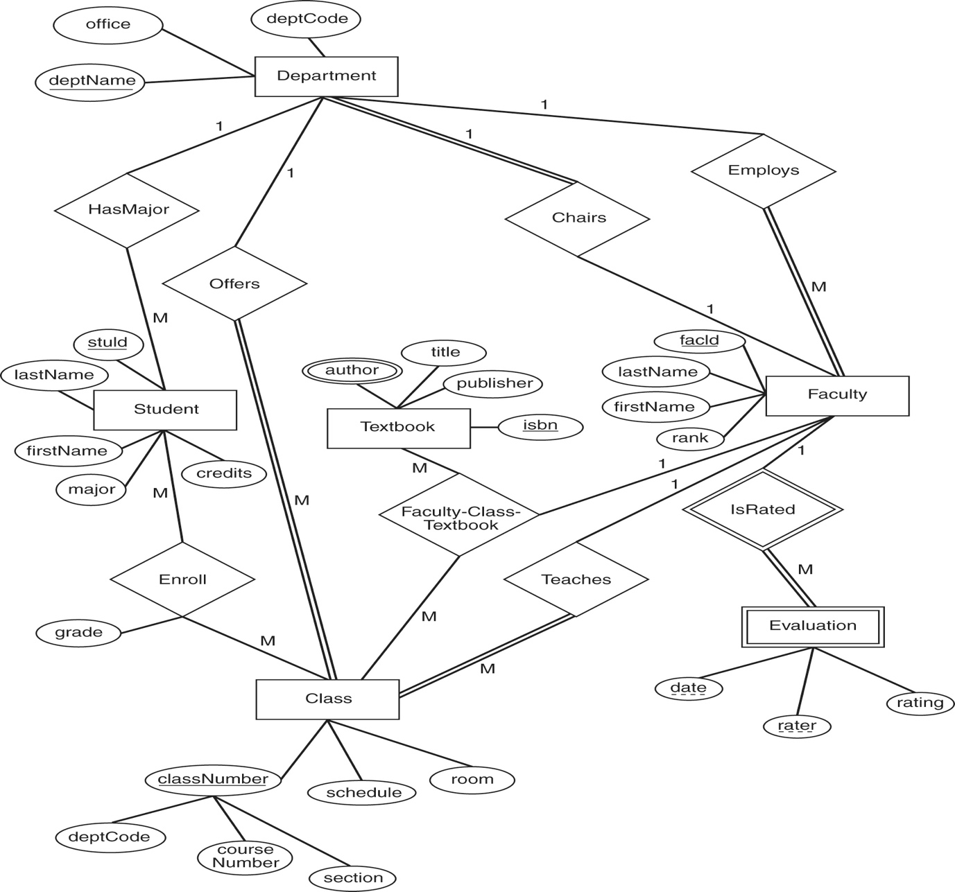

1. How many entities can you identify in the ER diagram?
2. How many relationships can you identify in the ER diagram?
3. What type of attribute is date in Evaluation entity?
4. What type of attribute is author in Textbook entity?
5. What type of relationship exists among Class, Textbook and Faculty entities?
6. Which of the relationships is recursive?
7. What type of relationship is IsRated?
8. What is the Cardinality Ratio of the binary relationship Enroll?