**Marcos Arroyo**

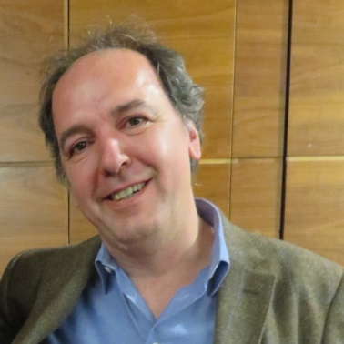

Associate Professor of geotechnical engineering at Universitat Politecnica de Catalunya, in ETCG Department.