BS2924
Information Management and Data Analytics

Word count: 2,746 Student ID: 2312275
Introduction 2
Information management for business intelligence 2
Data Mining and Knowledge Discovery in Databases 9
Evaluation and Conclusion 12
Appendices 14
Appendix A – Market Basket Analysis 14
Data exploration with python 14
Preparing the data with Excel 15
Building the model with Weka 16
Association Rules Metrics 17
References 18

Introduction
In today’s complex and data-rich world, it has become of extreme importance for survival and competitive advantage to follow an evidence-based approach rather than a more intuitional and speculative strategy (Gade R. K. 2021). By analyzing the vast amount of data available, businesses can uncover patterns and trends affecting their ability to identify market dynamics and customer behavior and effectively improve operational performance. As highlighted by Sylvestre C. (2024), Data-Driven Decision Making (DDDM) is a particularly powerful technique in this regard, as it allows organizations to derive actionable insights from these data and make informed decisions that align with their strategic objectives, as well as increasing their ability to adapt rapidly, with marginal costs hits, to the constantly changing environment .
Provost and Fawcett (2013) highlight that the exponential growth and diversity of data have surpassed the limits of manual analysis and traditional database systems. Simultaneously, advancements in computing power have created new opportunities for processing large-scale datasets. This convergence of vast data availability and enhanced computational capabilities has driven the widespread adoption of data science in business operations.
The process of transforming raw data into targeted and actionable insights consists of several crucial steps, including data collection, processing, analysis, and evaluation. Various strategies can be applied alongside data science principles to achieve this, among them, the CRISP-DM framework, an industry- and technology-independent approach for data mining projects, stands out (Wirth R. et al., 2000). The application of these principles and strategies enables companies to extract insights, trends, and often unusual patterns. For example, Walmart, the American retail giant, used techniques such as statistical analysis and machine learning to predict unusual product demand ahead of Hurricane Frances (Ganninger D. 2020).
This report aims to demonstrate key data science concepts through the application of analytical techniques to real-world datasets. The analysis is structured in three parts. First, information management techniques will be applied to NBA player statistics to derive actionable insights about performance trends. Second, a market basket analysis will be conducted on retail transaction data using the CRISP-DM framework to identify patterns in consumer purchasing behavior. Finally, the report will evaluate methodologies, tools, and technologies for information management and data analytics, contextualizing their practical relevance through a real-world business case. Together, these analyses highlight how data-driven approaches transform raw data into strategic decision-making assets.

Information management for business intelligence
What is Real-World Data?
Real world data (RWD) is defined by O’Leary P. et al (2019), as the data relating to patient health status and/or the delivery of health care routines, collected from a variety of sources typically outside clinical research settings such as, electronic health records (EHR), claims and billing data and data gathered through wearable devices and health application.
Although Kim H. et al (2018), denotes that nowadays there is still high mistrust in RWD, they believe that it proves an important addition to Randomized control trials (RCT). Real world data helps determine if the benefits seen in RCT research (undertook in strictly controlled settings) also extend to day-to-day clinical practice, furthermore RWD is to be taken into consideration in situations where RCT is missing altogether due to reasons such as feasibility costs, and clinical equipment.
The increasing accessibility of real-world data (RWD), combined with rapid advancements in artificial intelligence and machine learning, has significantly enhanced the importance of RWD in improving clinical research efficiency (Liu et al., 2022). As highlighted by Liu et al., RWD proved invaluable during the COVID-19 pandemic by enabling rapid generation of real-world evidence (RWE) on the virus's effects, including disease progression, symptom severity, and patient outcomes, data critical for guiding public health responses.
How to turn RWD into Real-world evidence (RWE)?
To generate trustworthy insights from RWD it is crucial to follow structured processes, Liu F. 2024, in his research showcases a tested and iterative model to extract relevant knowledge from multisource and multimodal RWD sets.
Real-world data (RWD) is notorious for being voluminous, messy, heterogeneous, and often incomplete. According to the proposed method, preprocessing is essential to prepare the data for analysis. This can be achieved using various techniques—some elementary, such as transformation and normalization, and others more sophisticated, such as imputation and advanced data science methods.
This stage aims to prepare the dataset not only for manual exploration but also for machine learning models. Some of the most common techniques, as highlighted by Liu F., include:
- Natural Language Processing (NLP): This involves converting unstructured human language—such as clinical notes, patient narratives, or medical literature—into a machine-readable format.
- Data Normalization, Standardization, and Transformation: These techniques are essential for ensuring the proper functioning of statistical and machine learning models, as real-world data (RWD) often varies in scale, distribution, and presence of outliers.
- Missing Data Imputation: A widely used and effective technique that enhances the performance of statistical and ML models by addressing missing inputs, which are usually not supported. This typically involves structured approaches to filling in missing values, such as mean imputation, regression-based imputation, or advanced machine learning methods.
Exploratory data Analysis (EDA)
Exploratory Data Analysis (EDA) is a critical early step following data collection and preprocessing. As emphasized by Komorowski et al. (2016), it serves as the foundational stage in any research analysis. EDA involves examining the data to uncover distributions, detect outliers and anomalies, and identify inherent patterns that can inform subsequent hypothesis testing.
Broadly speaking, exploratory analysis encompasses any technique used to inspect data without relying on formal statistical modeling or inference. This stage primarily focuses on visualizing (through graph representation of the data), plotting, and interactively exploring the data—free from predefined assumptions—to gain insights and guide further analysis.
The EDA process begins with data familiarization to understand the dataset's structure. Descriptive statistics (mean, median, standard deviation) help identify data quality issues and patterns (Vigni L. et al., 2013). As Vigni L. et al. (2013) emphasize, a key aspect involves iterative questioning to evaluate whether observed patterns represent genuine phenomena or merely data artifacts, while considering whether transformations might yield clearer insights.
Exploratory Data Analysis provides the necessary foundation for conducting more in-depth analytical research. The subsequent analysis demonstrates how these established EDA techniques facilitate meaningful insight extraction from complex datasets. This methodological progression - from initial data exploration to confirmatory analysis - represents a critical sequence in empirical research, where preliminary discoveries inform subsequent hypothesis testing.
The following investigation illustrates the practical application of these techniques, showcasing how systematic data examination leads to robust, data-driven conclusions.

First Dataset:
Name | NBA Player Stats
Description of data | Data set of NBA player stats per game from 1997 season through 2021 season
Location and/or Ownership | NBA Player Stats - dataset by etocco | data.world
Data Format | Structured
Data Collection Method | Secondary data (source: https://www.basketball-reference.com/)
Data Volume/Scale | 14,573 rows 31 colums
Data Quality | Quite extensive collection of players’ stats, data go all the way back to the 1997-98 season

Second Dataset:
Name | NBA Draft Combine Measurements
Description of data | Physical measurements of NBA drafted players
Location and/or Ownership | NBA Draft Combine Measurements - dataset by achou | data.world
Data Format | Structured
Data Collection Method | Secondary data
Data Volume/Scale | 517 rows, 19 colums
Data Quality | Data only include NBA players picked during the pre-season draft, and only include up to the 2012 draft

Analysis of the Datasets
The three analytical questions were under test during this research:
- What has been the most popular position over the years?
- What does the trend in attempted 3-point shots look like over the years?
- What is the relationship (if any) between the player's height and successful blocks?
Question 1
Description of relevant Variables:
Variable | Description | Type
Player | This represents the name of a Player of the NBA | String
Year | This represents the year the stats belong to | Date (Year)
position | This represents the position the player was playing in the specific year (usually the same across the years) | String
Position_count | This represents the number of players playing on a given position in a year | Integer

The query run looks as follow:

The relevant data was organized into Common Exception tables, firstly counting the frequency of each position every year, and then determining what position ranked 1 each year.
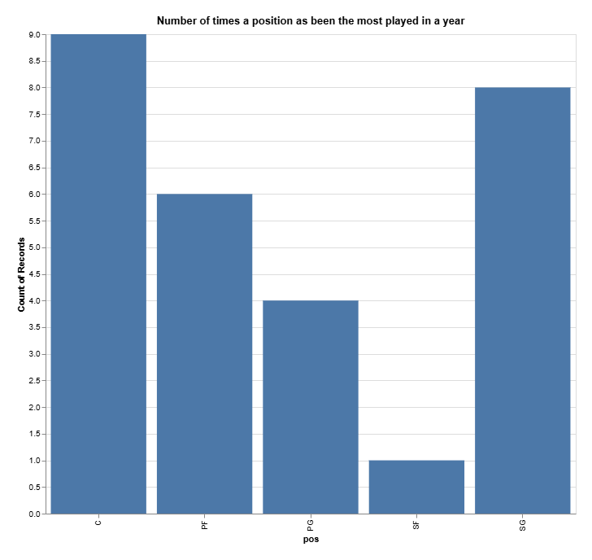
a visual representation, through a Bargrhap, helped gain deeper insight on the most played position over the years (by summing the number of first ranks of each position), noting how Center was the most played position for 9 years, followed closely by Shooting Guard.

Question 2
The general public’s opinion that the NBA is becoming more and more like a “3-point contest” stems from the league’s dramatic shift in playing style over the past decade (Gordon J, 2025). Teams are increasingly prioritizing long-range shooting over traditional post play and mid-range jumpers, leading to a game that feels dominated by three-point attempts.
This is what sparked the interest in the following analytical question
Description of relevant Variables:
Variable | Description | Type
Player | This represents the name of a Player of the NBA | String
Year | This represents the year the stats belong to | Date (Year)
3-points attempt | This represents the average 3-point shots taken per game by the corresponding player | Integer

The query run looks as follow:
Leveraging the used analytics software, the result data was averaged by year and turned into a graph for better visual representation
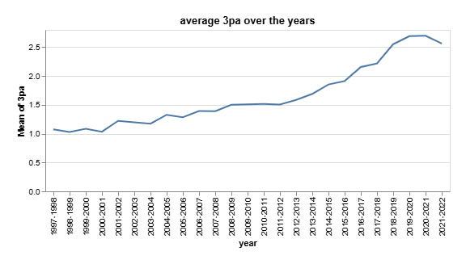
As we can notice 3-point attempts have always been on an upward trend before skyrocketing around the 2015-2016 mark.

Question 3
The last research served to define the relationship between a player’s height and his blocking ability.
To achieve this, a second database, group player’s physical characteristics was used
Description of relevant Variables:
Variable | Description | Type
Player | This represents the name of a Player of the NBA | String
Height_no_shoes | This represents the height of the player with no shoes | integer
blocks | This represents the players’ average successful blocks | Integer

The query run look as follows:
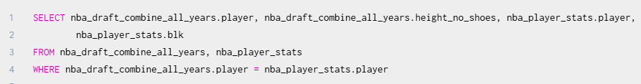
Here the players’ name was taken from both dataset in order to match their blocks to the height
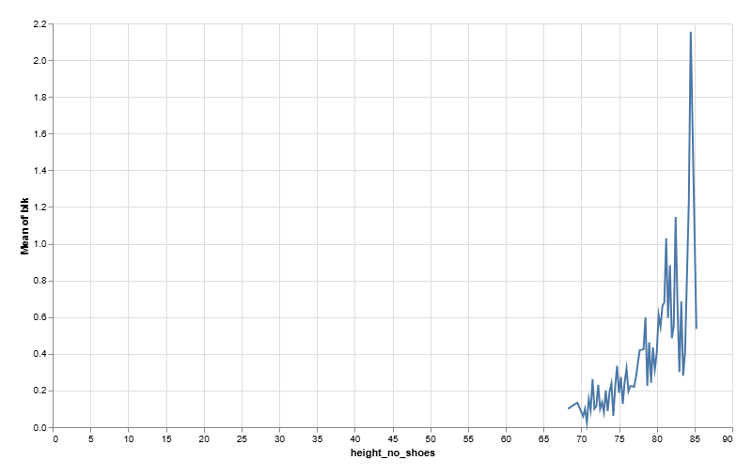
As evident, the average blocks increase dramatically along with the players height do, although a suspicious decrease happens around the 86” mark. Further analysis is required to determine the validity of this decrease.

Data Mining and Knowledge Discovery in Databases

Data mining is generally defined as the process of extracting information, relationships and patterns that exist in data sets which would otherwise remain hidden (Leventhal B. 2010). Data mining is often associated with large amounts of data, where manual analysis would prove insufficient and sophisticated tools are required to uncover hidden information as well as sanitizing the data to reduce wasted storage space.

Maksood F. et al (2016), develops on the main types of Data mining techniques (DMT), Classification, Clustering and Regression.
Classification, perhaps the most common technique, allows the user to classify large amounts of data into models, following a predetermined set of classes. This is often employed through supervised learning, and it is mostly used for predictive mining.
Clustering involves identifying pre-existing clusters and grouping similar items into clusters, primarily using unsupervised learning as opposed to Classification.
Regression aims to model a relationship between one or more attributes in order to predict the value of variables based on the changes of others. This is usually used to predict future market behavior.

Data Mining Frameworks

The CRISP-DM framework was developed to standardize data mining processes, as the industry previously relied heavily on individual or team expertise, hindering the replication of successful practices across enterprises (Wirth R. et al., 2000). This comprehensive model provided structured guidance for executing data mining projects, making them more reliable, faster and less costly.

Schoer C et all (2021) analyses the six core phases of the CRoss Industry Standard Process for Data Mining (CRISP-DM). The process begins with Business Understanding, where project goals are defined from an organizational perspective and translated into technical objectives. This naturally flows into Data Understanding, where analysts explore available datasets to assess quality and uncover preliminary patterns - a phase that frequently informs and refines the initial business problem definition.
The subsequent Data Preparation phase involves extensive work to create analysis-ready datasets through cleaning, transformation, and feature engineering. This labor-intensive stage often requires multiple iterations and directly informs the Modeling phase, where various algorithms are tested and optimized. Model Evaluation then assesses whether results truly meet business needs determined in the previous phases, serving as a critical checkpoint before Deployment, where insights are operationalized through methods ranging from simple reports to integrated decision-making systems. Throughout this lifecycle, phases frequently overlap and inform one another, emphasizing CRISP-DM's flexible yet structured approach to data mining projects.

Azevedo A et al. (2008) analyses other well-known frameworks such as the Sample, Explore, Modify, Model, Assess (SEMMA) methodology, developed by the SAS Institute for its Enterprise Miner tool. SEMMA’s five-stage process begins with Sample (optional data subsetting), followed by Explore (statistical and graphical analysis to detect trends), Modify (data cleaning and feature engineering), Model (algorithm application), and Assess (validation of results). Though tool-agnostic in principle, SEMMA is tightly coupled with SAS workflows and mirrors the KDD process. However, unlike CRISP-DM, SEMMA omits explicit phases for business alignment (e.g., Business Understanding) and deployment, focusing narrowly on technical execution. While SEMMA offers a streamlined approach for SAS users, CRISP-DM’s broader, industry-neutral framework—encompassing the full project lifecycle—has proven more adaptable for cross-domain applications and agile integrations.

CRISP-DM in use

The following market basket analysis was conducted following the CRISP-DM framework. The main goal of this study was to leverage the strength of association rules mining to uncover and potentially exploit hidden relationships between items in the provided transaction record dataset.

Understanding the data

Preliminary exploration of the data set using Weka returned no results for support range as low as 0.2, this could be attributed to the substantial number of products, against the lower number of transactions, making the presence of items scattered. To verify this, as well as gain more knowledge on the dataset, an initial analysis was conducted using python (Appendix A: Data exploration with python).

This exploratory stage helped us verify the theory that the given dataset experience low support levels, and it proved crucial in the progress of the Market Basket Analysis.

Preparing the data

"At this stage of the CRISP-DM framework, the data must be prepared—cleaned and structured appropriately—for the chosen machine learning algorithm, in this case, the Apriori algorithm. Thus the data set was turned into a Pivot table (Appendix A: Preparing the data with Excel).

Building the Model

Using Weka we built a model using the Apriori, the insights gathered during the exploratory phased proved crucial in setting the best algorithm’s constraints for optimal results (Appendix A: Building the model with Weka).

Analyzing the Data

At this stage of rule evaluation, the goal is to determine whether an association rule is strong and meaningful enough to influence business decisions.
To assess whether a rule is a valid candidate for decision-making, we must examine its statistical strength and business relevance.

As we can see the rules selected in the previous phase hold a high confidence, with most of them exceeding 0.5, but this metric alone won’t validate their strength, since confidence can be inflated by Y’s appearance, meaning that, if product Y were to be highly popular, the chances of it appearing with product X by pure luck would consequentially increase.

This is when the other metrics calculated by our model, such as Lift, Leverage and Conviction come in aid of confidence (Appendix A: Association Rules Metrics).

Evaluating the Discovered Association Rules

Understanding the metrics behind association rules is critical to assessing the validity of model results and ensuring data-driven decisions.
The selected rules demonstrate strong statistical significance across all key measures, making them highly actionable for business strategies, such as:

- Product recommendations ("Frequently bought together")
- Promotional bundling (Discounts on paired items)
- Inventory placement (Stocking related items nearby)
- Marketing campaigns (Targeting buyers of one product with ads for the other)

Notable Insight: Strong Bidirectional Relationship
The paper chain kits exhibit a particularly strong two-way association, confirmed by the high lift value:
- PAPER CHAIN KIT VINTAGE → 50S CHRISTMAS (Confidence: 68%, Lift: 5.42)
- PAPER CHAIN KIT 50S → VINTAGE CHRISTMAS (Confidence: 54%, Lift: 5.42)

The rules prove that customers who buy one of the items most often buy the other style too, making these products ideal for bundling, co-promotion, and strategic placement.

Evaluation and Conclusion

In today’s fast-paced and competitive business environment, organizations must efficiently manage information and leverage data analytics to make informed decisions. Information sources are categorized as internal, such as financial and operational data from accounting systems, and external, including regulatory policies, market research, and global datasets. Ensuring data quality, security, and proper integration is critical for strategic planning and economic security.

For tactical decision-making, tools like operational analysis, margin analysis, and CVP analysis are used, while strategic planning relies on investment analysis, business process mapping, and SWOT analysis. The SWOT matrix is particularly effective for visualizing strengths, weaknesses, opportunities, and threats, enabling businesses to devise measures that enhance economic security (Chernetska O. et al 2023).

Visualization techniques, including graphs and tables, aid in interpreting complex data, making it easier to identify trends and justify decisions. Supporting these efforts, IT tools and digital solutions are indispensable for efficient data processing, ensuring that businesses can quickly analyze information and adapt to dynamic environments. As digital transformation progresses, professionals must develop strong IT skills to fully leverage analytical insights for strategic and operational improvements.

A growing trend is the shift toward service-oriented models, where data, information, and analytics are treated as on-demand services (Delen D. et al 2013). Data-as-a-Service (DaaS) enables seamless access to integrated and cleansed data across locations, while Information-as-a-Service (IaaS) provides processed data to end users. Analytics-as-a-Service (AaaS) allows businesses to utilize advanced analytical tools without maintaining in-house infrastructure, supporting agile decision-making.

Walmart demonstrated to the public how analytical tools, when used correctly, can aid business decisions to drive profit growth while reducing costs and losses ( Hays L. C. 2004).
Upon the emergence of Hurricane Frances in 2004, the company adopted a different strategy. Dillman M. Linda, then Walmart’s Chief Information Officer, directed her team to perform predictive analysis. Using data gathered from a previous storm, Hurricane Charley, they generated forecasts and uncovered patterns in customers’ buying habits.

Thanks to the vast amount of shopper history stored in Walmart’s computer network, experts were able to identify trends, including a surge in sales of specific products beyond typical emergency items—such as Pop-Tarts (which rose to about seven times their normal sales rate) and beer.

This insight allowed the company to quickly adjust its stocking strategy, increasing inventory of the identified products at locations within Hurricane Frances’ projected path.

Appendices

Appendix A – Market Basket Analysis

Data exploration with python
The first analysis focused on answering foundational questions about the dataset:

- Total number of transactions
- Total number of products
- Average products per transaction

Though these metrics were not tied to a specific hypothesis, they provided essential familiarity with the dataset’s structure and scale, serving as a critical first step before deeper analysis.

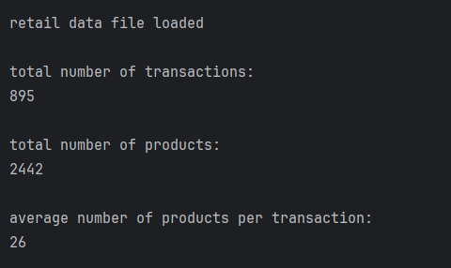

To guide further analysis, we focused on three key metrics:

- Top 10 Products by Sales Volume: Identifying the highest-selling products helps prioritize business focus areas and inventory planning.
- Bottom 10 Products by Sales Volume: While not the primary research focus, understanding low-performance products can inform potential discontinuation or promotional strategies.
- Average Product Support: This crucial metric established the baseline transaction frequency needed to properly configure the Apriori algorithm's parameters for subsequent association rule mining.
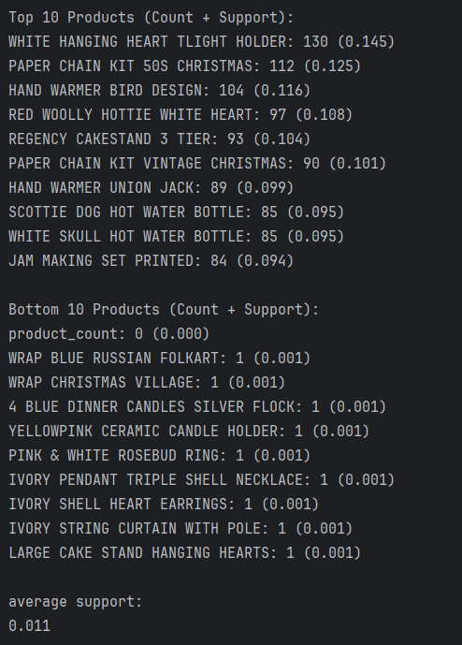

Preparing the data with Excel

In order to be able to turn the data set into a pivot table a Count column was added, this was necessary to be able to identify the presence of a product in a given transaction. The count value was set to yes due the chosen analysis tool, Weka, incompatibility with numeric values.
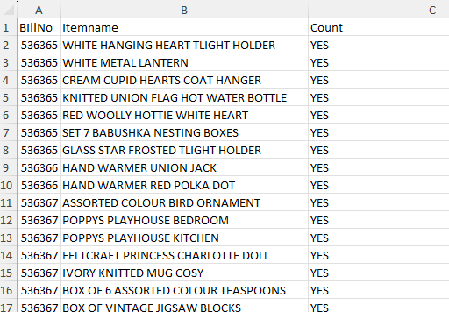

The set was now ready to be turned into a pivot table, additionally fields like the transaction id and the grand total were deleted as they are not of any use to the Chosen Associate rule mining algorithm, Apriori.


Building the model with Weka
At this stage the model was built, around the previously gathered insights.
We modified the Apriori algorithm parameters to account for the average support of 0.01, thus, to discard low impact products the minimum support was set to a value of 0.05.
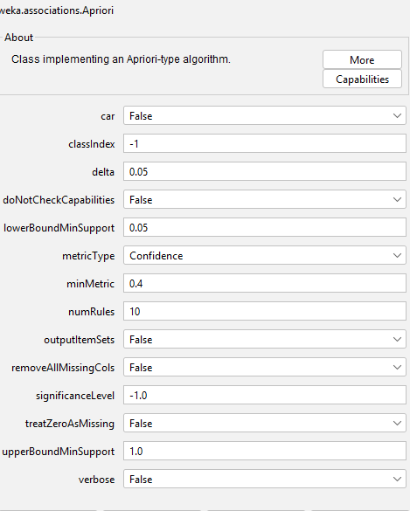

After a few rounds of trial and error, the minimum confidence level was set to 0.4, producing a total of 9 rules:
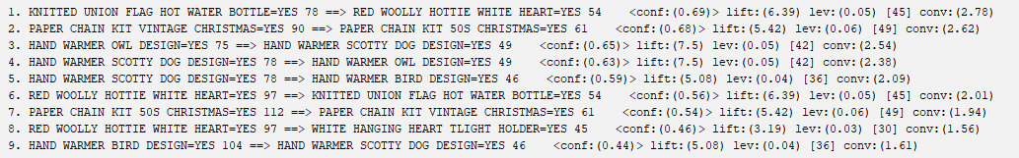
To narrow down the research scope, 3 rules were chosen for further analysis due to both their products ranking high in the top 10 most impactful products (see above), and a high confidence level:

PAPER CHAIN KIT VINTAGE CHRISTMAS =YES 90 ==> PAPER CHAIN KIT 50S CHRISTMAS = YES 61
<conf:(0.68)> lift:(5.42) lev:(0.06) [49] conv:(2.62)

RED WOOLLY HOTTIE WHITE HEART =YES 97 ==> KNITTED UNION FLAG HOT WATER BOTTLE =YES 54 <conf:(0.56)> lift:(6.39) lev:(0.05) [45] conv:(2.01)

PAPER CHAIN KIT 50S CHRISTMAS =YES 112 ==> PAPER CHAIN KIT VINTAGE CHRISTMAS=YES 61
<conf:(0.54)> lift:(5.42) lev:(0.06) [49] conv:(1.94)

Association Rules Metrics

- Lift: it factors in the appearance rate of Y, to validate the confidence of a rule.
“Do X and Y appear together often, only because Y already appears most of the time?”
Suppose That Milk had a very high support, this would make the high confidence of the rule Bread => Milk potentially purely coincidental.
Lift helps us evaluate the trueness of the confidence value by taking the appearance of Y into account. The further the value from 1 the stronger we can consider the value of confidence to be. On the other hand, a lift value closer to 1 would mean that the rule is not that much better than random guessing.

- Leverage: it compares how often two items appear together against the probability of randomly appearing together.
“Do X and Y actually appear together more often than their random probability would indicate?”
Suppose that two items X and Y had respectively support of 0.2 and 0.3. their combined probability of co-existence would be 0.5
Now to work out the leverage, we need to compare the chance rate against their actual rate of appearance. The leverage ranges from 0 to 1, therefore the closer the value to 1 the best an indication that this rule is better than random chance.

- Conviction: this measure how reliable the rules is against random guessing

“If I always guessed Y appears in X’ s transactions, would I be more successful than if I guessed Y appears in every transaction?”

So, when the conviction value is above 1, this gives us an indication that one would be more accurate at predicting the appearance of Y when X is also present, than if Y was predicted to appear in every transaction.
On the other hand, a conviction value below 1, would signify that the rule doesn’t hold strong, since randomly guessing Y holds a higher chance at predicting correctly, than if we take X into consideration.

References
- Ana Azevedo, Manuel Filipe Santos, KDD, SEMMA AND CRISP-DM: A PARALLEL OVERVIEW, IADIS European Conference Data Mining, 2008 available at: Informatics_DM_2008 [Accessed: 17/04/2025]
- Barry Leventhal, An introduction to data mining and other techniques for advanced analytics, August 2010, available at: dddmp.2010.35.pdf [Accessed: 17/04/2025]
- Chantal Emmanuel Sylvestre, The Role of Data-Driven Decision Making in Business Strategy, Research Output Journal of Education, 2024, pp. 80-84, available at: 2331_the-role-of-data-driven-decision-making-in-business-strategy.pdf [Accessed: 15/03/2024]
- Christoph Schröer, Felix Kruse, Jorge Marx Gómez, A Systematic Literature Review on Applying CRISP-DM Process Model, Procedia Computer Science, 2021. V 181 pp- 526-534 available at: https://doi.org/10.1016/j.procs.2021.01.199 [Accessed: 17/04/2025]
- Colin P. O'Leary , MatthewA.CavenderMD, Emerging opportunities to harness real world data: An introduction to data sources, concepts, and applications, Diabetes Obesity and Metabolism, Journal of Pharmacology and Therapeutics, April 2020, V 22 Issues S3, available at: Emerging opportunities to harness real world data: An introduction to data sources, concepts, and applications [accessed 09/04/2025]
- CONSTANCE L. HAYS, What Wal-Mart Knows About Customers' Habits, The New York Times, November 2004, available at: WalMart [Accessed: 05/05/2025]
- Daniel Ganninger, When Walmart Predicted What Shoppers Would Buy Before a Hurricane, Medium, November 2020, available at: When Walmart Predicted What Shoppers Would Buy Before a Hurricane | by Daniel Ganninger | Knowledge Stew | Medium [Accessed: 15/03/2024]
- Dursun Delen, Haluk Demirkan, Data, information and analytics as services, Decision Support Systems, Apri 2013, V 55 Issue 1, pp. 359-363, available at: https://doi.org/10.1016/j.dss.2012.05.044 [Accessed: 05/05/2025]
- Foster Provost, Tom Fawcett, DATA SCIENCEAND ITSRELATIONSHIPTO BIG DATA ANDDATA-DRIVENDECISION MAKING. Big Data, March 2013, V. 1 Issue 1 pp. 51-59 available at: Data Science and its Relationship to Big Data and Data-Driven Decision Making [Accessed: 15/03/2024]
- Fang Liu, Data Science Methods for Real-World Evidence Generation in Real-World Data, Annual Review of Biomeidcal Data Science, 2024, V 7 pp. 201-224, available at: https://doi.org/10.1146/annurev-biodatasci-102423-113220 [accessed 09/04/2025]
- Fang Liu, Demosthenes Panagiotakos, Real-world data: a brief review of the methods, applications, challenges and opportunities, BMC Medical Research Methodology, 2022, V 22(1):287, available at: Real-world data: a brief review of the methods, applications, challenges and opportunities [accessed 09/04/2025]
- Hun-Sung Kim , Suehyun Lee , Ju Han Kim , Real-world Evidence versus Randomized Controlled Trial: Clinical Research Based on Electronic Medical Records, Journal of Korean Medical Science, June 2018, V 33(34):e213, available at: Real-world Evidence versus Randomized Controlled Trial: Clinical Research Based on Electronic Medical Records - PMC [accessed 09/04/2025]
- Kishore Reddy Gade, Data-Driven Decision Making in a Complex World, Journal of Computational Innovation, 2021, V 1 Issue 1, available at: View of Data-Driven Decision Making in a Complex World
- Mario Li Vigni, Caterina Durante and Marina Cocchi, Exploratory Data Analysis, Department of Chemical and Geochemical Sciences, University of Modena and Reggio Emilia, 2013, V 28 pp. 55-126 available at: Exploratorypostprint.pdf [accessed 09/04/2025]
- Matthieu Komorowski, Dominic C. Marshall, Justin D. Salciccioli and Yves Crutain, Exploratory Data Analysis, 2016, Chapter 15, available at: 10.1007/978-3-319-43742-2_15 [accessed 09/04/2025]
- Olga Chernetska, Dmytro Chernetskyi, Enterprise management system analytical tools, Economics, Entrepreneurship, Management, 2023, V 10 (2), available at: Economics, Entrepreneurship, Management, Vol 10, No 2-8-16, 2023.pdf [Accessed: 05/05/2025]
- Rüdiger Wirth, Jochen Hipp, CRISP-DM: Towards a Standard Process Model for Data Mining, University of Bologna, 2020, available at: 10.1.1.198.5133.pdf [Accessed: 17/04/2025]

