DD

Contents
Introduction 3
Purpose 3
Scope 3
Definitions, acronyms and abbreviations 3
References 3
Design description 4
Overview 4
UML models 5
Mock-up 12
Algorithms 14

Introduction

Purpose
The goal of this document is to deliver a more detailed and technical overview of the PowerEnJoy system described in the RASD before. This document will address this goal in several parts dedicated to review of the models and components and will also provide different diagrams to better describe the decisions made about the architecture and the flow of the system.

Scope
PowerEnJoy provide car sharing to its users by using a mobile application for the user and an administration system to manage the cars involved and the related issues.
The system allow the users to search and reserve a car located in specific safe areas in which the user is encouraged to park once his trip is over. To allow a user to benefit from the service the system provide a registration and login service. In addiction to this PowerEnJoy offers a series of advantages to reduce the fee required to encourage the user to respect the environment.
The purpose of PowerEnJoy is to simplify car sharing allowing user to benefit from the service in an easy and fast way. The system will allow the users to reserve, drive and pay by simply using their smartphones. To encourage the user to use the service many discounts are applicable to the fee.

Definitions, acronyms and abbreviations
In this document several keywords are presented which may have a special meaning and definition. They are as follows:
- RASD: Requirements analysis and definition document.
- DD: Design document.
- GUI: Graphic user interface.
- DBMS: Database management system
- API: Application programming interface

References
- RASD document available on the GitHub page of the group.

Design description

Overview
The system consists of a mobile application, car control system (inside every car), a management system and a central data administration system (we assume the last three are already existing, check RASD for reference on assumptions). Each of them has its own GUI and interact with the central data system independently one with another via internet connection.
Thus we have a two-tier Architecture for each system considered alone.

UML models

Component diagram

The high level components architecture consists of five main components, four of which communicates with a central server that manages Customer Application, Car System and Administration System requests and DBMS queries.
As we can see from the diagram the Server offers an interface for each of the other four components which allow them to perform the following operations:
- AuthAndTripManager:
  - Register and Login;
  - Reserve a car;
  - Find safe areas;
  - Drive car.
- CarSystemManager:
  - Open/Lock car;
  - Display current fee.
- AdminManager:
  - Suspend account;
  - Mark car as out of order;
  - Manage safe areas.
- DBMS API:
  - (common DBMS transactions).

Statechart diagrams
This diagram describes the states of a car during the activities of the system. The state can be modified by both the User and an Operator and it changes through three simple states: available, out of order and occupied. We suppose that in the state available the car resides in a safe area.

Activity diagram
The following diagram describes the User activity flow using the system. Note that the User can look for a safe area in any moment outside this cycle and that the payment is included in the User parks car Activity.

Sequence diagrams
The diagrams below offer a better understanding of the communication between the components of the system and the time flow of this operations.

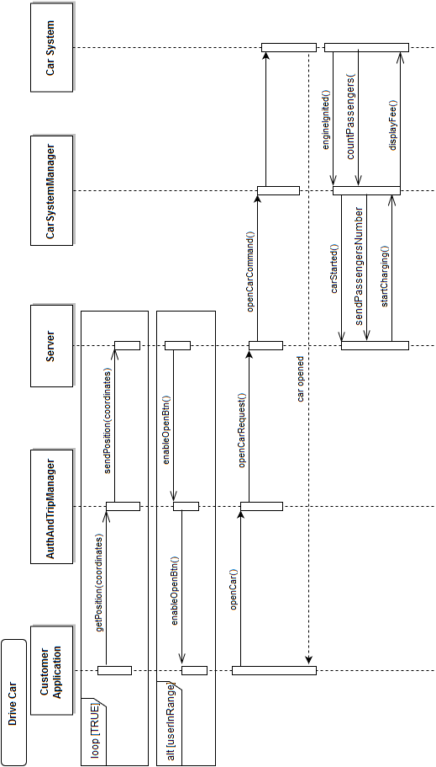

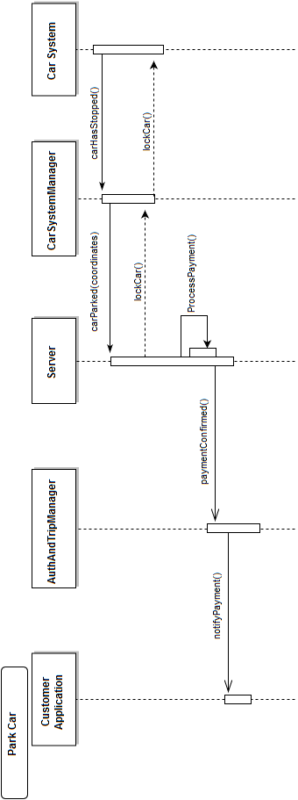

Mock-up

Homepage | Register page
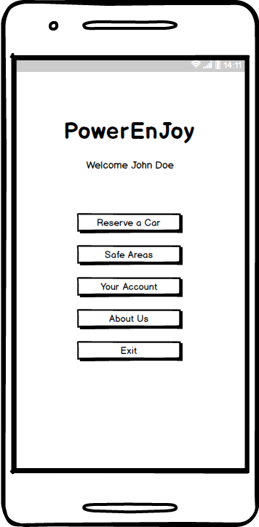 | 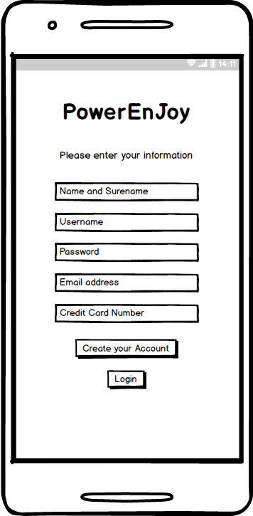

Login page | Account page
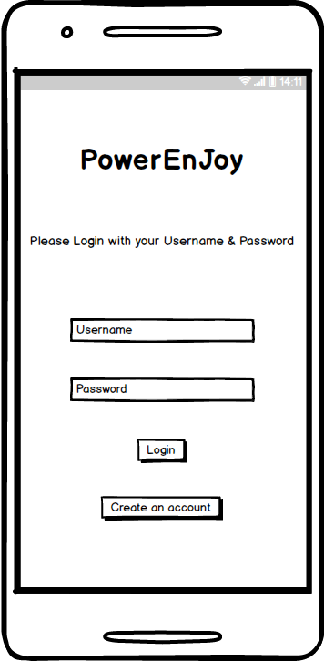 | 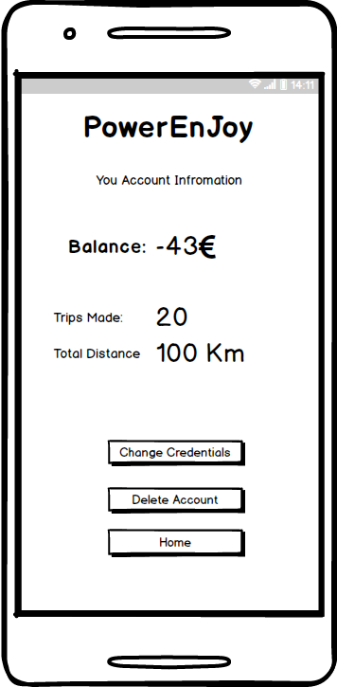

Map page | Reservation page
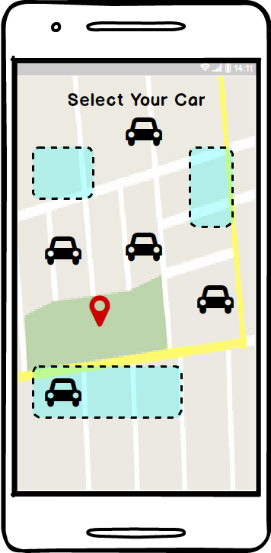 | 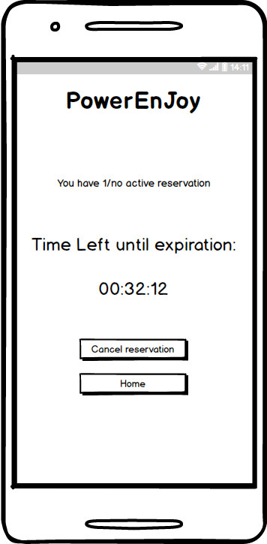

Algorithms

Our application has a function called “save money” which acts as a discount encouraging user to provide his destination and choose the system determined safe areas to park his/her car. For this reason, our system has to use an algorithm to calculate and find the nearest safe areas to the user destination. Our choice for this function is to use one of the methods of the Nearest Neighbor Search(NNS) more specifically K-NN.

Hours of work

Team member | Hours
Riccardo | 9
Saeed | 6
Ulvi | 6
Meetings | 4

Changelog

Version | Date | Comment
1.0 | 11/12/2016 | Release
1.1 | 28/12/2016 | Minor changes in the introduction, added statechart diagram
1.2 | 23/01/2017 | DriveCar sequence diagram updated

We outline those operation assuming they’re already implemented in the preexisting system

