DD

Contents

Introduction

Purpose

Scope

References

Design Description

Overview

UML models

Mock-up

Algorithms

Introduction

Purpose
The goal of this document is to deliver a more detailed and technical overview of the PowerEnJoy project for the Software Engineering 2 2016-2017 project. This document will address this goal in several parts dedicated to review of the models and components and will also provide different diagrams to better describe the decisions and the architecture and the flow of the system.

Scope
The scope of the project and these documents are as following. The system that we have in mind is made of 2 parts.one is a mobile application which targets the user of the system and provides them with the ability for registering and login, car reservation, paying the bills, and several money saving option. The other part is of course the backend part of the system which itself includes an interface system installed in the car and the logic and the database and other means of interacting with the external systems such as payment gateways. Also the main goals of the project are to simply provide an easy and efficient way for the ordinary and usually busy people to use the environment helping car sharing system which will also increase the value of the company.

References
- RASD document available on the GitHub page of the group.

Design description

Overview
The system consists of a mobile application, car control system (inside every car), a management system and a central data administration system (we assume the last three are already existing, check RASD for reference on assumptions). Each of them has its own GUI and interact with the central data system independently one with another via internet connection.
Thus we have a two-tier Architecture for each system considered alone.

UML models

Component diagram

The high level components architecture consists of five main components, four of which communicates with a central server that manages Customer Application, Car System and Administration System requests and DBMS queries.
As we can see from the diagram the Server offers an interface for each of the other four components which allow them to perform the following operations:
- AuthAndTripManager:
  - Register and Login;
  - Reserve a car;
  - Find safe areas;
  - Drive car.
- CarSystemManager:
  - Open/Lock car;
  - Display current fee.
- AdminManager:
  - Suspend account;
  - Mark car as out of order;
  - Manage safe areas.
- DBMS API:
  - (common DBMS transactions).

Activity diagram
The following diagram describes the User activity flow using the system. Note that the User can look for a safe area in any moment outside this cycle and that the payment is included in the User parks car Activity.

Sequence diagrams
The diagrams below offer a better understanding of the communication between the components of the system and the time flow of this operations.

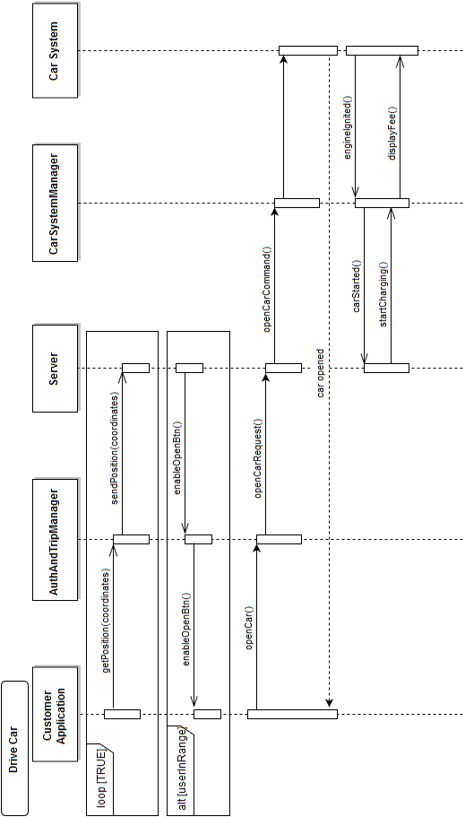

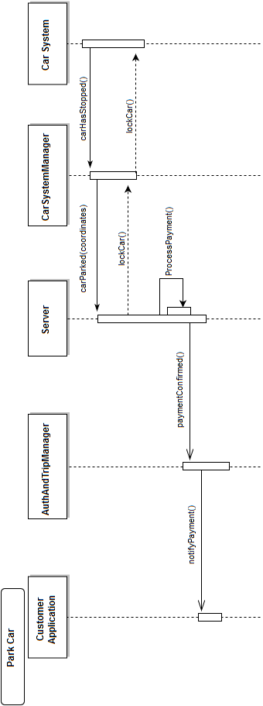

Mock-up

Homepage | Register page
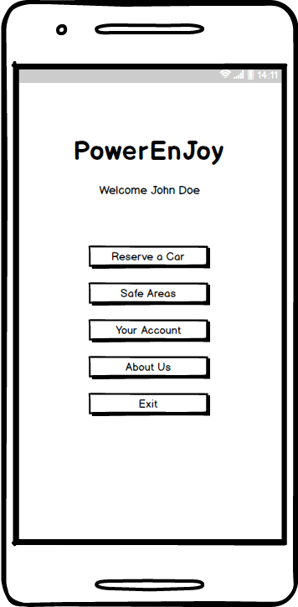 | 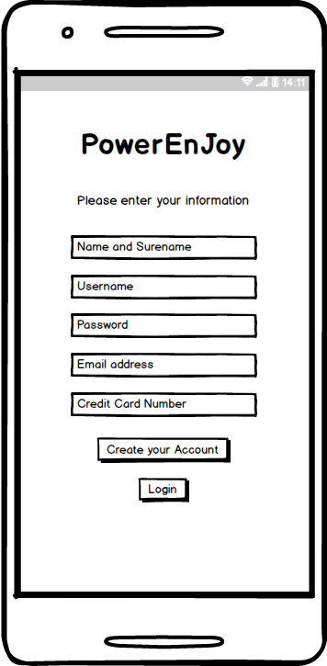

Login page | Account page
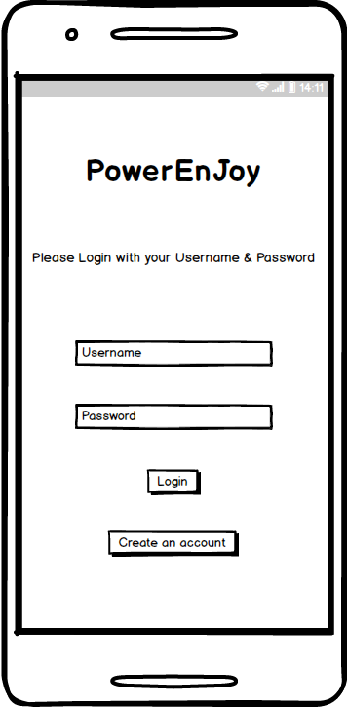 | 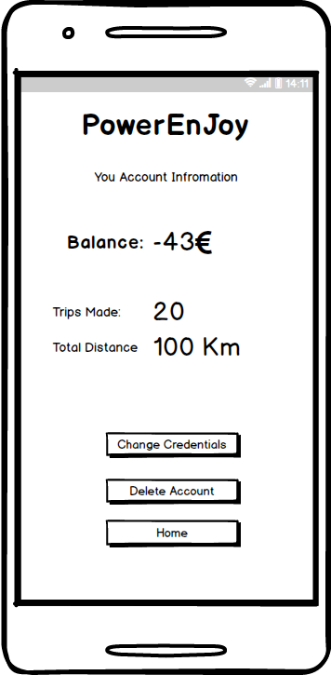

Map page | Reservation page
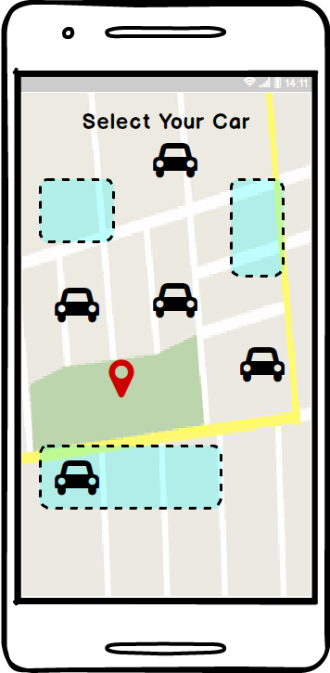 | 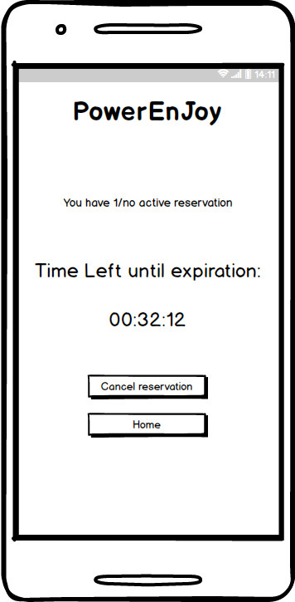

Algorithms

Our application has a function called “save money” which acts as a discount encouraging user to provide his destination and choose the system determined safe areas to park his/her car. For this reason, our system has to use an algorithm to calculate and find the nearest safe areas to the user destination. Our choice for this function is to use one of the methods of the Nearest Neighbor Search(NNS) more specifically K-NN.

Hours of work

Team member | hours
Riccardo | 5
Saeed | 4
Ulvi | 4
Meetings | 3

Changelog

Version | Date
1.0 | 11/12/2016

We outline those operation assuming they’re already implemented in the preexisting system

