PowerEnJoy
PP
Project Plan
Contents
Introduction 3
Purpose 3
Scope 3
Scope 3
Definitions, acronyms and abbreviations 3
References 3
Cost and effort estimation 4
Function points 4
COCOMO 2 5
Task division and Resources allocation 6
Risks 9
Hours of work 10
Changelog 11

Introduction

Purpose
The goal of this document is to describe the schedule adopted in the development process of PowerEnJoy. The document will also show the criteria used to estimate the total cost and effort of the project. The task division is enlisted in the second part of the document as well as the resource assignment to each task.

Scope
PowerEnJoy provide car sharing to its users by using a mobile application for the user and an administration system to manage the cars involved and the related issues.
The system allow the users to search and reserve a car located in specific safe areas in which the user is encouraged to park once his trip is over. To allow a user to benefit from the service the system provide a registration and login service. In addiction to this PowerEnJoy offers a series of advantages to reduce the fee required to encourage the user to respect the environment.
PowerEnJoy is a software solution which comes new in the market, moreover it represent a quite complex system since it has to communicate with different external entities (central system and cars).

Definitions, acronyms and abbreviations
In this document several keywords are presented which may have a special meaning and definition. They are as follows:
- RASD: Requirements analysis and definition document.
- DD: Design document.
- FP: Function Points.
- COCOMO: Contructive Cost Model.
- ILF: Internal Logic File
- ELF: External Logic File.
- SLOC: Source Lines Of Code.

References
- RASD available on the GitHub page of the group.
- DD available on the GitHub page of the group.

Cost and effort estimation

Function points
To estimate the complexity and dimension of the project we used function points which are assigned to each functionality of the system based on the complexity it presents.

Type | Functionality | Complexity | FP
ILF
 | user location | simple | 7
 | reservation | medium | 10
 | trip | medium | 10
ELF
 | safe area | medium | 7
 | car | complex | 10
 | reservation | medium | 7
 | user | simple | 5
External Input
 | login | simple | 3
 | logout | simple | 3
 | registration | medium | 4
External Output
 | find safe areas | simple | 4
 | find car | simple | 4
External Inqueries
 | reserve car | complex | 6
 | open car | medium | 4
 | start car | medium | 4
 | leave car | complex | 6
Total |  |  | 94

COCOMO 2
To evaluate the cost and effort corresponding to the FPs and our team and project qualities we use COCOMO2. The level assigned to each driver reflect the project described in the previous documents and the nature of our team.

Type of Driver | Driver | Level
Software Scale Drivers
 | Precedenteness | Low
 | Development Flexibility | Nominal
 | Architecture/Risk Resolution | High
 | Team Cohesion | High
 | Process Maturity | Low
Software Cost Drivers
Product
 | Required Software Reliability | High
 | Data Base Size | Nominal
 | Product Complexity | High
 | Developed for Reusability | Nominal
 | Documentation Match to Lifecycle Needs | Nominal
Personnel
 | Analyst Capability | Nominal
 | Programmer Capability | Nominal
 | Personnel Continuity | Nominal
 | Application Experience | Low
 | Platform Experience | High
 | Language and Toolset Experience | High
Platform
 | Time Constraint | Very High
 | Storage Constraint | Nominal
 | Platform Volatility | Low
 | Project Use of Software Tools | Nominal
 | Multisite Development | Nominal
 | Required Development Schedule | Nominal

Results:
Effort: ~27 Person-month
Total Equivalent Size: ~5000 SLOC
Task division and Resources allocation

In the following we show the plan of the project as a list of tasks and subtasks that cover the main activities required to implement the system. Each task has a starting and ending date and it is assigned to one or more members (U, S, R stands for Ulvi Ismayilov, Saeed Ektesabi and Riccardo Campo).

Task | Subtask | Assigned to | Starting date | Ending date
RASD |  | U, S, R | 17/10/16 | 04/11/16
 | Initial requirements elicitation | S, R | 17/10/16 | 28/10/16
 | Initial requirements modelling | U, S | 24/10/16 | 04/11/16
DD |  | U, S, R | 07/11/16 | 25/11/16
 | Architecture design | U, R | 07/11/16 | 18/11/16
 | Alghoritms | U, S | 14/11/16 | 25/11/16
 | Mockups | S, R | 21/11/16 | 25/11/16
Development |  | U, S, R | 28/11/16 | 10/03/17
User management |  | U, R | 28/11/16 | 16/12/16
 | Registration | R | 28/11/16 | 02/12/16
 | Login | U | 28/11/16 | 02/12/16
 | Account management | U, R | 05/12/16 | 16/12/16
API communicator |  | S | 28/11/16 | 05/01/17
 | Initial implementation | S | 28/11/16 | 16/12/16
 | Securing and optimizing | S | 19/12/16 | 05/01/17
Trip management |  | U, S, R | 19/12/16 | 03/02/17
 | Reservation management | U, S | 16/01/17 | 03/02/17
 | Map implementation | S, R | 19/12/16 | 13/01/17
UI design |  | U, S, R | 06/02/17 | 10/03/17
 | Initial design | U, S | 06/02/17 | 24/02/17
 | Wireframing | U, R | 20/02/17 | 09/03/17
 | Graphic design of icons and buttons | U | 06/03/17 | 10/03/17
Testing |  | U, S, R | 28/11/16 | 12/05/17
 | Constant testing | U, S, R | 28/11/16 | 10/03/17
 | Unit testing | U, S, R | 13/03/17 | 14/04/17
 | Solving bugs | U, S, R | 17/04/17 | 12/05/17
Final operations |  | U, S, R | 15/05/17 | 16/06/17

The diagram below helps visualize the tasks in the timeline of the project.

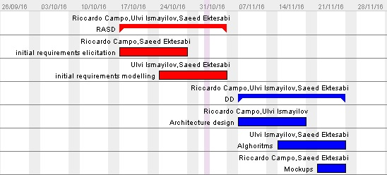

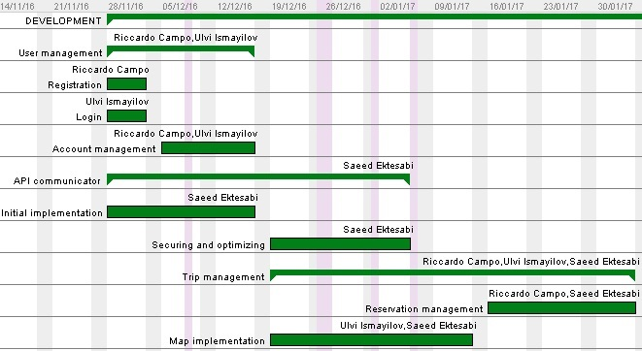

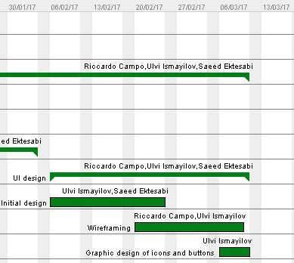

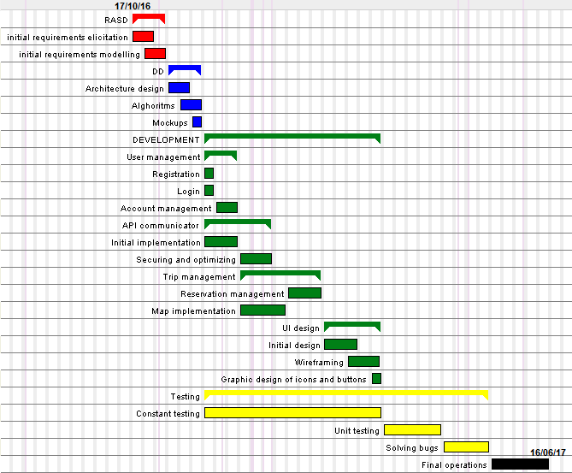
Risks
The following table describes the risks, their impact on the project and possible actions that can be take in order to react to these possible events.

P- Probability, I – Impact, E – Exposure of Risks
Ranking is done due to ---> E (Exposure of Risks) = P (Probability) x I (Impact)

Rank | Risk Definition | P | I | Action
4 | Little experience in group-working | moderate | marginal
1 | Issues appearing in complex systems involving cars | moderate | catastrophic
9 | Communication issues with central system | low | critical | Improve the communication with the old system hiring a member from the old system development team
5 | Key staff are ill at critical times in the project. | low | catastrophic | Reorganize team so that there is more overlap of work and people therefore understand each other’s jobs.
10 | Changes to requirements that require major design rework are proposed | low | marginal
8 | The organization is restructured so that different managers are responsible for the project | moderate | marginal
2 | The database used in the system cannot process as many transactions per second as expected | moderate | catastrophic | Investigate the possibility of buying a higher-performance database.
3 | Change of the city government | moderate | critical | Organize meeting with the new government representatives to clarify the changes in the municipal laws
7 | Wrong selected city in terms of market demand | low | catastrophic | Try to adapt the current system to an eventual new target city.
6 | Organizational financial problems force reductions in the project budget. | low | catastrophic | Prepare a briefing document for senior management showing how the project is making a consistent contribution to the goals of the business and presenting reasons why cuts to the project budget would not be cost-effective.

Hours of work

Team member | Hours
Riccardo | 5
Saeed | 4
Ulvi | 4
Meetings | 4

Changelog

Version | Date | Comment
1.0 | 22/01/2017 | Release
1.1 | 31/01/2017 | Extended task division part

The functionalities shown in the table are coherent to the one described in the RASD
Notice that the reservation is stored both in the internal storage and in the central system external to ours.
Note that both the requirements and the design is subject of change during the whole development process, so it may be necessary to update the documents

