PowerEnJoy
ITPD
Integration Test Plan Document

Introduction

Purpose
The goal of this document is to describe the plan to accomplish the test integration of PowerEnJoy. The document will explain the strategy adopted as well as a detailed listing of the steps that has been planned in order to test the integration between the components of the system. A list of required tools, program stubs and test data is given in the second part of the document

Scope
PowerEnJoy provide car sharing to its users by using a mobile application for the user and an administration system to manage the cars involved and the related issues.
The system allow the users to search and reserve a car located in specific safe areas in which the user is encouraged to park once his trip is over. To allow a user to benefit from the service the system provide a registration and login service. In addiction to this PowerEnJoy offers a series of advantages to reduce the fee required to encourage the user to respect the environment.
PowerEnJoy is a software solution which comes new in the market, moreover it represent a quite complex system since it has to communicate with different external entities (central system and cars).

Definitions, acronyms and abbreviations
In this document several keywords are presented which may have a special meaning and definition. They are as follows:
- RASD: Requirements analysis and definition document.
- DD: Design document.
- DBMS: Database Management System
- MbaaS: Mobile backend as a Service

References
- RASD available on the GitHub page of the group.
- DD available on the GitHub page of the group.
Integration Strategy

Entry criteria
Before starting the integration testing there are some conditions that has to be met. Since this integration testing plan is based on the RASD and DD, it is obvious that these two documents has to be completed in order to provide a correct view of the tested system.
Moreover, the integration testing process require a certain level of components completion, specifically:
- 80% Customer Application. The Customer Application will be the starting point for the majority of the test so only few details are not mandatory (like the UI design).
- 100% Server. The Server is important to establish the communication within the components so we require it to be fully functional.
- 60% DBMS. The DBMS should have at least some test data and all the logic functional.
- 70% Car System. The tests require mostly the Car System functionalities related to its interaction with the server (the actual person detecting can be simulated)
- 100% Administration System.

Elements to be integrated
The two main aspect that as to be tested are the Customer Application and the Administration System, so that we need to integrate them with the rest of the system.
- We integrate the Customer Application with the Server, and the latter with the DBMS and the Car System;
- We test the integration between the Administration System and the Server and its interaction with the DMBS.

Integration testing strategy
As state above we are interested in the testing of the main functionalities of the system which involves the integration of two main components (which are responsible of the majority of the functionalities) with the rest of the system. This need lead the testing process to a top-down approach.
Thus we will start from Customer Application and Administration System and add to them one component at time to test the way each couple of components interacts. This approach will help us understand where the problem is located starting form the most important features of the system that has to be granted.

Sequence of component integration
In the following we will provide a detailed list of the steps involved in the testing process
- AuthAndTripManager interface between Customer Application and Server with the help of a DBMS stub to simulate its functionalities.
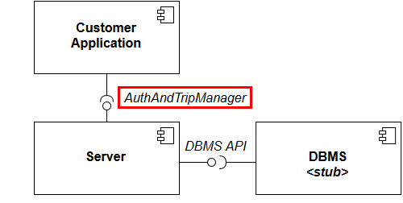

- DBMS API interface between Customer Application with Server and DBMS (not the stub).
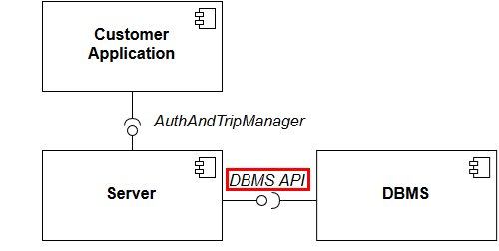
- CarSystemManager interface between Customer Application with Server and DBMS and Car System.

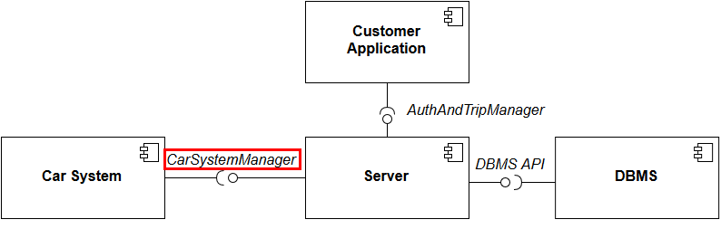
- AdminManager interface between Server with DBMS and Administration System.

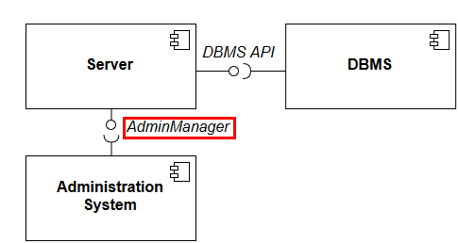

Individual steps and test description

This section of the document provide the detailed description of each test that has to be done. Each test refers to an interaction between two components (caller, called) and provide outputs to given inputs.

Customer Application → Server

sendPosition(coordinates)
Input | Effect
Null parameter | NullArgumentException raised
A set of non-valid coordinates | InvalidArgumentValueException raised
A set of valid coordinates | The User’s position is noted

openCarRequest()
Input | Effect
None | Request forwarded to the car currently reserved by the requesting user (see openCar())

tryLogin(credentials)
Input | Effect
Null parameter | NullArgumentException is raised
A set of valid credentials | The user is logged in and redirected to the menu page
A set of non-valid credentials | InvalidUsernamePasswordException is raised

registrationRequest(reg_data)
Input | Effect
Null parameter | NullArgumentException is raised, the user is notified of the required data to put
A set of non-valid data | InvalidUserDataException is raised and user is notified
A set of data with an already registered email address | DuplicateUserException is raised the user is notified
A set of valid data | The user is registered and redirected to the login page

SelectCar(Car-ID)
Input | Effect
Null parameter | NullArgumentException is raised, the user is notified to select a car
Non-valid Car_ID | InvalidArgumentValueDataException is raised and user is notified
Valid Car_ID | The user has successfully selected the car and reserved car is saved and deleted from List of Available cars

selectDestAddress(coordinates)
Input | Effect
Null parameter | NullArgumentException is raised.
A set of non-valid destination coordinates | InvalidArgumentValueException is raised
A set of valid destination coordinates | The user's destination coordinates are saved.
selectSafeArea(safe_area)
Input | Effect
Null parameter | NullArgumentException is raised.
A set of non-valid Data | InvalidArgumentValueException is raised
A set of valid Data | Server notes selected safe area where the user plans to park the car and SaveMoney option is enabled

requestSafeAreasList()
Input | Effect
None | Request forwarded to the server to get list of safe areas

Server → Customer Application

loginResult(bool)
Input | Effect
True | User is logged in and redirected to the main page
Null | NullException is raised and the user is notified to try again
False | User is notified of a non-valid credentials

confirmRegistration(new_pw)
Input | Effect
Null | NullException is raised and the user is notified to try again
A new password | User is registered and the new password is shown to the user

openBtnEnabled(bool)
Input | Effect
Null parameter | NullArgumentException raised
True | The open car button on the Customer Application is enabled
False | The open car button on the Customer Application is disabled

confirmReservation()
Input | Effect
None | The user is notified that his/her reservation has completed successfully

cancelReservation()
Input | Effect
None | The server notifies the user that his/her reservation is cancelled

sendSafeAreas(safe_areas)
Input | Effect
Null | NullArgumentException raised
A non-valid set of Safe Areas | InvalidArgumentValueException is raised
A set of valid Safe Areas | List of the safe areas sent to the user

paymentConfirmed()
Input | Effect
None | Payment confirmation is send to Customer Application

Server → DBMS

DBRequest(query)
Input | Effect
Null | NullArgumentException raised
Valid query | DBMS responses to this query.
Non-valid query | InvalidQueryException raised
Non-valid argument | InvalidArgumentValueException is raised

DBMS → Server

DBResponse(result)
Input | Effect
Null | NullArgumentException raised
Response Query | DBMS responses according to the query.

Server → Car System

openCar()
Input | Effect
None | The doors of the target car are unlocked

lockCar()
Input | Effect
None | The doors of the target car are locked

startCharging()
Input | Effect
None | Car System start counting and displaying the fee

Car System → Server

carParked(coordinates)
Input | Effect
Null parameter | NullArgumentException raised
A set of non valid coordinates | InvalidArgumentValueException raised
A set of valid coordinates | The car position is noted

carStarted()
Input | Effect
None | Car System notify the Server the engine has been ignited

sendPassengersNo(number)
Input | Effect
Null parameter | NullArgumentException raised
An invalid number | InvalidArgumentValueException raised
A valid number | The number of passengers is noted in the current trip of the driving User.

Administration System ↔ Server
In order to test the integration between Administration System and Server we will use the test provided by the old system documentation, or we will design our own tests based on the old system design and interface between the components.

Tools and test equipment required

For the integration testing of our product we will need several software and hardware tools and equipment, which we are going to describe in this section.

Software
We are going to use 2 different set of tools:
- Testing tools for the code
- Testing tools for the actual product

Fortunately, the large number of code testing in the market will provide us with enough 3rd party solutions for our code testing. We will mention some of them.

The Arquillian integration testing framework is a great and strong framework specially build for the integration testing which fits our purpose. With this tool we can contain our components separately and test the against each other in our test environment before deploying on the production server and user smart phones.
The second tool that we are going to use is the Citrus Integration Testing which enables us to test our REST transfer between the components to see the process of transferring data better between the necessary components that are involved. Also this tool provides an automation feature which can be used alongside other tools and testing phases.

As for testing of the actual product, because the product output is an android application, we need to set up an android environment such as emulators or an actual physical device to test our scenarios on them. Also we need a server to put and deploy our backend part of the application on it. Or as an alternative we can move towards cloud solutions, there are several MbaaS which can provides us with a platform to deploy our server code and database and start the test very fast and efficiently, also if the platform performance appear better, we could use them as the start point of our production cycle and then move the dedicated servers as the user-base grows. Finally if we had to deploy and test on our dedicated server, our server would need several software components such as an operating system (preferably a Red Hat distribution), JEE runtime, Java application server, Apache web server and a database management system such as Oracle DB.

Hardware
As for hardware of the test, if we are going to test the actual application we need several smart phones that are GPS enabled and have access to the internet.
As for the backend we can use cloud solutions and deploy it on cloud platform for efficiency and rapid testing.
Required program stubs and test data

Program stubs
For our testing purposes we will need several stubs and drivers which will act individually in our testing phases so we can isolate and integrate them efficiently without any external interferences.
Since in our project we have 4 interfaces or communication services between Server and Customer Application, DBMS, Car System and Administration System we are going to develop 2 drivers which will invoke these 4 interfaces with our test data and show the result based on the assertion that we put in the development of these drivers.
The first one will drive the user authentication interface it will invoke the login, registration methods of the server and assert the output coming from the server.
The second driver is going to focus on the car reservation, which invokes the method designed for reserving a car. The driver will assert the output data which represent the user’s reservation so that we can test the integration of this part of the system.
For the DBMS and Administration System we suppose that they are already implemented are the drivers; thus we should only invoke the methods provided and assert the information flow in our developed drivers and stubs.
Also, in the first phase of testing we need a DBMS stub that make the Server functional on its interaction with the Customer Application.

Test data
In order to accomplish the testing procedure described abode, we will certain sets of testing data.
First of all, for the testing purposes we need to populate our database with dummy information regarding each phase of the testing process (users, car information, safe areas, etc.).

After populating the database for each section we need several valid and non-valid data to be tested against our methods. For example:
- User login. We provide a set of valid credentials and a set of invalid credentials as well as null parameters
- User registration. We provide a set of valid user information such as email address, username, and a valid credit card numbers. To test the exceptions a set of null parameters and a set of non-valid information (such as badly constructed email address) will be provided.

In the same way the other components such as Car System and Server need their own set of valid and non-valid input (e.g. valid/invalid coordinates).

Hours of work

Team member | Hours
Riccardo | 6
Saeed | 5
Ulvi | 5
Meetings | 5

Changelog

Version | Date | Comment
1.0 | 05/02/2017 | Release

Notice that we assumed that the administration system is already implemented so we are considering it 100% complete.

