

**Requirements Analysis**

**And**

**Specification Document**

Authors:

Giovanni Bucci

Riccardo De Togni

1. **Introduction**
   1. **Description of the Problem**

The aim of the project is to improve taxi services of large cities. The objective is on one hand to simplify the access by users, making bookings easier and faster, and on the other hand to grant fairness in queue assignment for taxies.

The system should be able to register two main consumer categories: User and Taxi Driver. A Taxi Driver has to be registered in order to access the service, so it can communicate its availability and accept or deny a request.

An unregistered User could call a taxi just giving its identification data, without a regular access and even without a formal registration.

A Registered User could obviously call a taxi, once it accessed the system, and also book it in advance, providing starting and arriving point.

This is the peculiarity of this product, because it implements a feature that does not exist in the actual taxi service. In fact, it is impossible to reserve a taxi well in advance without using an application like the one that has been analysed here.

* 1. **Glossary**

Before starting to describe in details the project, it is necessary to define some words that will assume a specific meaning during the documentation:

* + - GUEST: a person who has not signed up yet. Guests have no power until they sign up with one exception. If a Guest just want to call a taxi it could simply insert its identification data.
    - USER: a person that has already signed up as a customer. It could call a taxi, as guest does, but it also could reserve it in advance, compiling a specific form.
    - TAXI DRIVER: a person who has signed up as a taxi driver. In order to complete its registration it has to provide its identification data and its driving license too.
    - SYSTEM: the environment formed by the application itself and its features.
    - QUEUE: an ordered list of taxi drivers that have previously provided their availability.
    - CALL A TAXI: the action which can be performed both by guests and user, that consists in asking for a single taxi ride without any advance.
    - RESERVE A TAXI: the action that could be performed only by Users. A user can forward the request for a taxi from a specified place to another in advance.
    - SERVICE: the service that is provided by the application.
    - CITY ZONE: each city is divided in zones. Every zone has more or less the same territorial extension, so a city zone is one of this portion of the metropolitan area.
    - DENY: when a request is not satisfied. It produce the shifting of the considered taxi driver to the bottom of the queue
  1. **Goals**

The system will provide the following features, grouped by user category:

* + - Guest
      * Sign Up into the system
      * Call a taxi
    - User
      * Sign Up into the system
      * Log into the system
      * Book a Taxi in advance
      * Call a taxi
    - Taxi Driver
      * Sign Up into the system
      * Log into the system
      * Give/Remove availability (Take place into a queue)
      * Respond to a request (Accept or Deny)
    - The system should track out the position of each Taxi and User in different moment for each one:
      * When a Taxi driver gives its availability
      * When User request for a Taxi
  1. **Domain Properties**

Here are some considerations about the system that are essential to ensure consistency:

* + - A person could have both taxi and user account but it can never be logged in at the same time.
    - The entire city territory is divided in zone of equal extension
      * Each zone has a related queue of taxis
  1. **Assumption**

It is necessary to make some assumption in order to build an unambiguous system. These decisions will remain unchanged for the whole documentation:

* + - Each queue has a First In – First Out (FIFO) policy based on chronological order: when a taxi driver give its availability it will be placed in the last position of its zone queue
    - There is no way to change the position of a particular taxi driver in a queue: at every request the queue will shift of one position
    - After a predetermined time, if the person who requested the taxi fails to appear to the rendezvous point it will be considered as a deny
    - After a predetermined time, if the taxi driver is not responding to a request (is on top of the queue but it does not accept or deny) it will be considered as a deny
    - Taxis after giving its availability will not exit its zone
    - Users can have just one reservation
  1. **Proposed System**
     1. **Product Perspective**

The service has to be consumed both through a web application and a mobile app. For this reason it will be implemented a web application, reachable simply by any kind of browser, and a dedicated app which will adapt the user interface of the web application to the mobile devices.

Farther the system will provide all needed APIs to grant the possibility for future implementation.

* + 1. **Constraints**
    - Regulatory Policy:
      * Privacy of all registered people must be granted; it means that the system will save all the data in order to work properly but nothing of these data will be visible or sold to third parts;
      * A taxi driver must have valid driving and taxi license
    - Hardware Limitation
      * The application could run both on personal computers and mobile devices, so it is necessary for the consumer to have one of those.
      * No particular hardware features are needed: you only need a browser
    - Interface with other application
      * This application has an interface with GPS related Apps, in general with an app that is provided with some localization protocol. This is in order to calculate Users’ position when they request a taxi (User) or they give availability (Taxi Driver)
  1. **Possible Future Implementations**

This application allows many potential farther implementations. Giving APIs to the programmers it permit to enlarge the service.

These are examples of possible future developments of the application:

* + - Create a social network-like where Users can communicate and for example in this way share a taxi.
    - Create a profiling instrument that aims to evaluate both taxi drivers and users reliability. It will depends on customer feedback: for example if a taxi driver miss an appointment it will receive a negative feedback.
    - Implement a Cost Evaluation instrument that allows to foresee the cost of a trip. It can do this collaborating with a Map App that support traffic evaluation.
  1. **Stakeholder**

As Taxi Service is a public service the main external stakeholder will be the local administration. Its aim is, as said, to improve the approachability for customers and fairness for taxi drivers. So the administration expects an instrument able to build a meeting point for these two categories. This project may have other side stakeholders, for instance the society that will provide the localization system, concerned to be the only partner of the project relatively to this compound. Although the idea is to maintain this application ad-free, it will keep open the possibility to insert some advertisements in order to raise money, so another stakeholder may be an advertising company.

1. **Specific Requirements**

In this chapter the requirements of the application will be analysed in detail. They are divided in functional requirements and non-functional requirements. The formers define the functions of the application i.e. the specific behaviour that occur in each situation. The latter denote criteria that can be used to judge the operation of a system.

* 1. **Functional Requirements**

Starting from the domain properties (proposed in paragraph 1.4) it is possible to find the functional requirements of the application:

* + - **Registration of people to the system**
      * The system should provide a form to fill with personal data in order to forward the registration request
        + To avoid bot attacks that can crash the system a person have to solve a captcha™
        + In this form it will be possible to specify the type of desired registration such as “Taxi Driver” or “User"
      * In case of Taxi driver registration an Administrator must check the validity of its license before it can start to use the service
        + After the validation the system automatically send a mail with a summary of the personal data
      * In case of User registration a confirmation mail will be delivered containing a link to activate the account
    - **Building a fair Taxi Queue**
      * The system should provide the functionality to build fairly a queue of taxis
        + A taxi driver could provide its readiness that can be translated in the desire to be queued

When a taxi give its availability the system view its position on the map and choose the right queue to post it

* + - * + The taxi is added to the queue of its zone in the last position; the order of taxis is based on the entry time
        + The fairness is granted by the impossibility to move up or down in the queue the taxis once they are included
    - **Calling a taxi**
      * The system should provide a functionality that allow customers to forward a taxi call
        + Taxi call can be forwarded both by Guests and Users
        + Guest has to provide each time its personal data in order to be recognized and it could call a taxi only from the web application (the mobile app needs a registration)
        + User has to log into the system to access the feature
        + Both have to specify the number of participants in order to advise the system properly about how many taxi are needed
        + It is required to have a location function to provide the precise position to the system

If the call is forwarded from the web application it is possible to specify manually the position given the inaccuracy of the locator based on Wi-Fi

* + - * The system should also provide a functionality that allow taxi drivers to accept or deny customers’ requests
        + When a request is forwarded the system advise the first taxi driver in the queue
        + The taxi drivers has to accept or deny the request

If it accepts the system will provide the identification code of the taxi to the customer

If it denies the system put it in the last position of the queue and it advise the next taxi driver

* + - **Book a taxi in advance**
      * The system will provide a feature only for registered users that allows to make a reservation for a taxi
        + A user that wants to reserve a taxi have to make the booking at least two hours in advance
        + It has to provide the starting and the ending point and the desired time
        + The system will look for the right queue and ten minutes before the reservation time will forward the request to the first taxi driver of the queue

To resolve contention due to simultaneous request the system must have a function that is able to build a sort of request queue that will be forwarded one by one waiting for the taxi driver response

The request queue are composed by reservation and normal request

Now given these requirements, it is possible to define more specifically the functionality of each category of customer:

* + - **Guest**: it can access only basic functionalities:
      * Sign Up into the system
      * Make a taxi call
    - **User:** it is a registered guest and it has the access on guest’s features and farther functionalities:
      * Log into the system
        + To do so it has to be activated in advance and fill the login form with correct credentials
        + Once logged in if it use a mobile app it will never have to fill the login form again, if it does not logout manually
      * Make a taxi call
        + It can call a taxi just giving (automatically or manually) its position since it is already recognized
      * Book a taxi in advance
      * Modify its own data
      * Retrieve the password
    - **Taxi Driver:** it is the mainstay of the system, it provides the taxi service and here there are its functionalities:
      * Log into the system as a taxi driver
      * Provide its availability
      * Accept/Deny taxi request
      * Modify its personal data
  1. **Actors Identifying**

The actors of this informative system are mainly four:

* + - Guest
    - User
    - Taxi Driver
    - Administrator

The first three have been already described in details in the glossary, they are the main consumer of the service. The administrator, as its name suggests, has administration powers.

* 1. **Actor: Guest**

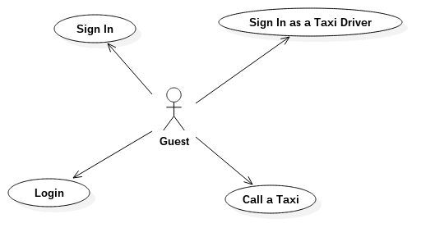

**Use Case: Sign In**

**Description**:

A guest, who doesn't have a profile yet, can submit his data to the system in order to become a registered User.

**Actors**:

Guest

**Input Condition**:

Null

**Output Condition**:

Guest successfully ends the registration process, and becomes a User. From now on he/she can log in to the application using his/her credential and have access to peculiar functionalities.

**Events flow**:

* Guest on the home page clicks on the “register” button to start the registration process;
* Guest fills in at least all the mandatory fields;
* Guest clicks on “confirm” button;
* The application will save the data in the database.

**Exceptions**:

* The guest has already registered;
* The chosen user name is already used;
* The email inserted is already associated to another user;
* One or more mandatory fields are empty or not valid;

All the exceptions cause the application to notify the error to the user with an alert window. The application then come back to the registration form, and the Event Flow will restart from the filling step.

**Use Case: Sign Up as Taxi Driver**

**Description:**

A guest, who doesn't have a profile yet, can submit his data to the system in order to become a Taxi Driver.

**Actors**:

Guest

**Input Condition**:

The Guest must have valid driving and taxi license.

**Output Condition**:

Guest successfully ends the registration process, and becomes a Taxi Driver. From now on he/she can log in to the application using his/her credential and have access to peculiar functionalities.

**Events Flow**:

* Guest on the home page clicks on the “sign up as a taxi driver” button to start the registration process;
* Guest fills in at least all the mandatory fields, and upload data related to driving license and taxi license;
* Guest clicks on “confirm” button;
* The application will save the data in the database.
* After a check by administrators, the Guest will be authorized to login as a Taxi Driver;

**Exceptions**:

* The guest has already registered;
* The chosen user name is already used;
* The email inserted is already associated to another user;
* One or more mandatory fields are empty or not valid;
* Driving license or taxi license are not valid;
* Driving license or taxi license are already associated to another user.

All the exceptions cause the application to notify the error to the user with an alert window. The application then come back to the registration form, to restart the Events Flow from the filling step.

**Use Case: Login**

**Description**:

A guest already registered can provide his credential to log in to the application, becoming a User and thus gaining User or Taxi Driver privileges.

**Actors**:

Guest

**Input Conditions**:

The Guest must be already registered to the system.

**Output Conditions**:

The Guest is promoted to User or Taxi Driver.

**Events Flow**:

* Guest fills in the log in form already present in the home page.
* The application verifies the inserted credentials, and if they are correct, promotes the guest and shows additional features.

**Exceptions**:

If the credentials are not correct, so user name and password don't match, an alert window will be shown and the access denied, remaining on the home page, and giving the guest the possibility to try again.

**Use Case: Call a taxi**

**Description**:

The guest has the opportunity to call for a taxi ride without being registered to the site.

**Actors**:

Guest, Taxi Driver

**Input Condition**:

Null

**Output Conditions**:

The first free taxi will answer the call and the guest will be served as requested.

**Events Flow**:

* Guest fills in the form in the home page, providing a name, a surname, the number of passengers and a phone number;
* Guest submits the request.
* His/her data, and his/her position, detected by using GPS, will be processed by the system, that starts sending the request to the first taxi in the zone queue;
* The taxi accept the request, and goes to take the guest in the place reported by the system.

**Exceptions**:

* If the guest doesn't fill in all the fields, or the values inserted are not valid, the request cannot be sent, and the user will be warned;
* If the taxi declines the request, the system will move that driver to the bottom of the queue, and proceeds asking to the next taxi in the queue, following the order.
* If problems arise with positioning or times, taxi drivers can use the customer's phone number to call them and make verbal arrangements.
  1. **Actor: User**

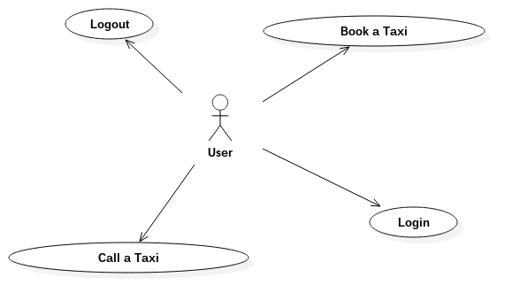

**Use Case: Login**

**Description**:

A User can provide his credential to log in to the application, being recognized by the system as a User and thus gaining in fact User privileges.

**Actors**:

User

**Input Conditions**:

The User must be already registered to the system.

**Output Conditions**:

The User is recognized and authorized to operate as a User.

**Events Flow**:

* User fills in the log in form already present in the home page.
* The application verifies the inserted credentials, and if they are correct, recognizes the User and shows additional features.

**Exceptions**:

If the credentials are not correct, so user name and password don't match, an alert window will be shown and the access denied, remaining on the home page, and giving the User the possibility to try again.

**Use Case: Logout**

**Description**:

This functionality allows the User to close the current session on the site and brings him/her back to Guest level.

**Actors**:

User

**Input Conditions**:

The User must be logged in.

**Output Conditions**:

The User closes the current session, loses his/her privileges and becomes a Guest.

**Events Flow**:

* User clicks on the “Logout” button in the page.
* The system close the session, and brings the User back to home page, as a Guest.

**Exceptions**:

There are no possible exceptions.

**Use Case: Call a taxi**

**Description:**

This functionality is similar to the one presented for the Guest use case, but in this case most of the data are already present in the database, so the procedure is faster and easier.

**Actors**:

User, Taxi Driver

**Input Conditions**:

The User must be logged in.

**Output conditions**:

The first free taxi will answer the call and the User will be served as requested.

**Events Flow**:

* User inserts the number of passengers for the requested ride;
* User submits the request;
* The system collects the number inserted, together with User data and his/her position tracked with GPS, and sends a request to the first free taxi in the zone queue;
* The taxi accept the request, and goes to take the User in the place reported by the system.

**Exceptions**:

* If the User doesn't provide the number of passengers, or the value inserted is not valid, the request cannot be sent, and the user will be warned;
* If the taxi declines the request, the system will move that driver to the bottom of the queue, and proceeds asking to the next taxi in the queue, following the order.
* If problems arise with positioning or times, taxi drivers can use the customer's phone number to call them and make verbal arrangements.

**Use Case: Book a taxi**

**Description**:

The User can book a taxi in advance, to be sure to have a ride on time and without problems.

**Actors**:

User, Taxi Driver

**Input Conditions**:

The User must be logged in.

**Output Conditions**:

The User will have a booked ride for the time and the ride requested.

**Events** **Flow**:

* The User fills in the form for the booking procedure, deciding the time of the ride, that has to be at least two hours after the time of the reservation procedure, the starting address, the destination, and the number of passengers;
* The system saves the values inserted;
* Ten minutes before the arranged time, the system generates an automatic request to ask for the ride requested by the User;
* The automatic call works as a normal call for generic guest or users (see use case Call a Taxi for specific information).

**Exceptions:**

If the User tries to insert a time that is not at least two hours later that moment, the system will reject the request, and will give the User the opportunity to try again with other times.

* 1. **Actor: Taxi Driver**

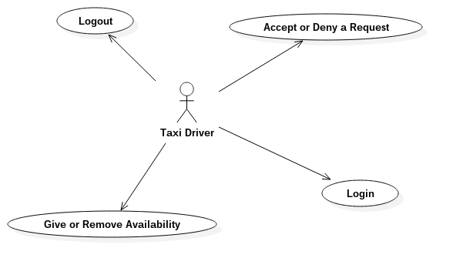

**Use Case: Login**

**Description**:

A Taxi Driver can provide his credential to log in to the application, being recognized by the system as a User and thus gaining in fact Taxi Driver privileges.

**Actors**:

Taxi Driver

**Input Conditions**:

The Taxi Driver must be already registered to the system.

**Output Conditions**:

The Taxi Driver is recognized and authorized to operate as a Taxi Driver.

**Events Flow**:

* Taxi Driver fills in the log in form already present in the home page.
* The application verifies the inserted credentials, and if they are correct, recognizes the Taxi Driver and shows additional features.

**Exceptions**:

If the credentials are not correct, so user name and password don't match, an alert window will be shown and the access denied, remaining on the home page, and giving the Taxi Driver the possibility to try again.

**Use Case: Logout**

**Description**:

This functionality allows the Taxi Driver to close the current session on the site and brings him/her back to Guest level.

**Actors**:

Taxi Driver

**Input Conditions**:

The Taxi Driver must be logged in.

**Output Conditions**:

The Taxi Driver closes the current session, loses his/her privileges and becomes a Guest.

**Event Flow**:

* User clicks on the “Logout” button in the page.
* The system close the session, and brings the Taxi Driver back to home page, as a Guest.

**Exceptions**:

There are no possible exceptions.

**Use Case: Give/Remove Availability**

**Description**:

The Taxi Driver let the system knows if he/she is available or not to accept requests.

**Actors**:

Taxi Driver

**Input Conditions**:

The Taxi Driver has to be logged in.

**Output Conditions**:

The Taxi Driver is inserted in a queue, or he/she is removed from it.

**Event Flow**:

* When ready to accept requests, a Taxi Driver gives the availability, and he/she will be inserted by the system in the zone queue based on his position tracked by GPS.
* When he/she removes the availability, he/she will be removed from the queue where he/she was lastly placed.

**Exceptions**:

There are no possible exceptions.

**Use Case: Accept/Deny a Request**

**Description**:

The Taxi Driver has the possibility to accept or decline a request from a customer.

**Actors**:

Taxi Driver

**Input Conditions**:

The Taxi Driver has to be logged in and be available.

**Output Conditions**:

If the Taxi Driver accepts the request, he/she will go to the place of the meeting with the customer; otherwise he/she will wait for another request.

**Event Flow**:

* When the Taxi Driver is the first of his zone queue, he/she will receive the next available request;
* Taxi Driver can decide to accept or reject the request;
* If he/she accepts, he/she can go to the place pointed by the system, to take on the customer;
* If he/she rejects, he/she will be put at the bottom of the queue.

**Exceptions:**

If the Taxi Driver doesn't answer the request, after a minutes time the request will be considered as rejected by the Taxi Driver, that will be moved to the bottom of the queue.

* 1. **Actor: Administrator**

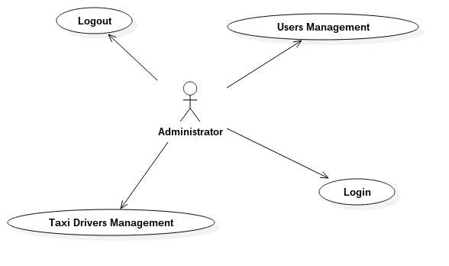

**Use Case: Login**

**Description**:

Administrator can provide his credential to log in to the application, being recognized by the system as an Administrator and thus gaining in fact Administrator privileges.

**Actors**:

Administrator

**Input Conditions**:

The Administrator must be already registered to the system.

**Output Conditions**:

The Administrator is recognized and authorized to operate as an Administrator

**Events Flow**:

* Administrator fills in the log in form already present in the home page.
* The application verifies the inserted credentials, and if they are correct, recognizes the Administrator and shows additional features.

**Exceptions**:

If the credentials are not correct, so user name and password don't match, an alert window will be shown and the access denied, remaining on the home page, and giving the Administrator the possibility to try again.

**Use Case: Logout**

**Description**:

This functionality allows the Administrator to close the current session on the site and brings him/her back to Guest level.

**Actors**:

Administrator

**Input Conditions**:

The Administrator must be logged in.

**Output Conditions**:

The Administrator closes the current session, loses his/her privileges and becomes a Guest.

**Event Flow:**

* Administrator clicks on the “Logout” button in the page.
* The system close the session, and brings the Administrator back to home page, as a Guest.

**Exceptions**:

There are no possible exceptions.

**Use Case: Remove Users**

**Description**:

The Administrator has the power to see the list of registered users, and remove any of them if necessary.

**Actors**:

Administrator, User (passive presence).

**Input Conditions**:

Administrator has to be logged in, User has to be registered.

**Output Conditions**:

The selected User will be removed from the system.

His data, however, will remain saved in the database.

**Events Flow**:

* Administrator clicks on the “users management” button to access the dedicated page;
* In the management page he/she can see the list of registered users;
* Administrator select one of the users by clicking on his/her user name;
* By clicking the “delete” button, the Administrator removes the user from the system.

**Exceptions**:

There are no possible exceptions.

**Use Case: Taxi Drivers Management**

**Description**:

The Administrator has the job to check every request from new taxi driver, in order to verify if data related to licenses are correct. If so, the Administrator gives the Taxi Driver the permission to work.

**Actors**:

Administrator, Taxi Driver (passive presence).

**Input Conditions**:

Administrator has to be logged in, Taxi Driver has to be registered.

**Output Condition**:

The Taxi Driver considered will be authorized to work, or rejected.

**Events Flow**:

* Administrator clicks on the “Taxi drivers management” button to access the dedicated page;
* In the management page he/she can see the list of pending requests;
* Administrator select one of the requests by clicking on the user name;
* A list of related data will be shown in the page, letting the Administrator check the information inserted by the user;
* By clicking on the “Accept” button the Taxi Driver will be accepted, otherwise by clicking on the “Deny” button the Taxi Driver will be rejected.

**Exceptions:**

There are no possible exceptions.

* 1. **Possible Scenarios**

**Scenario: Make a Taxi Call**

It's about midnight and Cinderella has to come back home after the party organized by Christopher, but she notices that her sisters already took her car, and she can't reach the house on foot. With relief she remembers of an advertising seen the day before, so she picks out her phone, and opens MyTaxi, an app for “Smart Taxi for a Smarter City” as the advertisement said.

She has to hurry, but she is not worried: she just needs to insert the number of passengers, and in a few minutes she receives a message with her taxi code and the estimated waiting time. Thanks to the new service, she could come back home.

**Scenario: Taxi Reservation**

Mr. White is working in his office, but he is anxious about an important meeting with Alice in the afternoon. How can he be sure not to be late? He then turns on the computer, and in the news he read about the improve in the taxi service, so he looks for MyTaxi website, he sign up, and he will be able to book a taxi just providing starting and arriving addresses, and for what time to book. The system saves his request, and at the indicated time a taxi will wait for him on time.