|  |  |
| --- | --- |
| **Architetture dei Sistemi di Elaborazione** | Delivery date:  4December 2024 |
| **Laboratory**  **9** | Expected delivery of lab_09.zip must include:   * zipped project folder for Exercise1.a and 1.b (they should be in the same project) * this document filled out and saved possibly in PDF format |

**Exercise 1.a) Implement a 8-bit LFSR**

A Linear Feedback Shift Register (LFSR) is a shift register[1]commonly used to implement pseudorandom number generators (PRNGs) in hardware. In LFSRs, the input bit is a linear function of its previous content, usually a XOR between some of the bits of the register.

* The content of the LFSR is called *state.*
* The initial state is called *seed.*
* The next input bit is computed by XORing some of the bits of the current state, called *taps*.
* The next state is computed by shifting the register right by one position and inserting the input bit in the leftmost position. For example, if the taps are bits 0, 2, 3 and 4, the LFSR can be graphically represented as below:

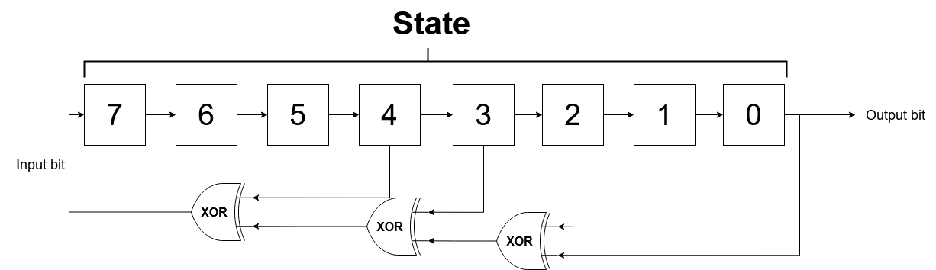

At each clock cycle:

* The input bit is computed using the current value of the taps.
* The state is shifted right by one position, outputting the rightmost bit.
* The input bit becomes the new leftmost bit.

Write a program **in C**that implements a 8-bit LFSR on the LANDTIGER board:

* Initialize the state (an unsigned char) with a seed that **you can choose freely**and show it using the LEDs.

**Note that choosing a seed equal to 0 will result in the LFSR always outputting a 0.**

* Each time KEY1 is pressed, call an **assembly** function called next_state that receives the current state and the bit position of the taps and returns the next state. The output bit is stored in an integer variable passed by-referencecalled output_bit. The taps are represented by a 8-bit variable containing a 1 in positions corresponding to the position of the taps and 0 elsewhere. For example, for the LFSR above, taps contains the value

0x1D16 = 000111012

* After next_state returns, update the current state and show it on the LEDs.

The function prototype is:

unsigned char next_state(unsigned char current_state, unsigned char taps, int *output_bit);

The function arguments are:

|  |  |  |
| --- | --- | --- |
| **Type** | **Name** | **Description** |
| **unsigned char** | current_state | The current LFSR state |
| **unsigned char** | taps | 8-bit long variable containing a 1 in correspondence of the bit position of the taps, 0 |
| **int \*** | output_bit | Pointer to an integer containing the output bit |

An example of how next_statecould look like in C when taps are in positions 0, 2, 3 and 4is given below:

// Compute the output bit

*output_bit = current_state & 1;

// Compute the input bit

// Note that the quantities by which you must shift current_state in order

// to compute input_bit **depend on the position of the taps**.

// The numbers reported here are***just an example***.

input_bit = (current_state ^ (current_state >>2) ^ (current_state >> 3) ^ (current_state >> 4)) & 1;

// Compute the new state

new_state = (current_state>> 1) | (input_bit << 7);

For example, if the initial state is 0xAA (10101010in binary), the next 8 states of the LFSR will be:

1. 110101012=0xD516 = 21310
2. 111010102=0xEA16 =23410
3. 111101012= 0xF516 = 24510
4. 111110102=0xFA16 = 25010
5. 011111012= 0x7D16 = 12510

**Exercise 1.b) Experiment with different taps**

Since the LFSR state is finite, after a certain number of iterations theLFSR will reach again its initial state and start repeating the same sequence of values.A *m*-bit LFSR is said to be*maximal-length* if the length of the sequence of values before the LFSR reaches the initial state is equal to . The length of the sequence depends on number and position of taps. For example, the LFSR of Exercise 1.a is maximal-length: the length of the sequence is .

Extend the program you wrote in Exercise 1.a by experimenting with number and position of taps and implementing the following features:

* Each time KEY2 is pressed, step the LFSR until it reaches its initial state[2]
* Count the length of the sequence and show it on the LEDs

Fill the table below, indicating the positions of the taps, the length of the sequence and the number of clock cycles needed to reach the initial state:

DISCLAIMER: I measure the CC starting from the initial “do” in the do-while statement up to the cycle before the execution of “LED_out(count)”

|  |  |  |
| --- | --- | --- |
| **Tap positions** | **Length of the sequence** | **Clock cycles** |
| 0, 2, 3, 4 | 255 | 42334 |
| **0, 2, 3** | 93 | 15349 |
| **2, 3, 5** | 2 | 334 |
| **1, 2, 3, 5** | 42 | 6976 |

You are welcome to experiment with more than three tap configurations.

**Note that poorly-chosentaps may cause a LFSR to reach an all-zeroes state (even with a non-zero initial state) from which it will never exit, resulting in an infinite loop. Since we are not requesting you to solve the halting problem, always maintain a tap in position 0, or, if you want to experiment anyway, always check for an all-zeroes state in your loop**

1. A shift register is a register which accepts one input bit at a time. The input bit is shifted in from the left, while the rightmost bit is shifted out from the right
2. “Initial state” in this context means the state in which the LFSR was when KEY2 was pressed