**Section 6**

* Expected Resistances
  + 10 Ω Resistor: 10.2 ± 0.2 Ω
  + Light Bulb: 9.4 ± 0.2 Ω
* Raw Data Sets for Resistor and Light bulbs
* 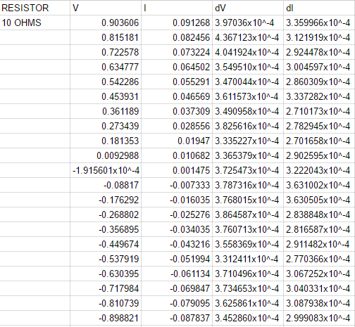
* 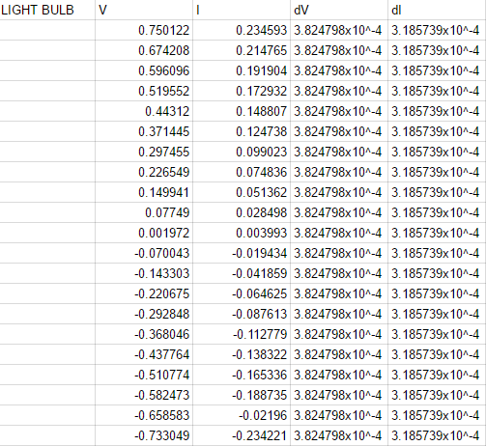

Perform a Fit to both Datasets:

* 10 Ω Resistor
  + I chose to follow the linear fit for this resistor because it is an ohmic resistor, and the shown changes in current are linear when compared to the changes in voltage
  + Enter estimate for parameter m: 10.2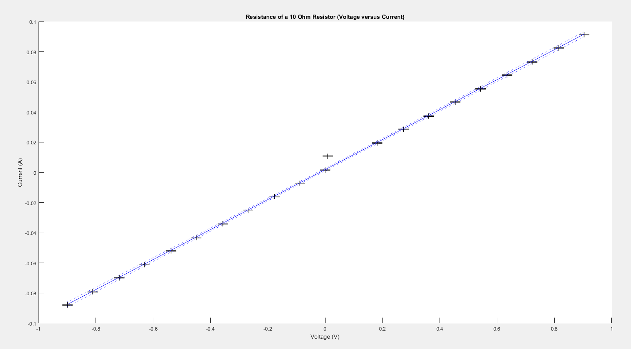
  + Enter estimate for parameter b: 0
  + Parameter 1: p(1) = 9.935611e-02 +/- 7.437959e-04
  + Parameter 2: p(2) = 1.847609e-03 +/- 4.058562e-04
  + Parameter m = 9.935611e-02 +/- 7.437959e-04
  + Parameter b = 1.847609e-03 +/- 4.058562e-04
* Light Bulb
  + 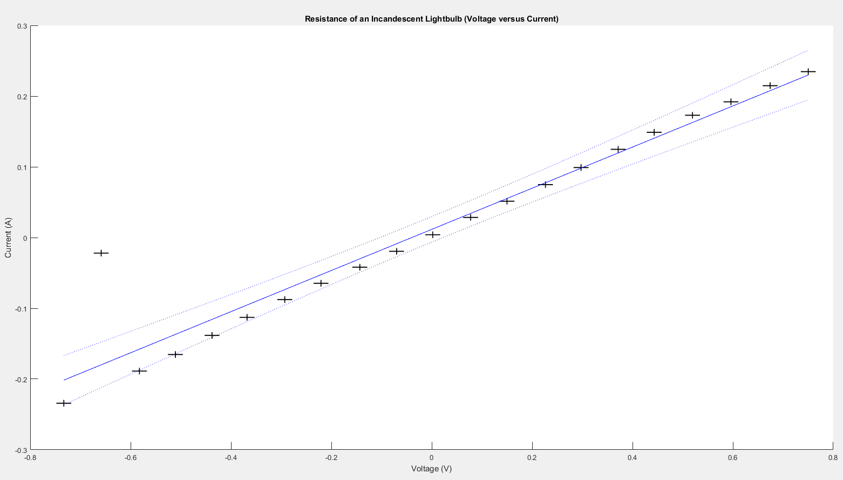I chose the linear fit for this model because for mine, It appeared to be the best fit, although there is much more variance from the fit line than in the resistor fit, suggesting that this resistor is not ohmic.
  + Enter estimate for parameter m: 9.4
  + Enter estimate for parameter b: 0
  + Parameter 1: p(1) = 2.908224e-01 +/- 1.926358e-02
  + Parameter 2: p(2) = 1.163233e-02 +/- 8.618399e-03
  + Parameter m = 2.908224e-01 +/- 1.926358e-02
  + Parameter b = 1.163233e-02 +/- 8.618399e-03
* The resistor appears to obey Ohm’s Law, the experimental slope of the graph appears to follow a full linear slope, The lightbulb, on the other hand, did not seem to, as it appears to have variance from the linear nature of the projected Ohmic slope of the line in its respective graph.

Calculations

* 10 Ω Resistor
  + M = 9.935611 x 10-2 ± 7.437959 x 10-4
  + M = slope of graph I = Current V = Voltage R= Resistance
  + M = $\frac{I}{V}$ $R= \frac{V}{I}= \frac{1}{M}$ $\frac{dR}{dM}= \frac{-1}{M^{2}}$
  + R = $\frac{1}{M}$ R = 10.06481 Ω
  + δR = $\sqrt{{(\left(\frac{-1}{M^{2}}\right)\left(δM\right))}^{2}}$
  + δR = 0.07535 Ω
  + R = 10.06 ± 0.08 Ω
* Light Bulb
  + M = 2.908224 x 10-1 ± 1.926358 x 10-2
  + M = slope of graph I = Current V = Voltage R= Resistance
  + M = $\frac{I}{V}$ $R= \frac{V}{I}= \frac{1}{M}$ $\frac{dR}{dM}= \frac{-1}{M^{2}}$
  + R = $\frac{1}{M}$ R = 3.43852 Ω
  + δR = $\sqrt{{(\left(\frac{-1}{M^{2}}\right)\left(δM\right))}^{2}}$
  + δR = 0.22776 Ω
  + R = 3.4 ± 0.2 Ω
* Calculation of T-scores
 $t= \frac{\left|x_{th}-x_{meas}\right|}{\sqrt{{δ_{th}}^{2}+{δ_{meas}}^{2}}}$

 + 10 Ω Resistor
    - Xth = 10.2 Ω Xmeas = 10.06 Ω
    - δth = 0.2 Ω δmeas = 0.08 Ω
    - T score = 0.65
    - Probability = 48.43
  + Light Bulb
    - Xth = 9.4 Ω Xmeas = 3.4 Ω
    - δth = 0.2 Ω δmeas = 0.2 Ω
    - T score = 21.21
    - Probability = unknown (too high to report)

**Discussion3**

Discuss what in particular makes the light bulb a non-ohmic resistor. How specifically does temperature affect resistance? Consider how increasing temperature is similar to changing the cross sectional area of the resistor.

Certain things like the increased temperature and the heat expansion of the filament will contribute to the resistance rating of the light bulb. Because of this, the resistance will be affected every time the current is changed. When the voltage is raised, the electrons will run into the metal atoms. The metal atoms will vibrate more and release the energy from the current and voltage as heat and light, which makes non-ohmic resistors useful for incandescent light bulb heating filaments and heating coils. The change in temperature increases the resistivity of the filament because of the fact that the metal nuclei are vibrating more, creating more resistance to the electrons’ movement. The increased temperature of the filament will also increase the diameter of the filament and therefore, the cross sectional area of the filament. This double punch of resistance increase will lead to the filament not having an ohmic line of resistance and increasing resistance as the voltage and the current are increased, but will leave the resistor with a more parabolic or exponential curve and vastly different levels of resistivity as the voltage and current are adjusted.