Experiment 1

Electrophysiology for Brain-Machine-Body Interfaces

Department of Bioengineering

University of California, San Diego

BENG 1

Moore, Joshua

Lam, Ricci

Yu, Zhilin

Oliphant, Haden

January 29, 2016

Section 01, Thursday 9:00am

**ABSTRACT**

This experiment is used to demonstrate the usage of the BioRadio in the recording of a subject’s heart rate in the form of ECG’s and the recording of brain waves in the form of single channel EEGs. Electrodes were placed on various places over the skin of a single test subject. Electrode cables were then strung up in different points and locations to simulate the different portions of the propagation of the heartbeat signal, particularly the QRS complex. The subject was then instructed to do activity to increase heart rate after the initial base control values were recorded. Finally, an EEG recording was taken of the subject to test the usability of the EEG readings and it was determined that increased sensory input would contribute to increased peak density of EEG readings.

**INTRODUCTION AND THEORY**

The electrocardiogram (or the ECG) is a graph of electrical activity across the body that relates to the heart. ECGs can be simplistic and use only 3 leads, or be more complex using up to 12 leads. The 12 lead ECG offers a more detail about the heart’s condition, however simple 3 lead ECGs can still offer basic information such as heart rate.

The electroencephalograph (or the EEG) is a graph of electrical activity emitted from the brain. EEGs are common for monitoring brain activity and human-machine interaction (thought controlled robotics).

The goal of this experiment was to find if the BioRadio produced an accurate ECG by measuring heart rate before and after physical activity. The ECG performed with the BioRadio should be able to accurately show heart rate and distinct P,QRS, and T waves.

The equation used in the experiment is as follows:

, where Rheart is the number of peaks from the ECG and *t* is the time the ECG was taken over in minutes. We divide the number of peaks by 3 because there is a P wave, a QRS wave, and a T wave per “beat.”

**EXPERIMENTAL MATERIALS AND PROCEDURES**

In this experiment we used a BioRadio along with its BioCapture software on the computer in order to take ECG and EEG readings from our subject. First we hooked up our consenting subject by setting gel based electrodes on the inside of each shoulder and on the inside of each ankle, similar to the diagram on the left below. We then connected an electrode cable to the ground of the BioRadio (blue port), and connected this cable to the electrode on the right ankle. A red, positive electrode cable was plugged into the BioRadio (red port), and this cable was connected to the left shoulder. A black, negative electrode cable was plugged into the BioRadio (black port), and was connected to the right shoulder. This represented the setup for Lead 1. Once all connected, the BioRadio was bluetooth connected to the BioCapture program and was ready for use. We then pressed play on the BioCapture program and right-clicked the graph to change the settings to a continuous Y-axis scaling in order to ensure that the results could be nicely viewed. The results were recorded and saved for further use. The electrode cables were then disconnected in order to complete leads 2 and 3. As seen in the diagram, for lead 2 the negative black cable was moved to the right shoulder, and the red cable was moved to the left leg, keeping the ground on the right ankle. The process done for lead 1 was then repeated. Once done, for lead 3 the black cable was moved to the left arm and the red cable was moved to the left leg, again keeping the ground on the right ankle. The process done for lead 1 was again repeated.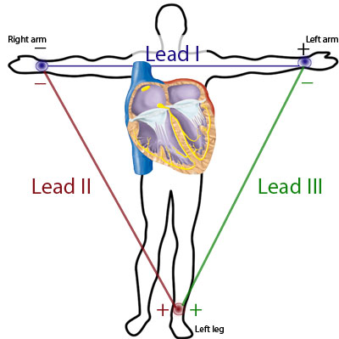

Once done with these three leads, we disconnected our subject and had him run a lap around the building in order to raise his heart-rate. We made sure that the subject had agreed to run, and told him not to get his heart-rate too high so as not to pose any health concerns. When he returned, we hooked him up in the lead 1 configuration and again used the BioCapture program to obtain an ECG.

When this was complete we went on the obtain an EEG from the subject. New gel electrodes were placed: one connected to the ground in the center of the forehead, one connected to the red positive cable above the subject’s left eye, and one connected to the black negative cable above the subject’s right eye. A brown electrode cable was then plugged into the next open spot on the BioRadio, and connected to a gel electrode behind the subject’s right ear. The same process used for lead 1 of the EEG was then used from here to capture a recording on BioCapture.

We then exported these recordings to Excel, and imported them to Matlab in order to find the results we wanted. A simple for loop was used to find the amount of peaks in each ECG and EEG recording.

**EXPERIMENTAL RESULTS**

We have found that the results shows that certain leads and lead typing would give you different heart rates, and that the readings from the EEG is telling about the brain activity. The density of the EEG peaks is representative of the proportion of neurons that are firing and the signals being sent from the brain to the eyes (as the density of the peaks increases as the eyes are open.) A way to reduce interference from the eyes is to simply close them and relax the eyelids, this had the effect of reducing the number of peaks with respect to time, as there was less communication between the eyes and the brain. The graphs shown below are excerpts of the whole readings that were taken as a part of the experiment. Note that all of the y-axes represent the readings in millivolts and the x-axes scales are divided by time in seconds. For all Graphs, please refer to the Appendix.

Table 1: Readings of Peak Count and Density of Peaks

|  |  |  |  |
| --- | --- | --- | --- |
| **Type of Lead** | **Number of Peaks** | **Time (seconds)** | **Beats per minute** |
| Lead 1 | 55 | 7.50 | 145 |
| Lead 2 | 88 | 9.75 | 185 |
| Lead 3 | 126 | 13.0 | 194 |
| Running Lead 1 | 175 | 16.5 | 212 |
| EEG | 265 | 18.5 | 277 |

**DISCUSSION**

This experiment is used to detect abnormalities related to electrical activity of the brain. This process tracks and record brain wave patterns. During the experiment, three electrodes(RA, LA, LL) are placed in the frontal plane, each at approximately equal distance from the heart. Differential measurement of voltage across three leads I, II, and III yield projections of the time-varying dipole cardiac vector M along these lead. The results of graphs show the electronic changes those three leads done in our body during different states our body is. It really explain the theory. These shows body surface biopotentials work.

Although we follow the instruction, we still can not trust the graphs absolutely if just depending on those result. For example, the picture of lead III shows a different peak-to-valley value and periods. It might result from some noisy backgrounds that disturb the final result. Hence, the conditions in the further experiments should be improved. For example, we should reduce the external interference factors such as clothing.

**CONCLUSION**

The results of this experiment indicate that it is possible to successfully take both an ECG and EEG using a BioRadio and its BioCapture program. Our findings show that although the BioRadio is not the most accurate when not calibrated to exclude outside noise, it does give a very nice general view of our subject’s ECG and EEG. Our results also showed that running greatly affects the average amount of beats per minute that a heart has in an ECG. Also, blinking greatly affects the EEG readings, along with any other visual input from the subject (sudden potential drops occurred when the subject blinked).

**REFERENCES**

"BioRadio User Guides - BioRadio: Wireless & Wearable Human Monitoring." *BioRadio Wireless Wearable Human Monitoring*. Great Lakes NeuroTechnologies, 2015. Web. 29 Jan. 2016.

"Cardiovascular Lab: Electrocardiogram: Setup." *Cardiovascular Lab: Electrocardiogram: Setup*. McGill, Oct. 2005. Web. 29 Jan. 2016.

Shapiro, Jeremy J. "Acquiring Digital Wealth — the Underlying Cultural Principles." *Ubiquity* 2000.March (2000): n. pag. Great Lakes NeuroTechnologies, 2011. Web. 29 Jan. 2016.

<http://www.medicine.mcgill.ca/physio/vlab/cardio/setup.htm>

<https://glneurotech.com/bioradio/support-page/support-bioradio-user-guides/>

<http://glneurotech.com/bioradio/wp-content/uploads/2014/08/Note_BioCapture-ECG.pdf>

**APPENDIX**

Graph 1: Lead 1 [Millivolts(mV) with respect to time(s)]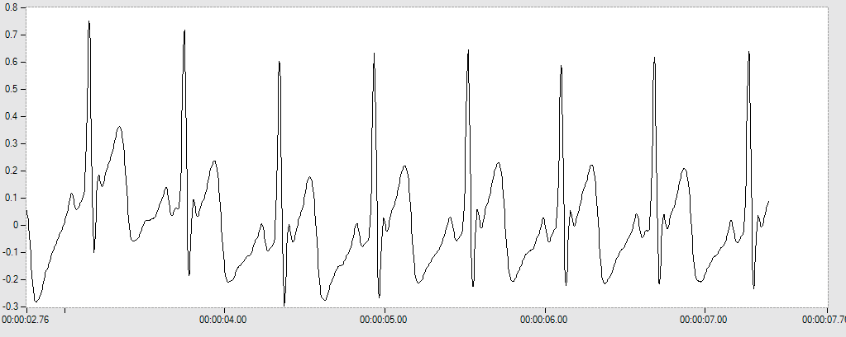

Graph 2: Lead 2 [Millivolts(mV) with respect to time(s)]

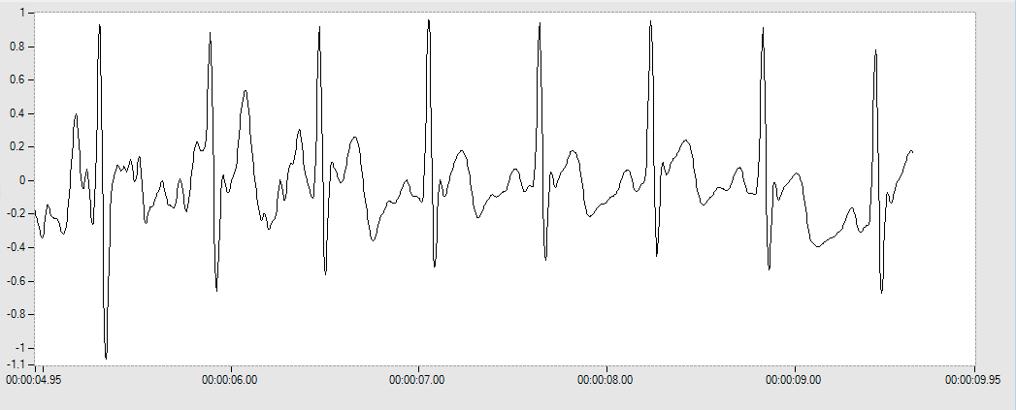

Graph 3: Lead 3 [Millivolts(mV) with respect to time(s)]

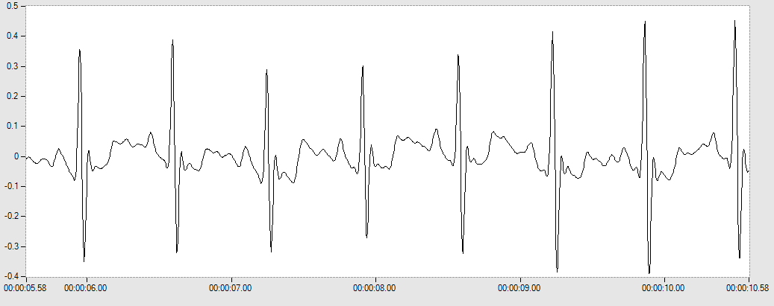

Graph 4: Lead 1 After Running [Millivolts(mV) with respect to time(s)]

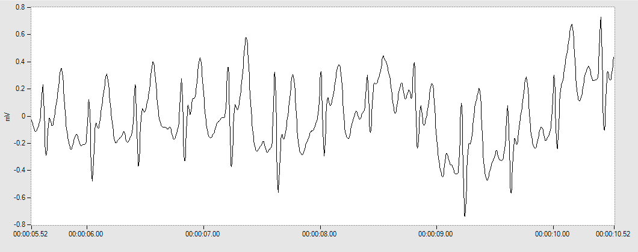

Graph 5: EEG Reading From the Forehead [Millivolts(mV) with respect to time(s)]

