Experiment 3
3D Printed Scoliotic Vertebra, T-7

Department of Bioengineering
University of California, San Diego
BENG 1

Moore, Joshua
Lam, Ricci
Yu, Zhilin
Oliphant, Haden
March 11, 2016
Section 01, Thursday 9:00am

ABSTRACT

This lab uses computed tomography and a 3D printer to produce a plastic model of a scoliotic spine. With this model, one can easily subject the spine to stress and strain tests. Scoliosis is a complex condition that affects how the spine reacts to stress.
Using a weight as a compressive stress on two vertebra and one disc, this lab observed the strain of the intervertebral disc by measuring the height before and after stress. The strain measured at 4.90 N was 0.19, which increased nonlinearly to 0.30 at 49.0 N. The disc, if it models human intervertebral discs correctly, showed significant deformation with initial strain, however the disc deformed exponentially less as the weight increased. This reaction can be extrapolated as a response of a scoliotic spine.

INTRODUCTION AND THEORY
The research topic central to this lab was the stress and strain of an intervertebral disc in a model scoliotic spine. How much does the disc decompress due to added force from the vertebra? Can researchers use 3D printing from x-rays to model the human spine, and with what limitations?
Scoliosis is a condition where the spine is curved abnormally, and often can be twisted. Measuring and classifying degrees of scoliosis can be difficult, but there is a broad spectrum of curvature to which the word “scoliosis” refers. Scoliosis affects growth, can damage nerves, and also affects the amount of compressive force the spine can handle. This lab focuses on the ability of a scoliotic spine (or more specifically, the spinal vertebra T6 and T7) to transfer their loads to their shared vertebral disc. This is important to understanding the scoliotic spine and its effect on human development.
In order to test the scoliotic vertebra, a plastic model was produced through a 3D computed tomography of the spine and a 3D printer. Two vertebra were produced with a hard plastic, modeling bone. A printed intervertebral disc was handed out and models the fibrous ring and inner gel-like sac of a human spinal disc. These three parts were then oriented and taped, and a weight was used as a compressive force against the structure. The force (or stress of the system) causes the disc to deform (a.k.a. strain), and that deformation was measured.
Strain was calculated for the intervertebral disc, using the equation: 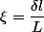. refers to the strain, which is unitless. refers to the change in length of the disc, in mm, and L refers to the total length of the disc before stress in mm.

EXPERIMENTAL MATERIALS AND PROCEDURES
In this experiment, a MakerBot 3-D printer was used to print out the T-7 vertebra. In order for the vertebra to be printed, many steps were taken. First a series of 2-D spine x-rays were imported into dataviewer. From these 2-D images, the T-7 vertebra was located and it was found to be in the range of transaxial pictures 476-520. These pictures were then imported into the cTan program and were set as our region of interest. From here, each and every one of our images in our region of interest were outlined in order to single out only the T-7 vertebra that was to be printed. The ribs and all other excess bone were not outlined in this section. Once finished outlining the region of interest images, the upper grayscale value was set to 255 and the lower grayscale value was set to 72. This ensured that whatever was to be printed was bone and not the tissue in between the vertebra. Once this was complete, the images were saved as a .stl file and were imported into MeshMixer. This program compiled all of the images together and presented them as a 3-D object. The object was very rough around the edges however, so the smooth function on the program was used. Once this was complete, the final .stl file was saved and sent to the 3-D printer.
The file was then opened on the 3-D software. The 3-D printer was then told to add a raft to the bottom of the object in order to allow for more precise printing. A couple hours later the product was complete. The raft was then peeled off and all of the extra plastic used to support the printing of the vertebra was stripped off. The vertebra was then ready for testing.
In order to test our vertebra, a pre-printed NinjaFlex intervertebral disk was used, along with the vertebra above ours, the T-6 vertebra. The two vertebrae along with the intervertebral disk in between were then lightly taped together using two small strips of duct tape in order to forge the act of tendons in the human body. Then, using a 500 gram, 1 kilogram, and 5 kilogram mass, the compression of the intervertebral disk was measured.

EXPERIMENTAL RESULTS

In this 3D Printing experiment, we get the the grayscale values of the T7, the top of which is 255, and the bottom is 72. Besides, we get the spine images of 467-520, and screenshot the eight images of them. The first is at 210, then 506, 502, 498, 494, 490, 486, 482 subsequently. We also have T6 measured in 16.69mm and T7 in 16.17 mm with the disc 9.09mm. According to these measurements, a table is created below.

Table1. Results for the Compression Force with Respect to Distance
 | Before compression | After compression | The difference | Strain
Distance from vertebra to vertebra  (500 g mass) | 41.95mm | 40.20mm | 1.75mm | 0.19
Distance from vertebra to vertebra  (1000 g mass) | 41.95mm | 39.68mm | 2.27mm | 0.25
Distance from vertebra to vertebra  (5000 g mass) | 41.95mm | 39.21mm | 2.74mm | 0.30

DISCUSSION
In this experiment, a human spine with scoliosis was used to test the weight bearing potential of the spine and the resulting compression of the intervertebral discs. The experiment involved the manufacturing of parts of the spine, testing the load bearing capability of the spine and intervertebral discs with weights, and measuring the resulting magnitude of compressions.
In our group, we reproduced the T7 vertebra with the use of 3D CAD software (Dataviewer, cTan,and MeshMixer). We ran into some problems with the CAD software and especially cTan, which was used to help us trace the slices of the vertebra. We, were unable to initially distinguish the beginning and the ends of the vertebra, but with proper adjustments on the area and a description of the actual bone shape, we were able to finish manufacturing the bone without further issues.
In this experiment, we compared the compressions with our bone (the T7 vertebra) and the T6 vertebra that was manufactured by another group. What we found was that applying a 5 kg mass (or 45 Newtons of force) on the spine caused the intervertebral discs to compress very little, only 2.74 millimeters (mm). The intervertebral discs (made of NinjaFlex©), which represents real-life cartilage in intervertebral discs, required much force to compress very little. Another problem that arose was that we were not able to make fine adjustments to the force.
A second source of error in this lab was that the discs, vertebrae, and weights were very difficult to put together and resulted in a significant amount of error, even after attempting to keep the system together for measurement through the use of duct tape. The system buckled depending on where the weight was situated, and the weight had trouble staying on top of the bone system, which makes it harder to get an accurate measurement due to the fact that someone needed to support the system. The bone also has a measurable deformation with the applied force, and therefore contributed to error in our experiment.
One proposal to finely tune our force would be to horizontally mount the bones and discs on a clamp along with a newton compression scale, which would allow much more accurate measurements of force to compressions of the bone system. The use of a horizontal clamp mount would allow a greater range of pressures to be applied to the bone and discs to test compressions and the load bearing capabilities of the vertebra.

CONCLUSION
Our experimentation on the bone showed that the intervertebral discs and the bones that make up the human spine are very strong and resistant to compression, at least according to the number and mass of weights that were tested on the spine according to the procedures. For real world application, the plastic that we used was strong enough to withstand much of the weight and force that was applied, meaning that it is theoretically possible to manufacture bone from this type of plastic. The resistive capabilities of the NinjaFlex means that it could also be used in cartilage replacement that would allow a surgeon to replace decaying or failing cartilage in patients.

REFERENCES

"Anatomy and Function." University of Maryland Medical Center. DePuy Acromed, 2003. Web. 11 Mar. 2016.
Bridwell, Keith. "Anatomical Planes of the Body." SpineUniverse. N.p., n.d. Web. 11 Mar. 2016.
Kaffery, J. "Standard Operating Procedures (SOPs)." Standard Operating Procedures (SOPs). N.p., 10 Feb. 2015. Web. 11 Mar. 2016.
Keller, Marisa. "BE001_CTsummaryTemplate_20160224_RLSmkk.pptx." Google Docs. N.p., 24 Feb. 2016. Web. 11 Mar. 2016.

APPENDIX
Appendix A, Transaxial images of the vertebra T7

Image 1
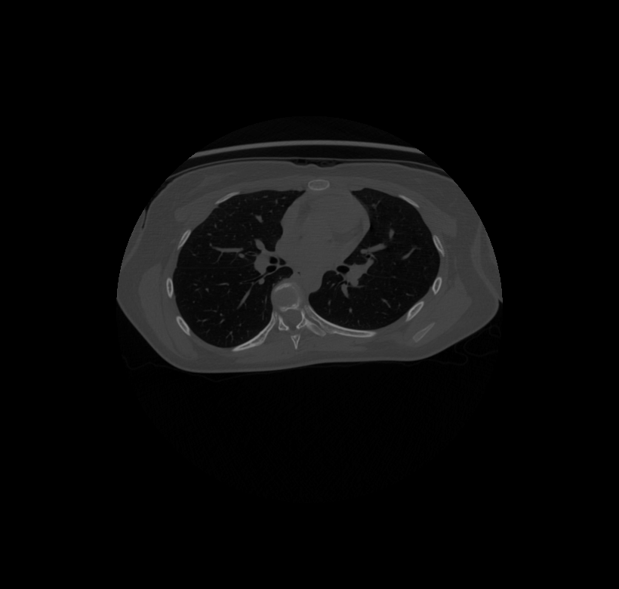
Slice 482

Image 2
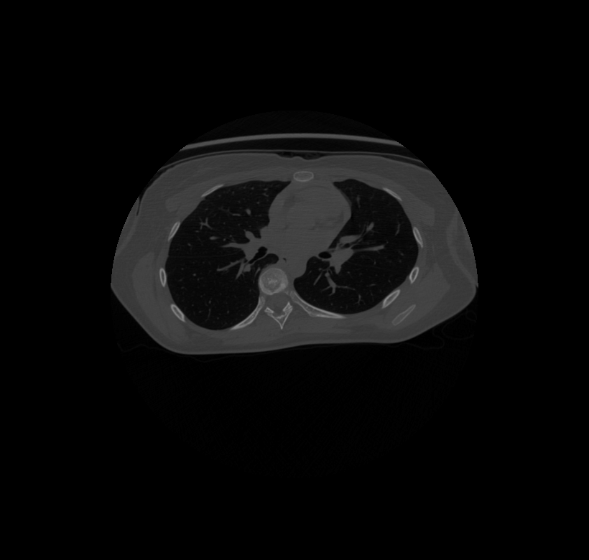
Slice 486

Image 3
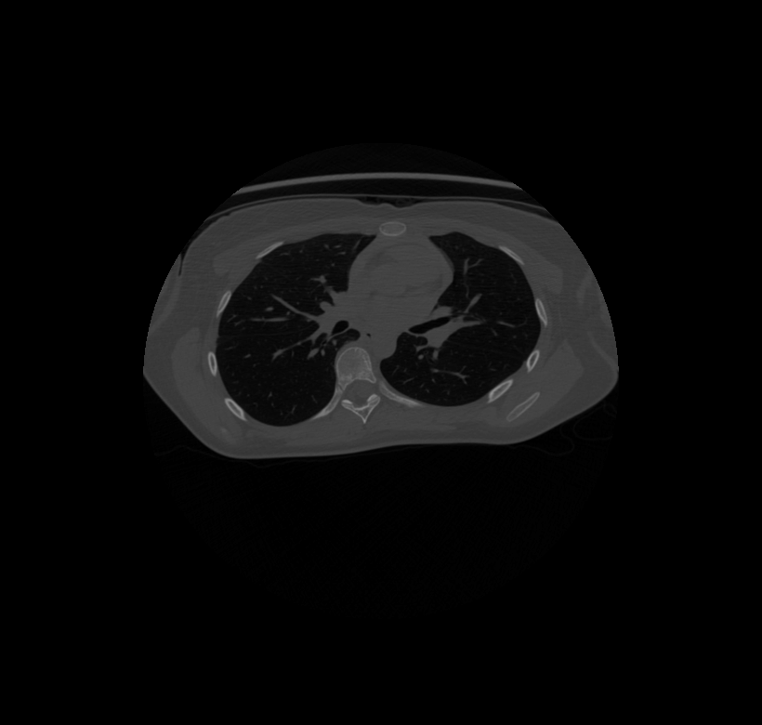
Slice 490

Image 4
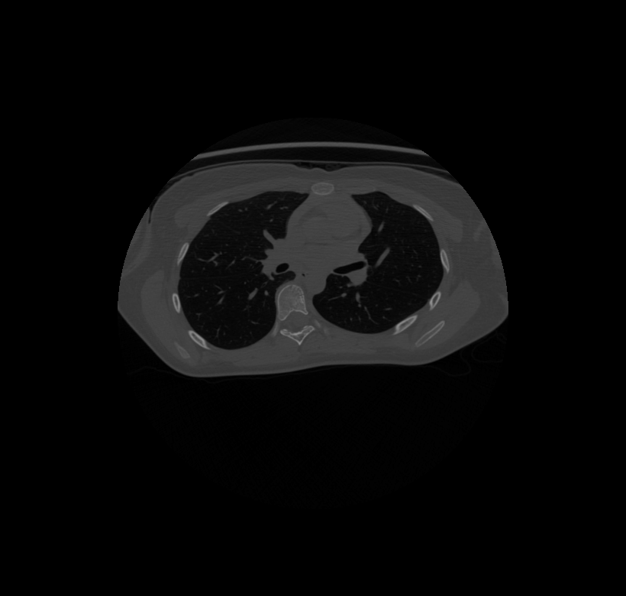
Slice 494

Image 5
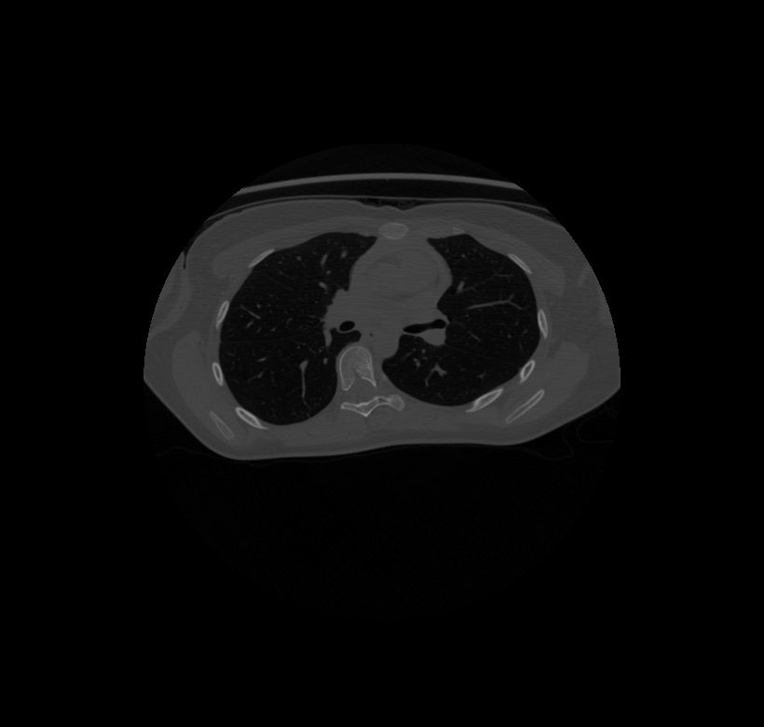
Slice 498

Image 6
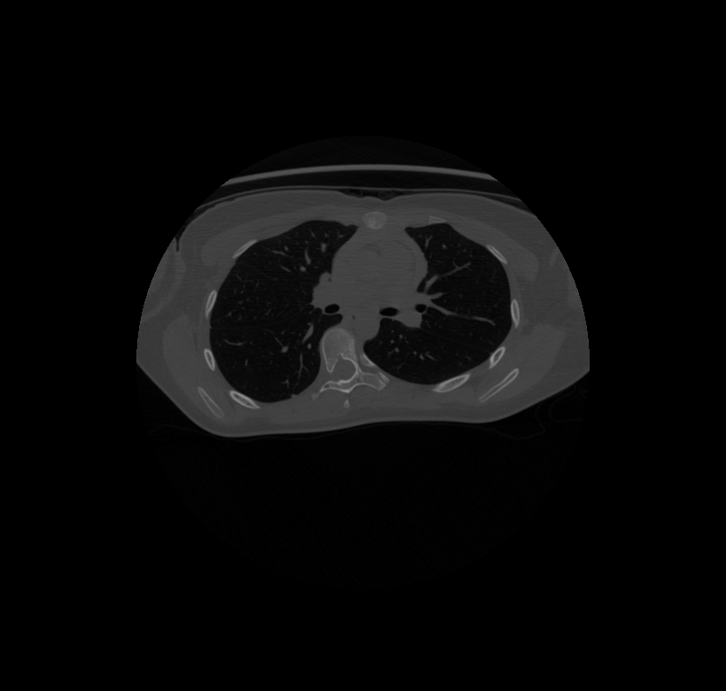
Slice 502

Image 7
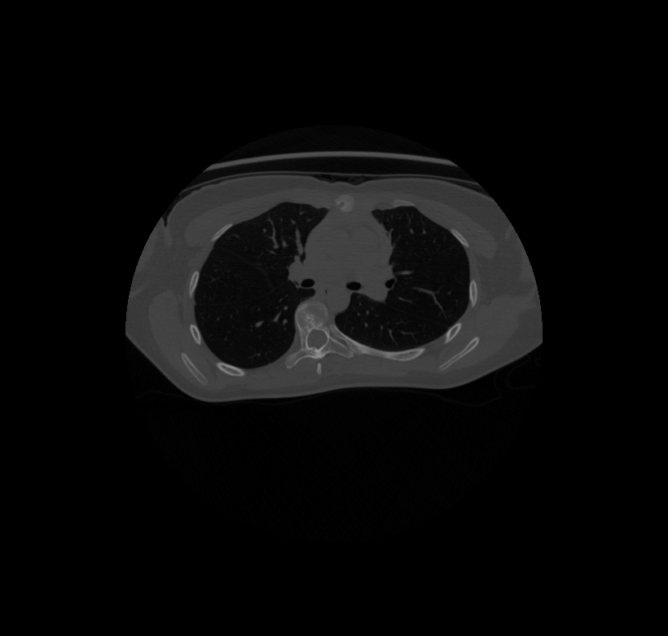
Slice 506

Image 8
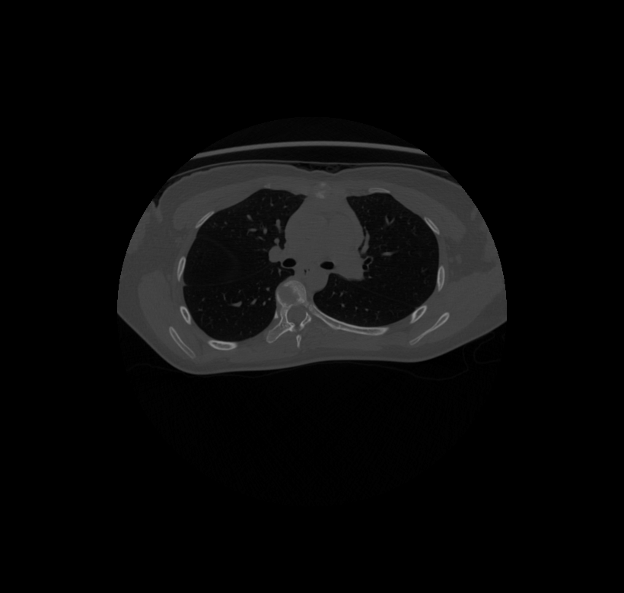
Slice 510

Image 9
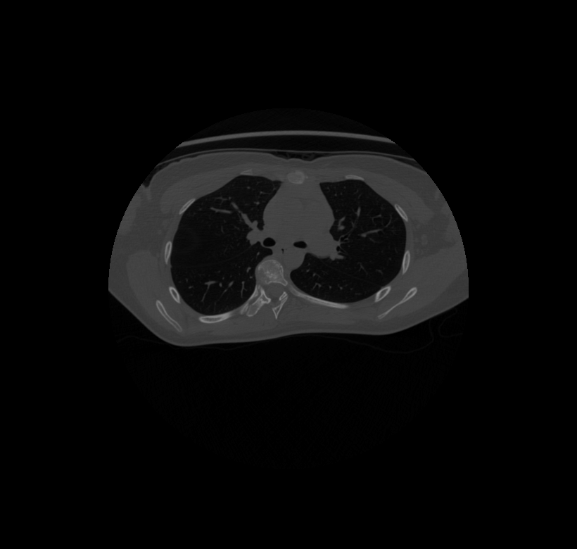
Slice 514

Image 10
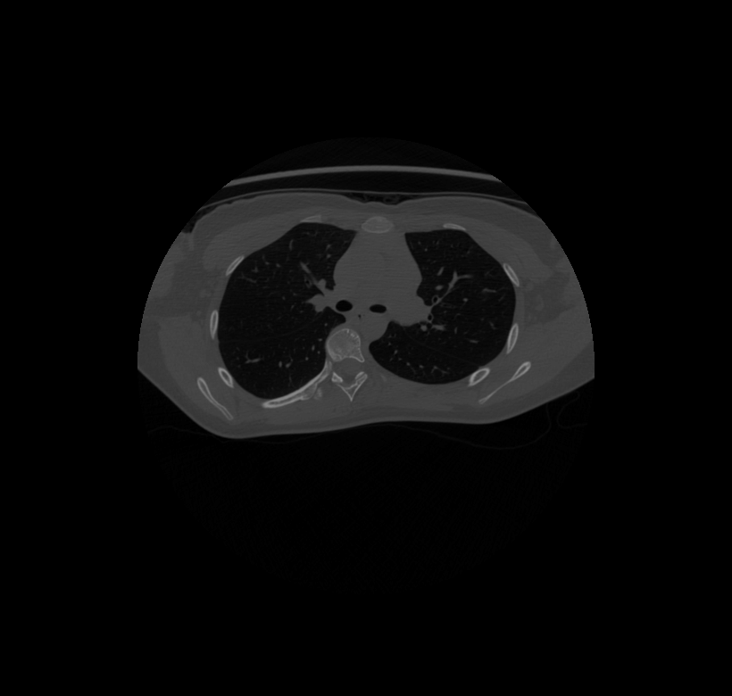
Slice 518

Appendix B: Powerpoint
Coronal, Sagittal and Transaxial CT Slices in Standard Anatomical Orientation
DataSet Patient X, T-7

screenshot from DataViewer at x=unknown, y=unknown, z=494
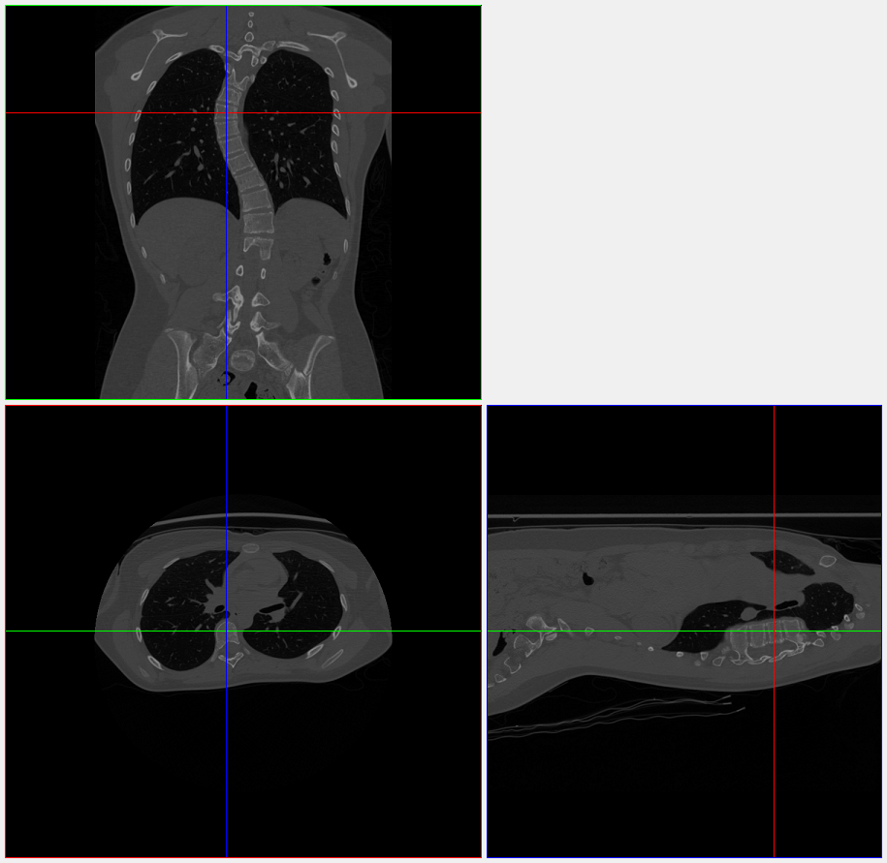

Proximal

Distal

Anterior Anterior

Posterior Posterior

Coronal, Sagittal and Transaxial CT Slices in Standard Anatomical Orientation
DataSet Patient X, T-7

screenshot from DataViewer at x=unknown, y=unknown
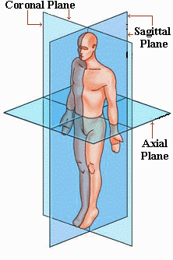

Coronal Sagittal

Transaxial CT Slices of Vertebra
DataSet Patient X, T-7

Z1=482 Z2=486 Z3=490
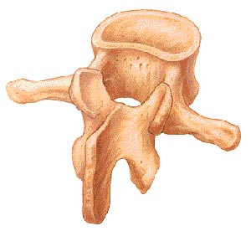
Z4=494 Z5=498 Z6=502 Z7=506
Z8=510 Z9=514 Z10=518

