Experiment 2

Designing a Finger Sticking Mechanism for Blind Diabetics

Department of Bioengineering

University of California, San Diego

BENG 1

Moore, Joshua

Lam, Ricci

Yu, Zhilin

Oliphant, Haden

February 19, 2016

Section 01, Thursday 9:00am

**Abstract**

Finger-sticking, a common blood-glucose test used for diabetics, involves pricking a finger and touching a device to the small blood sample. For blind diabetics or those with impaired vision, this process becomes impossible. As this report explains, a device was constructed to guide blindfolded patients using popular finger-sticking devices (a lancet and a glucose meter). Preliminary testing shows that this device can correctly guide the lancet and glucose meter without vision. The test was very limited; there were only four trials and one patient, and 7µL of sample was used in each.

**Introduction**

Diabetes is a serious issue in American society. It is a disease that requires constant monitoring by both the doctor and the patient. Although this monitoring is difficult for an average American diabetic, the problem becomes even more difficult when the diabetic patient is blind. Monitoring systems involve pricking your finger and touching a glucose meter’s test strip to the exact spot of where the blood drop is. This process is difficult enough for patients with perfect vision, but for blind patients, it is nearly impossible. Although this is a significant issue, there is currently nothing in the market that targets the struggle that blind diabetics face in touching a test strip to a very small blood drop that they cannot see.

This experiment is meant to design a prototype design that will allow blind diabetics to take their own glucose reading without any help from an outside source. By doing so, we hope to finally penetrate the market for blind diabetics, in which there are currently no products aimed at helping them.

**Experimental Materials and Procedures**

In this experiment 1 foot of duct tape, a 10 cm by 10 cm by 3 cm piece of foam, a Hot Knife wire foam cutter, a tabletop foam cutter, a hot glue gun, and an Exacto Knife were used. First, a 9 cm by 5 cm by 3cm section of the foam was cut from the large block of foam using the tabletop foam cutter, the rest of the foam is set aside. Then, a Hot Knife wire foam cutter was used to gouge out a cylindrical section in the longitudinal area of the foam with a radius of no more than 2 cm, the entry and exit point in the top of the block should be no wider than 5 mm, note that the cylindrical section is not offset and should be somewhat centered (refer to appendix 2 for appearance of the section). Cut off the extra 5cm by 1cm by 3cm section off the remaining block (it should already be sticking out from cutting the last cut) set aside the newly cut off section. Use the Exacto Knife to cut a 2cm by 3cm by 4 mm section from the center of the bottom of the larger foam block (the side where there is not extry/exit slit for the cutter), the section should be oriented the same way as the block of foam, with the 3 cm side matching with the 9 cm side and the 5 cm side matching with the 2cm side. At the center of that section, use the Exacto Knife again to cut an additional 4 mm deep cut into a section at the center of the depression, make the cut 1 cm by 1 cm (note that this 1 cm by 1 cm section should be a hole into the center cylindrical cavity) Refer to Appendix 3 and 4 for the appearance of the hole and the appearance of the entr/exit slit). Use the hot glue gun to attach the 1 cm by 5 m to either end of the 5cm by 9cm block (it is symmetrical and does not matter, make sure that the final product dimensions should be 5cm by 10 cm by 3cm) Take the remaining 10 cm by 5 cm section of the foam and cut 2 blocks of the size 3 cm by 2 cm. The extra foam may now be discarded. Take one 3 cm by 2cm block and cut a 2cm by 1.5 cm by 2.5 cm section from the small block using the Exacto Knife (note that the dimensions of the base are 2cm by 3cm. On the other side of the block (the uncut base), cut a 7mm by 1cm by 1cm hole in the center of the block (this should end up being a hole in the center of the block). Wrap the sides of the block with a 3cm by 11cm strip of duct tape to brace it, and set the block aside (this attachment is for the lancet pricker). For the other block, start by cutting out a 2.5 cm by 1.5 cm by 2.5 section from the block, then, cut a 1mm by 5mm hole in the other side of the block. Along the short edges with the gouged out section, cut a 1cm by 1cm square out of the side. Set aside the block, this attachment is for the reader and the test strips. For usage procedures, refer to the section titled:Ricci-Stick Manual on page 8 for instructions on how to use the Ricci Stick. Note that during testing, a micropipette that dispensed 7 microliters of sugar solution was used in place of the lancet. (for expected appearances of the final product, please refer to Appendix B)

**Results**

This prototype that was designed for blind people to test the glucose level is made of foam board with a hollow tube for the insertion of a finger. There is a hole made at the top of the device where each attachment can insert and work. In that way, the glucose level of the patient can be taken once the finger is pricked by the needle. The level of glucose in the blood of the patient can be tested efficiently and conveniently. The actual image of the prototypes are followed.

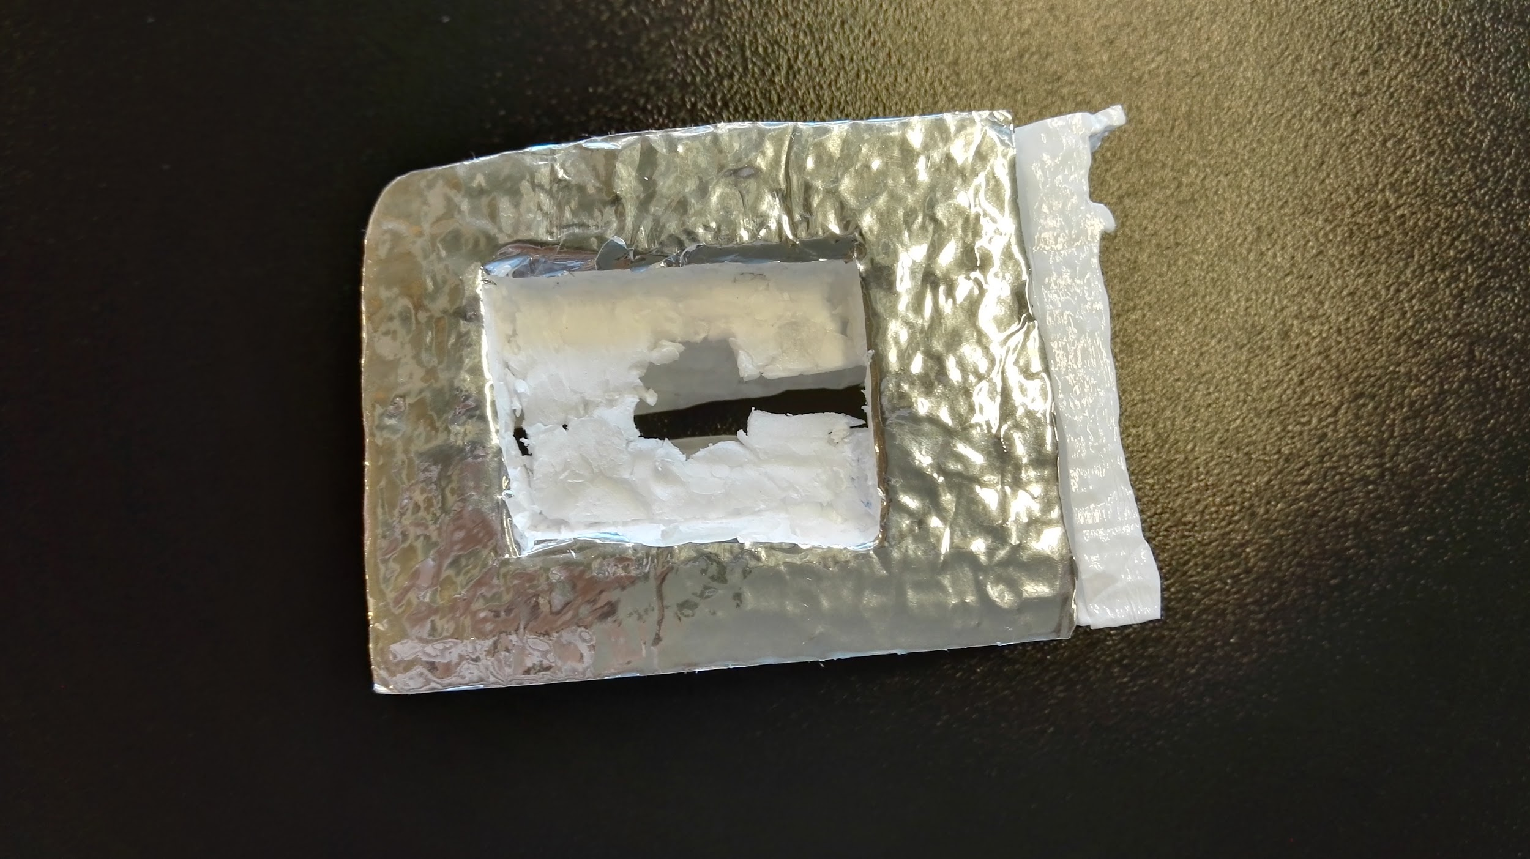

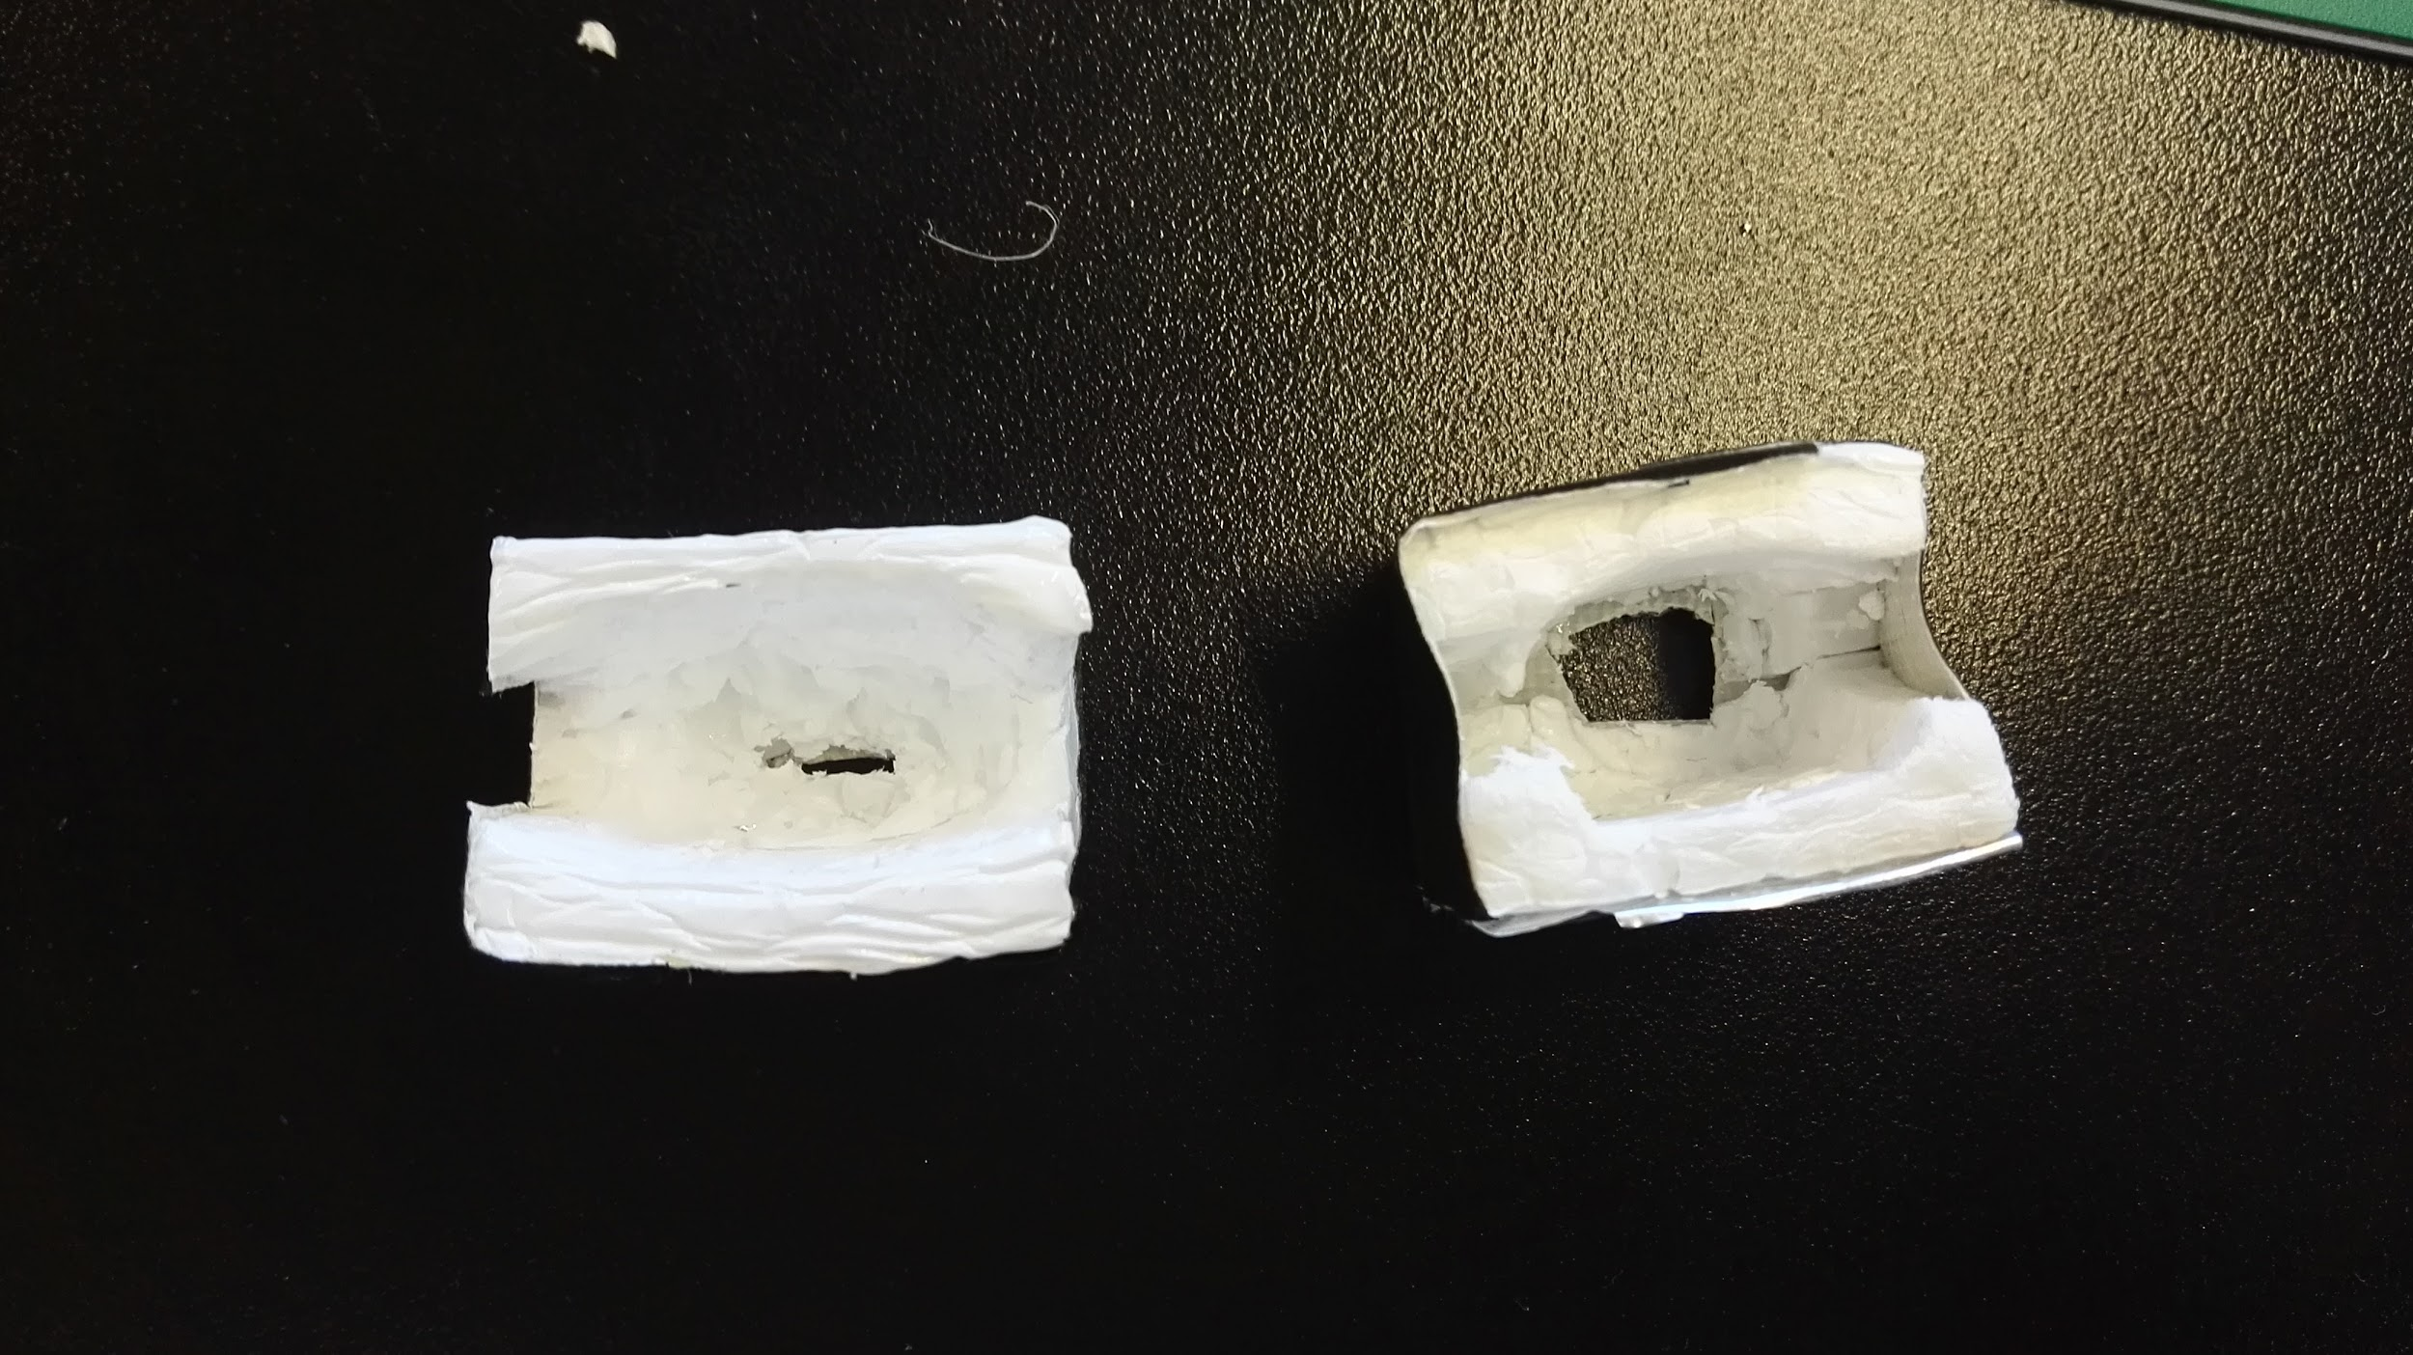

The experiment was performed four times. The first solution reading that was given was hyper, which means that there was a high level of sugar concentration in the glucose solution. The second and third time we used the device, it showed us an error 3 reading. The fourth time we used a different solution and took the test strip off once the meter made a beep. The meter gave us a reading back of 115 at this time. Although we received those numbers during the experiment, we actually forgot taking the pictures.

**Discussion**

This experiment used a group design for blind diabetic patients to test the glucose levels in their blood. It was made in a way that our group saw it as the easiest way for a blind patient to use. When going about the procedures however, we did run into a few problems. The first and most obvious is that the blind patient may have a hard time in inserting a new needle in the pricking device and a new test strip into the meter. These issues, however, were not what were addressed in this experiment.

In the actual design process, there were a few errors that were made. Due to the uses of the wire cutter, it was very difficult to make the correct sized finger hole. It was also very difficult to make the correct cuts without messing up. The exacto knife was used to help with this, but our design was not perfect. It would also be fairly difficult to remake the design, since it was not made using 3D software.

Although it seemed difficult at first, our “blind” patient was able to insert his finger into the device by himself, as well as insert the meter into its attachment by himself. He did need help when pipetting solution onto his finger, but would have been able to use the finger pricking system if needed. After the solution was pipetted, the patient put the meter attachment onto the design and it gave the reading hyper indicating that the solution glucose levels were high. On the second and third attempts, an error 3 code was received from the device. We see that there are two possible explanations for this. The first is that the solution glucose levels were too high and that the meter could not read them on the second and third time around (meaning that we found a slightly lower concentration area of the solution on the first attempt. The other and more realistic reason for the error message was that the test strip was left on too long. On the first attempt it was on for a very short amount of time. On the second and third attempts, it was left on for a lot longer. Due to these two issues, we switched solutions for the fourth attempt and took off the test stip from the solution as soon as the meter made a beep. This gave us the successful reading of 115.

Our results gave us two positive results and two negative results, but due to time constraints, we were not able to test the product further. We were only able to use one patient, but could tell that different products would have to be made for people with different finger sizes. Because of our success on the last attempt however, we do have confidence that our product can be successful with more testing.

**Conclusion**

The results of this experiment show that our design can be used by a blind patient in order to accurately take a glucose reading. It is clear that a 3D design should be made in order to facilitate easier and more accurate design production. It is also clear that there needs to be different finger sizes for our design in order to fit the need of the market. Our design can easily and cost efficiently penetrate a market that currently has no product in order to fit their need. Our product had a 50% success rate, which means that it should be tested more, however, we do not believe the error was due to our product. It was most likely an error due to the little knowledge we had of the glucose meter. Due to the success of two readings using only 7 microlitres of glucose solution however, we are very confident that our design has the ability to be successful once released to the market.

**References**

1."Agamatrix Owner's Guide." *OWNER‘S GUIDEKey Features in the AgaMatrix JazzTM* (2006): n. pag. *Agamatrix.com*. AgaMatrix Inc., 2005. Web. 19 Feb. 2016.

**Appendix A:**

**Ricci-Stick Manual**

To use the Ricci-Stick:

1. Make sure a new needle is on the lancet, and that a new test strip is on the meter.
2. Turn the meter on. Follow all directions provided by manufacturer.
3. Insert the finger you are to prick inside the Ricci-Stick2,3,4.*
4. Fit the Ricci-Adapters1 onto the lancet and glucose meter. These do not depend on orientation and will work as long as the adapters are fitted on.
5. Place the lancet onto the Ricci-Stick. The Ricci-Adapter should fit into the Ricci-Stick on one side. Operate the lancet to draw blood.
6. Place the glucose meter into the Ricci-Stick. The adapter should fit into the Ricci-Stick on one side. Operate the glucose meter as directed by the manufacturer.
7. If this test is inconclusive, repeat steps 1-7 on a new finger.

*\*superscripts refer to numbers on Appendix B*

**Appendix B**

1. 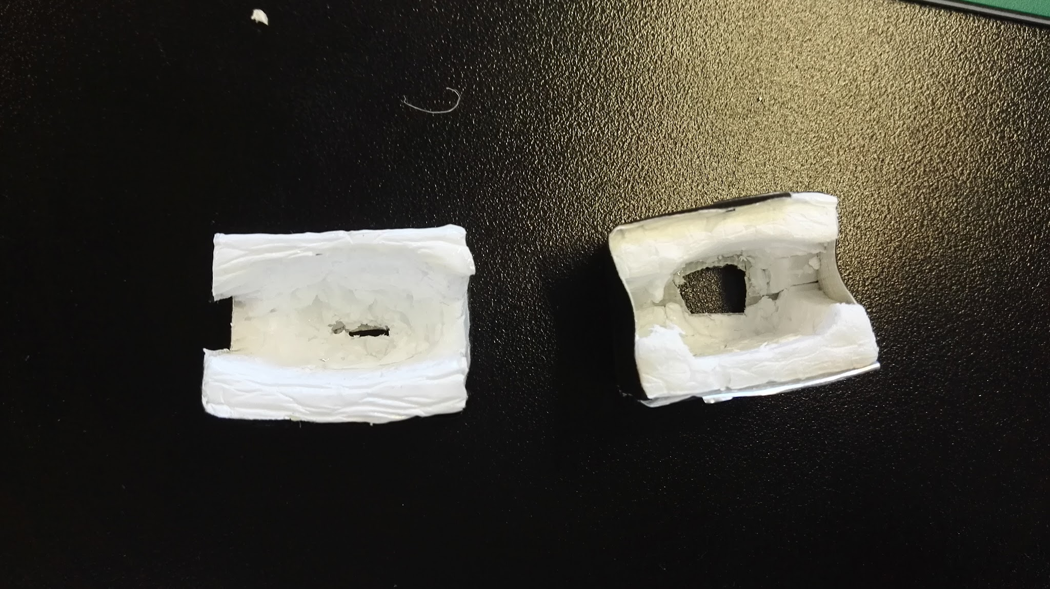
2. 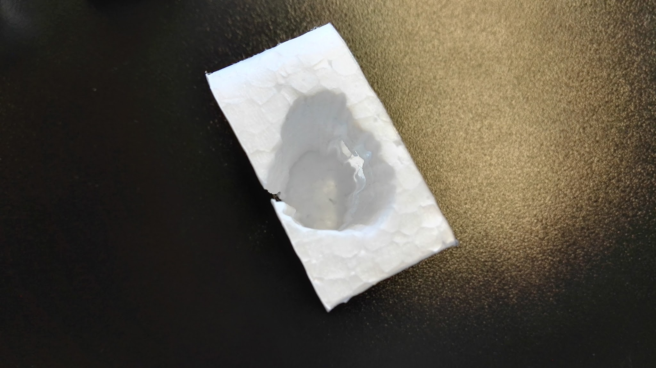
3. 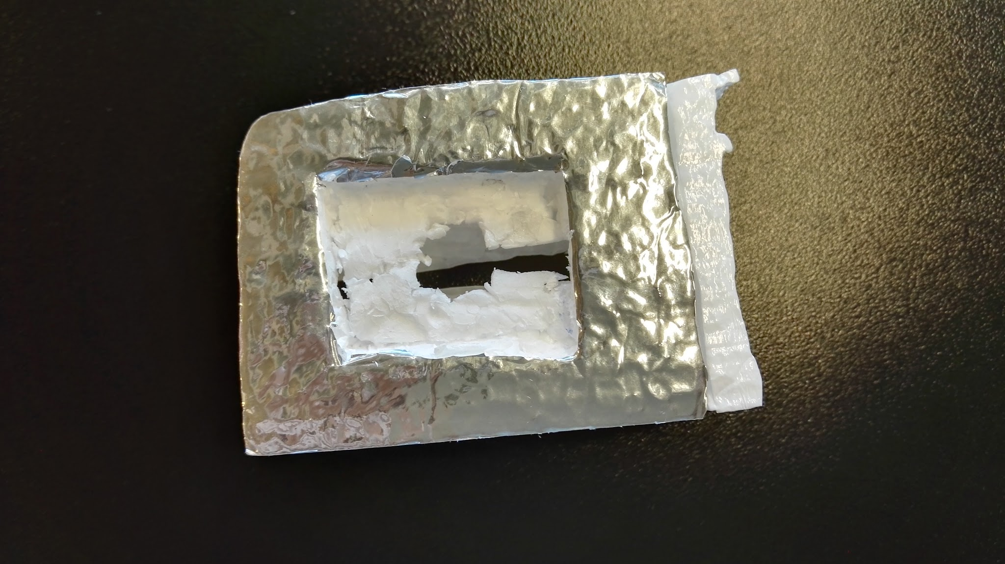
4. 