# The contents of this week

In week 1 we worked on low fidelity paper prototyping. The assignment was to create a low fidelity paper prototype for a two devices, a phone and a smart watch.

# Initial Design

For my initial design I used the windows music player and design patterns as prim inspiration. What this entails is that the interfaces are very minimalistic and clearly separate its content. It also entails is that I used the carousel menu for inspiration, with one clear difference in that it already clearly shows what you will be navigating to. Furthermore with the carousel the user can see where in the menu he is. The smart watch screen works on similar principles. However the menu carousel doesn’t contain a preview, as that would consume to much space.

# Examples

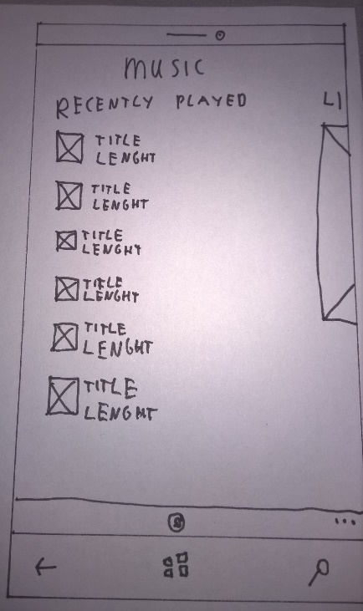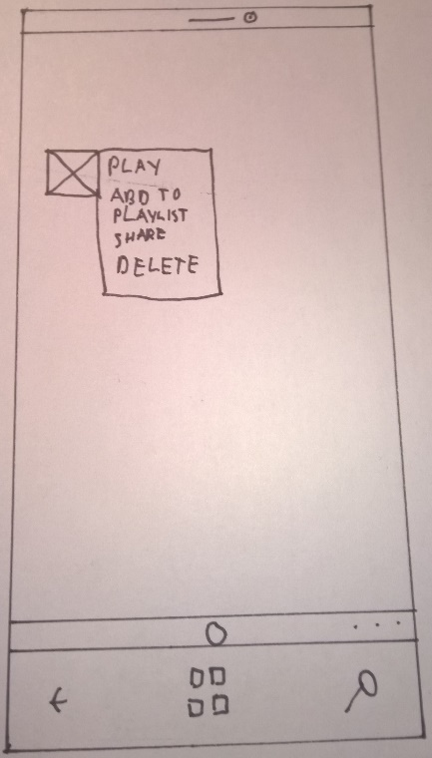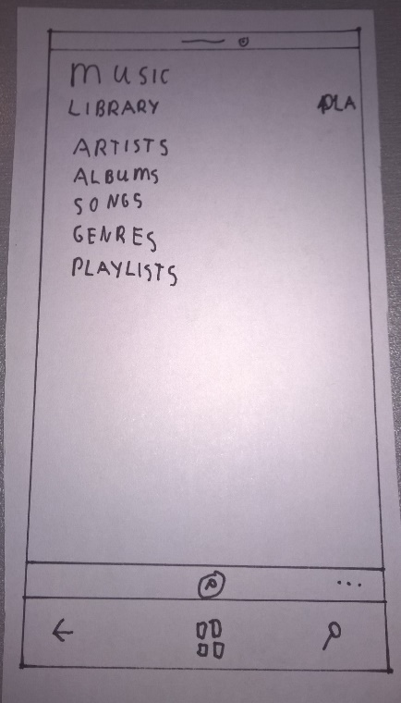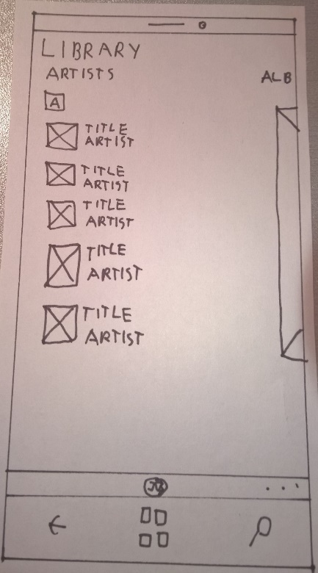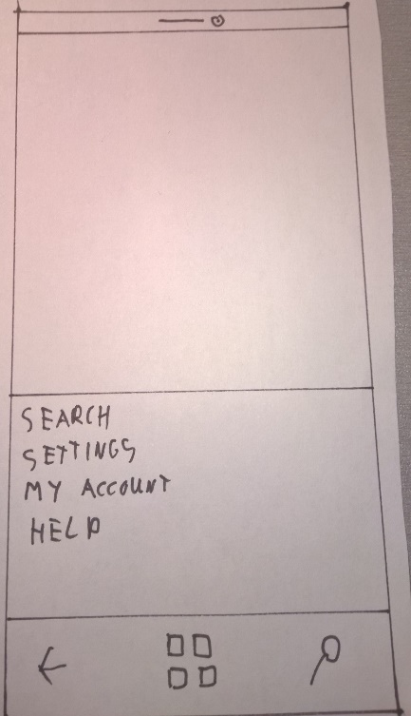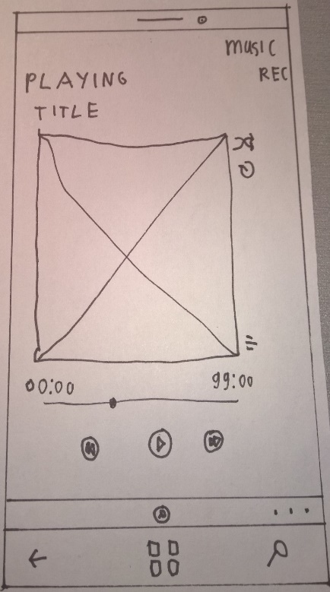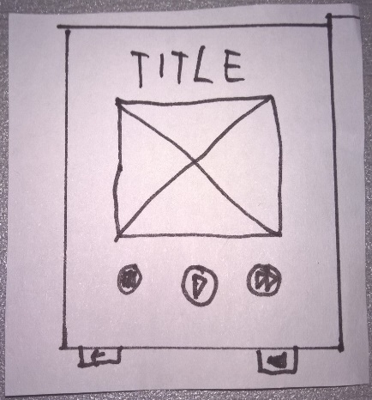 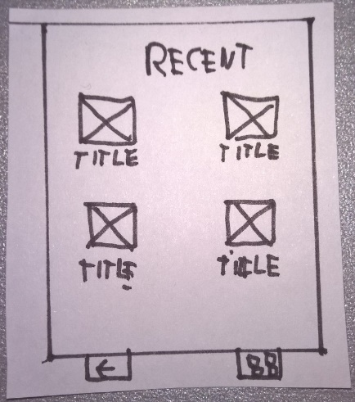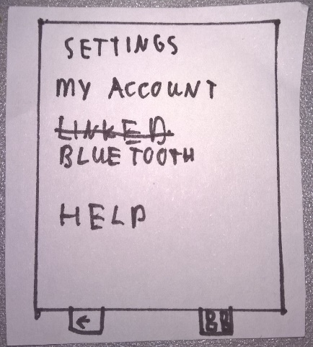

# Feedback

Most of the design was received fairly positively, as it being clear and all-encompassing. A few key elements of criticism were as follows. For non-windows phone users, the menu carousel made little to no sense and was difficult to navigate. Furthermore the smart watch application was lacking a library that the user could select his music from. I explained it as being connected to the phone, but this was countered with the question “Why would I even use the smart watch then?” To which I had no answers. This feedback resulted in 3 new screens, 1 for smartphone/smart watch and 2 for smart watch exclusively. The smartphone/smart watch screen contains a new menu the user can use for navigating the application, it contains module tabs, which still present the location in the app. The 2 smart watch screens allow the user to select a song or album from a playlist. This is achieved by having multiple layers, firstly the user selects what to search for and then selects from that selection.

# Examples

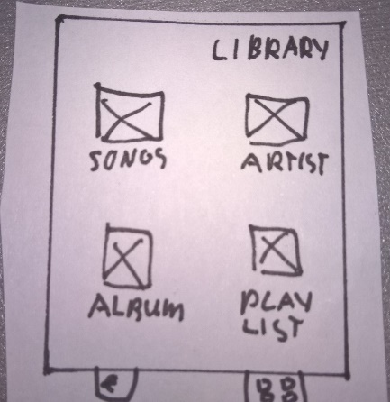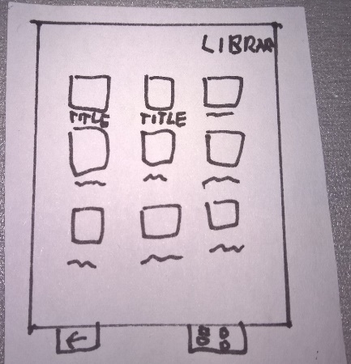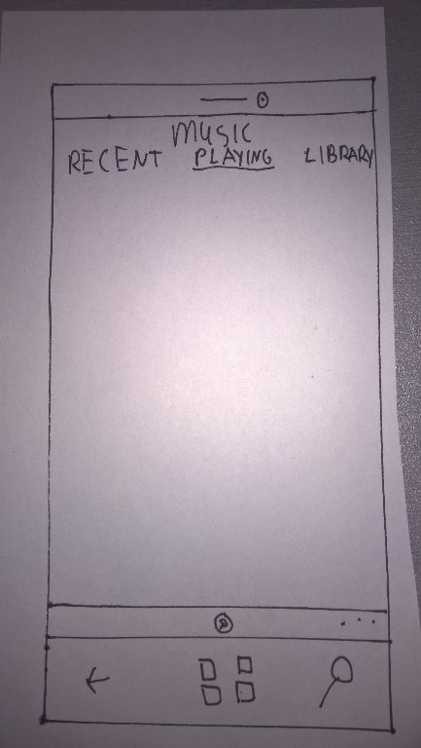Reflection

The insights I have gathered from this week are a multitude. Firstly, existing patterns, if unfamiliar, are not clear to the user, as such target group analysis is a must. Secondly, quick and dirty paper prototypes allow for quick iteration and are fairly forgiving. Therefore these paper prototypes can be used to test and verify early findings, or for brainstorming.