[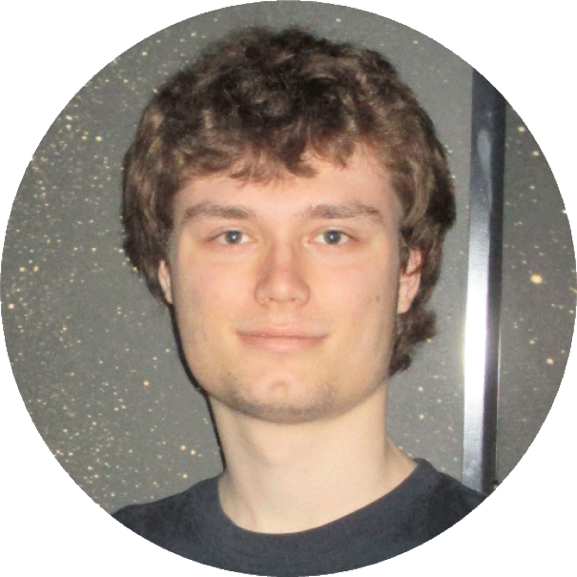](https://www.linkedin.com/in/riccardo-waardenburg/)

**Riccardo Waardenburg**

User Experience Designer

**Education­­**

**The Hague University of Applied Sciences**  
Internship Research Group Healthy Lifestyle 2017-2018  
in a Supporting Environment   
Propedeuse User Experience Design 2016-2017  
User Experience Design 2016-present

**TU Delft**  
Applied Computer Sciences 2015-2015

**Walburg College Zwijndrecht**  
VWO NG/NT 2009-2015  
Technasium 2009-2015  
International Baccalaureate (certified) 2013-2015  
Cambridge English: Advanced 2009-2013

**Courses**

**W3Cx via edX**  
HTML5.0x 2016  
HTML5.1x 2016  
HTML5.2x 2016

**Microsoft via edX**  
DEV211.1x 2016

**DelftX via edX**  
Calc001x 2015

**Self-study**AutoCAD 2015-2016  
Qgis 2017

**Working experience**  
**Research Group Healthy Lifestyle** 2018-2018  
**in a Supporting Environment**  
Independent contractor

**WionPlus BV**  
Website [www.wionplus.nl](http://www.wionplus.nl) 2016-present  
ICT support 2015-present  
AutoCAD infrastructural drawings 2016-present  
Qgis topographical 2017-present

**RicoFS**  
Website [www.ricofs.nl](http://www.ricofs.nl) 2015-present

**RicoUX**   
Independent contractor 2017-present

*“Young and enthusiastic, Is strive to learn as much as possible related to my field of work. ”*

**Personal**

**Name:**  
Riccardo Dennis Waardenburg

**Place of residence:**  
Hendrik-Ido-Ambacht

**Phone:**  
[+316 1967 2972](tel:+31619672972)

**E-mail:**  
[rico-ux@outlook.com](mailto:rico-ux@outlook.com)

**Date of birth:**  
13-10-1996

**Gender:**  
Male

**Nationality:**  
Dutch

**Languages:**Dutch – Native   
English – CAE/IB  
German – Intermediate

**Drivers licence:**  
B

Check for more @  
<http://ricofs.nl/ricoict/>

<https://www.linkedin.com/in/riccardo-waardenburg/>