**TT1pro 11/9/18** Patricia R. DeLucia, Adam Braly (Undergrad Assistant: Ruizheng Wang)

**IRB-FY2018-440. Studies in Visual Perception: Theories and Applications**

**Tactile TTC (TT1)**

**General Purpose, Rationale, and Approach**

The purpose of this tactile TTC research is to determine (a) whether people can use changes in the intensity of frequency of a tactile stimulus that is used to represent an approaching object to judge the object’s TTC. Although tactile stimuli do not have a natural association with distance because the stimulus is in contact with the skin, tactile stimuli that increase in frequency and intensity are used in mobility aids for the blind. Examples include the Mini-Guide and the Sunu wrist aid (lab has both), (b) whether the patterns observed in TTC judgments of visual and auditory objects also occur in TTC judgments of tactile objects. For example, as actual TTC increases does estimated TTC increase? Are the slopes the same across modalities? Is underestimation typical and does it increase as actual TTC increases? Is there an effect of “trajectory” and final magnitude (Size-arrival effect)? Is there an effect of task (PM task vs relative TTC judgments vs interceptive action)? Common response patterns would suggest that the mechanisms that underlie TTC judgments are independent of the sensory apparatus (i.e., are amodal) and represent a common process in the brain, (c) whether TTC judgments are better when tactile information is provided along with visual information (and/or auditory information) compared to tactile information alone, (d) the relative weights and influence of auditory, visual and tactile information in TTC judgments (both veridical and heuristic). Aims “b” and “c” replicate the AV1 study (DeLucia, Preddy, Oberfeld, 2016).

For this first experiment, TT1, we will attempt to partially replicate our AV1 study. We will use a PM task to measure TTC judgments and manipulate actual TTC and final distance. The tactor was held in the participant fingers because these have the lowest detection thresholds (Cholewiak, 1991), especially index and middle fingers (Duncan, 2007).

# 

# Hardware

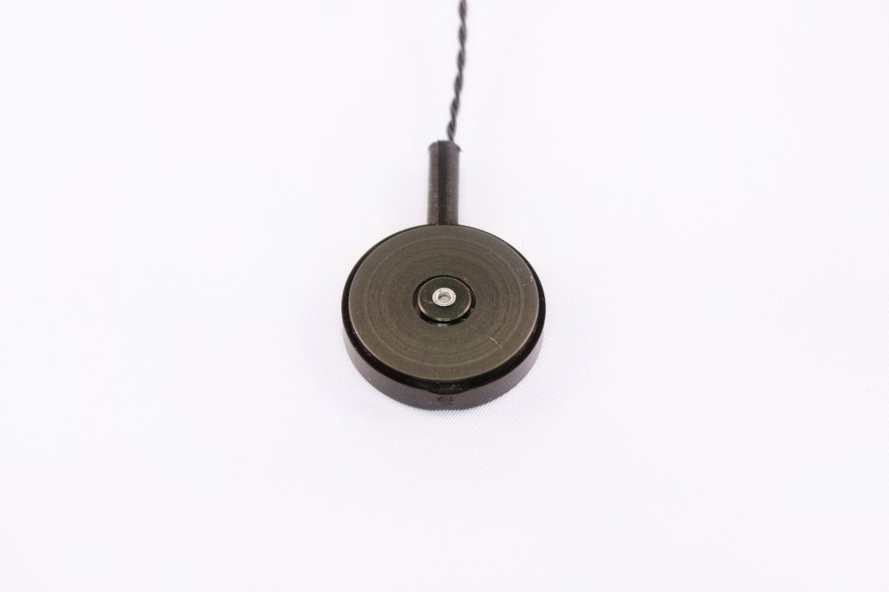This experiment was run in Sewall Hall PSYCH 150-F on a Dell OptiPlex 7050 (Rice tag# PD28-LAB4, Machine ID 7B7BEB0C-EBB7-4EFD-BA7E-99A8713DFD2F) with an Intel Core i7-7700 CPU @ 3.60GHz (8 CPUs), 16.0 GB of RAM, with an Intel(R) HD Graphics 630. Chesson assigned the machine name: PD28-LAB4. The Operating System was Windows 10 Enterprise 64-bit (10.0, Build 17134) (17134.rs4_release.180410-1804). The display card was an Intel(R) HD Graphics 630.

**Sound card.** The sound device was a sound card, Creative SB X-Fi with Hardware ID was PCI\VEN_1102&DEV_000B&SUBSYS_00411102&REV_04.

**Monitor Settings (for instructions):** Digital Display: Dell U2417H, Refresh Rate= 75 Hz, Resolution: 1280 x 1024, 32 bit color, Brightness 0, Contrast 50, Hue 0, Saturation 0.

**Lighting.** All lights were off except for the computer monitor.

C-2 Tactor

**Tactor.** The tactile stimulus was provided by a C-2 tactor built by Engineering Acoustics, Inc. This tactor is a small actuator that vibrates against the skin to provide a physical stimulus in response to an electrical input. The C-2 tactor is the “gold standard” for vibrotactile research. The C-2 is a linear actuator with a moving magnet design, and has a mechanical resonance in the 200-300 Hz range that coincides with the peak sensitivity of the body’s Pacinian corpuscle, the most sensitive of the skin’s mechanoreceptors.

**Headphone Amplifier.** The magnitude of the vibration was too low when the tactor was plugged directly into the output port of the sound card. To increase the magnitude of the vibration we used an amplifier, a Polsen HPA-4X2 4-Channel Stereo Reference Headphone Amplifier with 1x 1/4" TRS Stereo Input, Stereo RCA Inputs, 4x 1/4" Stereo Headphone Outputs and 4x Mini Plug Adapters.

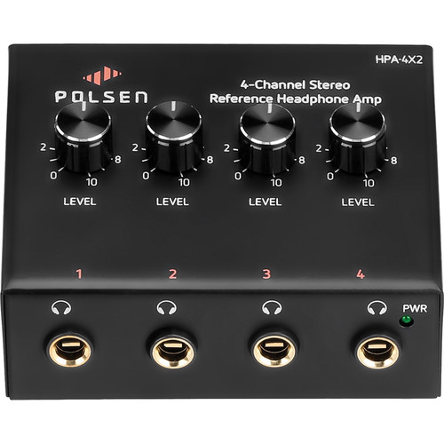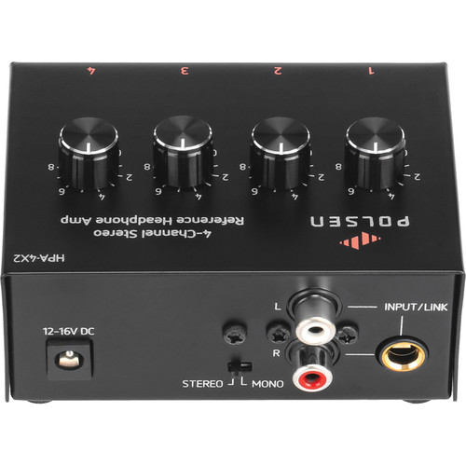

**The tactor and amplifier were connected to the computer as follows:**

* An iGreely 3.5mm 1/8- inch mono male plug (black) to RCA male jack (yellow) audio cable was used to connect the sound card to the amplifier. The end with the 3.5mm jack was plugged into the audio output port on the sound card. The end with the RCA jack was plugged into the RCA input port of the amplifier. NOTE: this did not work if we used the input line port on the amplifier. We used the left audio input port but the result should be the same if you connect it to the right input port.
* The 2.5 mm TRS jack of the C-2 tactor was plugged into a right-angle 2.55mm stereo to ¼” stereo adaptor. The adapter was then plugged into a headphone output port on the amplifier.
* Connect the amplifier to power as shown in green circle below.
* The amplification level was set to 10 by tuning the amplification level button.
* This resulted in a higher magnitude vibration of the tactor
* NOTE: it is expected that when a sound is played through the sound card, one can not only feel vibration through the tactor but can hear the sound slightly through the tactor
* NOTE: The settings on the sound card are critical. To set, go to control panel and then manage audio devices. Under Playback tab, select the Creative SB X-FI Speakers. The Speaker/Headphones used is Creative SB X-Fi with Hardware ID of PCI\VEN_1102&DEV_000B&SUBSYS_00411102&REV_04. Driver Version is 6.0.240.15. Recording device was not used in this experiment. In sound tab, sound scheme was set to be Windows Default (but probably not relevant). The sound volume should be at maximum value (100); this is set by clicking on speaker symbol in lower right corner of desktop.

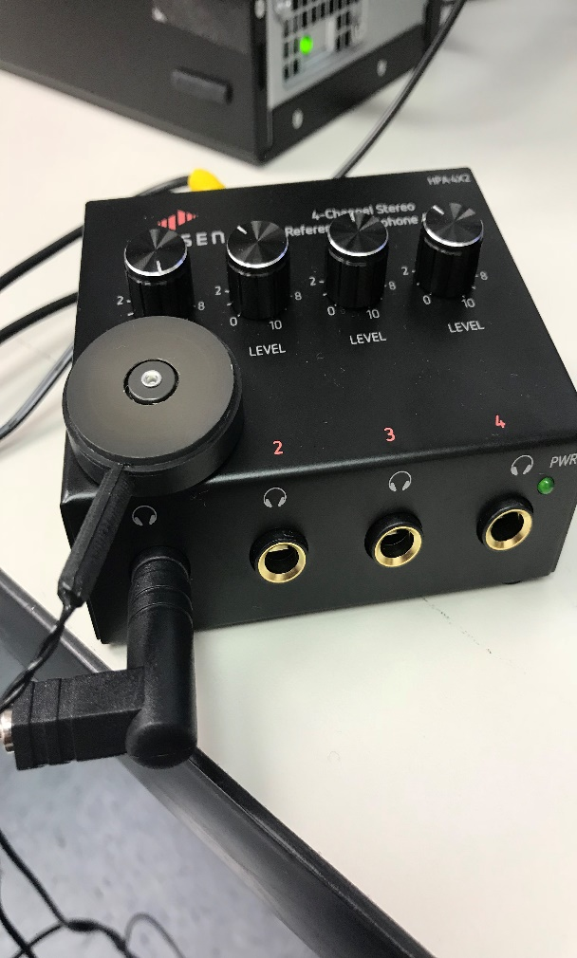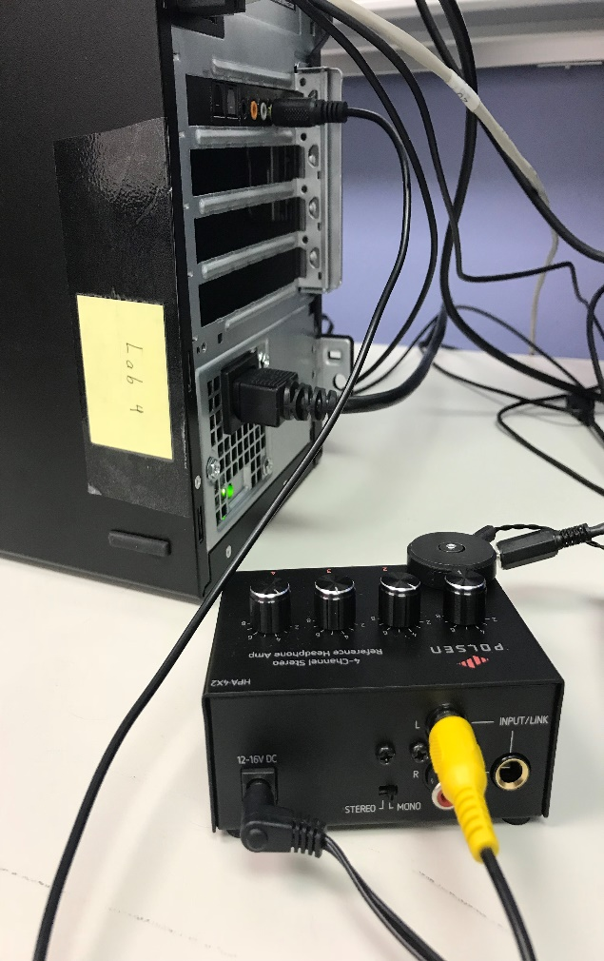

**Software and Files**

**Tactile stimuli can be created in several ways:**

**(1) Use the tactor development kit** (TDK) that came with the C-2 tactors. This comes with a predefined library of functions that allow direct control of the tactor parameters through the control box that is connected to the computer. To use this complete the following steps: a) Find Visual Studio on desktop; b) On the Visual Studio menu bar, choose File > Open > Folder, and then browse to the code location, which is \\STORAGE\R-HOME\rw28\DESKTOP\TactileTTC in this case; c) On the context (right-click) menu of the folder containing code, choose the Open in Visual Studio command; d) Choose the Open Folder link on the Visual Studio Start Page; e) Choose file TactorTest.sln; f) Click Start to run

**(2) Use Matlab to interface with the TDK** to input the parameters of the tactor as desired even if not possible through the libraries. In this case the tactor is connected to the control box which is connected to the computer. For example, Adam created a “looming” vibration stimulus with the code in file “LoomingCurve.m”. The code is shown in the appendix.

**(3) Use Daniel’s Matlab code** to generate a sound (.wav) file that has the desired parameters and then play this through the sound card and amplifier to which the tactor is connected. The code is contained in file TT1.m and copied in the appendix.

**(4) The method we used in TT1 is similar to step 3) except** that the sound files we used were from the AV1 experiment (DeLucia, Preddy, Oberfeld, 2016) and generated by some Matlab files and trimmed by Audacity. Detailed operation procedures will be discussed later in protocol.

**Matlab R2018a** and **Psychtoolbox version3** were used to present the stimuli. Matlab was installed by Rice IT (Chesson) and can be found at <https://www.mathworks.com/products/matlab.html>. Rice students should have free access to it. Psychtoolbox is the Psychophysics Toolbox which is a free set of Matlab and functions for vision research and can be used to control visual and auditory stimuli. It interfaces between Matlab and the computer hardware and is widely used in the vision science community. It was installed on the Dell computer after downloading it from <http://psychtoolbox.org>.

**Audacity 2.2.2** was used to edit the sound files as needed when sound files were used to create the tactile stimuli. Audacity is an open-source digital audio editor and recording application software. It was used for audio file trimming in this experiment. It was downloaded from <https://www.audacityteam.org/>.

**Matlab Files**

**TT1.m**

This is the main file to run the experiment.

**tt1*_*TTC1.m; tt1*_*TTC2.m; tt1*_*TTC3.m; tt1*_*TTC15.m; tt1*_*TTC25.m; tt1*_*TTCp5.m; tt1*_*TTC6.m**

These are the files that are used to generate padded sound files. (Paddings are used to avoid problems generated from clicks due to "lost" samples /Windows problem)

The main Matlab file that runs the experiment uses trimmed sound files as the input. It reads the sound files from a text file (analogous to an .ord file in winobj), named “tt1sound.txt”. Edit this file so that it lists the sound files in the order you want them played. You must include the .wav extension in the sound filename. Note that in the TT1.m, a 0.4s was subtracted from response time result due to screen flipping.

The tt1.m Matlab program also creates a data file in .txt format which stores the participants’ response times. There is one file per subject. The response time is the time between the end of the vibration that participant experiences and the participant’s button press. The file is saved in a folder named “data’ (\\storage\r-home\rw28\DESKTOP\Tony\TTC Experiment 2.0\data).

The data file has 4 columns. From left to right, the values shown are: *Subject Number*, *Trial Number*, *Sound File Name*, and *Response Time*. Subject number is entered when you run “TT1.m”. The number you enter becomes the name of the data file (e.g., 1.txt). **Be sure that the number you give did not exist before, otherwise it will replace the old data.**

**maxvib.m**

This is an extra file that is used to generate the maximum vibration in case we want to give participants a reference to what the maximum is.

**cosineSquaredRamps.m**

This is a function used in TT1.m and files that generate sound.

**Sound (.wav) Files**

These are the sound files generated by the six Matlab sound generation files above but then trimmed by Audacity. The number in the filenames such as t0.5, t1, represent the TTC in seconds. 3500, 8500 represent the corresponding distance. “Copy” occurs from editing Audacity. The sound files were automatically copied for editing.

tt1t0.5n_3500.wav

tt1t0.5f_8500.wav

tt1t1n_3250.wav

tt1t1f_8250.wav

tt1t1.5n_3000.wav

tt1t1.5f_8000.wav

tt1t2n_2750.wav

tt1t2f_7750.wav

tt1t2.5n_2500.wav

tt1t2.5f_7500.wav

tt1t3n_2250.wav

tt1t3f_7250.wav

tt1t6n_750.wav

tt1t6f_5750.wav

**maxvib.wav**

This is the maximum vibration sound file generated by the maxvib.m Matlab file and trimmed by Audacity. This file will be presented to subject at the beginning of experiment for comparison.

**lowvib.wav**

This is the minimum vibration sound file that will be used in this experiment. This file will be presented to subject at the beginning of experiment for comparison.

**halfvib.wav**

This is the medium vibration sound file that will be used in this experiment. This file will be presented to subject at the beginning of experiment for comparison.

**Image Files**

These are the images that we used within *TT1.m* to display to participants during instructions.

**arrow.png; cross.png; endpractice.png; highvib.png; instruction.png; intro.png; lowvib.png; midvib.png; ready.png; startpractice.png; startreal.png; thankyou.png**

**Text Files**

There are two methods to run tactors. One way is to input sound parameters and generate vibration from them.

The second way is to read sound files directly with Matlab and generate vibration from them. We will only be

using the second method in this experiment, that is to generate vibrations directly from sound files.

**tt1sound.txt**

This txt file contains names of sound files to be played in *TT1.m.*

**tt1soundpractice.txt**

This txt file contains name of sound files to be played in the practice part of *TT1.m.*

**order.txt**

This txt file contains the parameter input for method 3) discussed above. By parameters, we mean the stimulus properties such as TTC and velocity. This file will not be modified in this experiment.

**config.txt**

This txt file informs Matlab of which methods to run. Default was set to run with sound files in this experiment and it will not be modified in this experiment.

**Other Files**

There is a folder called “data”, and all the data from experiment are saved here. Saved data are named as “tt1dat_X.txt”. X is the participant number, and each participant will have his/her own data file in txt.

**How to generate sound files using *tt1_TTC1.m***

* Find Matlab on taskbar, or at "C:\Program Files\MATLAB\R2018a\bin\matlab.exe".
* Right click Matlab icon and select “Run as administrator”.
* In Matlab, navigate to “\\STORAGE\R-HOME\rw28\DESKTOP\Tony\TTC Experiment 2.0”
* Double click *tt1_TTC1.m* to open the file in the Matlab editor.
* Press F5 or click Run button on top of the script, and two WAV sound files will be generated. The name should be tt1t0.5_3250.wav and tt1t0.5_8250.wav.
* There are currently seven Matlab scripts, named as *tt1_TTC1.m, tt1_TTC2.m, tt1_TTC3.m, tt1_TTC15.m, tt1_TTC25.m, tt1_TTCp5.m, tt1_TTC6.m* Repeat the procedures above to generate a total of 14 sound files.
* There will be some zeros as paddings added to the beginning and end of the sounds (~1.2 second) to avoid problems generated from clicks due to "lost" samples and Windows problem, and we will trim them off from the generated sound files, which is what will be done in the next step.

**How to trim sound files using *Audacity***

* Trimming can be done through either Matlab or Audacity. We used Audacity.
* Find Audacity on taskbar, or at "C:\Program Files (x86)\Audacity\audacity.exe".
* Go to File -> Open -> tt1t0.5_3250.
* Then a sound wave should be displayed, which lasts 2.2 seconds. The first and last 0.6 seconds are to be 0s because we padded them when generating the sounds from Matlab.
* Select the first 0.6 second. Select edit on top of Audacity and click delete. Repeat for the last 0.6 seconds. The remaining 1 second is the trimmed sound file without paddings. See example figures below. In other words, the duration of the vibration is 1 s. This step takes out the 1.2 s padding that was present in the av1 files.
* Repeat procedure for the rest of the sound files. There are 12 sound files in total.
* All sound files for this experiment are trimmed already.

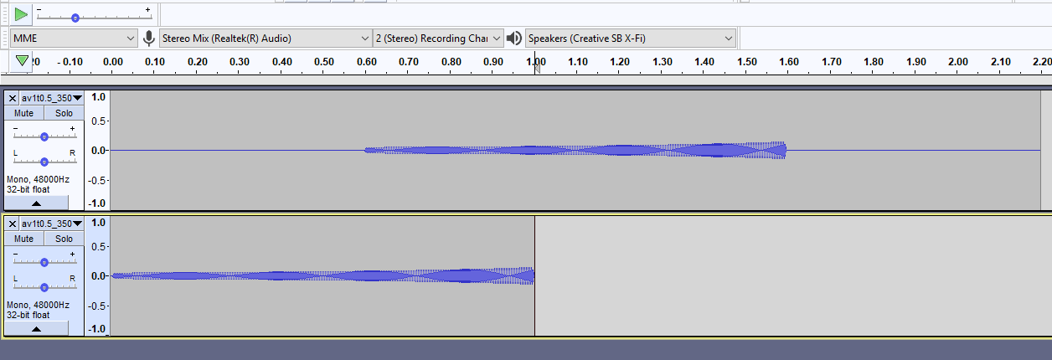

Sound File Trimming in Audacity

# Design for TT1

There are two variables in this experiment**.**

**Actual TTC when tactor stimulus ended (7, within):** 0.5s, 1s, 1.5s, 2s, 2.5s, 3s, 6s

**Final distance (2, within):** Near, Far

NOTE: The far distance has a higher velocity than the near distance, therefore there are 2*7 = 14 different speeds, which are 140 & 340, 130 & 330, 120 & 320, 110 & 310, 100 & 300, 90 & 290, and 30 & 230 ft/s for the 7 scenes listed above, respectively.

**Pre-experiment Maneuvers**

**Experimetrix (derived from approved IRB)**

**Criteria.** Participants must be 18 and have normal or corrected-to-normal vision, no color blindness or other visual deficiencies. Participants must have normal hearing and normal motor control.

**Time.** TT1 will take about 30 minutes.

**Materials needed**

1. This protocol, consent form (including blanks), run table, and survey (open word doc that has qualtrics survey links)

2. Pen

3. One C-2 tactor connected to sound card and amplifier

4. Goggles or glasses that occlude vision

5. Sound damping headphones

6. Sound damping box for tactor

**Before Subject Arrives**

1. Fill in Subj #, Date, etc on run table.

2. Turn on power supply then computer.

3. Log into computer with Rice ID

4. Check run table for condition

5. Go to **c:\users\public\publicdocuments\DeLuciaTactileTTC\TT1Final**

6. Set windows volume level in the lower right corner of desktop to **100** (MAX)

7. Run Matlab **as administrator** by right clicking Matlab on task bar.

8. Once in Matlab, navigate to **c:\users\public\publicdocuments\DeLuciaTactileTTC\TT1Final**

9. Double click *TT1.m* to open the file in the Matlab editor.

10. Press F5 to start the experiment.

11. Put "Experiment in progress" sign on outside of door.

**When Subject Arrives**

1. Greet participant and close door.

2. Tell them to “Please read and sign the consent form.” (Make sure they read before signing)

3. Ask subject questions (see instructions). On Run Table, record gender, acuity, etc. Note: If wearing contacts or glasses to get to 20/20, that is fine. If subject does not have 20/20 and is not wearing corrective lenses, ask if they can see the text on the screen clearly.

4. Ask participant to read instructions on screen as you read them aloud.

5. Stay in room with until start of practice instructions ensure task is understood and done correctly.

6. Pre-screening questions should be looked at again before running the participant. If any of the questions indicate that the participant does not have normal motor function, we cannot run that person.

7. Enter subject number, and then click OK to continue.

**NOTE:** If subject asks questions, do not improvise. Re-read that section of the instructions. Also, write down their question and how you answered it (verbatim). Finally, please do not deviate from the instructions or the procedure. Also, during experiment, use comments box on run sheet to record any oddities, problems with computer etc. Also, write down verbatim any questions the subject asks and exactly how you responded. Also, record any deviations from the protocol.

**After subject completes session: (see notes after instructions)**

**Instructions**

(based on AV1: DeLucia, Preddy, & Oberfeld, 2016; and Lobo, Travieso, Jacobs, Rodger, & Craig, 2018)

**NOTE: To abort experiment, press Esc**

Welcome! The aim of this experiment is to study the perception of moving objects. We will use a tactile device that simulates the motion of an object that moves directly toward you. [**Show device**]. This is the tactile device. It is called a tactor. Please hold the tactor with your left hand using your index and middle finger placed on either side of the center hole, and your thumb on the hole of the opposite side. Then place your hand in this box which will remain in front of you. [**Show** **sound damping box**]. The tactor vibrates like this [**give example at middle intensity**]. The magnitude or intensity at which it vibrates can be low like this [**give example of lowest intensity of all stimuli**] … or higher like this [**give example of highest intensity of all stimuli**].

In this experiment, the intensity of the vibration represents the distance of a simulated object that is approaching you. You will not see or hear the object. The only information you will have about its distance is how strong it vibrates. This is similar to some mobility aids that are used by people who have lost their vision.

The less intense the vibration the farther the object is; the more intense the vibration, the closer the target is. Thus, as the object approaches you, the intensity of the vibration will increase. Then at some point it will stop.

~~Your task is to press the “0” key on number pad with your right index finger when you think that the object would hit you, had the simulation of the object’s motion continued in the same manner as it was when you could feel it.~~

~~If you think that the object would not actually hit you but rather would pass to the side of you, press the key at the time it would pass you. Assume that the object continues to move in the same manner after you no longer feel the vibration.~~

There will be a variety of approaching scenes. For example, the initial distance between you and the object may be small or large. Also, the object may approach you at different speeds.

In all cases, your task is to press the “0" key at the **exact** time that you think that the object would hit you or pass you had the motion continued **after the vibration stopped**. Remember that the object’s motion continues in the same manner after the vibration stops. **Please do not press the key before the vibration stops.** ~~Do you have any questions?~~

If you think that the object would not actually hit you but rather would pass to the side of you, press the key at the time it would pass you. Assume that the object continues to move in the same manner after you no longer feel the vibration. Do you have any questions?

To help you focus solely on the vibration, we will ask you to close your eyes and wear these goggles which will occlude your vision. In addition, we will ask you to wear these headphones.

We will start with 14 practice trials. To summarize, the tactile device will simulate the motion of an object that moves directly toward you. As the object gets closer the intensity of the vibration will increase. Then the vibration will stop. Press the #0 key at the **exact** time that you think that the object would hit you or pass you had the motion continued **after the vibration stopped.** After you press the #0 key, press the “→” next to it to advance to the next trial.

[**CHECK tactor position, blindfold, and headphones]**

I am going to turn off the lights. Are you ready?

[**After practice**] That is the end of practice. Do you have any questions?

There will be another block of about 140 trials. If you need to rest or pause before any trials, just don’t press the key. Are you ready?

[After all trials] Good job! You have completed the trials. Thank you. We have a survey for you to complete before we finish.

**AFTER SUBJECT COMPLETES SESSION**

1. Administer questionnaire at qualtrics link (subject can complete themselves after you input subject number).

<https://riceuniversity.co1.qualtrics.com/jfe/form/SV_cIPzAdwquNMYrUV>

**IMPORTANT: Before the subject leaves, look over each written questionnaire and ask further questions if needed for clarification. Record all comments and any questions you ask or elaborations you provide.**

2. **Debrief:** “The purpose of this study is to understand how people perceive three-dimensional space and how that affects their actions, such as driving a car or catching a ball. We wanted to see whether people could use vibrations to make judgments about collision. This type of stimulation is used in some travel aids to help blind people move through their environment without hitting obstacles. This research has importance for theories of perception and for applications in assisting the blind and improving driving and accident prevention. Do you have any questions?”

3. GIVE PARTICPANT THEIR CELL PHONE AND A BLANK COPY OF CONSENT FORM.

4. Back up data on BOX and USB, and send to Dr. DeLucia

5. Store paper data in folder. Make photocopy back up of each questionnaire after running subjects for the day.

**RUNNING TABLE**

|  |  |  |  |  |  |
| --- | --- | --- | --- | --- | --- |
| **From Randomizer:**  **Run Ss in this order** | **SUBJECT #** | **GENDER**  F= 0  M=1 | **Acuity** | **Normal vision, hearing, motor control? Y-N** | **COMMENTS**  **And Notes** |
| 12 | 1 | 0 |  |  |  |
| 20 | 2 | 1 |  |  |  |
| 2 | 3 | 0 |  |  |  |
| 14 | 4 | 1 |  |  |  |
| 15 | 5 | 0 |  |  |  |
| 10 | 6 | 1 |  |  |  |
| 13 | 7 | 0 |  |  |  |
| 18 | 8 | 1 |  |  |  |
| 8 | 9 | 0 |  |  |  |
| 9 | 10 | 1 |  |  |  |
| 1 | 11 | 0 |  |  |  |
| 5 | 12 | 1 |  |  |  |
| 17 | 13 | 0 |  |  |  |
| 11 | 14 | 1 |  |  |  |
| 7 | 15 | 0 |  |  |  |
| 6 | 16 | 1 |  |  |  |
| 16 | 17 | 0 |  |  |  |
| 3 | 18 | 1 |  |  |  |
| 4 | 19 | 0 |  |  |  |
| 19 | 20 | 1 |  |  |  |

Research Randomizer from Social Psychology Network: <https://www.randomizer.org/>

**Put in qualtrics and run from a hyperlink**

**TT1.** Subj #____ Date_____ Normal Motor______ M or F Age:___

Enter Subject Number _____

1. Did the tactile simulation of the objects give you the experience that the object moved in depth toward you (was the tactile simulation realistic)? NO YES

2. Are there any specific characteristics of the tactile stimulus (vibration) to which you most attended or on which you based your judgments? NO YES (please list)

3. Did you base your judgments on what you felt on your skin as opposed to strategies, assumptions, knowledge or other methods? NO YES

If no, on what were your judgments based?

4. Overall, how confident are you that your responses were accurate?

No Extremely

Confidence_____________________ _Confident

1 2 3 4 5

5. Did the object ever seem like it was coming from any directions that were not directly in front of you

(e.g., approaching from the side) NO YES (if so, on how many trials?)

6. Did you experience any discomfort during the study (e.g., headache, dizziness, nausea, etc.)? NO YES (If "YES" please describe symptoms on the back of this page)

7. Please note other comments here:

**Consent Form for Participation in Research**

**Study Title:** Studies in Visual Perception: Theories and Applications

**Rice IRB Number**:IRB-FY2018-440

**Principal Investigator:** Professor Patricia R. DeLucia, Department of Psychological Sciences, Rice University, 6100 Main St., 464 Sewall Hall, Houston, TX.,77005. Phone: 713-348-3844. Email: pat.delucia@rice.edu.

**\*\*\*\*\*\*\*\*\*\*\*\*\*\*\*\*\*\*\*\*\*\*\*\*\*\*\*\*\*\*\*\*\*\*\*\*\*\*\*\*\*\*\*\*\*\*\*\*\*\*\*\*\*\*\*\*\*\*\*\*\*\*\*\*\*\*\*\*\*\*\*\*\*\*\*\*\*\*\*\*\*\*\*\*\*\*\*\*\*\*\*\*\***

**You may be eligible to take part in a research study. This form gives you important information about the study. It describes the purpose of the research, the risks and possible benefits of participating in the study.**

**Purpose of this Study:** The purpose of this study is to better understand how people perceive the environment. What we learn may help people, and we hope to publish the results of this study.

**Procedures/What will happen to me in this study?** In this study, you will be asked to complete tasks using a driving simulator or computer-generated displays that presents visual, auditory, and/or tactile (vibration) displays. You also will be asked to complete surveys. Some questions will be about you. Some questions will be about your behavior while performing the task.

You will be asked to make judgments about three-dimensional objects, scenes, or people, or about computer simulations (e.g., driving simulation, HTC Vive VR system), images from camera, video, fiberoptic or endoscopic devices, vibrations applied to your skin, or about stimuli printed on paper. Some images may be medical and thereby graphic in nature. You also will be asked to perform perceptual-motor tasks such as manual-aiming, manual manipulation, tapping, driving, walking, marching, talking, or humming. You also will be asked to complete surveys. Some questions will be about you. Some questions will be about your behavior while performing the task. Some may be considered sensitive in nature.

Your judgments will be recorded verbally or in writing, or by button, joystick or other peripheral devices, or by videotape, or voice. In the event that you are videotaped or your voice recorded while you perform the task, your data will be reported anonymously. You will be given rest periods when needed.

If moving computer-generated displays or head-mounted displays or VR systems are used, there is a possibility of motion sickness. You are not permitted to participate in the study if you have a seizure disorder that is activated by viewing moving or stroboscopic displays or if you respond with any illness when viewing moving or stroboscopic displays or motion simulations. By signing this consent form, you are indicating that you do not have such health characteristics and are willing to participate.

This study will take place in Sewall Hall at Rice University. The expected duration of participation in this study is 1 hour and 30 minutes.

**Participant Requirements:** To be included in this study, you must be over 18 years old and have normal or corrected-to-normal vision, and no color blindness or other visual deficiencies. You must have normal hearing and normal motor control, and in some experimental conditions must be a licensed driver.

**Risks:** The risks and discomfort associated with participation in this study are no greater than those ordinarily encountered in daily life or during activities such as driving, playing video games, watching television or attending a movie in a theatre. Minimal risk and discomforts may include boredom and fatigue. With the use of large or immersive displays, there is a possibility of motion sickness. If this occurs, you should remain seated and tell the experimenter so that the display can be stopped.

**Benefits:** There may be no personal benefit from your participation in the study but the knowledge received may be of value to humanity. By participating in this study, you should learn something about research.

**Compensation & Costs:** You will not be compensated monetarily for your participation. There will be no cost to you if you participate in this study

**Ending the Your Participation:** Your participation in this study is entirely voluntary. You are free to refuse to be in the study and your refusal will not influence current or future relationships with Rice University and participating sites.

**Confidentiality:** By participating in the study, you understand and agree that Rice University may be required to disclose your consent form, data and other personally identifiable information as required by law, regulation, subpoena or court order. Otherwise, your confidentiality will be maintained in the following manner:

Your data and consent form will be kept separate. Your consent form will be stored in a locked location on Rice University property and will not be disclosed to third parties. By participating, you understand and agree that the data and information gathered during this study may be used by Rice University and published and/or disclosed by Rice University to others outside of Rice University. However, your name, address, contact information and other direct personal identifiers in your consent form will not be mentioned by Rice University in any such publication or dissemination of the research data and/or results.

The researchers will take the following steps to protect participants’ identities during this study: (1) Each participant will be assigned a number; (2) The researchers will record any data collected during the study by number, not by name; (3) Any original recordings or data files will be stored in a secured location accessed only by authorized researchers.

**Rights:** Your participation is voluntary. You are free to stop your participation at any point. Refusal to participate or withdrawal of your consent or discontinued participation in the study will not result in any penalty or loss of benefits or rights to which you might otherwise be entitled. The Principal Investigator may at his/her discretion remove you from the study for any of a number of reasons. In such an event, you will not suffer any penalty or loss of benefits or rights which you might otherwise be entitled.

**Right to Ask Questions & Contact Information:** If you have any questions about this study, you should feel free to ask them now. If you have questions later regarding the study or a research-related injury, or if you have complaints, concerns, suggestions about the research, desire additional information, or wish to withdraw your participation please contact the Principal Investigator by mail, phone or e-mail in accordance with the contact information listed on the first page of this consent.

For questions about your rights as a research participant, or to discuss problems, concerns or suggestions related to the research, or to obtain information or offer input about the research, you should contact Stephanie Thomas, Compliance Administrator, at Rice University. Email: irb@rice.edu or Telephone: 713-348-3586. Please reference Rice IRB Number**:** IRB-FY2018-440**.**

**If you experience emotional distress from participation in the research, please contact**:

The Barbara and David Gibbs Wellness Center, 1st floor  
Office Hours: 9 AM - 5 PM, Monday through Friday  
Telephone: (713) 348-3311 (24 hours phone line)  
Fax: (713) 348-5953

By signing below, you agree that the above information has been explained to you and all your current questions have been answered. You understand that you may ask questions about any aspect of this research study during the course of the study and in the future. By signing this form, you agree to participate in this research study.

PARTICIPANT SIGNATURE DATE

I certify that I have explained the nature and purpose of this research study to the above individual and I have discussed the potential benefits and possible risks of participation in the study. Any questions the individual has about this study have been answered and any future questions will be answered as they arise.

SIGNATURE OF PERSON OBTAINING CONSENT DATE

**Looming Curve.m (Adam’s TDK code creating an increasing intensity of vibration based on Shaw paper but using r instead of r*r in the denominator as per Oberfeld.**

prompt1 = 'enter the value of time ';

T = input(prompt1);

prompt2 = 'enter the value of distance ';

r = input(prompt2);

v = r./T;

t = 0:0.001:T;

tmax = t(end);

I0 = (r-v*(t-0.001)).^(-1);

I1 = (r - v*(tmax-0.001)).^(-1);

STDI = I0./I1 .* 25500;

k =STDI/I0

plot (t,STDI)

xlabel('Time Elapsed(s)');

ylabel('Intensity(a.u.)');

set(gcf,'color','white');

legend(['speed = ' num2str(v),'m/s',' distance = ' num2str(r),'m']);

set(gca,'fontsize',14)

title('Intensity as Function of Time for Rectilinear Approach')

ylim([0 255]);

%xlim([0 T])

**Emails from Daniel (see others in DeLucia’s desktop tactile folder)**

Sounds good!

Sure, you could use the av1 design (or the improved design from the experiment we ran at Toronto).

You only need to change the tone frequency – I believe that was 1 kHz in the av1 study, for the tactile stimulation 250 Hz is best.

If I were you, I’d do both the sound creation and the presentation/response collection in Matlab, preferably using Psychtoolbox, which gives you nice timing accuracy. Adam, you used this type of setup for the TTCAV_emo study, if I remember correctly?

Best

Daniel

Hi Daniel

We are making progress on the tactor study

I thought we would use stimuli comparable to those from av1 in terms of TTC, vel, final dist

Does it make sense to play those av1 sound files fed into the ampflier and then out through the tactors?  Would that give the same looming pattern as the av1 study?

Or need we still use the script you sent and set up the ttc, vel, dis in that?

Thanks

Pat

**Example Script from Daniel: ttc_tactile_example.m**

fs=44100; %sampling frequency

nBits=16; %audio resolution

freqSignal=250; %frequency of the vibration in Hz

%motion parameters

v=30/3.6; %velocity in m/s

TTC=0.5; %ttc in s

travelDuration=2; %duration of the simulated motion in seconds

Dfinal=TTC*v; %the motion stops here

D0=Dfinal+travelDuration*v; %distance at trial start

%sound level parameters

Dcalib=1; %calibration distance in m

% %ALTERNATIVE: fix digital amplitude at final sample

% Dcalib=Dfinal; %calibration distance in m

calibdBFS=-6; %digital level at the calibration distance

%create sine wave

nsignal=(0:round(travelDuration*fs))'; %vector of increasing numbers. Each number represents one sample. Time steps: 1/fs

signal=sin(2*pi*freqSignal/fs*nsignal); %this creates a pure tone

%simulate "looming" approach motion at constant speed on the midsaggital plane (monaural signal, no interaural differences, only intensity change)

distanceSamples=D0-v.*nsignal./fs; %at each instant t, the distance from the observer is D0-v*t. The distance is computed for each sample

signal=signal.*Dcalib./distanceSamples; %For each sample, the amplitude is divided by the distance (inverse law for sound pressure). At Dcalib, the digital level is unaltered (multiplied by 1)

%set the digital level so that calibdBFS is produced at Dcalib

signal=signal*(10^((calibdBFS)/20));

% apply cos-squared ramps

rampMs=20; %ramp duration in ms

cos2Ramp=cosineSquaredRamps(nsignal/fs*1000,rampMs,length(nsignal)/fs*1000-2*rampMs);

signal=cos2Ramp.*signal;

sound(signal,fs,nBits) %this should play the sound

plot(signal)

xlabel('sample')

ylabel('amplitude')

audiowrite('trial.wav',signal,fs,'BitsPerSample',nBits);

**Script from Daniel: cosineSquareRamps.m**

%----------------------------------------------

function out=cosineSquaredRamps(t_ms,ramp_ms,steadystate_ms)

%returns multiplicator for envelope

%relational operators perfom 'listwise': [1 2 3 4] < 3 = [1 1 1 0]. -> no if statements possible!

out= ( ...

(t_ms<0)*0 + ... %t<0

((t_ms>=0).*(t_ms<ramp_ms)) .* (sin(t_ms.*pi/2/ramp_ms).^ 2)+ ... %inramp

((t_ms>=ramp_ms).*(t_ms<(ramp_ms+steadystate_ms)))*1 + ... %steady state

((t_ms>=(ramp_ms+steadystate_ms)).*(t_ms < (ramp_ms+steadystate_ms+ramp_ms))).*(cos((t_ms-(ramp_ms+steadystate_ms)).*pi/2/ramp_ms).^ 2) ... %outramp

);

**tt1_ttc1.m (script for av1 scene ttc=1 s)**

Dcalib=500; %distance at which the sound has finalLevel.

signal=sin(2*pi*tonefreq/fs*nsignal)*(Dcalib*10^((finalLevel)/20)); %this creates a pure tone with the level (finalLevel) that was selected for the Dfinal= 500 - trajectories differ in final level

% apply cos-squared ramps

cos2Ramp=cosineSquaredRamps(nsignal/fs*1000,rampMs,length(nsignal)/fs*1000-2*rampMs);

signal=cos2Ramp.*signal;

%simulate approach motion at constant speed on the midsaggital plane (monaural signal, no interaural differences)

distanceSamples=D0-v.*nsignal./fs; %at each instant t, the distance is D0-v*t. The distance is computed for each sample

%plot(distanceSamples);

signal=signal./distanceSamples; %For each sample, the amplitude is divided by the distance (inverse law for sound pressure)

%zero-padding with 600 ms at beginning/end to avoid clicks due to "lost" samples /Windows problem)

signal=[zeros(round((600/1000)*fs),size(signal,2));signal;zeros(round((600/1000)*fs),size(signal,2))];

%sound(signal,fs,nBits) %this should play the sound

filename=['tt1t',num2str(TTC), '_', num2str(v),'.wav']; %filename: "tt1tTTC"

wavwrite(signal,fs,nBits,filename); %save the sound in wav format

%write parameter values to the structrure parameterList;

counter=counter+1;

parameterList.v(counter)=v;

parameterList.TTC(counter)=TTC;

parameterList.D0(counter)=D0;

parameterList.tVis(counter)=tVis;

parameterList.travelDuration(counter)=travelDuration;

parameterList.Dfinal(counter)=Dfinal;

parameterList.finalLevel(counter)=20*log10(Dcalib*10^((finalLevel)/20)/Dfinal);

parameterList.levelChange(counter)=20*log10(D0/Dfinal);

end %for TTC

end %for v

save('parameterList.mat', 'parameterList')

**Example of saved output data file**

TRIAL SOUND RT

1 tt1t0.5_3500.wav 4.039788

2 tt1t0.5_8500.wav 2.670826

3 tt1t1_3250.wav 4.389648

4 tt1t1_8250.wav 4.527336

5 tt1t1.5_3000.wav 3.123766

6 tt1t1.5_8000.wav 2.069440

7 tt1t2_2750.wav 2.635677

**Random Order of stimuli using social website randomizer:**

Number in first column is assigned for randomeorder generation

Old filename new file name

1. av1t0.5_3500 - Copy.wav tt1tp5n_3500.wav
2. av1t0.5_8500 - Copy.wav tt1tp5f_8500.wav
3. av1t1_3250 - Copy.wav tt1t1n_3250.wav
4. av1t1_8250 - Copy.wav tt1t1f_8250.wav
5. av1t1.5_3000 - Copy.wav tt1t15n_3000.wav
6. av1t1.5_8000 - Copy.wav tt1t15f_8000.wav
7. av1t2_2750 - Copy.wav tt1t2n_2500.wav
8. av1t2_7750 - Copy.wav tt1t2f_7750.wav
9. av1t2.5_2500 - Copy.wav tt1t25n_2500.wav
10. av1t2.5_7500 - Copy.wav tt1t25f_7500.wav
11. av1t3_2250 - Copy.wav tt1t3n_2250.wav
12. av1t3_7250 - Copy.wav tt1t3f_7250.wav
13. av1t6_XXXX - Copy.wav tt1t6n_xxxx.wav
14. av1t6_XXXX - Copy.wav tt1t6f_xxxx.wav

**Practice Order (14 trials):** 6, 7, 13, 14, 11, 5, 1, 3, 8, 4, 12, 2, 10, 9

**Main experiment order (140 trials):**

9, 1, 3, 14, 13, 7, 11, 5, 10, 4, 12, 8, 6, 2

2, 4, 12, 1, 6, 14, 3, 9, 13, 5, 10, 8, 11, 7

8, 10, 2, 5, 9, 11, 13, 7, 6, 1, 4, 12, 14, 3

6, 8, 11, 10, 5, 9, 7, 3, 1, 2, 12, 14, 4, 13

1, 9, 14, 8, 12, 4, 13, 10, 5, 11, 6, 7, 3, 2

2, 1, 4, 10, 3, 8, 6, 7, 14, 5, 12, 13, 9, 11

9, 6, 2, 12, 7, 11, 1, 13, 14, 10, 5, 8, 4, 3

4, 3, 14, 8, 11, 13, 1, 6, 12, 10, 9, 2, 7, 5

8, 6, 1, 5, 9, 10, 14, 3, 4, 2, 12, 7, 13, 11

11, 4, 6, 2, 12, 13, 8, 7, 10, 14, 5, 9, 3, 1

**Reference Articles**

DeLucia, P R. “Audiovisual Integration of Time-to-Contact Information for Approaching Objects.” Brill, 20 Oct. 2015

Shaw, B K. “An Acoustic Variable Specifying Time-to-Contact.” Ecological Psychology, 1991, Cancar, L. “Tactile-Sight: A Sensory Substitution Device Based on Distance-Related Vibrotactile Flow.” International Journal of Advanced Robotic Systems, Feb. 2013.

F, Meng. “Tactile warning signals for in-vehicle systems.” Accident Analysis and Prevention, 2014

A, Brock. “Using wrist vibrations to guide hand movement and whole-body navigation.”

S, Maidenbaum. “Sensory substitution: Closing the gap between basic research and widespread practical visual rehabilitation” Neuroscience and Biobehavioral Reviews, Nov. 2013

Lawson, B.D. “Conveying Looming with a Localized Tactile Cue” USAARL Report No. 2015-10

Duncan, R. O., & Boynton, G. M. (2007). Tactile hyperactuity thresholds correlate with finger maps in primary somatosensory cortex (S1). Cerebral Cortex, 17, 2878-2891

Cholewiak, R., & Collins, A. A. (1991). Sensory and physiological bases of touch. In M. A. Heller and W. R. Schiff (Eds). The psychology of touch. (pp 23-60). Hillsdale, NJ: Lawrence Erlbaum Associates.