Adriann Liceralde

Dr. Brian McPherson

EGI at the University of Utah

CSI Arduino Collection Project

Last Updated January 26, 2022

**Information for the CU-1106 series of CO2 Sensors**

**Introduction**

* The CU-1106 is a series of NDIR-based CO2 sensors

**Important Notes**

**Specifications**

|  |  |  |  |  |
| --- | --- | --- | --- | --- |
|  | **CU-1106-C** | **CU-1106H-NS** | **CU-1106SL-N** | **CU-1106SL-NS** |
| **Range** |  |  |  |  |
| **Accuracy** |  |  |  |  |
| **Repeatability** |  |  |  |  |
| **Frequency** |  |  |  |  |
| **Current** |  |  |  |  |
| **Voltage** |  |  |  |  |
| **Response Time** |  |  |  |  |
| **Lifespan** |  |  |  |  |

**Links**

**Wiring**

* This guide will cover how to wire and operate the CU-1106 sensors:
  + CU-1106 via I2C
  + CU-1106 via UART
  + CU-1106H-NS via UART
  + CU-1106SL-N via UART
  + CU-1106SL-NS via UART

**CU-1106-C via I2C**

**CU-1106-C via UART**

**CU-1106H-NS via UART**

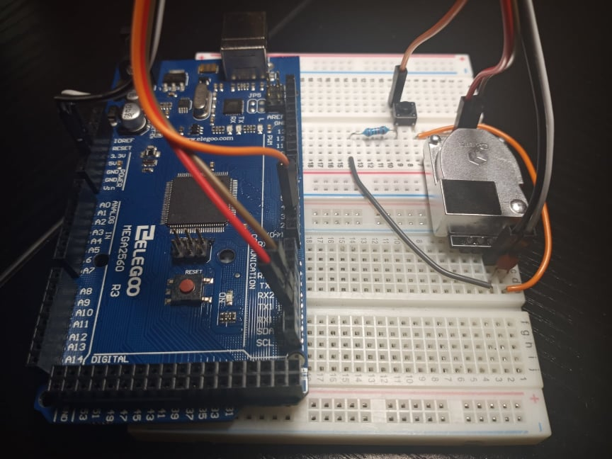

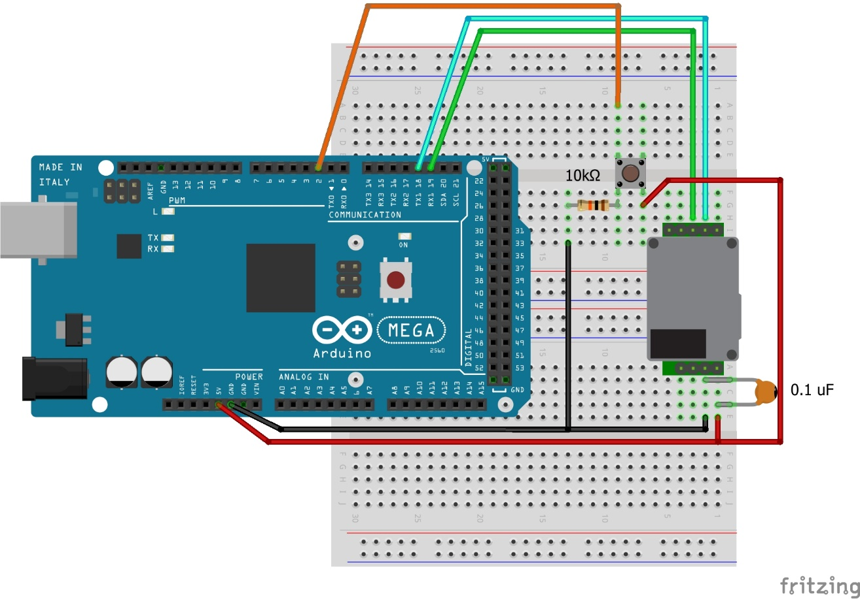

**CU-1106SL-N via UART**

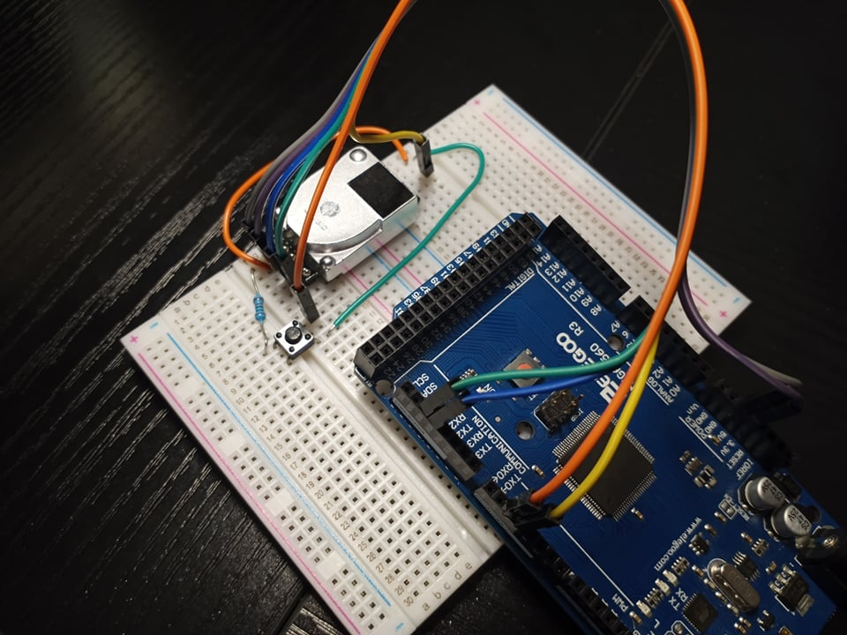

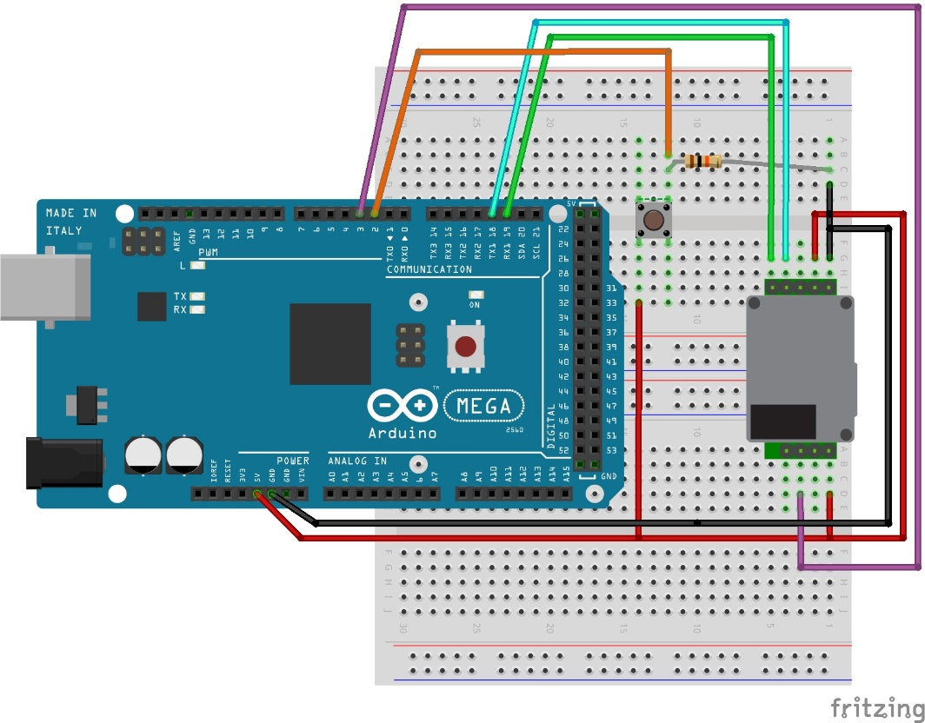

**CU-1106SL-NS via UART**

