Adriann Liceralde

Dr. Brian McPherson

Carbon Science Research at the University of Utah

CSI Arduino Collection Project

Last Updated January 26, 2022

**Information for the DS3231 Real-Time Clock Module**

**Introduction**

* The DS3231 is an electronic device that keeps track of time.
* Any microcontroller can control this sensor. However, this guide and the associative codes use an Arduino Uno to operate the device.
* Communicating with the device is performed via the I2C method.
* The breakout board has space for a CR2032 battery.
* The module is extremely accurate. It can take weeks until the module is one second off from the true time.

**Important Notes**

* The module can operate without the battery, if it is connected to an external power source (e.g., an Arduino Uno).
* If a battery is connected, the module will continue keeping time, even if it gets disconnected from the external power source.
* If the battery is removed while there is no main power source, then the module’s time will be reset and lost. The time will have to be manually set again.

**Links**

* Datasheet:

<https://datasheets.maximintegrated.com/en/ds/DS3231.pdf>

* Arduino Code:

<https://github.com/RiceAllDay22/EGI_Arduino_Collection/tree/main/DS3231>

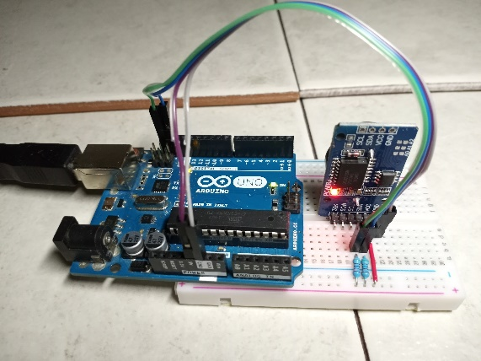

Figure 1. Picture of the module connected to an Arduino Uno

**Wiring**

* Communication with the module is performed via the I2C method.
* The SDA and SCL pins from the module will need to be pulled-up to the 5V line using two 5 kΩ resistors.
* Run the DS3231 code to operate.
* Below is a wiring diagram and a schematic diagram of the circuit.

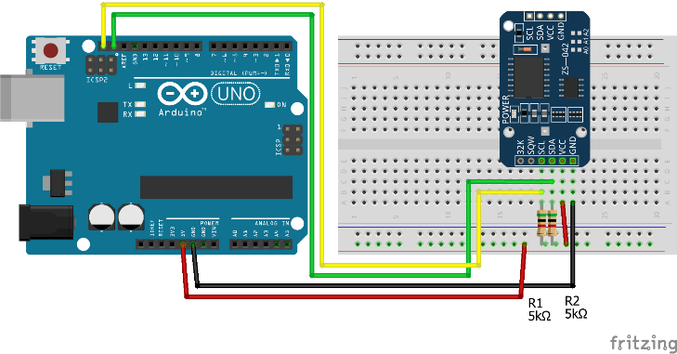

Figure 2. Wiring Diagram for the DS3231 with pull-up resistors

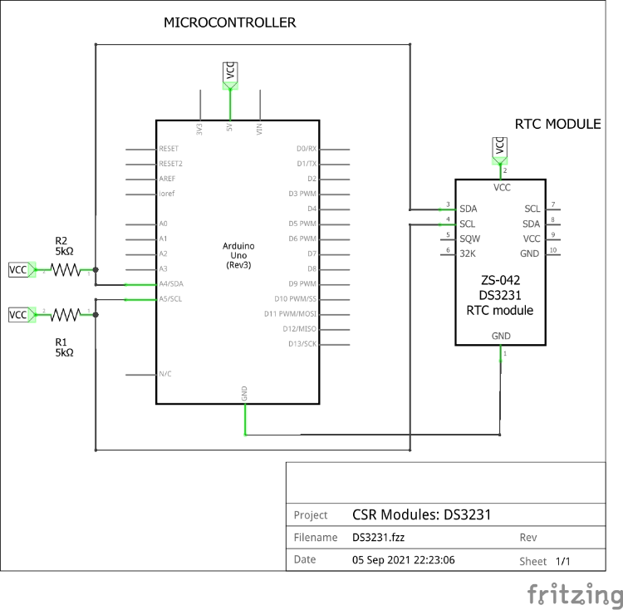

Figure 3. Schematic Diagram for the DS3231 with pull-up resistors

**Contact**

For any questions or assistance, email Adriann Liceralde at adriann8399@gmail.com.