Adriann Liceralde

Dr. Brian McPherson

Carbon Science Research at the University of Utah

CSR Arduino Collection Project

Last Updated February 28, 2022

**Information for the CU-1106 series of CO2 Sensors**

**Introduction**

* The Cubic CU-1106 is a series of NDIR-based CO2 sensors.
* These sensors have four variations: the C, the H-NS, the SL-N, and the SL-NS.
* All four versions look identical but have slightly different configurations and specifications, such as accuracy and measuring range.
* Any microcontroller can control this sensor. However, this guide and the associative codes use an Arduino Mega to operate the device.
* An Arduino Uno can also control the device too. However, the Serial monitor cannot view the data because the CU-1106 sensors use the Serial line to communicate with the Arduino, which the Uno only has one.
* An Arduino Mega, on the other hand, has multiple Serial lines. Therefore, one line is for communication between the sensor and the Arduino. And another line is dedicated to communication between the Arduino and the Serial monitor.

**Important Notes**

* This device is EXTREMELY sensitive to electrostatic discharge.
* NEVER touch the sensor UNLESS wearing Anti-Static Gloves.
* Exercise extreme caution even if the sensor is not connected to a power source.
* DO NOT place the CU-1106 sensors in direct contact with sunlight

**Specifications**

|  |  |  |  |  |
| --- | --- | --- | --- | --- |
|  | **CU-1106-C** | **CU-1106H-NS** | **CU-1106SL-N** | **CU-1106SL-NS** |
| **Range** | 0-5000 ppm | 0-10000 ppm | 0-5000 ppm | 0-5000 ppm |
| **Accuracy** | ± (50ppm+5% of reading) | ± (30ppm+3% of reading) | ± (50ppm+5% of reading) | ± (50ppm+5% of reading) |
| **Frequency** | 1 sec | 1 sec | 4 sec | 4 sec |
| **Current** | < 45mA | < 50mA | 60 µA | 60 µA |
| **Voltage** | 4.5 - 5.5 V | 4.5 - 5.5 V | 3.3 - 5.5 V | 3.3 - 5.5 V |
| **Lifespan** | ≥ 10 years | ≥ 15 years | ≥ 15 years | ≥ 15 years |
| **Cost** | N/A | $89 | $129 | $89 |

**Links**

* Product Info for Sensors:

<https://gaslab.com/products/single-beam-ndir-co2-sensor-cubic>

* Arduino Codes:

<https://github.com/RiceAllDay22/CSR_Arduino_Collection/tree/main/Individual_Modules>

**Wiring**

* This guide covers how to wire and operate the CU-1106 sensors:
  + CU-1106 via I2C
  + CU-1106 via UART
  + CU-1106H-NS via UART
  + CU-1106SL-N via UART
  + CU-1106SL-NS via UART
* The guide uses an Arduino Mega to view the collected data in real-time when operating via UART.
* If using an Arduino Uno is necessary, the data is viewable in real-time if a liquid-crystal display (LCD) module is implemented.
* Another option is implementing a microSD card module to store collected data.
* It is highly recommended that there is a 0.1 µF filter capacitor between the power pin and the ground pin.
* Each schematic contains a button reserved for manual calibration.

**Calibration**

* Manual calibrations occur via software and button-press.
* The following line of Arduino code sets the calibration point to 1100 ppm.
  + int calValue = 1100;
  + The calValue range is 400 to 1500 ppm. DO NOT GO OUT OF RANGE
* Pressing the button triggers a calibration to a value specified by the user in the code.

**CU-1106-C via I2C**

[Incomplete]

**CU-1106-C via UART**

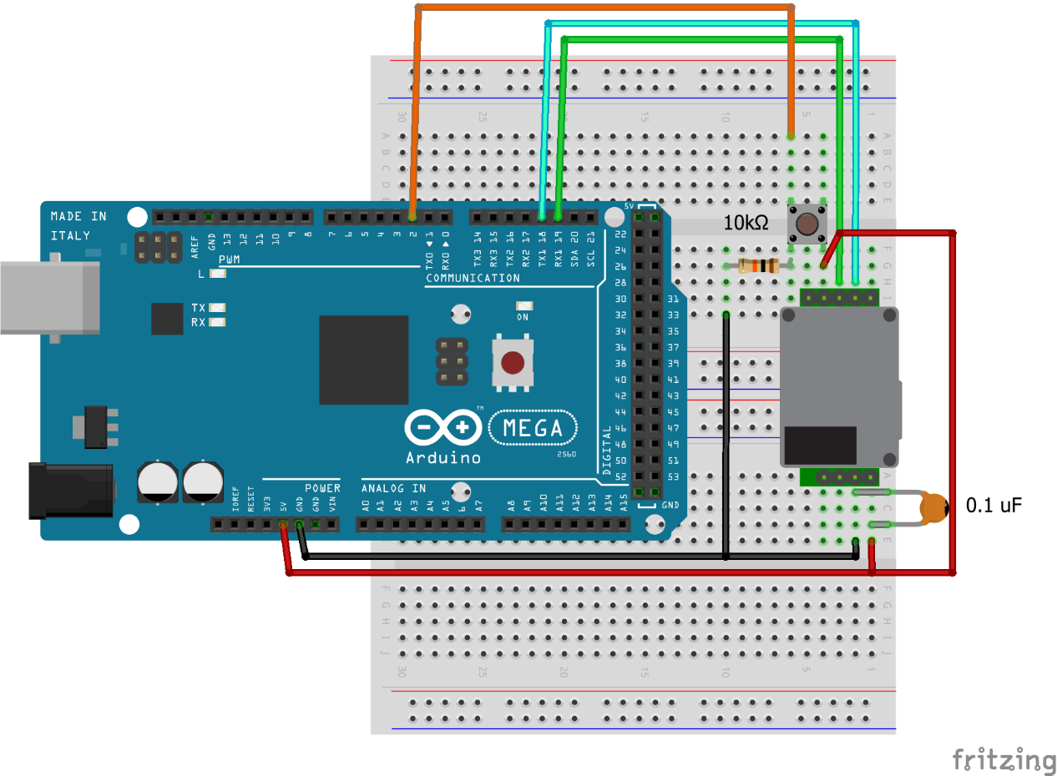

**CU-1106H-NS via UART**

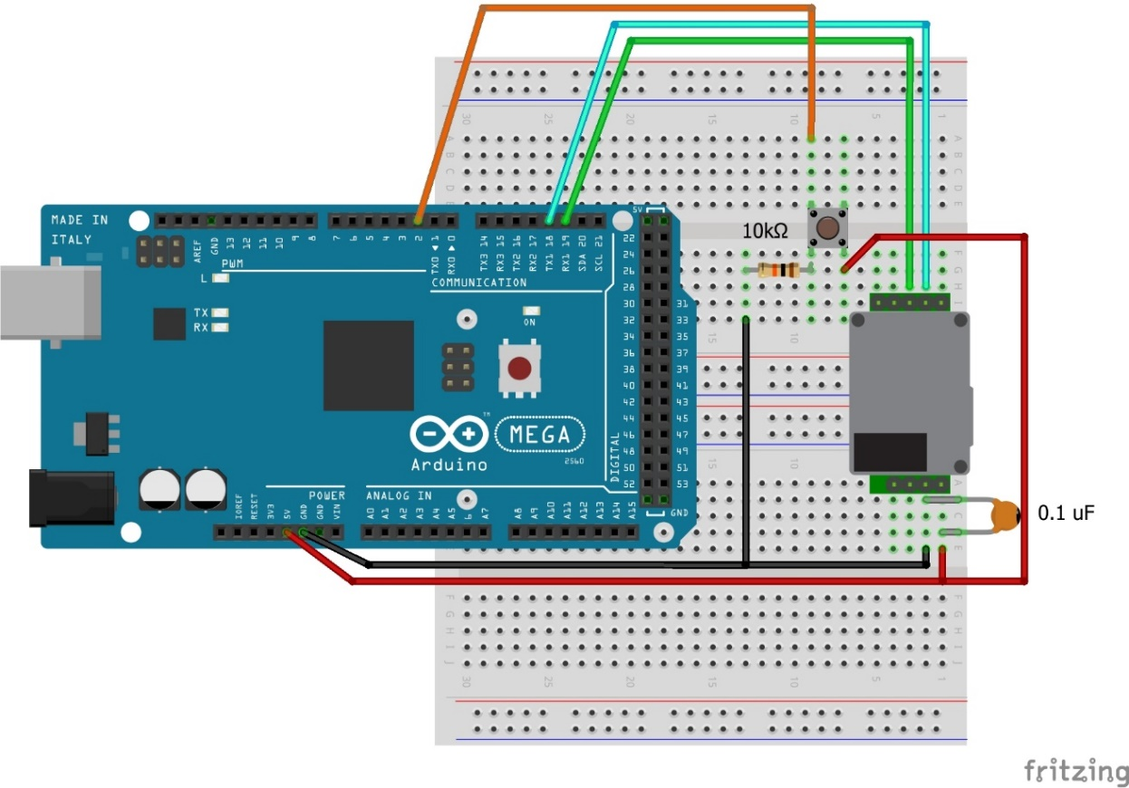

**CU-1106SL-N via UART**

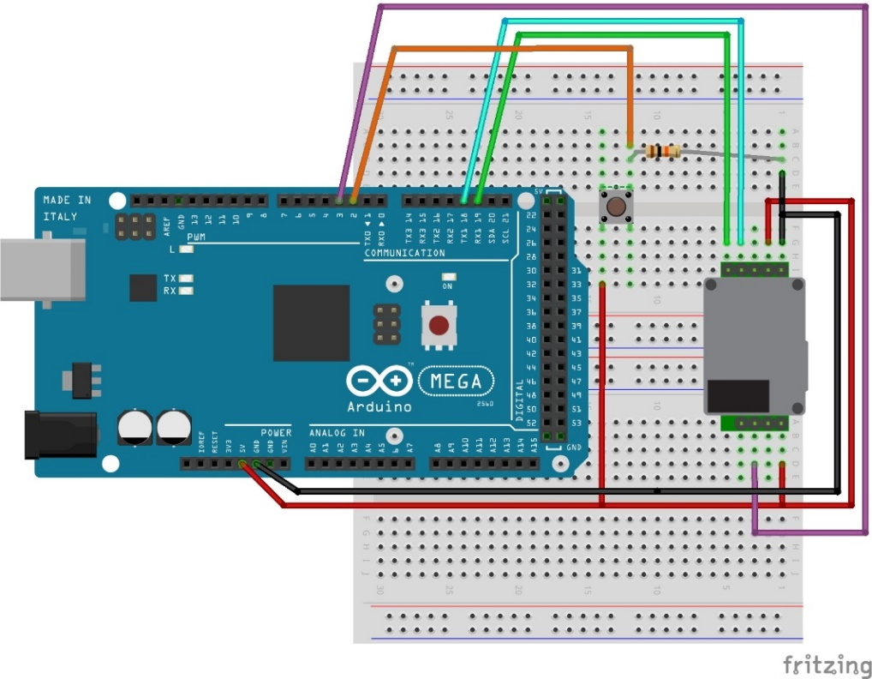

**CU-1106SL-NS via UART**

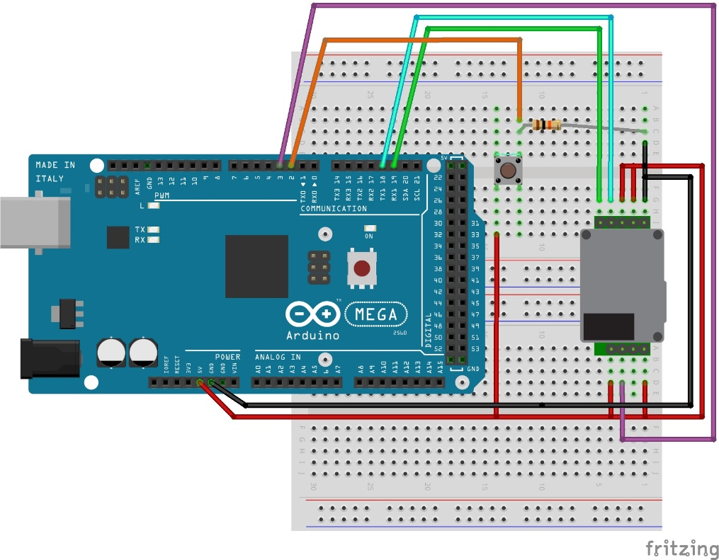

**Contact**

For any questions or assistance, email Adriann Liceralde at adriann8399@gmail.com