Adriann Liceralde

Dr. Brian McPherson

Carbon Science Research at the University of Utah

CSR Arduino Collection Project

Last Updated February 21, 2022

**Information for the Davis 6410 Anemometer**

**Introduction**

* The Davis 6410 is a low-cost anemometer that measures wind speed and wind direction at a relatively low cost of $170 (as of 2022).
* The wind vane portion of the device uses a linear potentiometer to determine the direction of a wind source.
* Each rotation of the wind cups emits a pulse.
* Converting from the number of pulses to wind speed is performed with the following formula:

$$V=P\left(\frac{2.25}{T}\right)/ 2.237$$

Where:

V = speed (meters per second)

P = number of pulses per sample period

T = sample period (seconds)

**Specifications**

|  |  |
| --- | --- |
| Model | 6410 |
| Brand | Davis |
| Range of Direction | 1 to 360 ° |
| Range of Speed | 0.5 to 89 m/s |
| Accuracy of Direction | ± 3° |
| Accuracy of Speed | ±1 m/s or ± 5% |

**Links**

* Product Link:

<https://www.davisinstruments.com/products/anemometer-for-vantage-pro2-vantage-pro>

* Product Info

<http://cactus.io/sensors/weather/anemometer/davis-anemometer>

* Original Hookup Guide

<http://cactus.io/hookups/weather/anemometer/davis/hookup-arduino-to-davis-anemometer>

* Arduino Code

<https://github.com/RiceAllDay22/CSR_Arduino_Collection/tree/main/Individual_Modules/Davis>

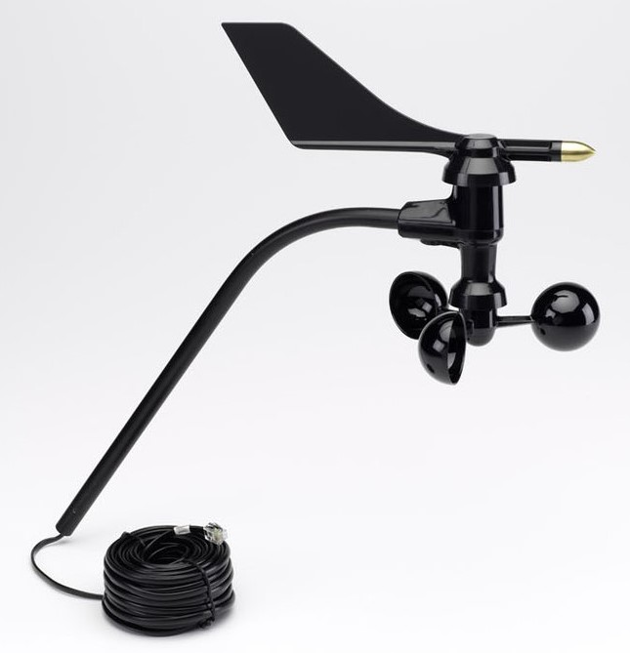

Figure 1. Image of the anemometer.

**Wiring**

* An RJ-11 port is used for connecting the Davis anemometer to an Arduino Uno
* The Davis anemometer has a 6-pin connector that inserts into the RJ-11 port.
* There is a 4.7 kΩ resistor between the power pin and the wind speed pin.
* There is no specific input voltage required for the anemometer.
* Either 3.3V or 5.0 V for power will work
* If 3.3 V is used, then a slight change in the code is needed. The associated Arduino code will mention this.

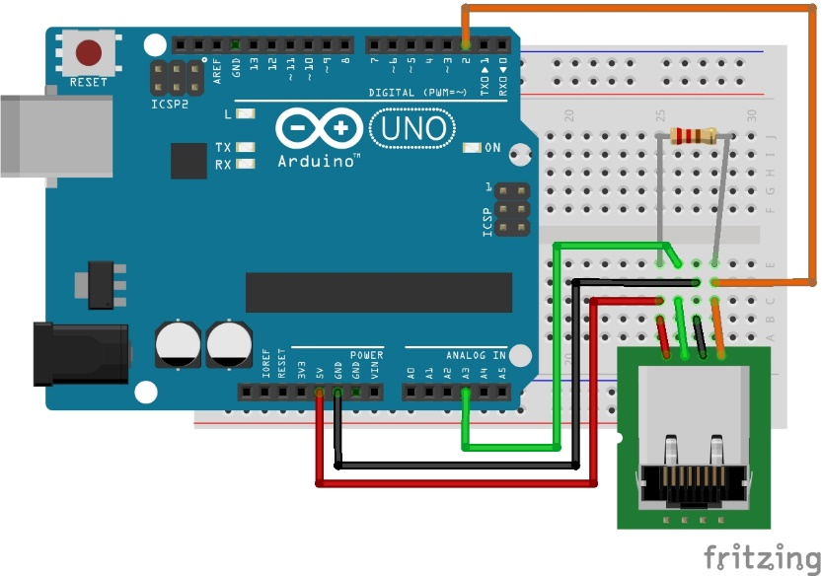

Figure 1. Wiring Diagram for the RJ-11 pin connector to the Arduino.

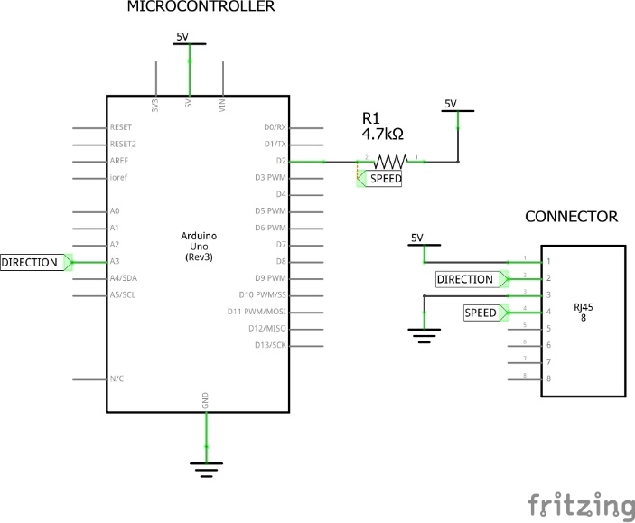

Figure 2. Schematic Diagram for the RJ-11 pin connector to the Arduino.

**Contact**

For any questions or assistance, email Adriann Liceralde at adriann8399@gmail.com.