Adriann Liceralde

Dr. Brian McPherson

Carbon Science Research at the University of Utah

CSR Arduino Collection Project

Last Updated February 20, 2022

**Information for the MH-Z16 CO2 Sensor**

**Introduction**

* The MH-Z16 is a low-cost rod-shaped sensor that uses NDIR technology to measure CO2.
* Any microcontroller can control this sensor. However, this guide and the associative codes use an Arduino Uno to operate the device.
* It is compatible with three different communication methods: I2C, UART, and PWM.
* The sensor connects to a blue I2C/UART Interface board that easily connects to an Arduino or Raspberry Pi.

**Important Notes**

* The sensor is sensitive to sunlight. Therefore, DO NOT place it in direct contact with sunlight.
* Do not expose the sensor to water or rainy conditions.

**Specifications**

|  |  |  |
| --- | --- | --- |
|  | **Via I2C/UART** | **Via PWM** |
| **Range** | 0 – 10,000 ppm | 0 – 5,000 ppm |
| **Accuracy** | ± (100ppm+5% reading) | ± (50ppm+5% reading) |
| **Resolution** | 1 ppm | N/A |
| **Current** | 60 mA (avg)  150 mA (max) | 60 mA (avg)  150 mA (max) |
| **Voltage** | 4.5 V - 5.5 V | 4.5 V - 5.5 V |
| **Response Time** | 60 sec (T90) | 60 sec (T90) |
| **Lifespan** | > 5 years | > 5 years |

**Links**

* Product Info:

<https://sandboxelectronics.com/?product=mh-z16-ndir-co2-sensor-with-i2cuart-5v3-3v-interface-for-arduinoraspeberry-pi>

* Datasheet:

<https://sandboxelectronics.com/wp-content/uploads/2018/08/Z16DS.pdf>

* Arduino Library:

<https://github.com/SandboxElectronics/NDIR>

* Arduino Code for I2C: <https://github.com/RiceAllDay22/EGI_Arduino_Collection/tree/main/MH-Z16_w_I2C>
* Arduino Code for PWM:

<https://github.com/RiceAllDay22/EGI_Arduino_Collection/tree/main/MH-Z16_w_PWM>

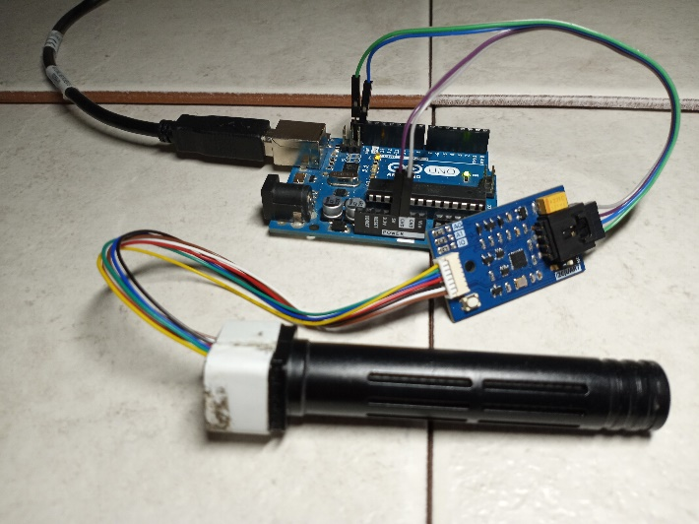

Figure 1. Picture of the sensor and the interface board connected to an Arduino Uno

**Wiring**

* Communication with the sensor is performed via the I2C, UART, or PWM methods.
* The Interface board allows for the I2C and UART methods.
* The MH-Z16 sensor is still operable without an Interface board via the PWM method.
* This guide covers how to use the sensor through I2C and PWM.
* NEVER make wiring connections while the Arduino Uno is on.

**Wiring – Method # 1 (Recommended for ease and more accurate data)**

* This method requires the Interface board so that I2C is used to communicate with the sensor.
* Connect the sensor rod to the interface board using the 7-wire Grove connector. Then connect the interface board to an Arduino Uno using four M/F jumper wires.
* The interface board has a switch. Ensure that it is set to I2C mode.
* Run the MH-Z16_w_I2C code to operate.
* Below is a wiring diagram and a schematic diagram of the circuit.

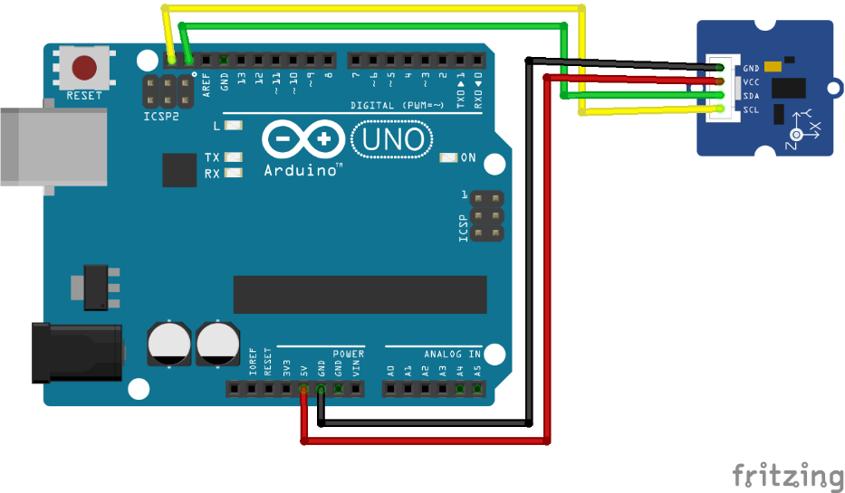

Figure 2. Wiring Diagram between an Arduino Uno and the interface board

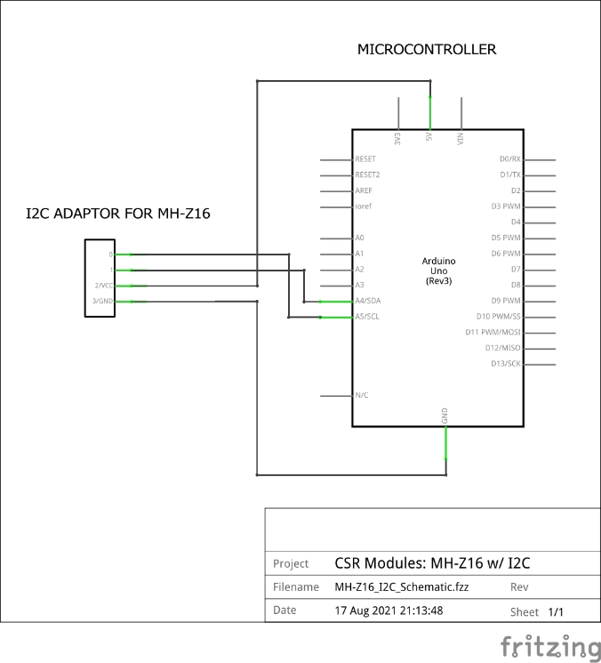

Figure 3. Schematic between an Arduino Uno and the interface board

**Wiring – Method #2 (Not recommended, but is usable)**

* This method does not require the Interface board.
* Use this only if an Interface board is unavailable.
* Run the MH-Z16_w_PWM code to operate.

[CURRENTLY UNFINISHED]

**Calibration for I2C mode**

* There is a white button on the blue adaptor.
* Once the sensor has been in a stable condition for a few minutes, hold the button for 10 seconds.
* The sensor starts giving readings around 400 ppm.
* The calibration point is always at 400 ppm and cannot be altered. The workaround to this limitation is to add offset values to a dataset.
* For example, if the gas used for calibration is 500 ppm, add 100 to every measurement after the calibration.

**Contact**

For any questions or assistance, email Adriann Liceralde at adriann8399@gmail.com.