Adriann Liceralde

Dr. Brian McPherson

Carbon Science Research at the University of Utah

CSR Arduino Collection Project

Last Updated February 20, 2022

**Information for the MicroSD Card Module**

**Introduction**

* The MicroSD Card module is an electronic device that stores data from a microcontroller into a microSD card.
* Any microcontroller can control this sensor. However, this guide and the associate codes use an Arduino Uno or an Arduino Mega to operate the device.
* Communicating with the device is performed via the SPI method.
* The module is compatible with any microSD card.

**Important Notes**

* Only insert/remove a microSD card when no power supply is connected. Doing so while power is active may result in errors or damage.
* This module has six pins that need to be connected to an Arduino microcontroller. If any pin is slightly disconnected, then the module will not operate. If a module is not working, the most likely reason is a loose pin.
* The SD card file must be safely closed before power is disconnected. A Toggle Switch can be implemented to do this, which will be explained in the Wiring section.

**Links**

* Product Search for Module:

<https://www.amazon.com/s?k=micro+sd+card+module+arduino&crid=24MLFBXJ18ZYD&sprefix=micro+sd+card+module+arduin%2Caps%2C214&ref=nb_sb_noss_2>

* Product Info for Level Converter:

<https://www.sparkfun.com/products/12009>

* Arduino Library:

<https://www.arduino.cc/reference/en/libraries/sdfat-adafruit-fork/>

* Arduino Code:

<https://github.com/RiceAllDay22/EGI_Arduino_Collection/tree/main/SDCardModule>

**Wiring**

* In the following sections, four different examples are shown:
  + Arduino Uno without Logic Converter
  + Arduino Uno with Logic Converter
  + Arduino Mega without Logic Converter
  + Arduino Mega with Logic Converter
* Each example contains an Arduino board, a MicroSD card module, and a Toggle Switch.
  + The Toggle Switch is used to close the SD file safely.
  + When the switch is positioned “left” towards the 5V line, then the file remains open.
  + When the switch is positioned “right” towards the GND line, then the file closes.
* Two of the examples use a Logic Converter module.
  + This converter ensures that the MOSI, SCK, and CS pins are operating at 3.3 V, as required by the datasheet.
  + Those three pins can still operate at 5.0 V; however, doing so may result in errors or damage to the module and/or the SD card.
  + Therefore, it is highly recommended that a Logic Converter is implemented when using the microSD card module.
* The operating procedure, which applies to all the examples, is shown below:
  + 1. Assemble the circuit using one of the methods shown further in the guide
  + 2. Insert a microSD card into the slot
  + 3. Flip the switch to the “left” position
  + 4. Connect the power supply
  + 5. Upload the Arduino software
  + 6. The microSD card module boots up
  + 7. The circuit continuously stores data into the microSD card
  + 7. Flip the switch to the “right” position to close the file
  + 8. Disconnect the power supply
  + 9. Eject the microSD card from the slot
* The Arduino code is the same across all four examples.
  + The inclusion of the Logic Converter does not change the software.
  + No Arduino Mega-specific features are used in these examples. Therefore, the code is compatible with both the Uno and the Mega.

**Wiring – Arduino Uno Method #1 (Simpler but NOT recommended)**

* This example does not include the Logic Converter.
* If the application involves long-term use, then do not use this method because the chances for errors and damage are high.

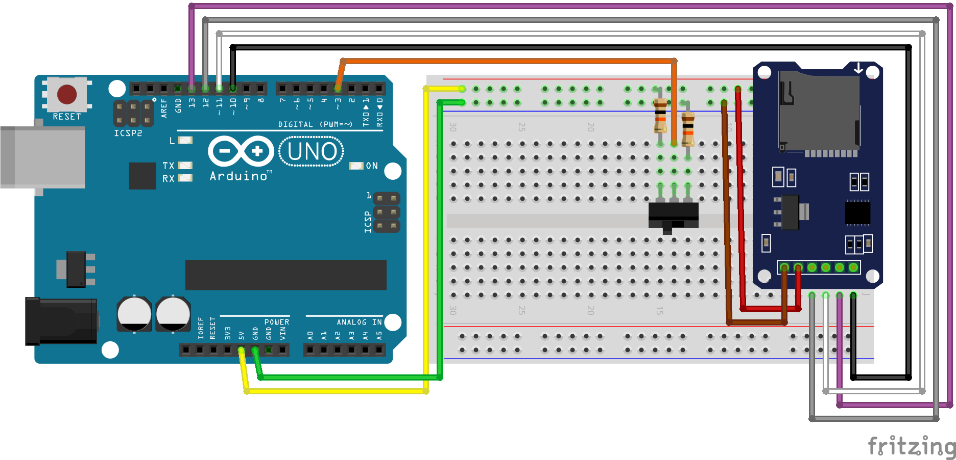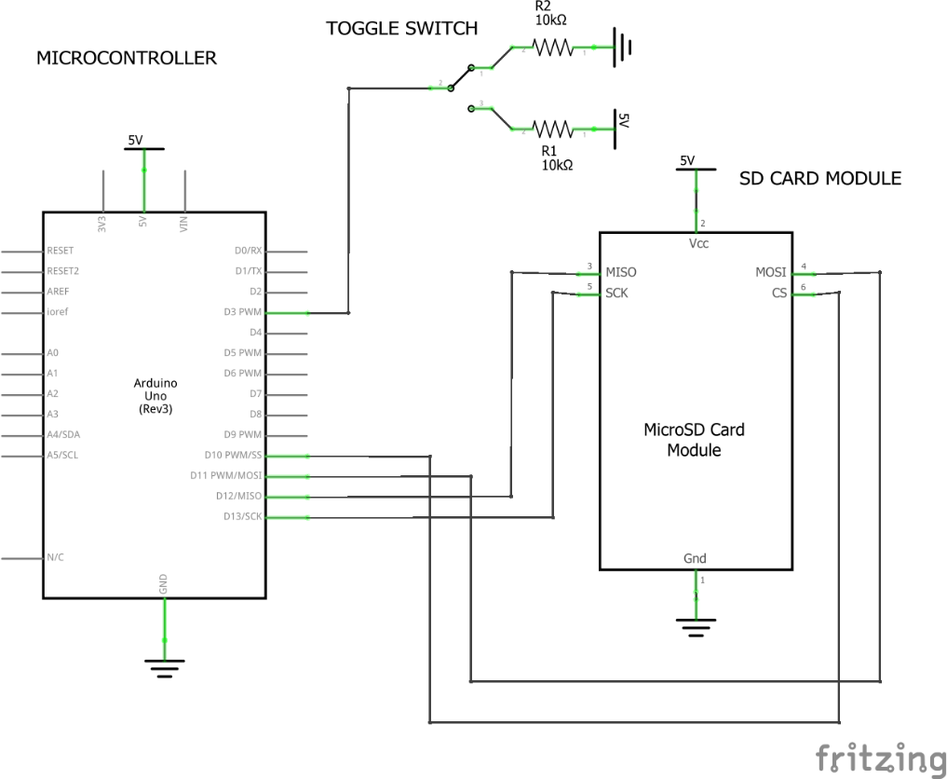

Figure 1. Wiring and Schematic diagrams for the module via an Uno without a Logic Converter

**Wiring – Arduino Uno Method #2 (Recommended for reliability)**

* This example contains the Logic Converter, making the module more reliable and less likely to fail.

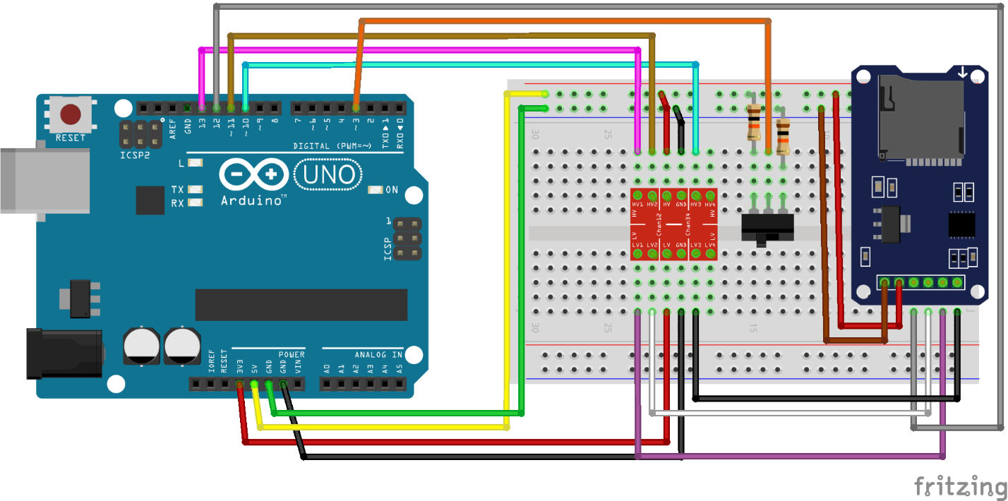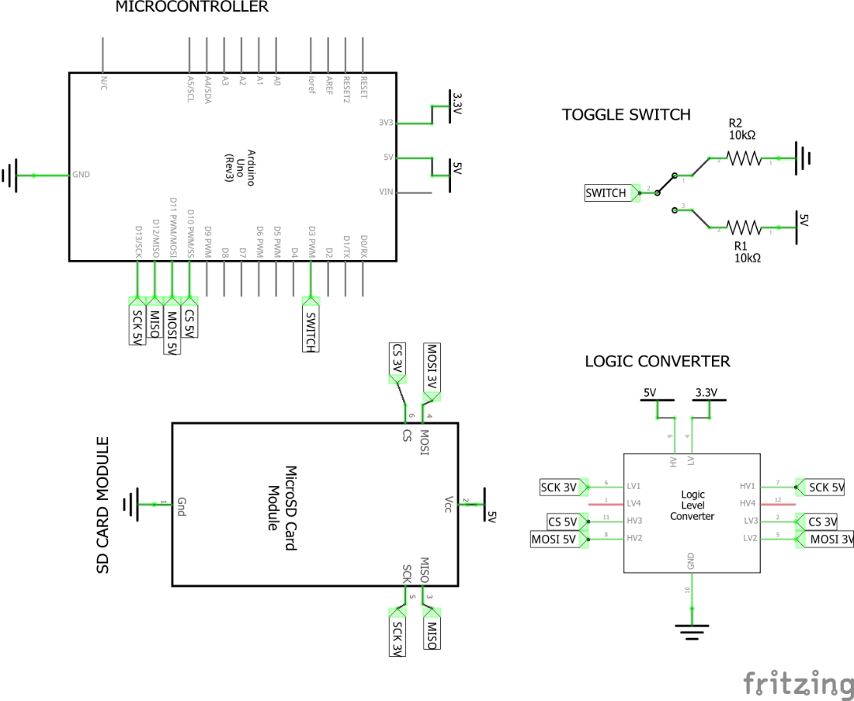

Figure 2. Wiring and Schematic diagrams for the module via an Uno with a Logic Converter

**Wiring – Arduino Mega Method #1 (Simpler but NOT recommended)**

* This example does not include the Logic Converter.
* If the application involves long-term use, then do not use this method because the chances for errors and damage are high.

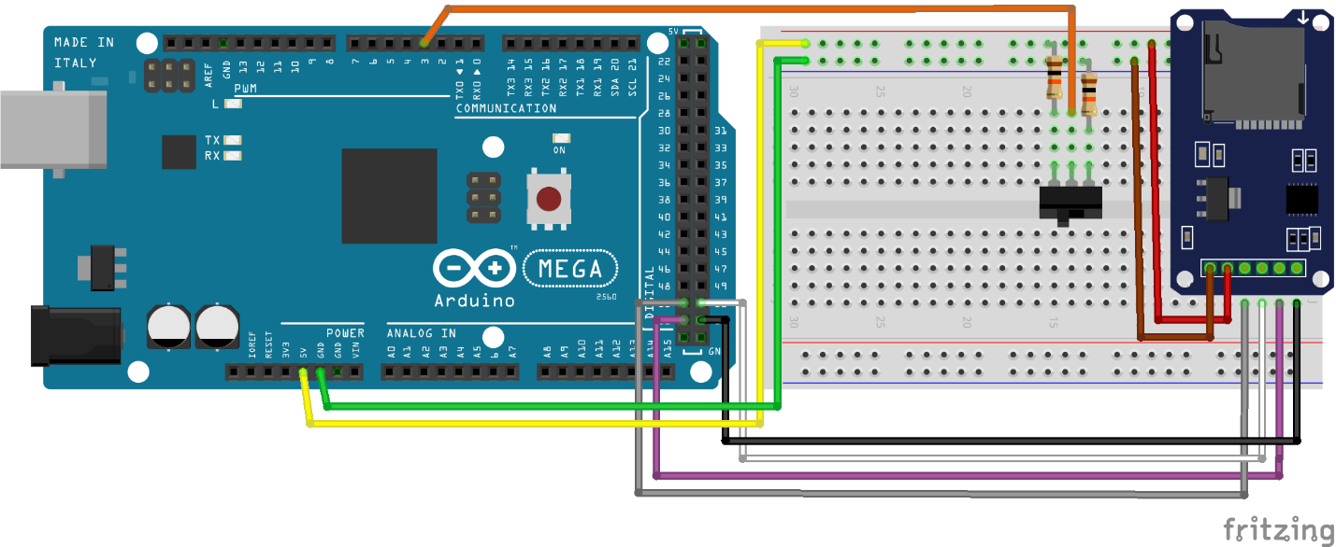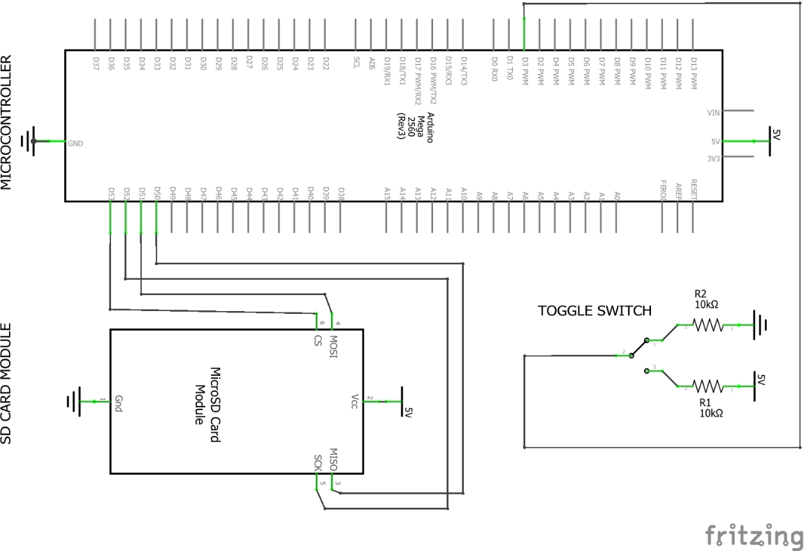

Figure 3. Wiring and Schematic diagrams for the module via a Mega without a Logic Converter

**Wiring – Arduino Uno Mega #2 (Recommended for reliability)**

* This example contains the Logic Converter, making the module more reliable and less likely to fail.

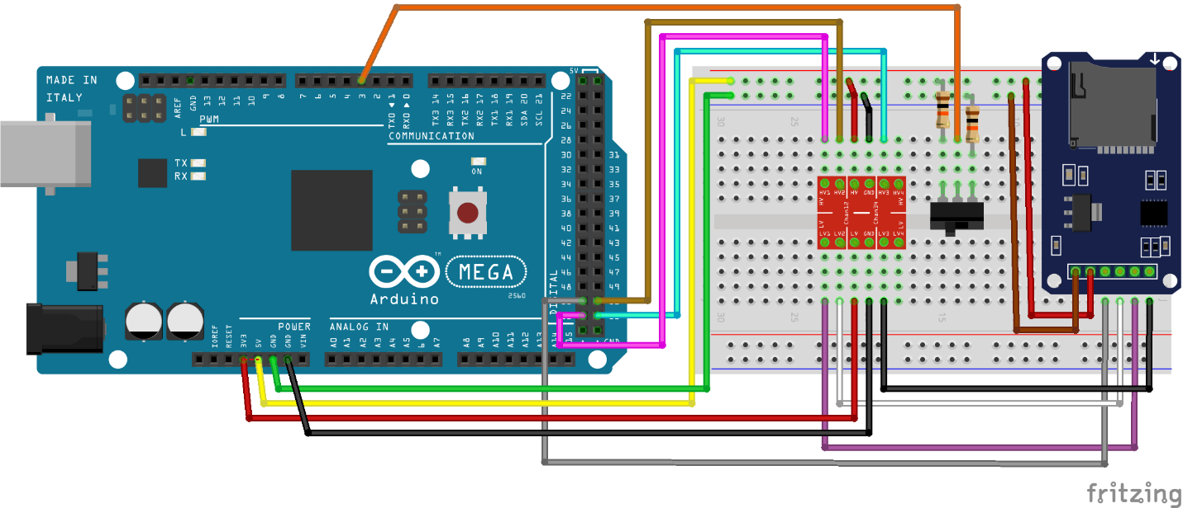

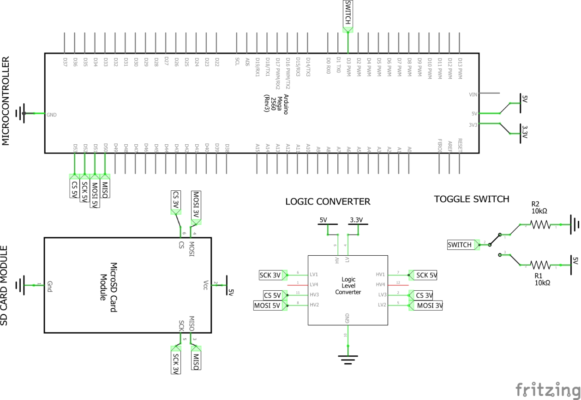

Figure 4. Wiring and Schematic diagrams for the module via a Mega with a Logic Converter

**Contact**

For any questions or assistance, email Adriann Liceralde at adriann8399@gmail.com.