Adriann Liceralde

Dr. Brian McPherson

EGI at the University of Utah

CSI Arduino Collection Project

Last Updated January 26, 2022

**Information for the MH-Z16 CO2 Sensor**

**Introduction**

* The MH-Z16 is a low-cost rod-shaped sensor that uses NDIR technology to measure CO2.
* Any microcontroller can be used to control this sensor. However, this guide and the associative codes will use an Arduino Uno to operate the device.
* The sensor connects to a blue I2C/UART Interface board that easily connects to an Arduino or Raspberry Pi.

**Important Notes**

* The sensor is sensitive to sunlight. Therefore, DO NOT place in direct contact with sunlight.
* Do not expose the sensor to water or rainy conditions.

**Links**

* Product Info: <https://sandboxelectronics.com/?product=mh-z16-ndir-co2-sensor-with-i2cuart-5v3-3v-interface-for-arduinoraspeberry-pi>
* Datasheet: <https://sandboxelectronics.com/wp-content/uploads/2018/08/Z16DS.pdf>
* Arduino Library: <https://github.com/SandboxElectronics/NDIR>
* Arduino Code for I2C:
* Arduino Code for PWM:

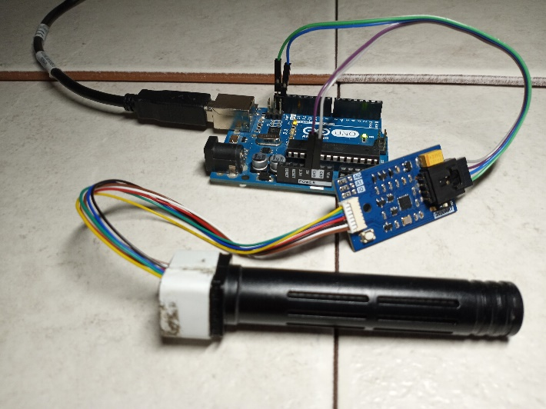

Figure 1. Picture of the sensor and the interface board connected to an Arduino Uno

**Wiring**

* Communication with the sensor is performed via the I2C, UART, or PWM methods.
* The Interface board allows for the I2C and UART methods.
* The MH-Z16 sensor is still operable without an Interface board via the PWM method.
* This guide will cover how to use the sensor through I2C and PWM.

**Wiring – Method # 1 (Recommended for ease and more accurate data)**

* This method requires the Interface board so that I2C is used to communicate with the sensor.
* Below is a wiring diagram and a schematic diagram of the circuit.

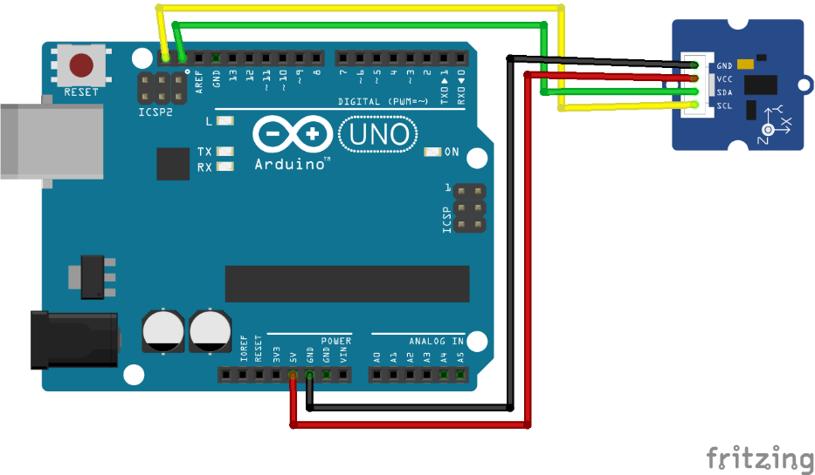

Figure 2. Wiring Diagram between an Arduino Uno and the interface board

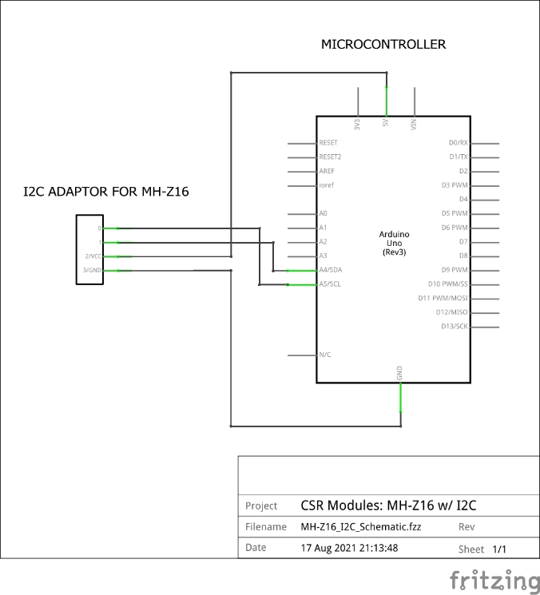

Figure 3. Schematic between an Arduino Uno and the interface board

**Wiring – Method #2 (Not recommended, but is usable)**

* This method does not require the Interface board.
* Use this only if an Interface board is unavailable.

[UNFINISHED]

**Contact**

For any questions or assistance, email Adriann Liceralde at adriann8399@gmail.com.