**Adriann Liceralde**

**EGI at University of Utah**

**August 6, 2021**

**Information for SCD-30 CO2 Sensor**

**Introduction**

* The SCD-30 is a low-cost NDIR-based sensor that measures CO2, temperature, and humidity.
* Any microcontroller can control this sensor. However, this guide and the associative codes will use an Arduino Uno to operate the device.

**Important Notes**

* This device is EXTREMELY sensitive to electrostatic discharge.
* NEVER touch the sensor UNLESS wearing Anti-Static Gloves.
* Even if the sensor is not connected to a power source, still exercise extreme caution.
* The sensor is sensitive to sunlight. Therefore, DO NOT place in direct contact with sunlight.

**Links**

* Product Info: <https://www.sensirion.com/en/environmental-sensors/carbon-dioxide-sensors/carbon-dioxide-sensors-scd30/>
* Arduino Library: https://github.com/sparkfun/SparkFun_SCD30_Arduino_Library

**Wiring**

* To operate the sensor, a minimum of 4 pins are required to be connected to an Arduino:
  + VIN (Voltage Input)
  + GND (Ground)
  + SCL (Clock Line for I2C communication)
  + SDA (Data Line for I2C communication)
* The sensor can accept a voltage input range of 3.3V to 5.5 V.
* The I2C pins can be at 5V but are highly recommended to be at 3.3 V.
* Therefore, the sensor can be wired up in two ways.

**Wiring – Method #1 (Recommended method for long-term use)**

* This method powers the sensor at 5V with the SCL and SDA lines operating at 3.3V using a Bi-Directional Logic Converter.
* Below is a breadboard view and a schematic of the circuit.

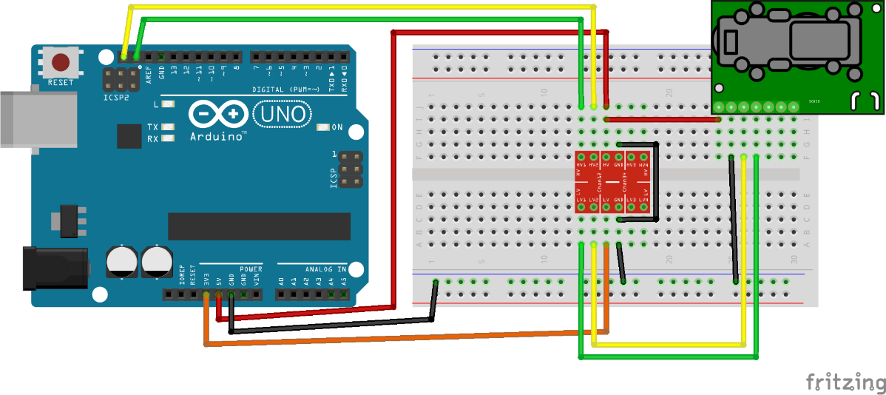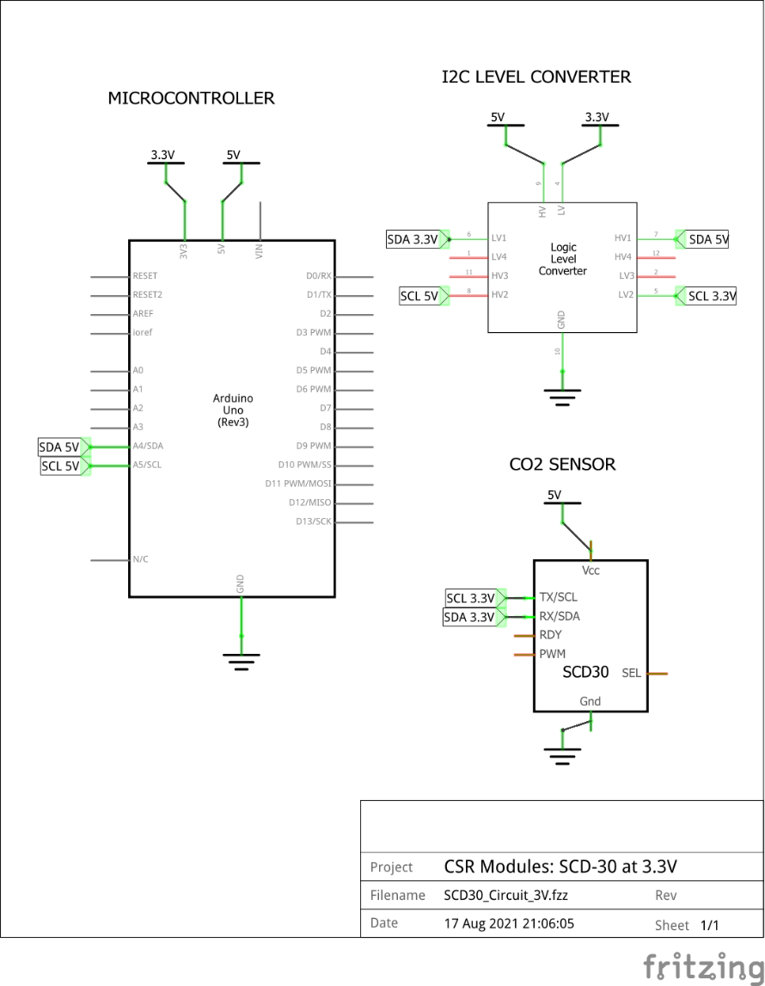

**Wiring – Method #2 (Not recommended, but is the simpler method)**

* This method powers the sensor at 5V with the SCL and SDA lines operating at 5V.
* Below is a breadboard view and a schematic of the circuit.

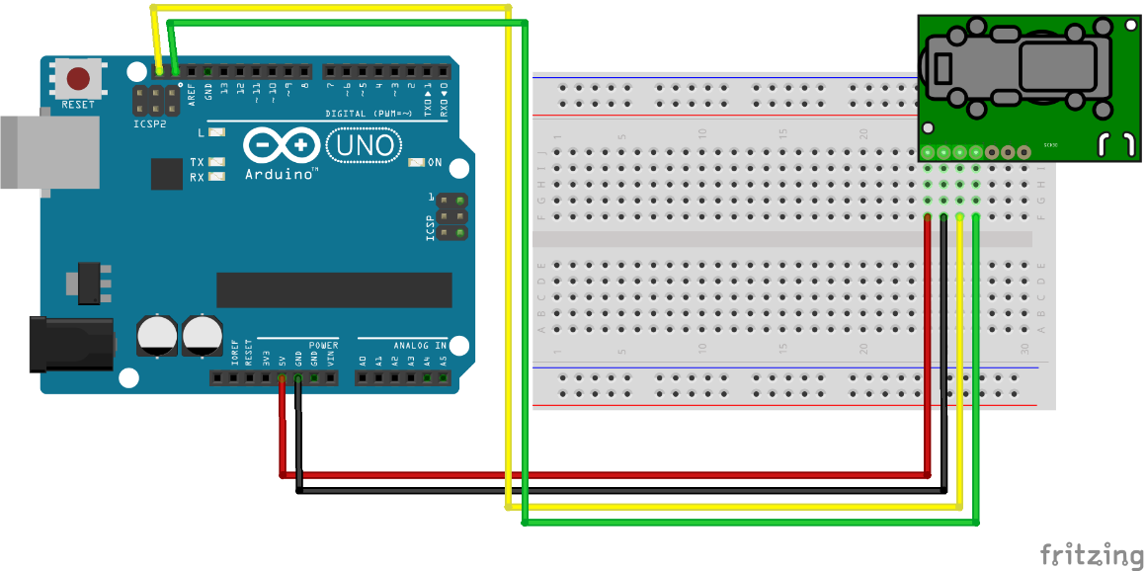

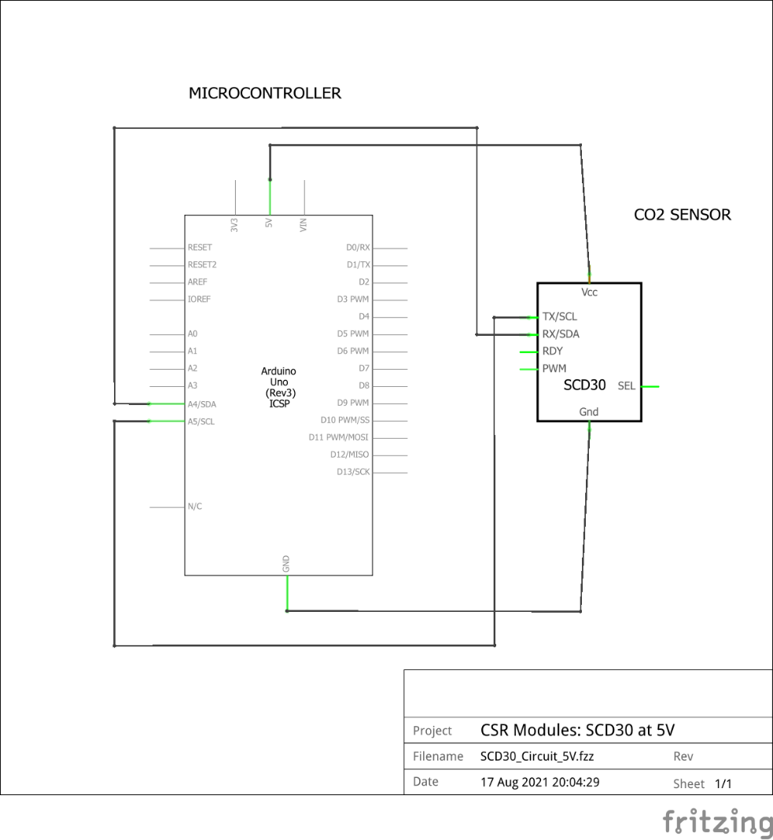

**Contact**

For any questions or assistance, contact Adriann Liceralde at adriann8399@gmail.com